A Training Manual on

TRAIL BRIDGES

(For Practitioner Overseers)
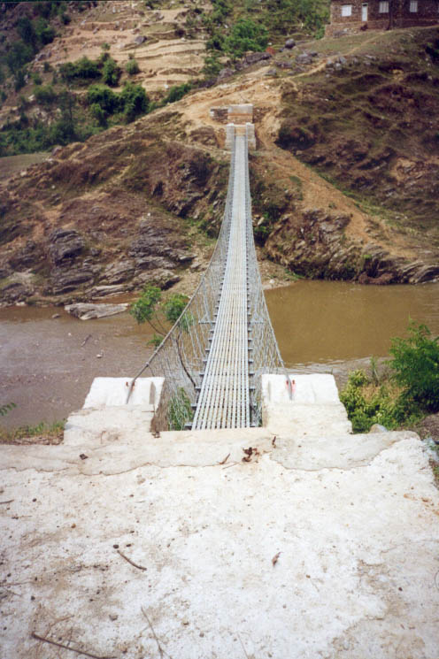


Research and Training Unit
DEPARTMENT OF CIVIL ENGINEERING

INSTITUTE OF ENGINEERING, TRIBHUVAN UNIVERSITY

December 2003

