7. Bridge Maintenance

7.1 Introduction
Maintenance, in most of the cases in our country had been a neglected affair. However, these days maintenance of any facility is getting due consideration and is a good sign of change of attitude. Maintaining a facility economizes resources utilized for its construction in a country like Nepal where the resources are limited.

Maintenance of trail bridges is very crucial for keeping the mule and foot trails functional throughout the year. It is extremely essential to guarantee their permanent and safe use, maintain them in usable condition, and to preserve the investment made in these bridges. In order to determine the required maintenance, regular inspections of the bridge should be made after completion of the construction work.

7.2 Classification of Bridge Maintenance
The bridge maintenance work consists of the following two categories:
- Routine Maintenance
- Major Maintenance

A brief description of these two maintenance categories is given in the following sub-chapters.

7.2.1 Routine Maintenance
Routine maintenance (RM) is very crucial for Trail Bridges. Routine maintenance is a preventive type of maintenance and should be done regularly. It is important to protect the bridges from getting big and irreparable damages and assures long-term use by keeping them in serviceable condition. After completion of the bridge construction, routine maintenance should be carried out on a regular basis. In general, the works under routine maintenance are simple in nature.

The routine maintenance work includes the following important tasks:
1. Cleaning around the most important bridge elements
Cleaning and removing all sorts of debris, dirt, plants and bushes in and around the drainage channels, the cable anchorage terminals, the tower base, the area around foundations, the area below the bridge entrance and the bridge access trails.
2. Fixing and re-tightening of bridge parts
Fixing and re-tightening of walkway wire mesh, nuts and bolts, bulldog grips, etc. which have become loose.
3. Repairing the walkway deck
Re-tightening of loose nuts and bolts of the steel decks and J-Hooks.
4. Minor repairing of gabion boxes for bank and slope protection purposes
Inspection and checking of the slope and riverbank protection structures and execution of minor repair work.
5. Reporting of the bridge condition
Inspection and checking the general condition of all the bridge parts and structures and reporting to the concerned DDC and/or VDC and seek their necessary support in case of big landslides, bank erosion, etc. which may damage the bridge foundations and structures or even cause the collapse of the bridge.
Routine maintenance work can be carried out either by forming a Bridge Maintenance Committee (BMC) or by appointing a bridge warden. In both cases, one trained person must be assigned for regularly inspecting the bridge. S/he should preferably live close to the bridge and should be equipped with some basic tools.
Primarily the concerned VDCs are responsible for ensuring that routine maintenance is done. The DDCs, who bear the overall responsibility, shall monitor the routine maintenance and shall support the VDCs in cases beyond their capacity.

7.2.2 Major Maintenance
Major maintenance (MM) work includes all works, which need proper planning, survey, design and cost estimates. A certain level of knowledge and skill is required to execute major maintenance of the bridges.

Major maintenance work includes the following tasks:

- Replacing rotten wooden planks with galvanized steel decks.
- Replacing rotten wooden crossbeams with galvanized steel beams.
- Repairing of windguy arrangements/system.
- Repair, adjustment or replacement of suspenders including adjustment of the camber of suspension bridges.
- Re-painting of all non-galvanized steel parts.
- Re-tensioning of all loose cables and adjusting bridge alignment.
- Coaltar treatment of all non-galvanized threads.
- River bank and slope protection works.

The existing bridges, which were constructed in the past with wooden walkway decks and non-galvanized steel, need major maintenance work in the first instance. These bridges may require almost all the tasks mentioned above under major maintenance.

Major maintenance responsibilities are gradually operationalised at the district level by imparting technical know-how, methods and practices for carrying out maintenance work and providing material support. The DDCs are becoming better prepared to implement major maintenance works and are responsible for their execution independently or with the support of the Trail Bridge Section (TBS), or other concerned bridge building agencies.

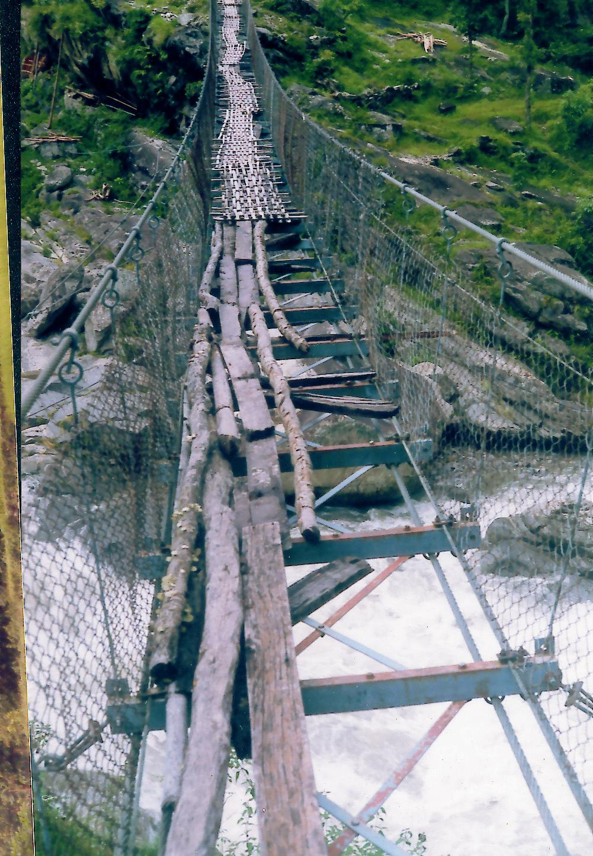
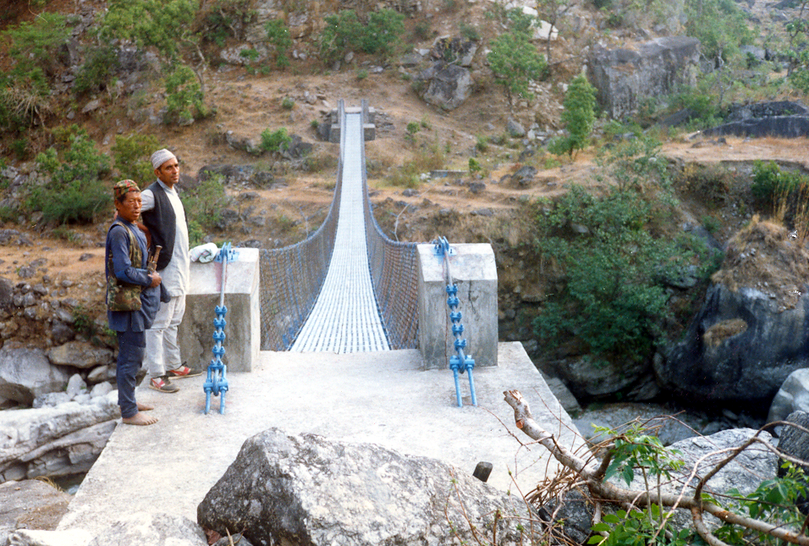

Figure: 7.1:A Bridge before maintenance. The same bridge after maintenance

7.3 Bridge Condition Investigation
DDC is becoming better prepared to investigate the condition of the trail bridge. This investigation provides information about the condition of the bridge. The following components ought to be investigated carefully during the survey.

- River bank condition
- Hill slopes condition
- Tower condition
- Deadload condition
- Cable condition
- Walway condition
- Walway deck (wooden or steel deck) condition
- Missing of Nuts and bolts and washers.

However, according to the requirement of different organisations involved in the trail bridge sector, the Bridge Condition Investigation format can vary although the points mentioned above should never be overlooked.

For details on Trail Bridge maintenance please refer to the following documents:
- Bridge Maintenance Concept, Suspension Bridge Division, (SBD), DoLIDAR, HMG/N, August 2000.
- Routine Maintenance Manual for Trail Bridges, Suspension Bridge Division, HMG/N, 1999.
- Directives on execution of Routine Maintenance of Main Trail Bridges through Bridge Wardens, Suspension Bridge Division, DoLIDAR, HMG/N, Shrawan 2057.
- Local Bridge Repair, Maintenance and Management, BBLL, Kathmandu.

7.4 Review Questions
Answer the following questions:

- Distinguish between the routine and major maintenance in Trail Bridge.
- What are the important tasks in routine maintenance of a Trail Bridge?
- State the important tasks in major maintenance of a Trail Bridge?
- What are the important items in conducting a bridge condition investigation?

