1. Introduction

1.1 Trail Bridges

1.1.1 Definition
Any crossing providing passage over an obstacle without closing the way beneath is called a bridge. Such structures over rivers/streams along trails, particularly in the hills and mountains, can be termed as trail bridges. These bridges serve especially pedestrian and animal traffic.

1.1.2 Historical Background on Trail Bridge Development
It is probable that, just as the modern girder bridge was first suggested in nature by the falling of trees across streams, the suspension bridge owes its origin to the extravagancies of ropes of creepers, vines and other trailing plants in warm countries.

The earliest recorded forms of suspension bridges are the rope and bamboo cable bridges of the Eastern Himalayas and South America. It has been suggested that the origin of suspension bridge construction lies in the eastern part of the Tibetan massif because of the frequency and the prevalence of many types from the simplest to the most advanced catenary deck forms. It is possible that early Chinese travellers exported the idea and the technology to South America. The idea of a connection between the cultures of China and South America, long unpopular, is at present being carefully reconsidered.

Primitive bridges were probably in use in these regions long before the earliest known contemporary record. The first written reference to a suspended type bridge was recorded in 90 A.D. and refers to a source of the year 25 B.C. The bridge described was situated in the Hindukush range. The following chart shows the history of the development of bridges. (Figure 1.1).

Figure 1.1: Development of Trail Bridges

a) First Suspension Bridge in Asia

The Funicular Bridge
One of the earliest types of sophisticated river crossings was the funicular bridge. It consisted of two cables, each anchored with one end higher than the other and inclined in the opposite direction. The passenger rode in a cradle slung under the cable and fastened to a hollow tubular sleeve, which was usually of wood and greased with animal fat. The passenger rode the descending cable and the cradle was then pulled back up empty to its original position by ropes attached to its back end.

Sometimes, if the cable hung in a shallow catenary, another rope attached to the front of the cradle would help the traveller up the last slope to the anchorage (Figure 1.2).
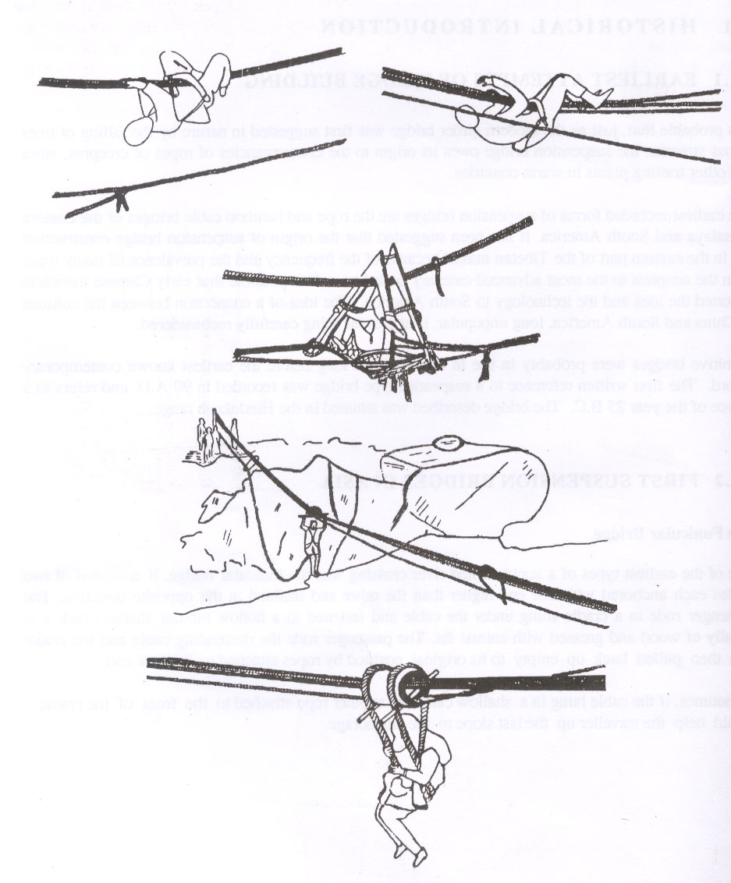

Figure 1.2: Types of Funicular Bridges

The "V" Bridge
A second ancient type of suspension structure consisted of three parallel ropes, two of them at the same height and the third lower and between the other two. Secondary ropes or wooden sticks connected the upper two to the lower and formed a woven "V"-shaped channel in which the traveller walked supporting himself on the two upper ropes as handrails. This type was common on the Yunnan-Burmese border where they are still referred to as the "grape-vine" type. They are also to be found in several other parts of South-east Asia. In Ladakh and other northern parts of the Indian sub-continent, where they are still in widespread use, they are called "Jhulas" (Figure 1.3).

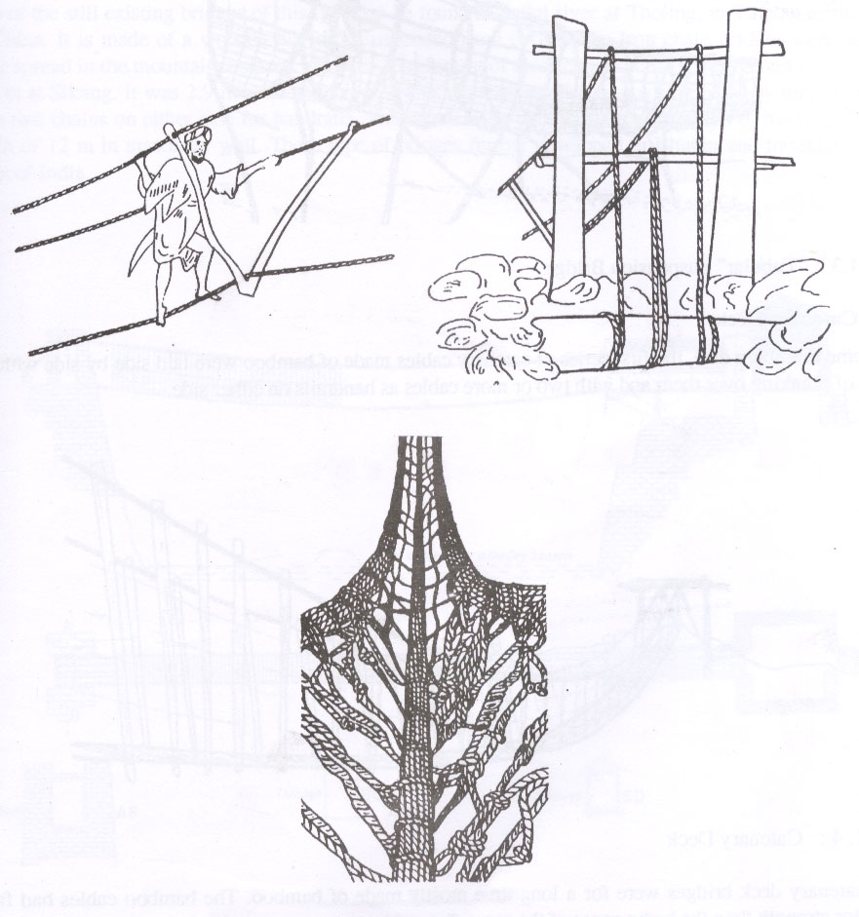

Figure 1.3: Types of "V" Bridges

The Tubular Bridge
The third type is a tubular construction consisting of four ropes, three of which are arranged as in the "V"-type and the fourth directly overhead. Usually this type has a diameter of about 100-160 cm and has been known to exist in spans up to about 245 m with a swing of 15 m. This type was chiefly manufactured by the Abor tribesmen on the Assam-Tibet border (Figure 1.4).
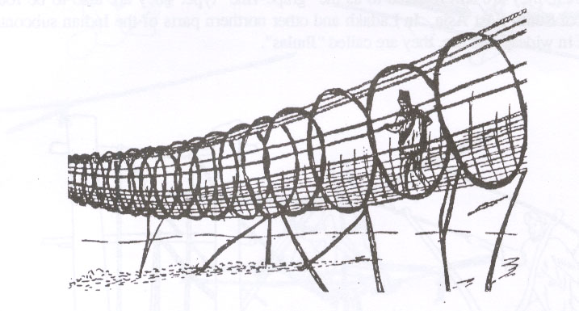

Figure 1.4: "Tubular" Suspension Bridge

The Catenary Deck
At some unknown date, the first series of catenary cables made of bamboo were laid side by side with a deck of planking over them and with two or more cables as handrails on cither side.
The catenary deck bridges were for a long time mostly made of bamboo. The bamboo cables had far more superior strength than the hemp ropes of the same dimensions.
Bamboo strips from the softer inner part of the culms formed the core in the centre of the rope. Around them was woven a thick plaiting of bamboo strips taken from the outer silica containing layers, which are extremely resistant to wear. The diameter of the rope was generally around 5 cm (Figure 1.5).

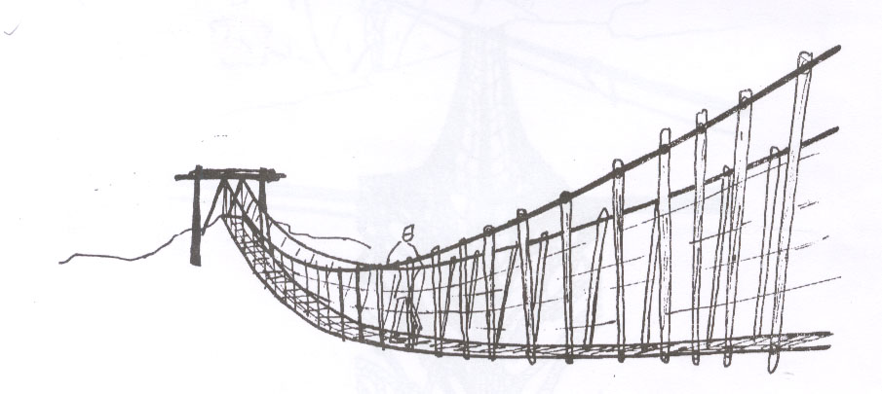

Figure 1.5: Catenary Deck

b) Iron Chain Bridge

In replacement of the bamboo cable bridges, the iron chain suspension bridges came in light as more advanced technology.

Among the ancient bridges, these were the most permanent structures, as the iron chains were of a very good quality and lasted for a long period. They were also more convenient for traffic, with platforms protected on either side by a bamboo or other fence.

The oldest known iron chain suspension bridge was built in Yunan, China in the sixth century A.D. One of the still existing bridges of this type can be found across the Satlaj River at Tholing, in the Tibetan territory of China. It is made of a wooden platform, suspended from two chains. Iron chain bridges were widespread in the mountainous regions of China. The largest of these chain bridges had a span of 100 m at Sikang. It was 2.9 m wide and the deck was made of wooden beams supported by nine chains with two chains on either side for handrails. The chains were imbedded on both banks of the river to a depth of 12 m in masonry wall. These types of bridges further developed in Bhutan and the mountainous regions of India (Figure 1.6).

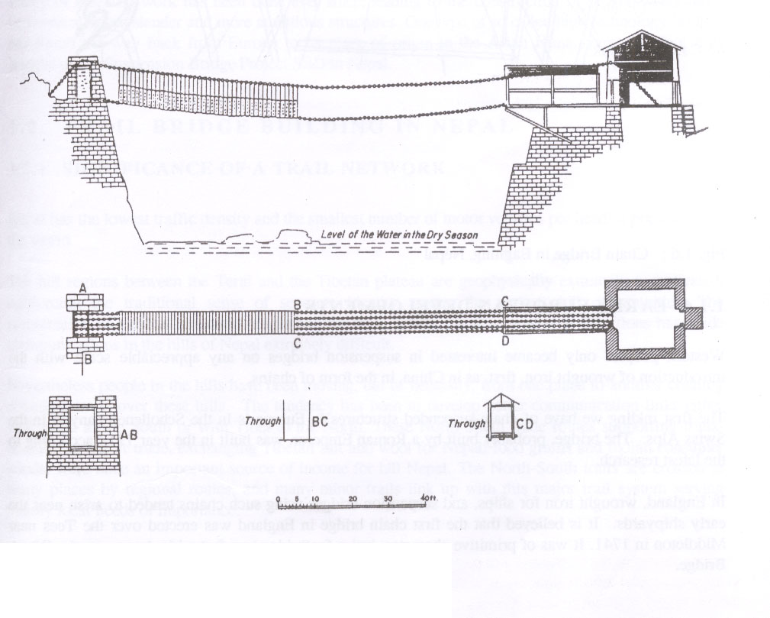

Figure 1.6: Sophisticated Chain Bridge in China.

1.1.3 Trail Network in Nepal
The hilly regions between the Terai and the Tibetan Plateau are geo-physically extremely complicated, reinforcing the traditional sense of separate identities among the various hill communities. The combination of various mountain ranges and river systems running in counter directions has made communications in the hills of Nepal extremely difficult.

Nevertheless, people in the hills have been moving from one place to another, out of necessity; thus creating countless trails over these hills. The tendency has been to develop better communication links either with India to the South or with Tibet to the North. These north-south trade routes, supporting trans-Himalayan barter trade, exchanging Tibetan salt and wool for Nepali foodgrains and Indian consumer goods, were once an important source of income for the hills of Nepal. The north-south trails are crossed at many places by regional routes, and many minor trails link up with these major trail systems, serving mainly local needs of importance.

The weakest points on these trail systems are the countless rivers and 'kholas' which cross them in counter-directions, creating big obstacles to smooth and proper communication. The problem of bridging these rivers for integrating the diverse social and regional units into a modern nation-state is still very real. The solution to this problem is not the development of a nation-wide road system, which would not be a feasible proposition for many years to come, because Nepal's economy will certainly not be able to support such a road network system for the foreseeable future. One is left with the only option of building improved trails and trail bridges that will help to improve the socio-economic situation in the hills of Nepal.

1.1.4 Types of Rivers
The Himalayan geology has resulted in a densely packed network of streams. Geology influences the drainage pattern of the more than 6,000 streams in Nepal, which can be grouped into three types of rivers. These major and minor rivers totaling about 45,000 km in length result in a drainage density of 0.3 km/km². This reflects the closeness of the drainage channels. There are four snow-fed river basins, seven non-snow-fed basins and hundreds of rain-fed sub-basins.

In terms of fordability, these rivers can be categorised as major, medium and minor types:
a. Major river : Perennial and non-fordable throughout the year
b. Medium river : Perennial and fordable with difficulty during dry seasons only
c. Minor river : Non-fordable during flash floods only

Naturally, a river crossing over a major river should have a higher priority for bridge construction than others.

1.1.5 Present Scenario of Trail Bridges and Future Demand
People in the hills of Nepal have always built their own bridges out of sheer necessity. Only in a few areas, such as Baglung and its surrounding districts, trail bridge activities have for a long time been coordinated and executed by higher authorities at the district level. It was in 1903, when His Majesty's Government of Nepal (HMG/N) for the first time got actively involved and mobilised resources to build bridges for the public.

At that time, Chandra Shamsher Rana gave Scottish firms the job of constructing footbridges along the main trade routes. Many of the constructions have survived erosion and the tough climate until now.

A second series of Scottish bridges was ordered in the 1930's. A new promoter of bridge construction emerged in the shape of Prime Minister K.I. Singh.

In 1958 A.D., a planned suspension bridge building programme sponsored by USAID took shape. Until 1964 A.D., the Public Works Department was responsible for all bridge building activities in Nepal. Then, on the advice of USAID, HMG/N instituted a new administration unit with the exclusive task of coordinating and supervising trail bridge construction - the Suspension Bridge Division (SBD).

Since 1960 A.D., with an interruption between 1965 and 1972 A.D., the Swiss Government has been assisting in the construction of suspension bridges on the main trail networks of Nepal. A new agreement for a further cooperation has been signed for the period 2001-2006 A.D.

By far the biggest category of bridges, the thousands of crossings for local use spread all over Nepal, are today still mainly built and maintained by the users themselves: single farmers, local user groups, village development committees, etc.

The idea of supporting indigenous trail bridge building activities at the local and district levels has been picked up by several donor agencies in recent years: CARE-Nepal with the Remote Area Development Committee (RADC), the Netherlands Development Organization (SNV) through its Trail Bridge Building Programme (TBBP), the Swiss Association for International Cooperation through Trail Bridge Sub-Sector Project, Helvetas, to name just a few. Trail bridge building at the national level is solely coordinated by the Suspension Bridge Division (SBD) of HMG/N.

With the advent of the Local Self-Governance Act 2055, a permanent Trail Bridge Section (TBS) was created in 2000 within the Department of Local Infrastructure Development and Agricultural Roads (DoLIDAR) of the Ministry of Local Development. With this major accomplishment, TBS has to deal with the new challenges of transferring SBD's skill and know-how of coordinating the private sector to local governments and to focus on the tasks of policy-making, setting standards and norms, and coordinating cooperation amongst districts.

The main responsibility of TBS is to enhance the decentralization process which is to result ultimately in capacitating the DDCs to coordinate the entire trail bridge sub-sector and TBS to gradually become a facilitator responsible for policy-making and coordination of bridge builders ensuring compliance with standards and norms.

1.2 Types of Bridges/Crossings

1.2.1 Types of Bridge and Their Application
a) Cable Bridges

The different types of cable bridges are as mentioned in Figure 1.7. The main structural components of these bridges are of cable. Besides cables, other important parts are constructed from structural steel sections, reinforced cement concrete, etc. Since cable is the main load-carrying material which is extensively used in such bridges, this type of bridge is called a Cable Bridge.

In the present manual, only trail cable bridges are discussed. These bridges have gained wide popularity in Nepal, mainly because of its relatively simple structural system and ease in construction with simple lifting and pulling instruments. Highly skilled manpower is also not required for the construction of such bridges.

All these trail bridges are highly flexible. Hence, they are termed as unstiffened Cable Bridges.

Figure 1.7: Different Types of Cable Bridges

b) Trail Cable Bridge

The following are the two main types of trail cable bridges constructed in Nepal:
- Suspension Bridge
- Suspended Bridge

(Refer to Article 3.1 of Chapter 3 for further explanation of these types of cable bridges.)

1.2.2 Classification of Trail Bridges
a) Modern Bridges

This category of bridges requires a rather high technical input. They are generally constructed by central level agencies and sometimes by district level authorities. They are suspension, suspended, stay cable and steel truss bridges. The anchorages and foundations are made of concrete. The superstructure is generally made of steel; sometimes towers are made of concrete. The walkway is made of timber or steel. These bridges have an engineering design, fulfill high safety standards and are relatively expensive.

Suspension Bridge
The suspension bridge is a light bridge construction with an un-stiffened walkway, towers, and generally gravity anchorages on both river banks. The walkway is hung on adjustable suspenders, which are attached to the main cables above. The longest suspension bridge constructed so far in Nepal has a span of 271 m. Figure 1.8 gives an overview of a suspension bridge.
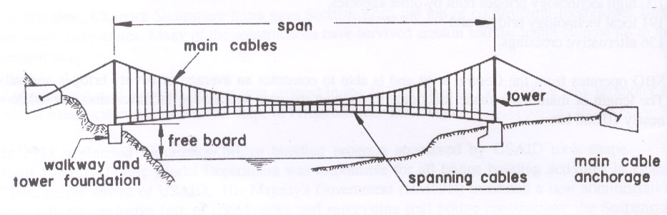

Figure 1.8: Suspension Bridge
Stay Cable Bridge
The stay cable is another kind of cable bridge. Stay cables directly connect the walkway with the tower top at different angles. Figure 1.9 gives an overview of a stay cable bridge.

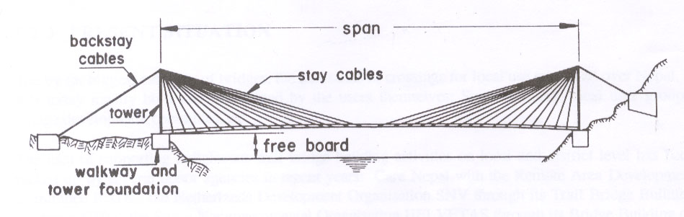

Figure 1.9: Stay Cable Bridge

Suspended Bridges
The suspended bridge, often referred to as the catwalk, is a modern version of the traditional chain bridge. The walkway is unstiffened and directly fixed on the main cables lying underneath. The sagging walkway is anchored directly to the main anchorage blocks without using any tower structures. The longest suspended bridge so far constructed in Nepal has a span of 350 m.
Figure 1.10 gives an overview of a suspended bridge.

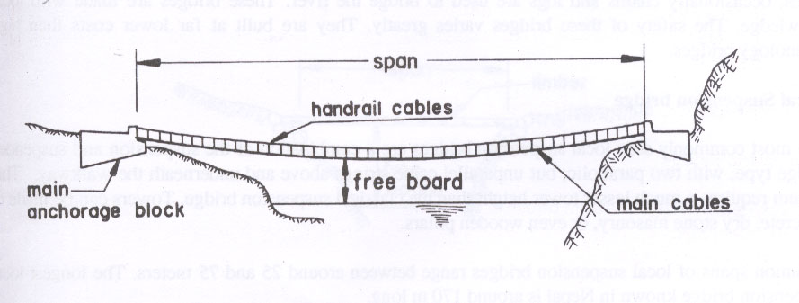

Figure 1.10: Suspended Bridge

Truss Bridge
Truss bridges are built in different shapes, normally of steel. The trussed beams consist of vertical suspending pieces and diagonal struts. Figure 1.11 gives an overview of a truss bridge.

Truss bridges are generally not constructed for spans upto 32 m.
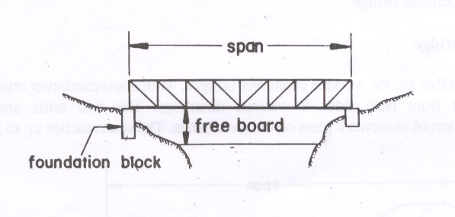

Figure 1.11: Truss Bridge

b) Traditional Local Bridges

Such bridges are usually of low technical standard and generally constructed at district or village level. They are local suspension bridges, wooden cantilever and wooden log bridges. Local materials like boulders, cocks and sometimes tree trunks are used for the anchorages and foundations. Wire ropes, and occasionally chains and logs, are used to bridge the river. These bridges are made using local knowledge. The safety of these bridges varies greatly. They are built at a far lower cost than modern bridges.

Local Suspension Bridge
The most commonly seen local suspension bridges are a combination of the suspension and suspended bridge types, with two parabolic but unparallel cable strings above and underneath the walkway. This system requires a tower of much lower height than the classical suspension bridge. Towers can be made of concrete, dry stone masonry, or even wooden pillars (Figure 1.12).

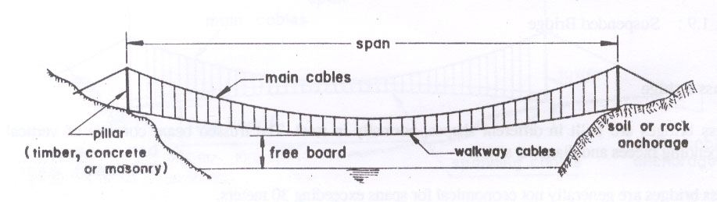

Figure 1.12: Local Suspension Bridge

Wooden Cantilever Bridge
Wooden cantilever bridges are quite elaborate and durable. Two cantilever arms are built with timber superimposed on both sides in various directions. The two arms are kept with a counterweight in the form of stonework piers on the river banks (Figure 1.13). The span reaches up to 30 m.

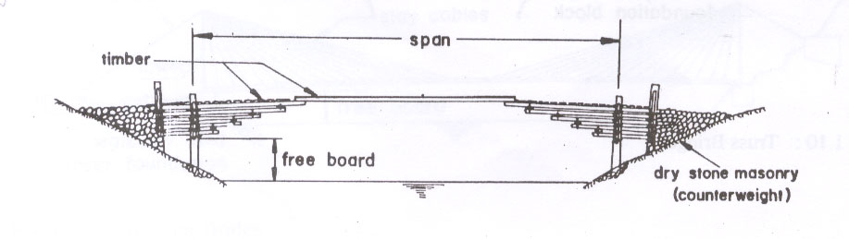

Figure 1.13: Wooden Cantilever Bridge

Wooden Log Bridge
The wooden log bridge is the simplest type of river crossing, with a span of up to a few meters. This type of bridge often consists of a tree trunk or shaped timber pieces thrown across a river. Bamboo is another material commonly used (Figure 1.14).

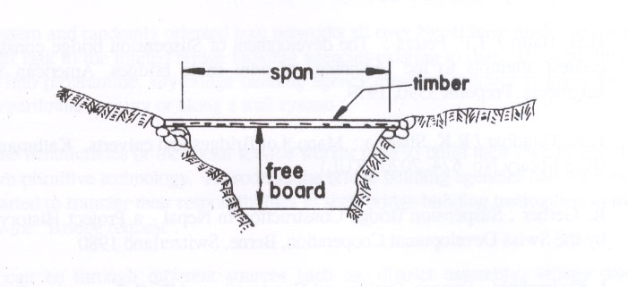

Figure 1.14: Wooden Log Bridge

c) Alternative Crossings

Alternative crossings are temporary bridges. Examples of alternative crossings are cable cars, modern versions of the ancient cableways, using steel or wooden boxes to be pulled along a main cable, ferries (boat) and fords.

1.2.3 Demarcation Convention
Standardization of trail bridges is necessary to facilitate various aspects of their design, construction and maintenance. Therefore, HMG/N has categorised pedestrian trail bridges as follows:

- Bridges up to a span of 120 m as Short Span Trail Bridges (SSTB)

- Bridges with a span greater than 120 m as Long Span Trail Bridges (LSTB)

This manual deals only with the site survey, design, construction and maintenance of SSTB.

1.3 Trail Bridge Terminology
The typical plan and elevation of a suspended SSTB is shown below (Figures 1.15 & 1.16).

Figure 1.15
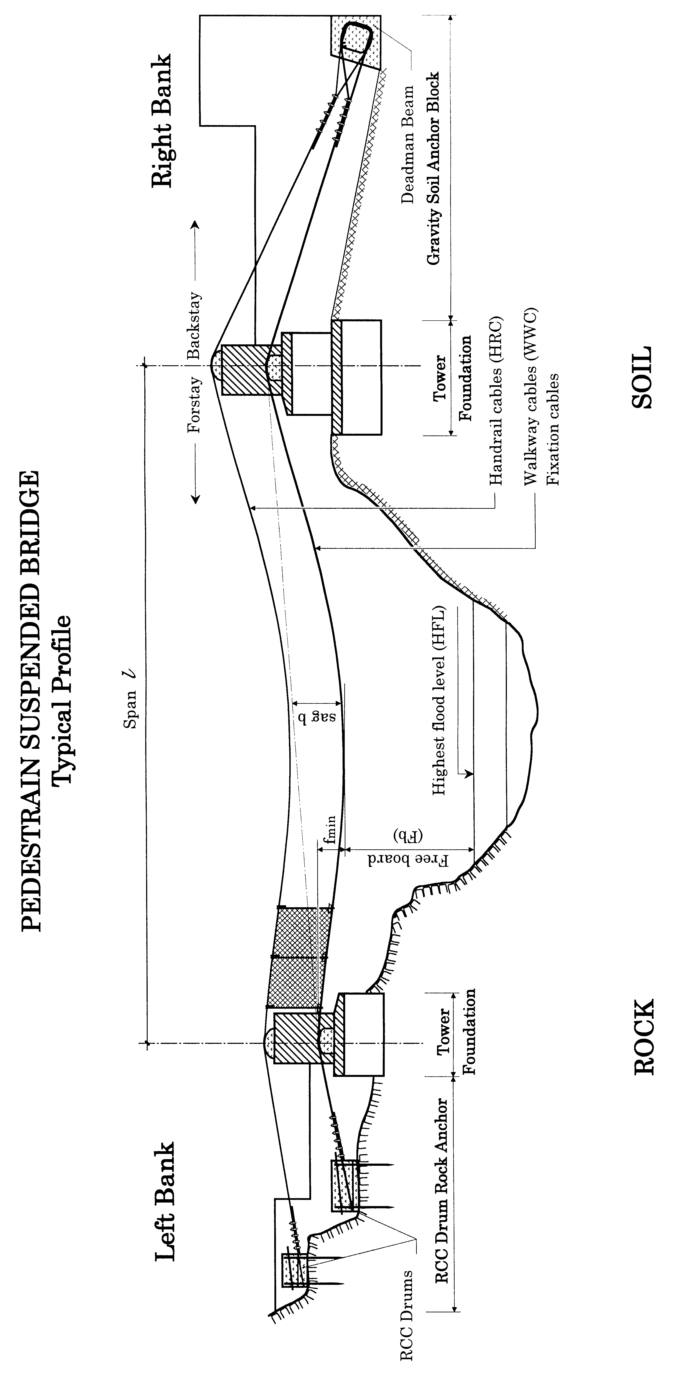
LWL

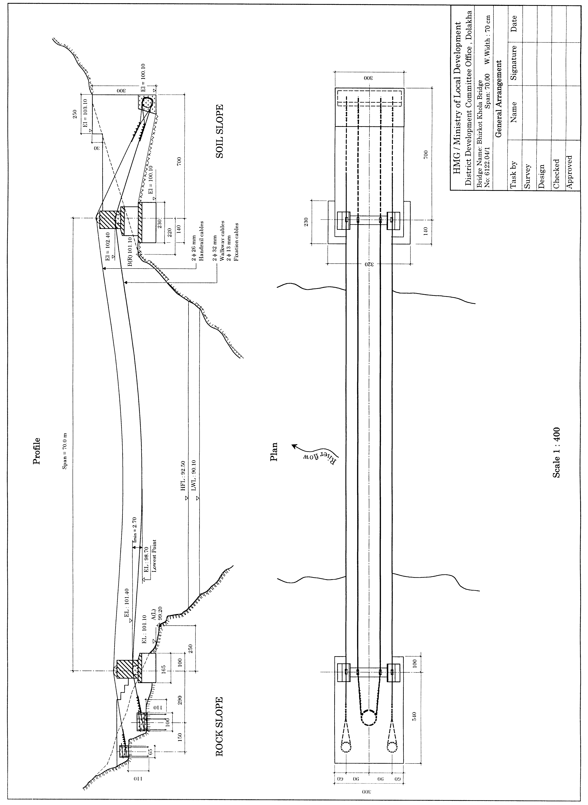

Figure 1.16

EL=100.10
The following are the frequently used terminology in the trail bridge construction:

- Suspended bridge | : | In this type, the whole load is carried jointly by the main cable and handrail cables in proportion to their cross sectional areas. In this case lengths of all the suspenders are equal.
- Suspension bridge | : | In this type of the bridge, the main cable carries the whole load. The dead load of the walkway and other system and the live load is transferred to the main cables through the suspenders. In this case the length of the suspender increases from mid span to the bridge end.
- Reconnaissance | : | Rapid survey of an area with a view to ascertaining the feasibility of an area of route for the purpose specified is known as reconnaissance.
- Bridge profile | : | The outline of the bridge transferred from the plan to the ground is known as the bridge profile.
- Contour line | : | A contour line is continuous line passing through points of equal elevation.
- Highest flood level (HFL): | : | The maximum water level attained by the river during the highest flood occurrence.
- Free board: | : | It is the difference between the designed highest flood level, allowing for afflux, and the lowest part of the bridge structure.
- Waterway: | : | The area through which the water flows under a bridge superstructure is known as the waterway of the bridge.
- Traffic volume | : | It is the number of pedestrians and in some cases animals that pass a bridge during a specified time period.
- Skew alignment: | : | If the bridge axis is at some angle (except the right angle) to the axis of the river it is called skew alignment.
- Square alignment: | : | If the bridge axis is at right angle to the axis of the river it is called square alignment.
- Economic span: | : | The economic span of the bridge is the one in adopting which the total cost of constructing the structure is the least.
- Foundation | : | It is the lowest part of a structure, which provides a base for the super structure.
- Dead load | : | The dead load is the weight of the structure and the weight of the portion of the superstructure, which is supported wholly or in part by the structure.
15. Deadman beam | : | Deadman beam is a soil anchor cast in reinforced cement concrete (R.C.C.) that lies buried under the gravity structure.
16. Drum anchorage |  | Drum anchorage is a rock (hard and soft) anchor cast in reinforced cement concrete (R.C.C.).
17. Live load | : | It is the load of the traffic including the people. They are also called super imposed loads.

18. Retaining wall | : | Wall constructed in heavy embankment to protect the slope from failing is called retaining wall.
19. Sag | : | When a cable is suspended at each end and allowed to hang freely under its own weight, it forms a curve, which is a part of a catenary. This is called sag.
20. Suspender | : | This is adjustable hanger rod. In suspended type it is placed between main and handrail cable while in suspension type it is placed in spanning and main cable.
21. Walkway | : | The walk able portion of the bridge.
22. Wind load: | : | Load caused by the wind is called wind load. It acts horizontally. It is based on the measurement of wind velocities and characteristics of the structure acting as the obstruction.
23. Bulldog grips | : | It is the grips used for cable terminal to secure the cable ends.
24. Wind guy | : | It is the wind bracing to provide the lateral stability of a bridge under wind load but applicable only for bridge with span greater than 120 m
25.Routine maintenance | : | Routine maintenance is a preventive type of maintenance and is carried out regularly by the local people. In general, the works under routine maintenance are simple in nature.
26. Major maintenance | : | Major maintenance (MM) work includes all works, which need proper - planning, survey, design and cost estimates. A certain level of knowledge and skill is required to execute the major maintenance of the bridges.
27. New construction | : | Construction of an entirely new bridge.

1.4 Trail Bridge Implementation Approaches
There are two types of the bridge building approaches prevailing in Nepal for the construction of the suspended bridge. They are:

- Implementation by the Community
- Implementation through Contractor by Public Tender

The HNG/N constructs trail bridges through contractor by public tender. In this process the responsible government department prepares design the bridge and prepare cost estimates, after which they call for public tenders. Those who offer to construct the bridge with the lowest cost are awarded the tenders. During the process, the department has to follow the financial guidelines. However, this approach ignores community participation and the majority of these projects fail to serve their purposes. There is no sense of ownership in the community. The second approach is implementation by the community with minimum financial and technical support. The basic idea of this approach is to empower the local people's sense of ownership, honoring local skills and human resources. Both of these methods, however, have some similar procedures.

1.4.1 Example of Community Bridge-Building
a) A Stepwise Approach to Typical Community Bridge-Building
Here, a stepwise approach to community bridge-building is given as an example. The main characteristic of the approach is the community [the Users' Committee (UC)] taking the initiative, followed by the District Development Committee (DDC) reciprocating. The supporting agency (SA) here is referred to as an institution that supports the construction of trail bridges.

- The community takes the initiative and completes an application form for submission to the DDC through the Village Development Committee (VDC) and Ilaka. The form shows the tentative quantity of local materials that are required.
- Subsequently, the DDC compiles a list of all requests. The District Council (DC) decides on the priority of all requests, then approves the final list.
- In the third step, the DDC submits the approved requests along with the application forms to the SA.
- In the fourth step, the SA screens the requests for securing the funds. The SA only accepts those bridges for which the DDC, VDC and the UC dedicate adequate resources.
- In the fifth step, the prospective users form a UC. The UC must comprise an adequate number of users, i.e.,, not less than 25 persons signatory, including not less than 30% women and a fair representation of marginalized people.
- a. In the sixth step, the DDC takes charge of a social and site assessment including a detailed survey.
b. In this step, the DDC confirms that the site the community selected is acceptable. The DDC submits its findings to the Chairperson of the UC as well as to the SA.
- a. In this step, the UC collects local materials. The quantities are based on the preliminary (first) estimate as per the community's application form.
b. This step includes the development of a design with a (second) more accurate Quantity and Cost Estimate as well as instructions on the Demonstration Model Bridge Training (DMBT) to the UC by the DDC proper.
- In this step, the users conclude a community agreement by having it signed by the Chairperson of the UC and the DDC's representatives.
- This step concerns the "topping up" of local materials by the UC for the second quantity estimate that may be slightly higher than the first one.
- This step includes the delivery of "foreign" materials to the nearest roadhead to the UC. The UC is to porter these materials from the roadhead to the bridge site.
- This step concerns the construction of the bridge by the UC. The DDC is responsible for ensuring that the quality of the bridge is good.
- This step concerns the conversion of the UC into a BMC for routine maintenance.

The DDC may include a wide range of local organisations such as local NGOs, private sector organisations specialised in community bridge-building in any of the above-mentioned steps.

1.5 Review Questions

Answer the following questions:

- Define the following terms:
Trail Bridge, Sag, Highest Flood Level, Waterway, Windguy, Windload and Freeboard
- What are the three types of rivers in terms of river fordability?
- What are the types of cable bridges constructed in Nepal?
- Give the names of the local technology bridges in Nepal?
- How is the Short Span Trail Bridge (SSTB) classified in terms of its span?
- Briefly distinguish between community- and contractor-based bridge-building approaches prevailing in Nepal.

