2. Social and Technical Survey

2.1 Survey and Bridge Site Selection
Careful Surveys and Bridge Site Assessments are the basis for proper planning and designing and form the main source for successful bridge construction. The main objective of the Survey and Bridge Site Assessment is to identify the proper bridge site by considering socio-economic as well as technical points of view. Survey and Bridge Site Assessment is done in two stages as:

Social Feasibility Survey and
Technical Survey

Both surveys are equally important. The social feasibility survey establishes community ownership and responsibility while the technical survey ensures that bridge construction is sound and safe.

The Survey process follows as per the flow chart below (Figure 2.1):
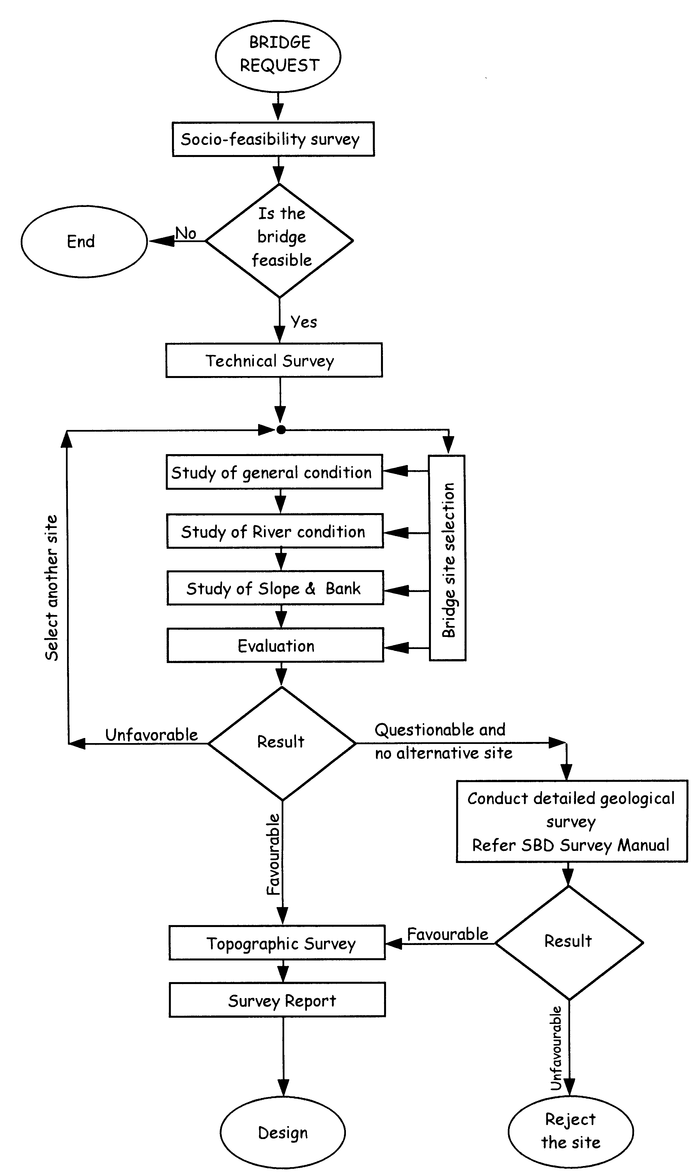
Social feasibility survey

Figure 2.1: Flow chart showing the survey process.

2.1.1 Social Feasibility Survey
Complex river system and randomly oriented trail networks all over the Nepal have made the realization of a bridge a difficult task to the limited bridge building agencies existing to date. Prior to undertaking a particular bridge into programme, any bridge building agency therefore requires to know the necessity of the bridge at a particular locality or along a trail system.

The primary objective of constructing rail bridges in remote areas is aimed at providing maximum benefits to number of rural people so the justification of a bridge site will involve time, labour and money saved in crossing the turbulent rivers by the presence of such bridges. It is also clear that all the bridge sites will not be socio-economically be feasible at every requested place. Thus before selecting a bridge site it is necessary to analyse the cost involved in constructing the bridge and the return received by the rural people. There are several methodologies to make the social assessment but it has to be kept in mind that the implementation approach explained earlier in chapter 1 may guide the particular method for the assessment.

For details on social aspects, please refer to chapter 6 of this manual.

Bridge request:
For bridge request and other details about it please refer to article 6.1, Social Organisational Support at Community Level on chapter 6 of this manual.

2.1.2 Technical Survey
The technical survey includes:
- Bridge site selection and Topographic Survey of the selected bridge site

2.2 Preparation for Survey
The following preparatory work must be completed before going to the field for the survey:
- Collect maps with tentative location of the bridge and any available background information.
- Collect the survey equipment.

Survey equipment consists of the following materials:

For Survey by Abney Level
- Abney Level, Survey Form and Checklist
- Measuring Tape (50 or 100 m and 3 m)
- Red Enamel Paint and Paint Brush
- Marker Pen, Scale and A3 Graph Paper
- Camera and Film Roll
- Hammer
- Ranging Rod (prepared at site)
- Calculator, Note Book and Pencil
- Nylon Rope (min. 50 m) Masons Thread
- Plumb Bob

2.3 General Data Collection
General data is required for need assessment and construction planning of the proposed bridge. Collect the following general data and information:

- Location of bridge site - Transportation distance - Nature of crossing and fordability
- Availability of local materials - Traffic volume - Availability of local bridge builders
- Temporary crossing - Local participation

2.3.1 Location of Bridge Site
Describe the location of the bridge site (Table 2.1):

Table 2.1: Bridge location

 | Left Bank | Right Bank
VDC
Ward No.
Ilaka No.
District
Zone

Draw a bridge site location map covering the proposed bridge’s area of influence as shown in the example below. The map should contain the following information:
- River system with names and river flow direction
- Location of proposed bridge and traditional crossing point
- Location of the nearest bridge (approximate walking distance from the proposed bridge site)
- Existing trail system and, if required, specify length of new trail for access to the proposed bridge
- Location of villages, health posts, schools and other important places with approx. distances to the bridge site
Bridge Site Location Map (Example)
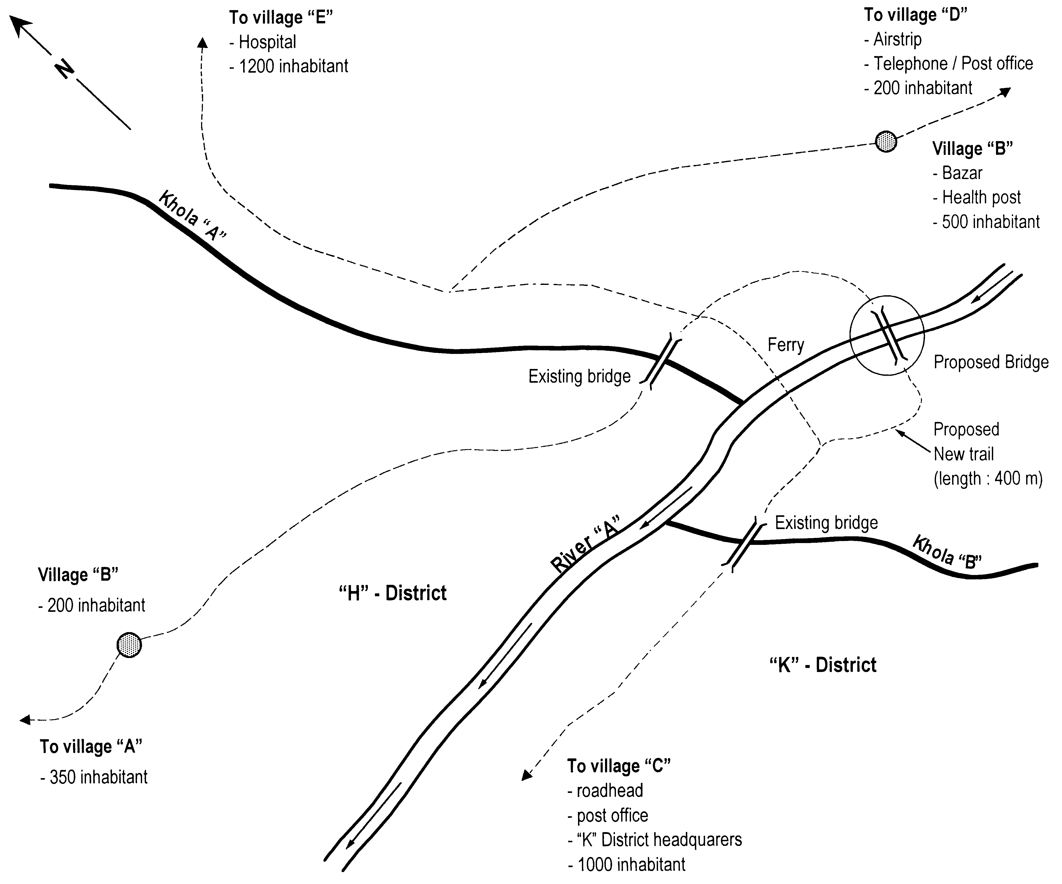

Figure 2.2: Typical Bridge site location map

2.3.2 Nature of Crossing and Fordability
Examination of the present crossing situation is necessary to determine the need and the priority of the requested bridge.

Assess the period of time the river cannot be crossed in one year.

a. whole year
b. some months per year only
c. some days during high flood only

Situation (a) should be given the first priority for construction and the least priority should be given to situation (c).

Study the type of crossing facility available at present and also the location of the nearest bridge. Assess whether the available crossing facility or the existing nearest bridge is sufficient for the crossing or if a new bridge is necessary.

2.3.3 Traffic Volume
Traffic volume at the crossing is one of the key indicators in the need assessment of the bridge (Table 2.2). Information should be collected by two methods. Count traffic volume at the traditional crossing point for at least one day. And then interview the local people to form a broader impression of the traffic volume throughout the year.

Table 2.2: Determination of traffic volume

 |  | Number of Traffic per Day
Goods Traffic | Porters
Goods Traffic | Pack Animals
Non-goods Traffic | Persons
Non-goods Traffic | Animals

Determine the purpose of the traffic (Table 2.3) by interviewing the persons crossing the river and the local people as per the table below. This will indicate the importance of the crossing.

Table 2.3: Determination of purpose of the traffic

Access to | Yes | No
Schools
Hospital / Health posts
Bazaar/Markets
Road head
Post office/Telephone
Farming
Others (specify)

The most important crossing is one which provides access to schools, hospital and health posts.

2.3.4 Width of Walkway
The standard walkway width in this handbook is 70 cm or 106 cm.

In most cases, the 70 cm walkway is sufficient. Instances of heavy traffic, mule and pack animal passage carrying bulky goods, or if the crossing is on a main trail, require a 106 cm walkway is necessary.

Discuss this issue with the local people, informing them that more work, especially collection of stones, is required for the 106 cm walkway.

Recommended Width of Walkway: 70 cm 106 cm

2.3.5 Local Participation
The commitment and participation of the local people in the construction of the proposed bridge will truthfully indicate the need of the bridge. The stronger the commitment and participation, the greater is the need of the bridge.

For informing the community on how much labor is overall necessary for constructing the bridge, the following formulas can be used to compute the tentative preliminary number of man-days:

- Man-days for skilled Labor: = 1.3 x span [m] + 400
- Man-days for unskilled Labor: = 5 x Span [m] + 1300

Assess the availability of local participation for bridge building from within the concerned local community (Table 2.4).

Table 2.4: Assessing the local participation

By Whom | Type of Participation
Local Community
Users' Committee
VDC
DDC
Local NGO
Individual
Others (specify)

2.3.6 Transportation Distance
Information on the transportation distance from the nearest roadhead, airstrip and helipad to the site is required for planning the construction of the bridge (Table 2.5).

Table 2.5: Information on transportation distance

Type of Transport | Name of nearest Roadhead/Airstrip etc. | Distance from Site up to Roadhead/Airstrip
Type of Transport | Name of nearest Roadhead/Airstrip etc. | Km/Kosh | Porter Days | By Mule, Days
Served by Truck
Served by Tractor
Airstrip
Helipad

2.3.7 Availability of Local Materials
Assess the availability of local materials needed for the bridge construction. Identify the nearest collection place for these materials (Table 2.6).

Table 2.6: Information on local material and haulage distance

Description | Haulage Distance, m | Remarks
Stones
Natural Gravel
Sand
Wood
Bamboo

2.3.8 Availability of Local Bridge Builders
There may be local bridge builders in the villages nearby who have already built some bridges. Their skill can be used for the construction of the proposed bridge. If such people are available, record their names.

Table 2.7: Record of local bridge builders

Names | Skill (Mason, Bridge Fitter) | Village / Address

2.3.9 Temporary Crossing

Is a temporary crossing necessary
during the construction of the bridge? Yes No

If yes, what kind of temporary
crossing do you propose? Ferry Cable Car

…………meter
Temporary Bridge, Span

2.4 Bridge Site Selection
The main purpose of the technical field survey is to select the appropriate bridge site. The site should optimally serve the local people. The selected site must be economically justified and have long life span:

- fulfill the general condition - have stable bank and slope conditions
- have favorable river conditions - have shortest possible span

2.4.1 General Condition
The bridge site should fulfill a number of general conditions:

- traditional crossing point - minimum freeboard
- maximum bridge span - space for the bridge foundations

Use the following checklist to evaluate the general condition (Table 2.8):

Table 2.8: Checklist to evaluate the general bridge site condition

Features | Condition
Traditional Crossing Point
The bridge site should be selected at or near the traditional crossing point.
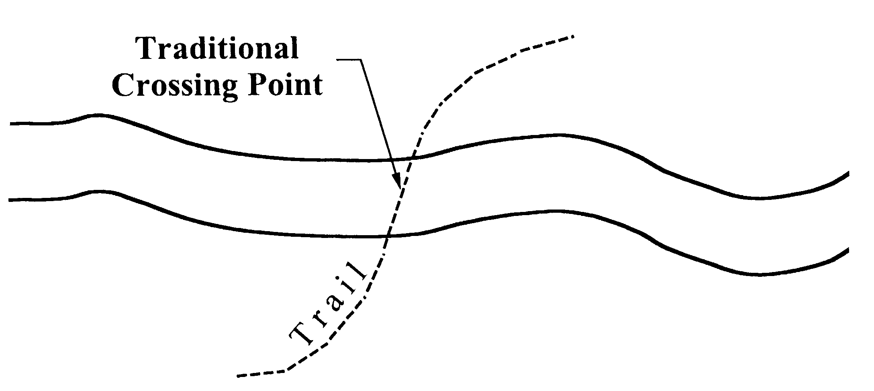 | Favorable:  Selected site is at or near the traditional crossing point  Unfavorable:  Selected site is far from the traditional crossing point
- For minor rivers, detour from the traditional crossing point is not acceptable.
- For major rivers, detour up to 500 m u/s and 500 m d/s from the traditional crossing point may be acceptable.
Bridge Span
The bridge span in this standard is limited to 120 m span.
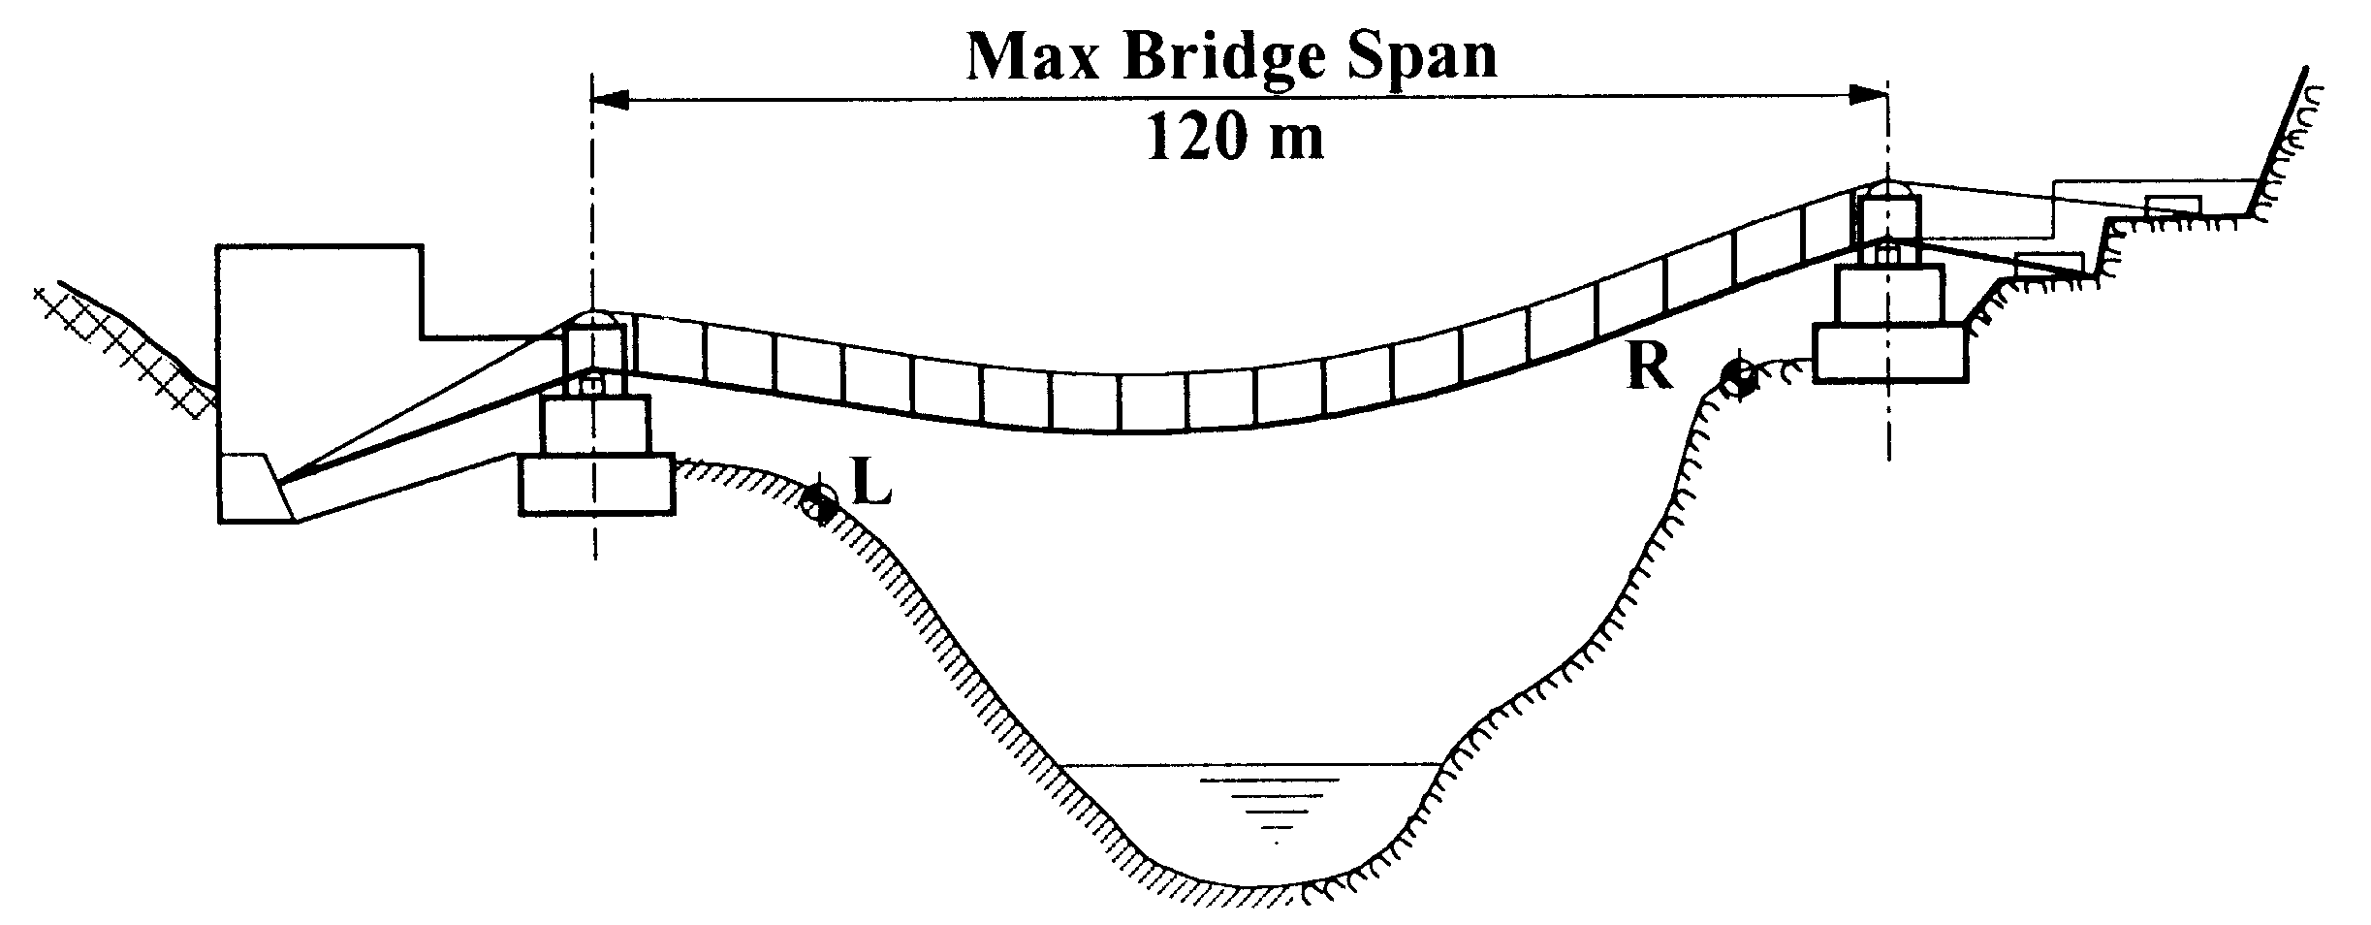  l | Favorable:  span, l is equal to or shorter than 120 m  Unfavorable:  span, l is longer than  120 m
- Measure tentative span
- Compare with the limit

Features | Condition
Level Difference between two Banks
The level difference h between the two foundation blocks should
not be more than l /25.
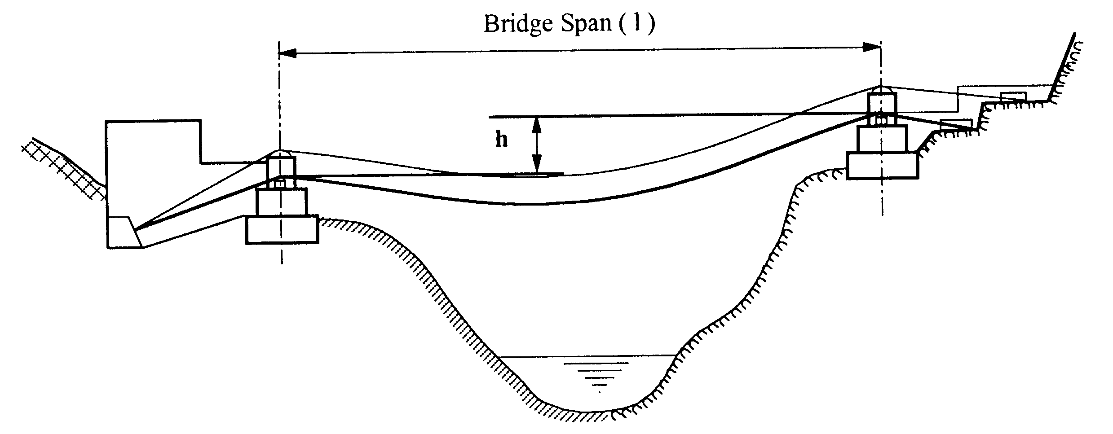 | Favorable:  h is equal to or less than  l /25  Unfavorable:  h is greater than l /25
- Locate the tentative position of the bridge foundations on both banks
- Measure the level difference h between the foundations on the two banks.
- Compare with the condition.
Space for Foundation
Foundation should be placed at least 3 m behind the soil slope and 1.5 m behind the rock slope from the front edge of the riverbank.
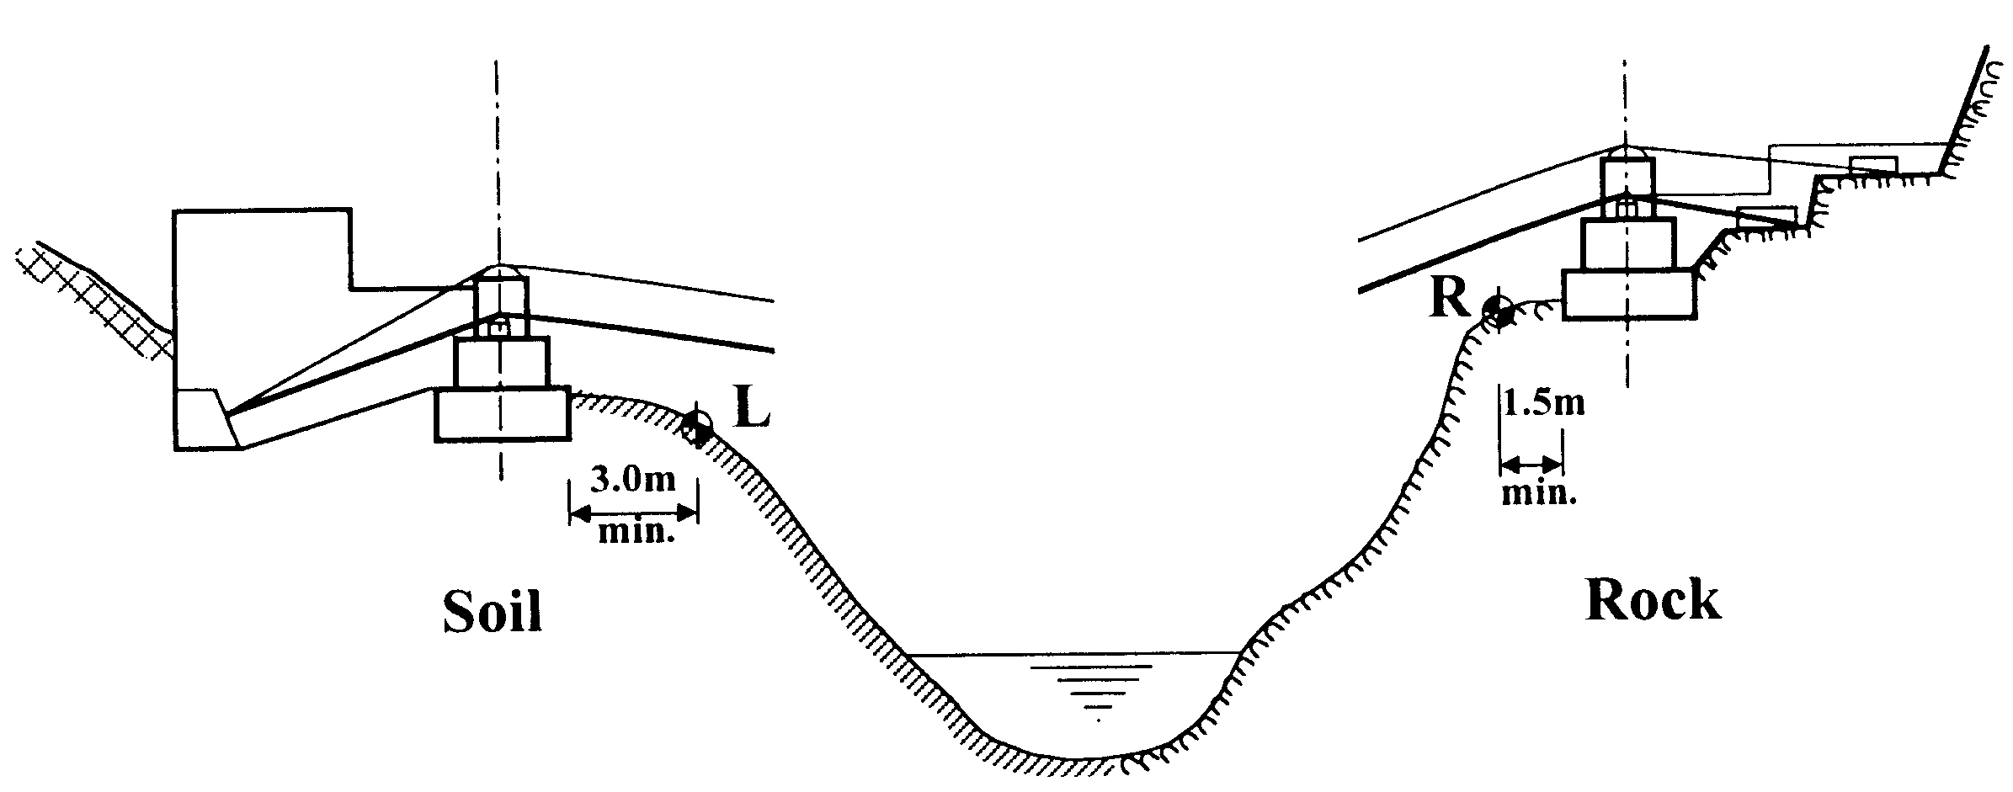 | Favorable:  Condition can be fulfilled  Unfavorable:  Condition cannot be fulfilled

Features | Condition
Slope Profile
The bridge foundation should be placed behind the line of the angle of internal friction. (Angle of internal friction is the angle of slope of soil or rock at which it is still stable and does not slide).
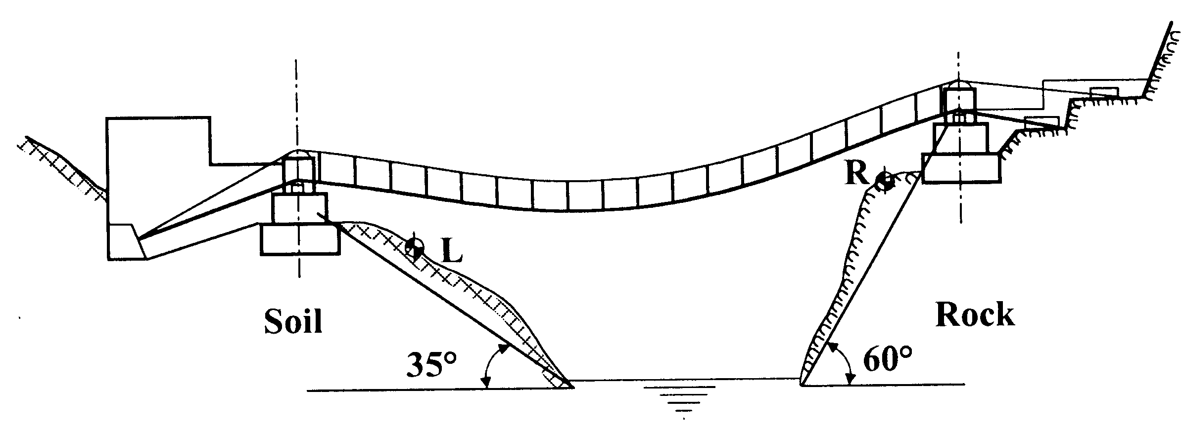  - Draw a slope line of 35º (angle of internal friction) in case of a Soil slope and 60º in case of a Rock slope.  - Foundation should be placed behind this line.  - Check if these conditions can be fulfilled  Freeboard  The Freeboard between the lowest point of the bridge and the highest flood level should not be less than 5 m. For this, sufficient clearance between the lower foundation saddle and HFL should be maintained. | Favorable:  Condition can be fulfilled  Unfavorable:  Condition cannot be fulfilled
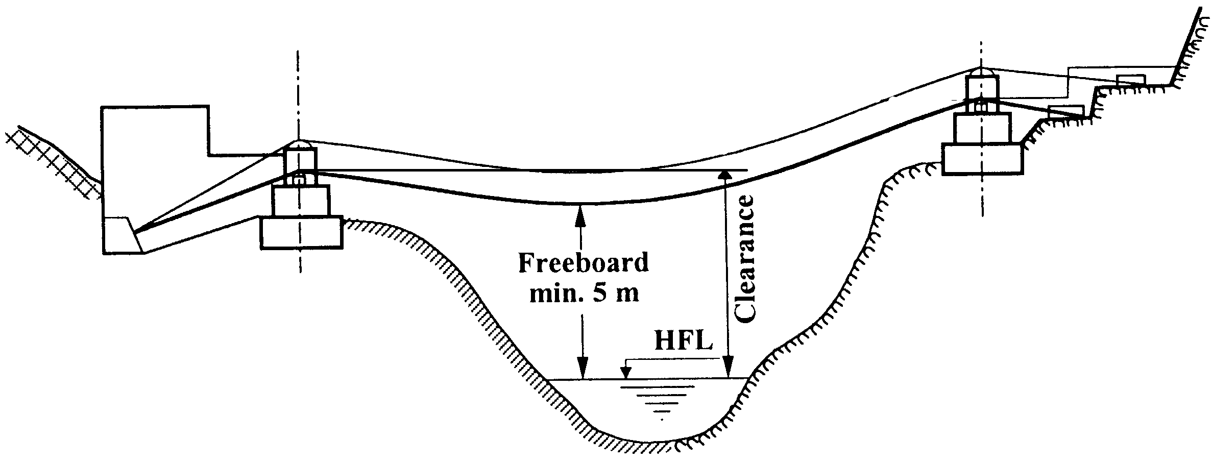  span  up to 50 m  51 - 70 m  71 - 90 m  91 - 110 m  110 - 120 m | Favorable Unfavorable  Clearance between the lower foundation saddle and the HFL is:  not less less than:  than:  7.5 m 7.5 m  8.0 m 8.0 m  9.0 m 9.0 m  10.0 m 10.0 m  11.0 m 11.0 m
- Identify the HFL by local observation and villagers’ information.
- Calculate available clearance and compare with the requirement.
- Exception: In case of flat or wide river banks the freeboard may be reduced. In case of gorges the freeboard may have to be increased.

2.4.2 River Condition
The selected bridge site must have favorable river conditions. Accordingly, a bridge should be located:

- on a straight reach of the river
- beyond the disturbing influence of larger tributaries
- on well defined banks

Use the following checklist to evaluate the river condition (Table 2.9):

Table 2.9: Checklist to evaluate the river condition

Features | Condition
River Flow
In order to protect the bridge from sudden over-flooding and strong erosion, the bridge site should not be located near the confluence area of two rivers.
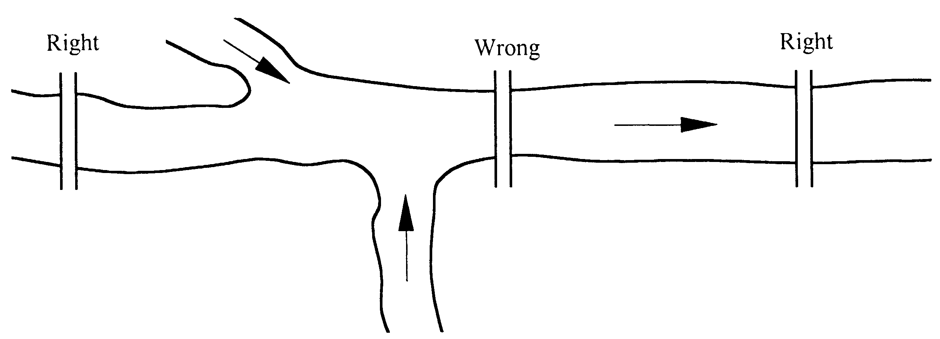 | Favorable:  Bridge site far from river confluences  Unfavorable:  Bridge site near river confluences
Riverbed
The riverbed at the selected bridge site should be stable without the possibility of erosion or filling up with bed load (boulders, gravel, silt, or sand)
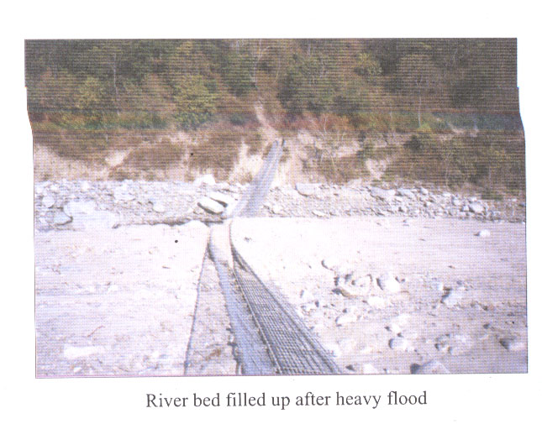
 | Favorable:
 | Riverbed is not erosive, not filling up
 | Unfavorable:
Photo: Rawa Khola
 | Riverbed is erosive or filling up
River bed filled up after heavy flood

2.4.3 Slope and Bank Condition
A bridge should be located at a site with safe and stable slope and bank conditions. The surveyor must identify any potential instability features or failure modes of the soil or rock slope and along the bank.

If the slope and bank is soil, potential instability features and failure modes are:
- bank erosion
- toppling instability of the bank
- erosion of the slope
- land slide

If the slope and bank is rock, potential instability features and failure modes are:
- plain failures in a rock slide along the slope.
- wedge failure leading to the fall of rock mass.
- toppling leading to the fall of rock blocks.
- rotational slide is similar to the landslide in a soil slope. Such failure is likely when the material of the rock is very weak (soft rock) and the rock mass is heavily jointed and broken into small pieces.

To avoid the above instability features, use the following checklist to evaluate the slope and bank of the selected site (Table 2.10):

Table 2.10: Checklist to evaluate the slope and bank condition of the selected bridge site.

Features | Condition
If the River Bank or Slope is SOIL
Bank Profile
The bank profile should be smooth.
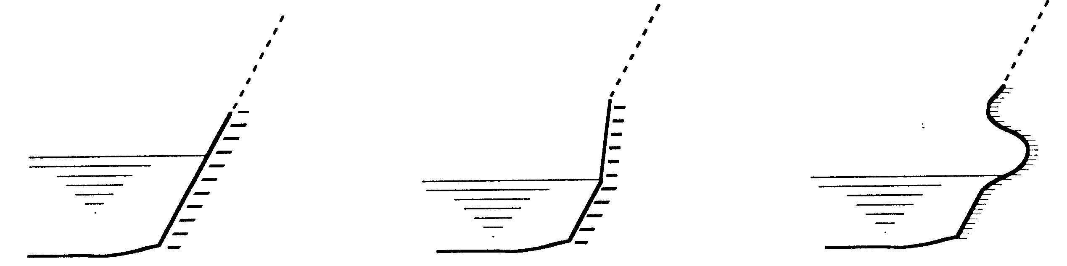  Smooth Partially cut out Strongly cut out | Favorable:  Bank profile is smooth to partially cut out  Unfavorable:  Bank profile is strongly cut out
River Bank Contour
The bridge site should be located at the straight reach of the river to avoid the river from undercutting or bank erosion.
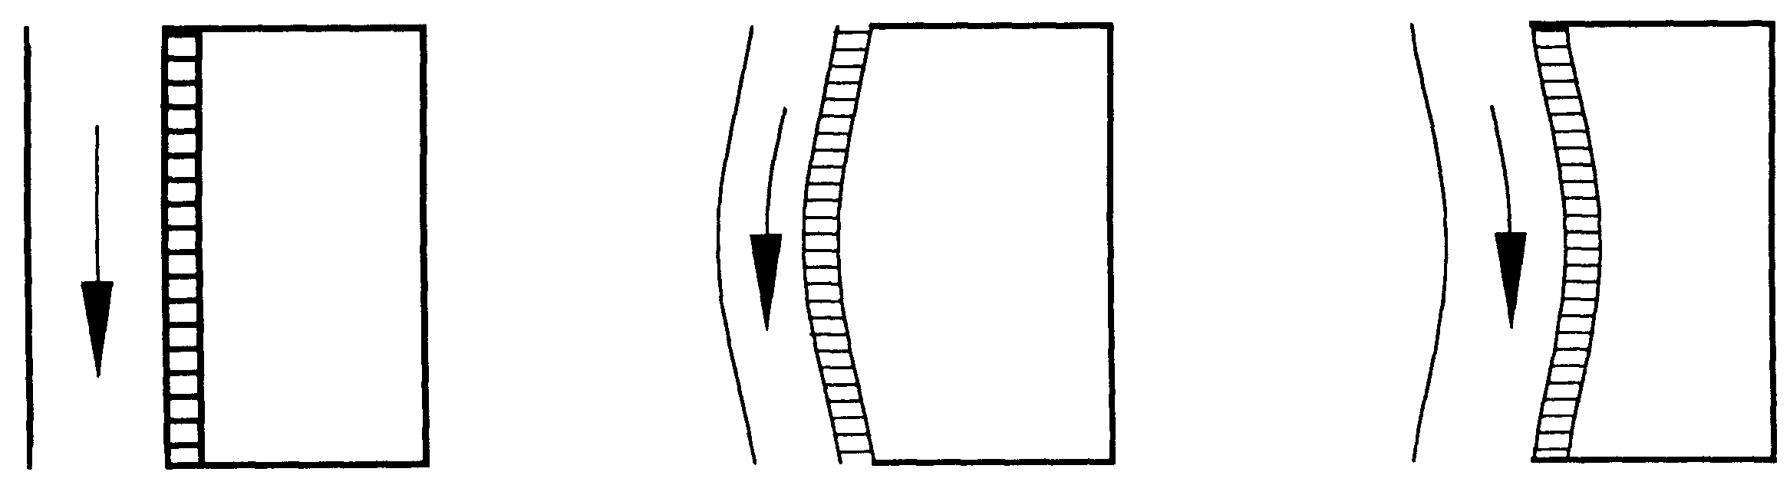  Straight Convex Concave | Favorable:  River contour is straight or convex  Unfavorable:  River contour is concave

Features | Condition
Bank Erosion
The river bank should not show any sign of erosion.
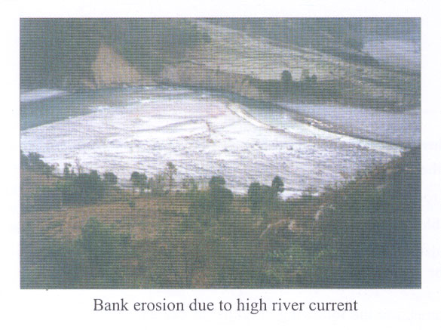  Photo: Damsadi Ghat  Bank erosion due to high river current | Favorable:  No sign of fresh erosion  Unfavorable:  Presence of fresh erosion
Slope Profile
The slope profile should be smooth.  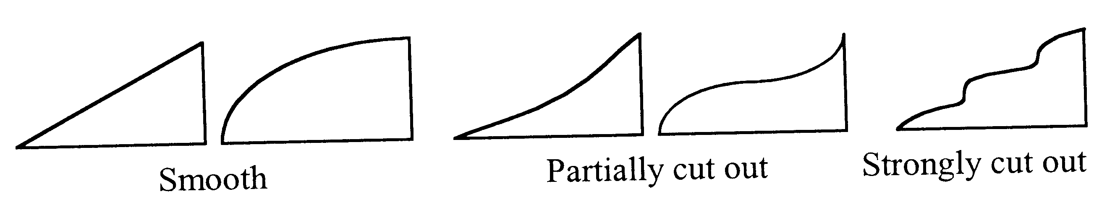 | Favorable:  Slope profile is smooth to partially cut out  Unfavorable:  Slope profile is strongly cut out
Transverse Slope
The transverse slope should be smooth.
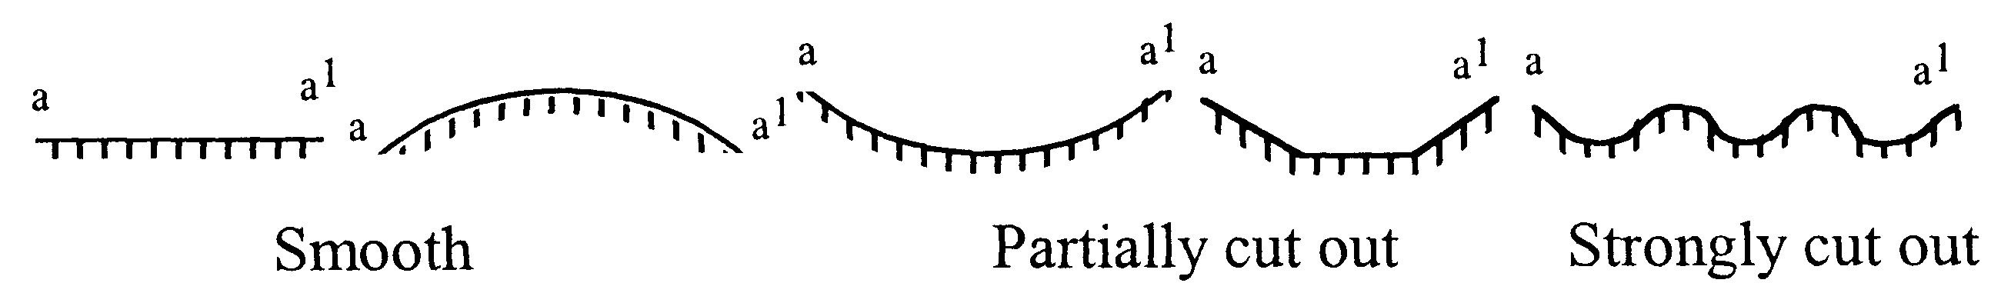  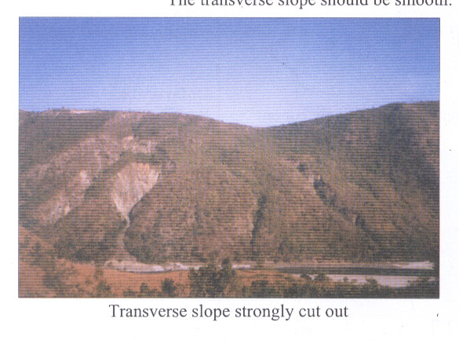 | 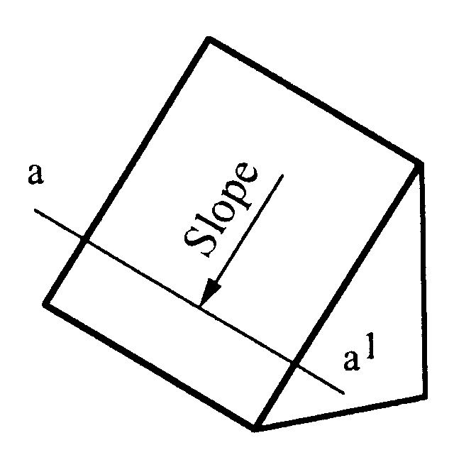  Favorable:  Transverse slope is smooth to partially cut out  Unfavorable:  Transverse slope is strongly cut out

Features | Condition
Slope Inclination (Soil Slope)
The slope inclination should be less than 35º.
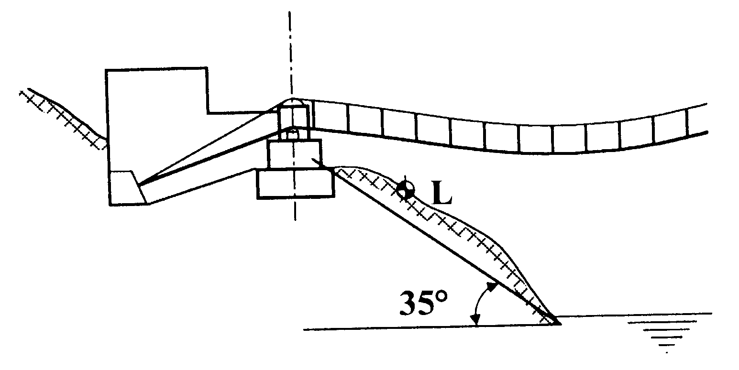  ½ sketch (5)  Estimate the slope inclination and compare it with the condition. If the site has an unfavorable slope inclination, it can still be selected provided the general condition of slope profile is fulfilled. | Favorable: Slope inclination is equal to or less than 35º  Unfavorable: Slope inclination is greater than 35º
River Undercutting
The bridge site should be free from river undercutting which may lead to landslide.
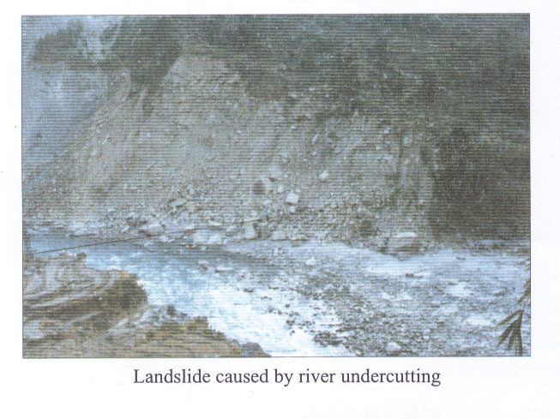  Photo: From MRE ICIMOD, Page 20 | Favorable:  There is no river undercutting  Unfavorable:  River undercutting is active or there is potential for river undercutting
Features |  | Condition
Inclined Trees
The selected site should not have inclined trees, which indicate an active landslide.
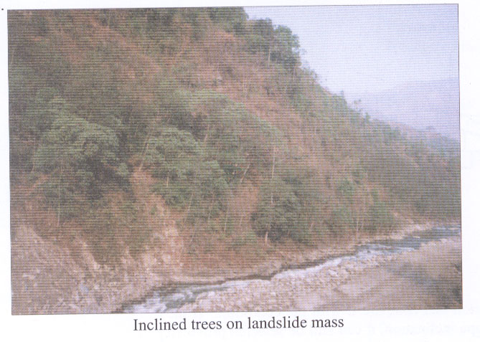 |  | Favorable:  Inclined trees are not present  Unfavorable:  Inclined trees are present
Seepage or Swampy Area  The bank slope should not have any seepage or swampy area, which may lead to slope instability. |  | Favorable:  No seepage or swampy area is present  Unfavorable:  Seepage or swampy area is present
Gully Erosion
No signs of gully erosion should exist within the vicinity of the selected site.
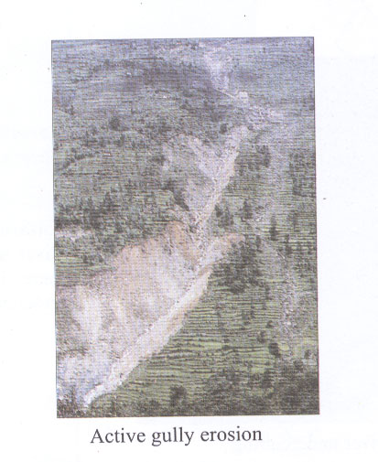  Photo |  | Favorable:  No sign of gully erosion or only light gully erosion  Unfavorable:  Heavy gully erosion exists
- Observe if any rivulets are within the vicinity of the selected site.
- If rivulet exists, examine the dimension of the gully cutting.

Features | Condition
Slipped (Slump) Soil Mass
The bridge should not be located on an already slipped soil masses.
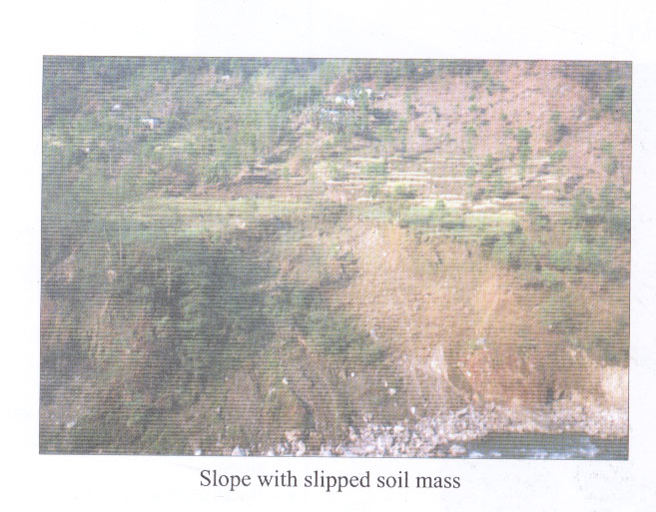
Photo | Favorable:  There are no back scars or signs of soil mass movement
Unfavorable:
There are back scars or signs of soil mass movement
Slope with slipped soil mass
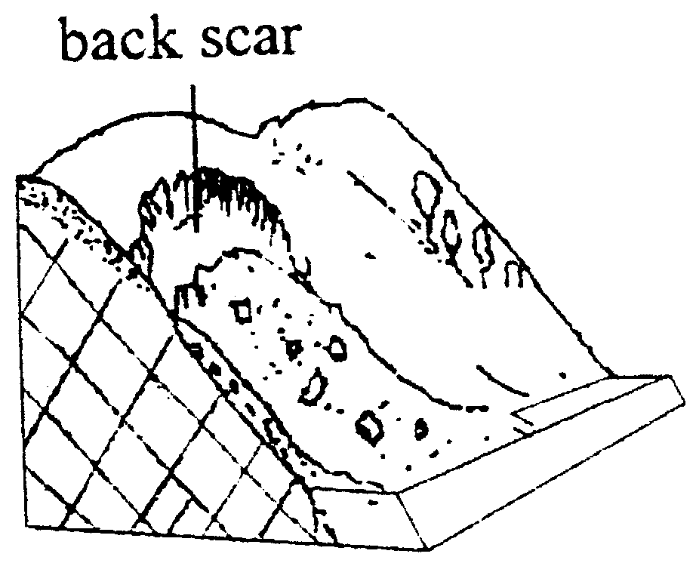
Slope Failure Model

- Examine and identify any indication of soil mass movement. This can be done by observing traces of back scars on the slope.

Features | Condition
If the River Bank is Rock
Plain Failure
Plain failures lead to the slide of rock layers along the slope. The rock bank/slope of the selected site should not have any feature of plain failure.  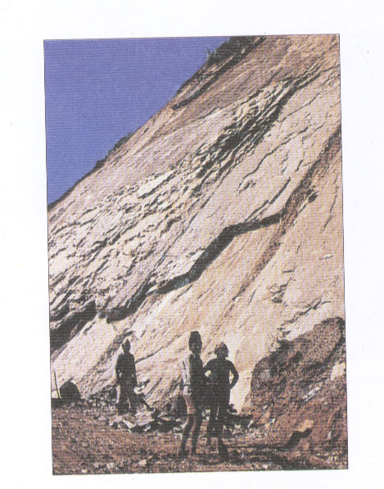  Bedding plain is parallel to the slope and plain failure is active.  Site is extremely unfavorable!  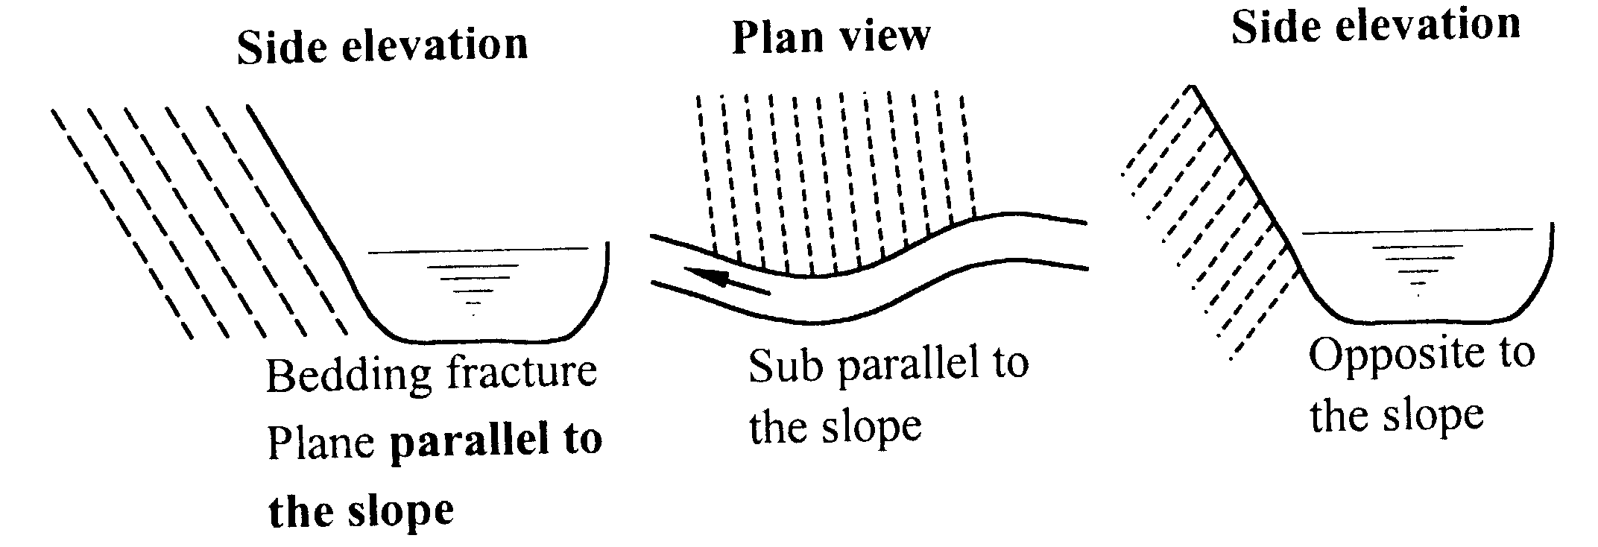 | Favorable:  Plain failure will not take place if  - Bedding/fracture plain is sub-parallel to opposite the slope  - Bedding/fracture plain is parallel to the slope, but inclination is less than 35º  Unfavorable:  Plain failure will take place if  - Bedding/fracture plain is parallel to the slope and inclination is greater than 35º  - Presence of old rockslides
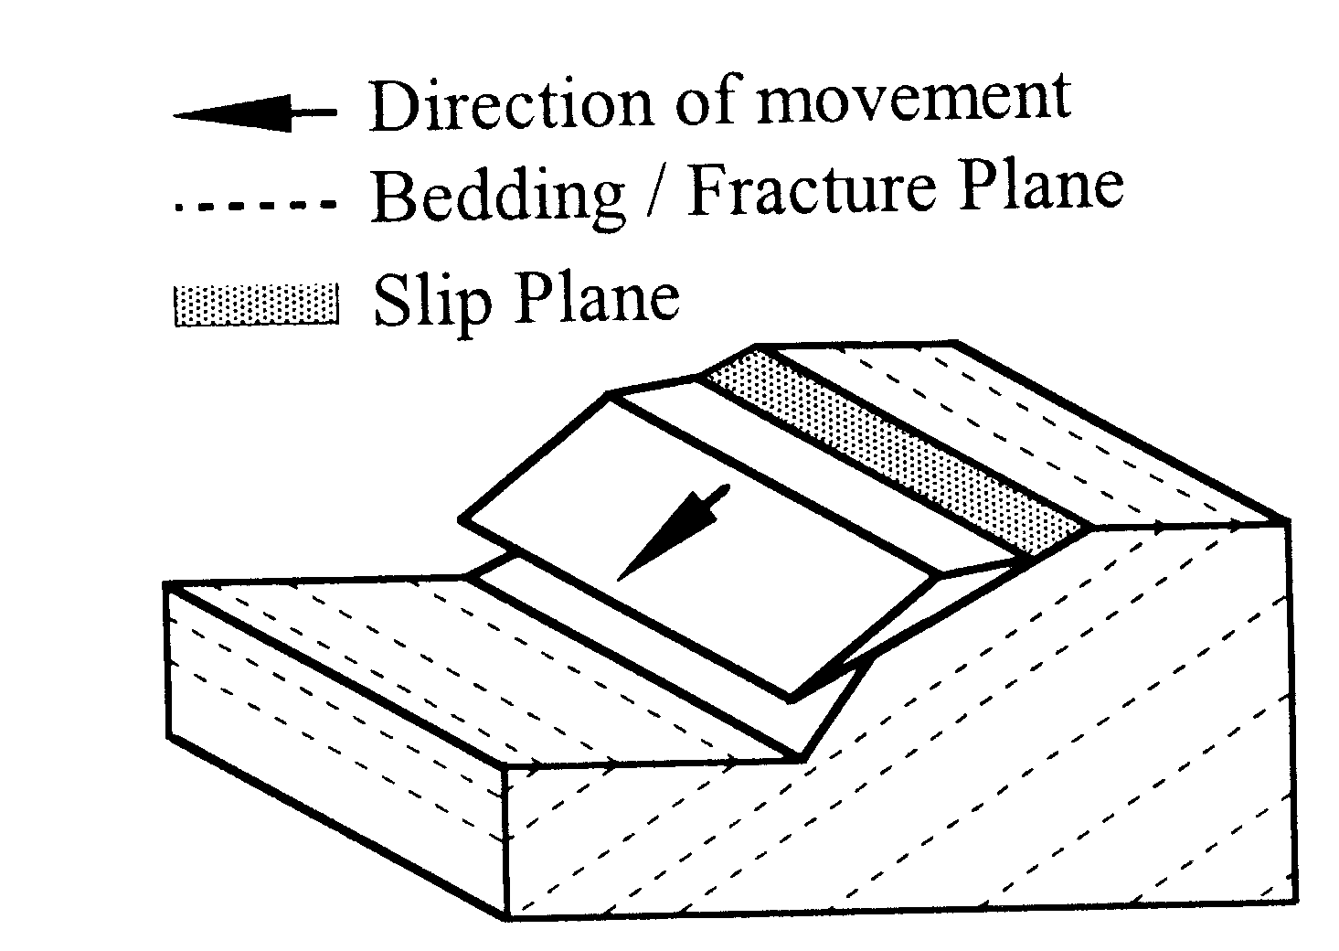

Plain Failure Model

- Identify bedding/fracture plain (layers of rock)
- Check its direction and inclination
- Compare with the conditions

Features | Condition
Wedge Failure
Any form of wedge failure leads to sliding of rock masses. The rock bank/slope should not have wedge failures or potential wedge failures.  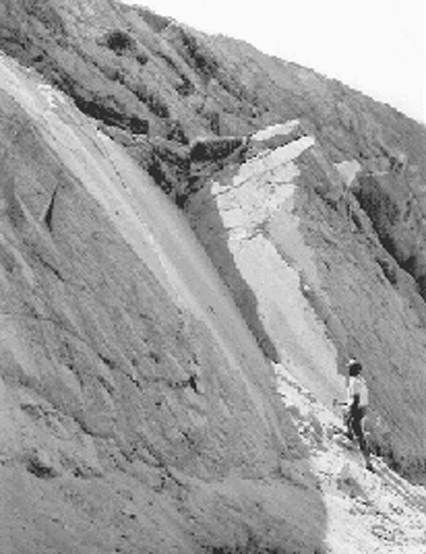  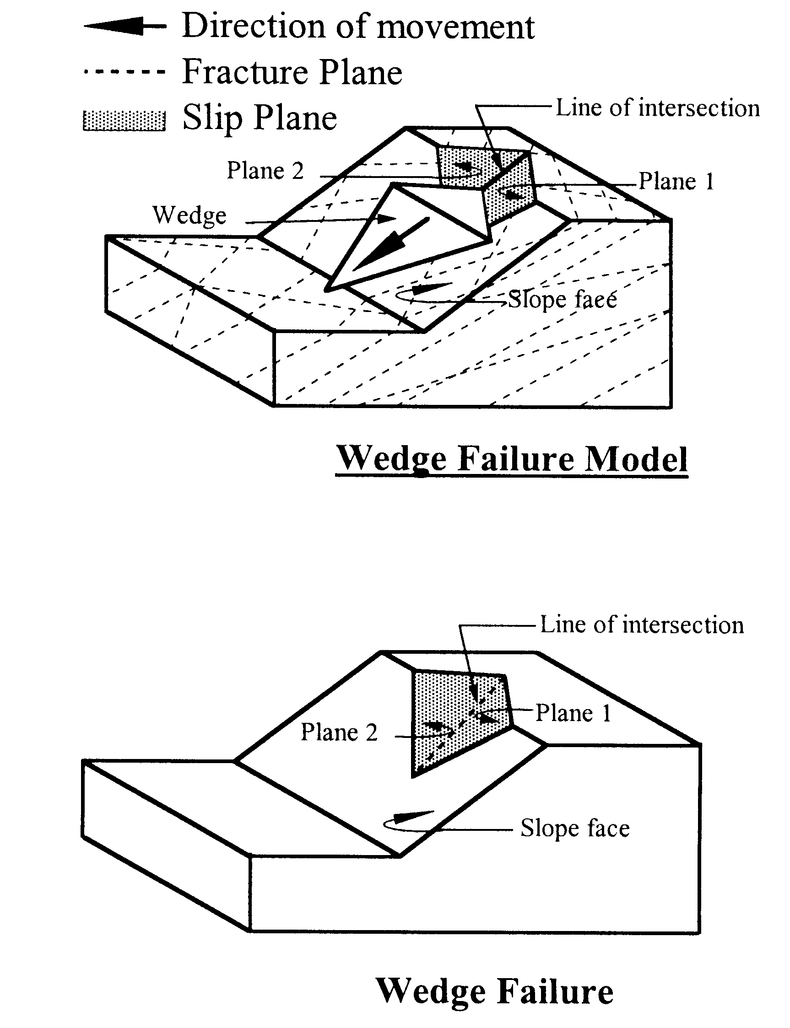  Photo  Traces of wedge failure | Favorable:  Wedge failure will not take place if  - There are no fracture plains facing each other  - There are two or more intersecting fracture plains but the inclination of its line of intersection is less than 35º  - There are two or more intersecting fracture plains but the inclination of its line of intersection is opposite the slope  Unfavorable:  Wedge failure will take place, if  - There are two or more intersecting fracture plains and the inclination of its intersection line is more than 35º to the slope  - Presence of old wedge slides
- Identify if there are fracture plains facing each other (intersecting)
- Check the inclination of the intersection line
- Compare with the conditions

Features | Condition
Toppling Failure
The rock bank/slope should not have any features of toppling failure.
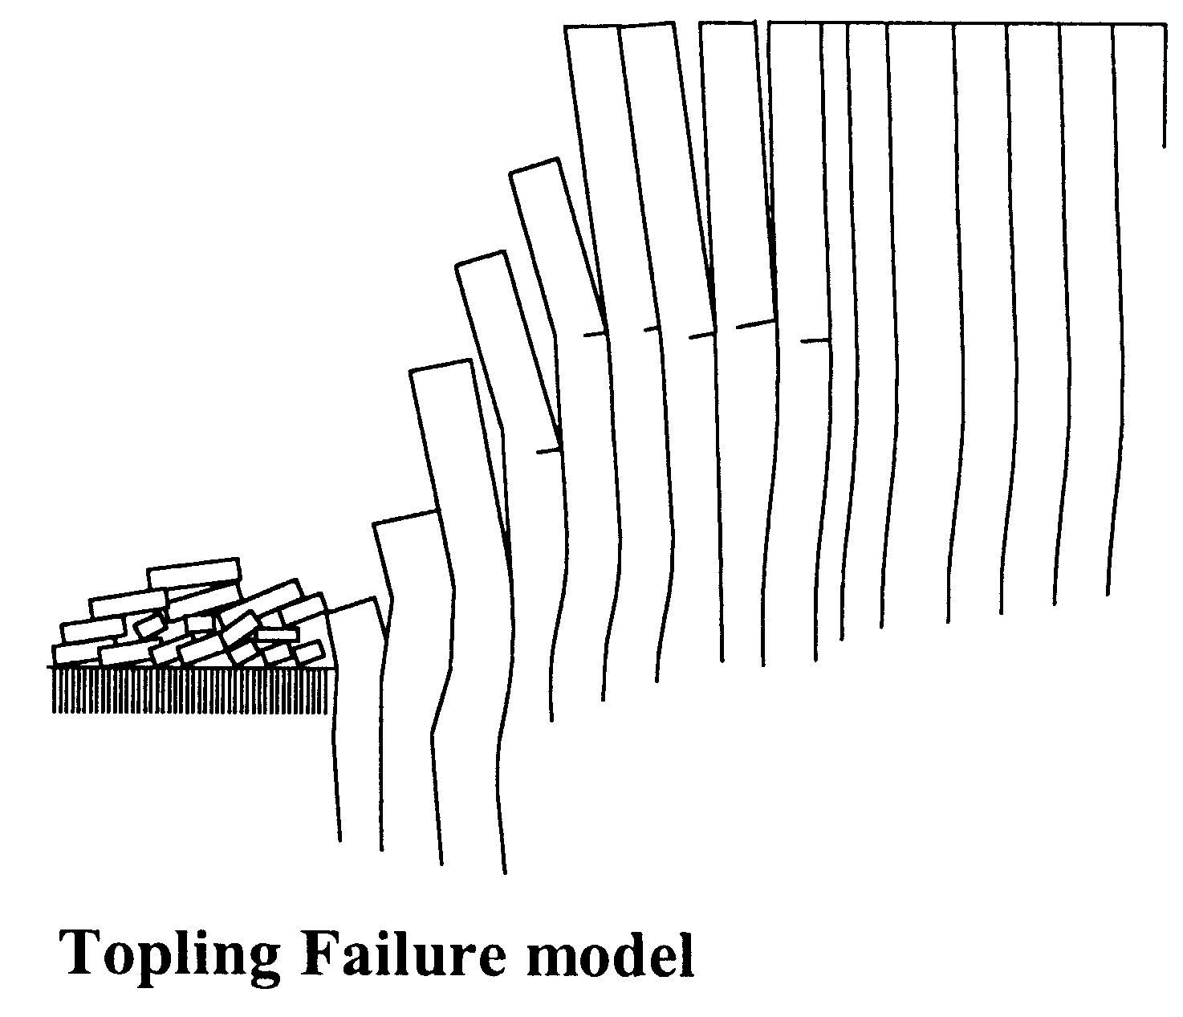  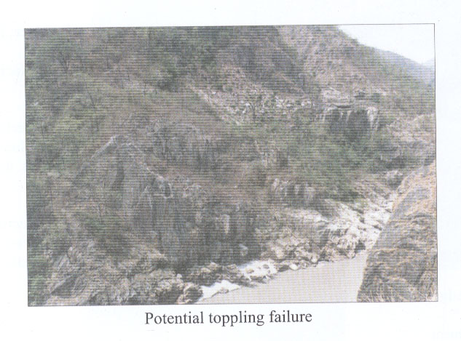  Photo  Sketch  Toppling Failure Model | Favorable:  Toppling will not take place if  - The Rock slope is less than 60º  - There is no formation of rock blocks  - There is a formation of rock block but b/h (width of the block/height of the block) is greater than 1  Unfavorable:  Toppling will take place if  - There is a formation of vertically elongated rock blocks in a steep slope greater than 60º and the blocks are tilted towards the slope  - Old toppled rock blocks are present
- Identify if there is formation of vertically elongated rock blocks (cubes) due to vertical and horizontal fracture planes/joints
- Estimate inclination of the slope
- Estimate inclination and orientation of the rock block and compare with the conditions

Features | Condition
Translation Failure (Slide)
The rock slope should not have any potential of rotational failure.
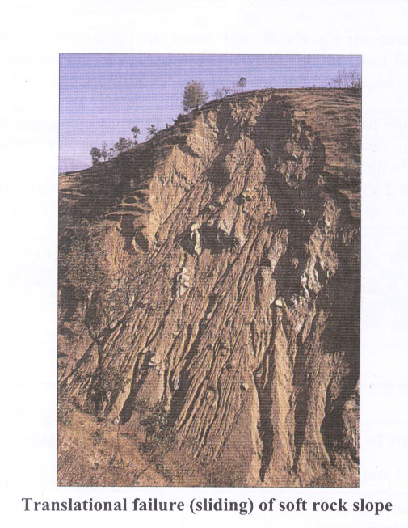
 | Favorable:
Sliding will not take place if the

- Slope is hard rock
Photo | - Slope is soft rock but not weathered
 | - Slope is soft rock and weathered but not steeper than 40°
 | Unfavorable:
Translation failure (sliding) of soft rock slope | Sliding will take place, if  - The slope is highly weathered soft rock and steeper than 40°
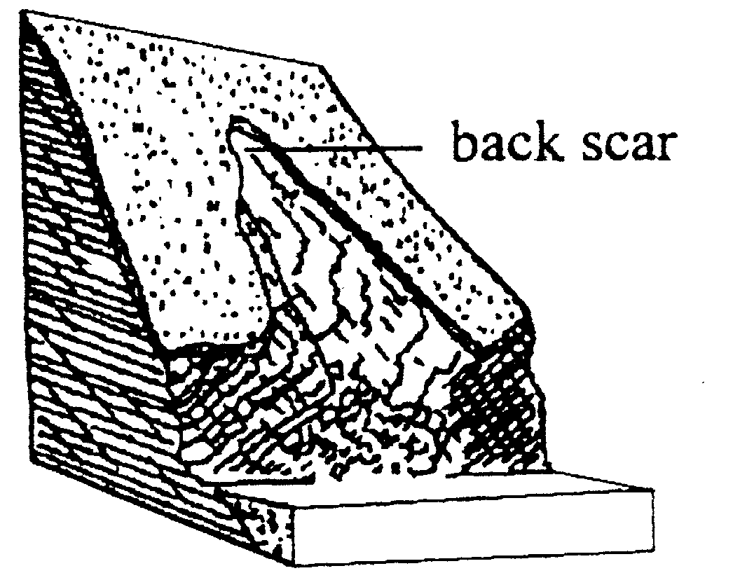 | - Back scars or old slides are present
Failure (Slide) Model

- Identify type of rock and its weathering grade
- Estimate inclination of the slope
- Compare with the conditions

2.4.4 Evaluation of the Bridge Site
After completing an investigation of the site as per Chapter 2.4.1 to 2.4.3, categorize the bridge site as

Good All or most of the features are favorable and if the surveyor is confident about the stability of the slopes, proceed with further survey work.

Bad Most of the features are unfavorable. Reject site.

Questionable Most of the features are favorable and some are unfavorable. The site is questionable. In this case, further detailed investigation by an experienced geo-technical engineer is necessary. For details refer to the SBD Survey Manual.

As far as possible, the bridge site should be selected at a location where protection works will not be required. If protection works are unavoidable determine the required special structures like retaining wall, drainage channels, etc. A tentative design with dimensions and location of these structures should be illustrated in a sketch showing a plan view and a typical section. But it is best to avoid bridge sites, which require river protection works.

2.4.5 Classification of Soil and Rock
Identification of Soil and Rock types is required for appropriate foundation design. Soil and Rocks can broadly be classified as per the following tables and figures (Table 2.11 &2.12 and Figure 2.3).

Table 2.11: Soil classification, identification and parameters.

Soil Type |  | How to Identify | Soil Parameters |  |  | Applicable  Foundation  Design
 |  | How to Identify | Bearing Capacity,  [kN/m²] | Angle of Internal Friction, ϕ° | Unit  Weight,  γ  [ kN/m³] | Deadman Anchor
Coarse Grained Soils  More than half of the materials are of individual grains visible to the naked eye (grain size bigger than 0.06 mm) | Gravelly Soils | Estimate the percentage (%) of coarse grains larger than 6 mm.  If, more than half of the coarse fraction is larger than 6 mm, the soil is Gravelly Soil | 400-600  (400) | 32-38  (35) | 19 | Deadman Anchor
 | Sandy Soils | If, more than half of the coarse fraction is smaller than 0.06 mm grain size, the soil is Sandy Soil | 200-300  (200) | 31-37  (33) | 18 | Deadman Anchor
Fine Grained Soils  More than half of the materials are individual grains not visible to the naked eye (grain size smaller than 0.06mm) | Silty Soils | Prepare moist soil ball from the soil sample and cut it with a knife.  If, the cut surface is dull or scratched, the soil is Silty Soil | 150-200  (150) | 30-32  (30) | 17 | Deadman Anchor
 | Clay | Prepare moist soil ball from the soil sample and cut it with a knife.  If, the cut surface is smooth and shiny, the soil is Clay. | 100-200  (100) | 9-25  (22) | 16 | Deadman Anchor
For estimating the percentage (%) of coarse grains use the following figure (Figure 2.3).

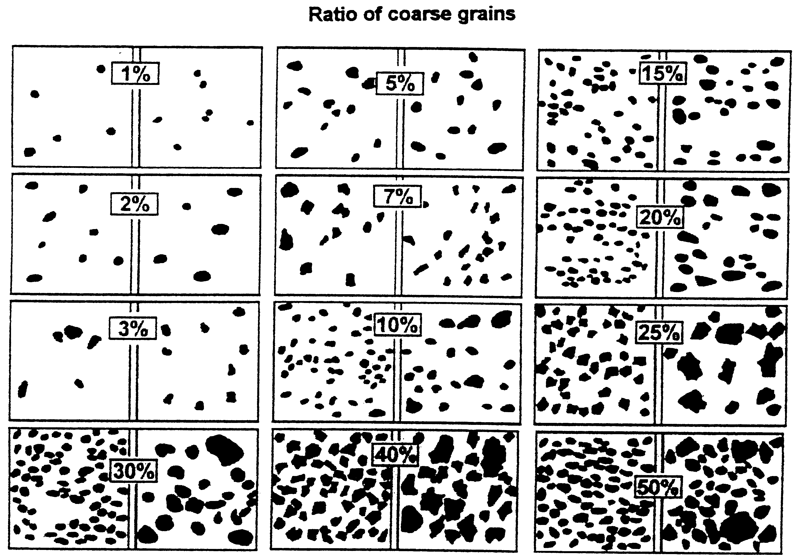

Figure 2.3: Ratio of coarse grain in soil

Table 2.12: Rock identification and classification.

Rock Type | Examples | How to Identify | Degree of Fractures or Weathering | How to Identify | Rock Parameters |  | Applicable Foundation Design
 |  |  |  |  | Bearing Capacity, [kN/m²] | Angle of Sliding Friction, ϕ° | Applicable Foundation Design
Hard Rock | Quartzite  Limestone  Granite,  Dolomite  etc. | Gives metallic sound after hammer blow | Rock is sound and fresh to fairly weathered | Rock has no sign of weathering or only faint signs of weathering up to 1-5 cm thickness | 1500-2000 (1500) | 35-50  (40) | Drum Anchor in Hard Rock
Hard Rock | Quartzite  Limestone  Granite,  Dolomite  etc. | Gives metallic sound after hammer blow | Highly fractured rock and fresh to fairly weathered | In the rock exists widely open cracks, fractures and bedding | 1500 | 35-50  (40) | Drum Anchor in Fractured Rock
Soft Rock | Phylite  Slate  Siltstone  Claystone  Schist  etc. | Gives dull sound after hammer blow | Fresh | No sign of weathering | 1300 | 25-40  (30) | Drum Anchor in Fractured Rock
Soft Rock | Phylite  Slate  Siltstone  Claystone  Schist  etc. | Gives dull sound after hammer blow | Fairly to highly weathered | Most of the original rock has been seriously altered  Rock can be broken by hand | 600-750  (650) | 25-40  (30) | Deadman Anchor

2.4.6 Identification of Soil and Rock
Excavate a test pit with a depth of up to the estimated foundation level (but not less than 2.0m) or up to the bedrock at the proposed foundation locations. If the bank/slope is soil, investigate each layer of soil in the pit and classify the soil according to the Soil Classification chart, filling in the soil investigation table as per the following example.

Example for Soil

Location: Main Anchorage Foundation at Right Bank (Table 2.13)

Table 2.13: Information on right bank.

Sketch | Depth from Surface,  [m] | Soil Type | Soil Parameter |  | Remarks
Sketch | Depth from Surface,  [m] | Soil Type | Bearing Capacity, [kN/m²] | Angle of Internal Friction, ϕ | Remarks
 | 0.0 | Top soil
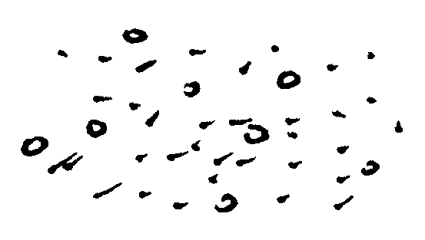 | 0.3 | Sandy Soil
 | 1.1 | Gravelly Soil | 400 | 35 | Foundation Design Parameter

If the bank/slope is rock, investigate the rock type according to the Rock Classification chart, filling in the rock investigation table as per the following example.

Example for Rock

Location: Main Anchorage Foundation at Left Bank (Table 2.14)

Table 2.14: Information on left bank.

Rock Type | Degree of Fracture/Weathering | Rock Parameter |  | Applicable Foundation  Design | Remarks
Rock Type | Degree of Fracture/Weathering | Bearing Capacity, [kN/m²] | Angle of Sliding  Friction, ϕ | Applicable Foundation  Design | Remarks
Hard Rock | Highly fractured and fairly weathered | 1500 | 40 | Drum anchorage foundation in fractured rock

2.5 Topographic Survey
After the final selection of the bridge site, the surveyor proceeds with the topographic survey.
The purpose is to:
- provide a topographic map of the bridge site with details relevant to the bridge design
- establish axis pegs and bench marks for use during construction of the bridge

2.5.1 Survey Area
Area to be covered by the topographic survey:
For bridges without Windguy arrangement,
- A profile along the bridge axis covering up to 25 m behind the main anchorage blocks.
For bridges with Windguy arrangement,
- A profile along the bridge axis covering up to 25 m behind the main anchorage blocks and a topographic plan covering an area 10 m upstream and 10 m downstream from the tentative location of the Windguy foundations.

2.5.2 Setting of Bridge Centerline
Fix the bridge centerline with two permanent axis points A on the left bank and B on the right bank (Figure 2.4). The permanent axis points A and B should be fixed on a rock outcrop along the bridge centerline, if available. If a rock outcrop is not available, these points should be marked on a boulder sufficiently embedded in the ground as per the sketch below:

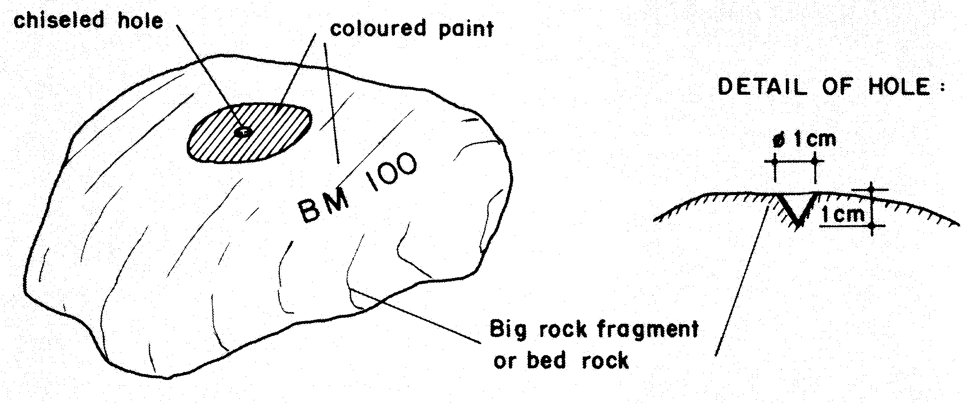
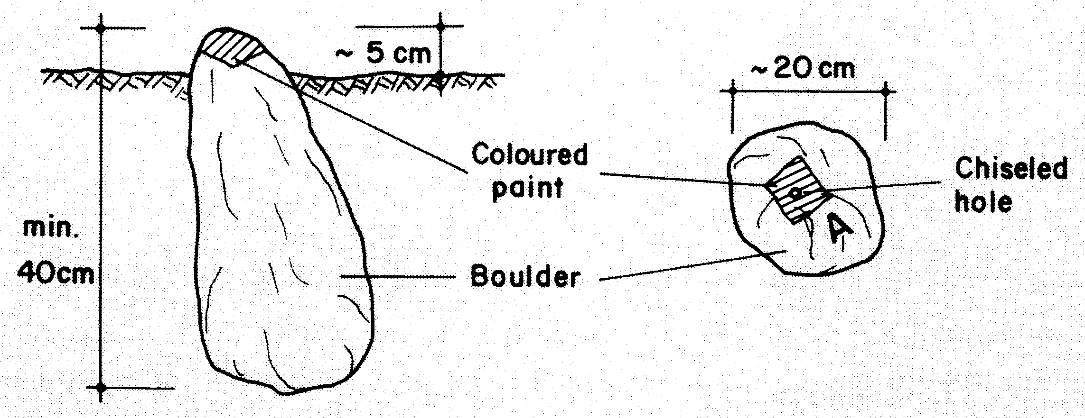

OR

Figure 2.4: Setting the Permanent axis points “A” & “B”

Additional survey points should be fixed along the centerline to survey the bridge axis profile as shown in the sketch below (Figure 2.5). These survey points should be fixed at the breaking points of the slope and terraces, which will accurately indicate the topography of the bridge axis. The profile should extend from 25 m behind the main anchorage block up to the edge of the river flow.
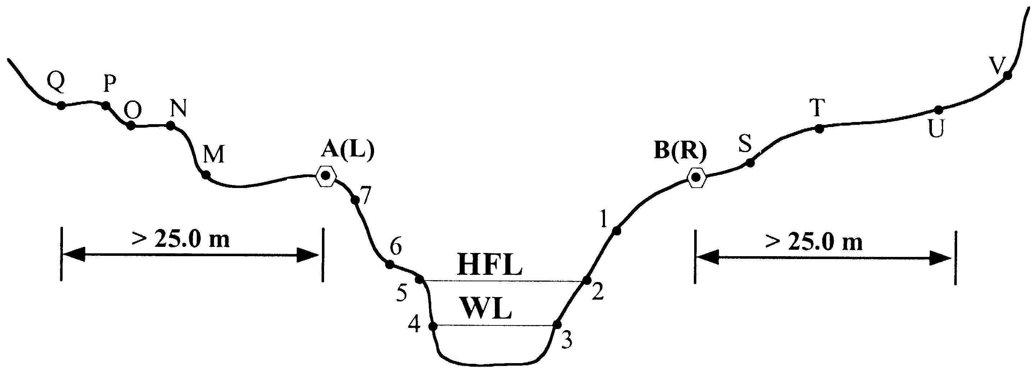

Figure 2.5: Fixing the bridge axis profile

Draw a sketch of the profile/cross section of the bridge axis (centerline) showing the axis points A and B, all the survey points and topographic features, as well as the tentative position of the bridge foundations, the low water level and the high flood level (Figure 2.6).
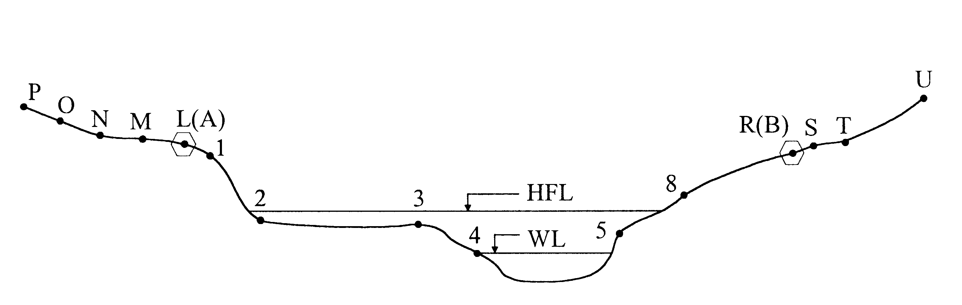

Figure 2.6: Drawing the bridge axis profile / cross section

Draw a plan view showing the bridge axis (centerline), the axis points A and B, all the benchmarks and the fixed objects like trees, houses, etc. Give distances and directions from the reference points so that the axis points and benchmarks can be located during the construction. A plan view is necessary only when a Windguy arrangement needs to be considered in the bridge design (Figure 2.7).

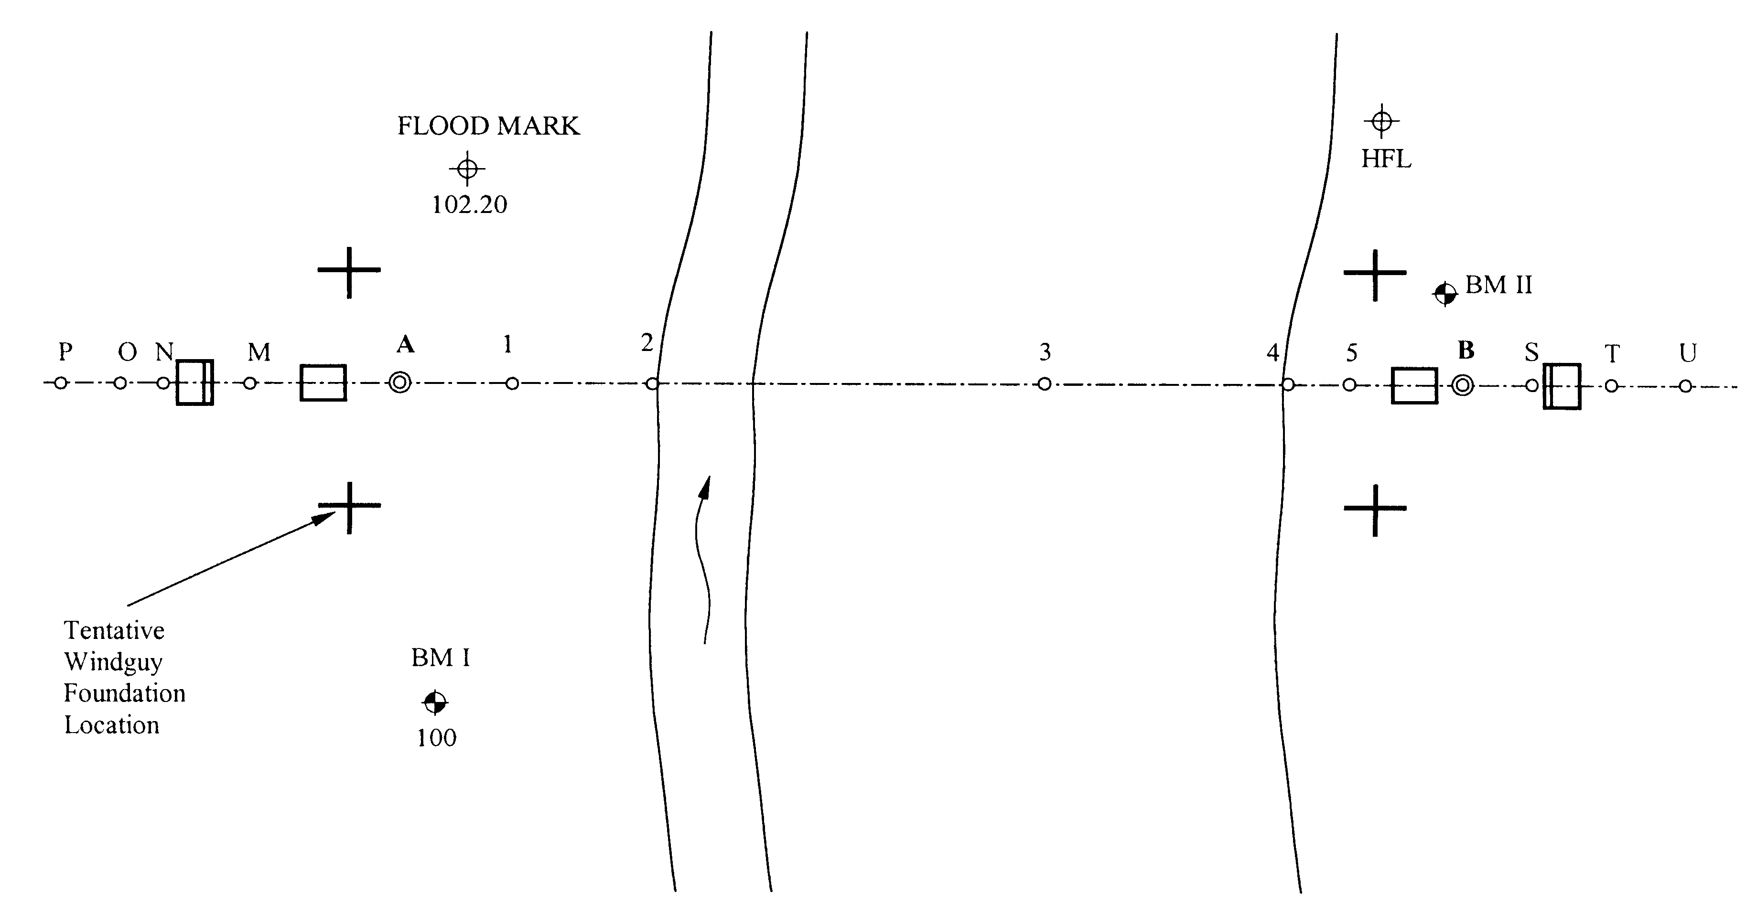

98.00

Figure 2.7: Drawing the bridge plan.

2.5.3 Survey Methods
There are two options for conducting the topographic survey. Depending upon the span and type of bridge, a profile along the bridge axis or a more detailed survey including contour lines will be necessary.
In general, a Windguy Arrangement is not required for bridges with spans of up to 120 m.

- A detailed profile along the selected bridge axis is sufficient for bridges without a windguy arrangement. A topographic profile can be made by the Abney level, however, for fixing precise levels, a Level Instrument is necessary.

- For bridges requiring a Windguy arrangement a more detailed topographic survey is necessary, from which a detailed contour plan can be plotted. This type of survey should be done by a Theodolite.

2.5.4 Survey by Abney Level
The main function of the Abney Level is to measure the vertical angle ϕ. By measuring the slope distance d between the survey points with a measuring tape, the horizontal distance D and the vertical difference of elevation ΔH can be calculated.

Measurement of Vertical Angle:
The principal of measuring the vertical angle by the Abney Level is illustrated in the sketch (Figure 2.8) and procedure described below:
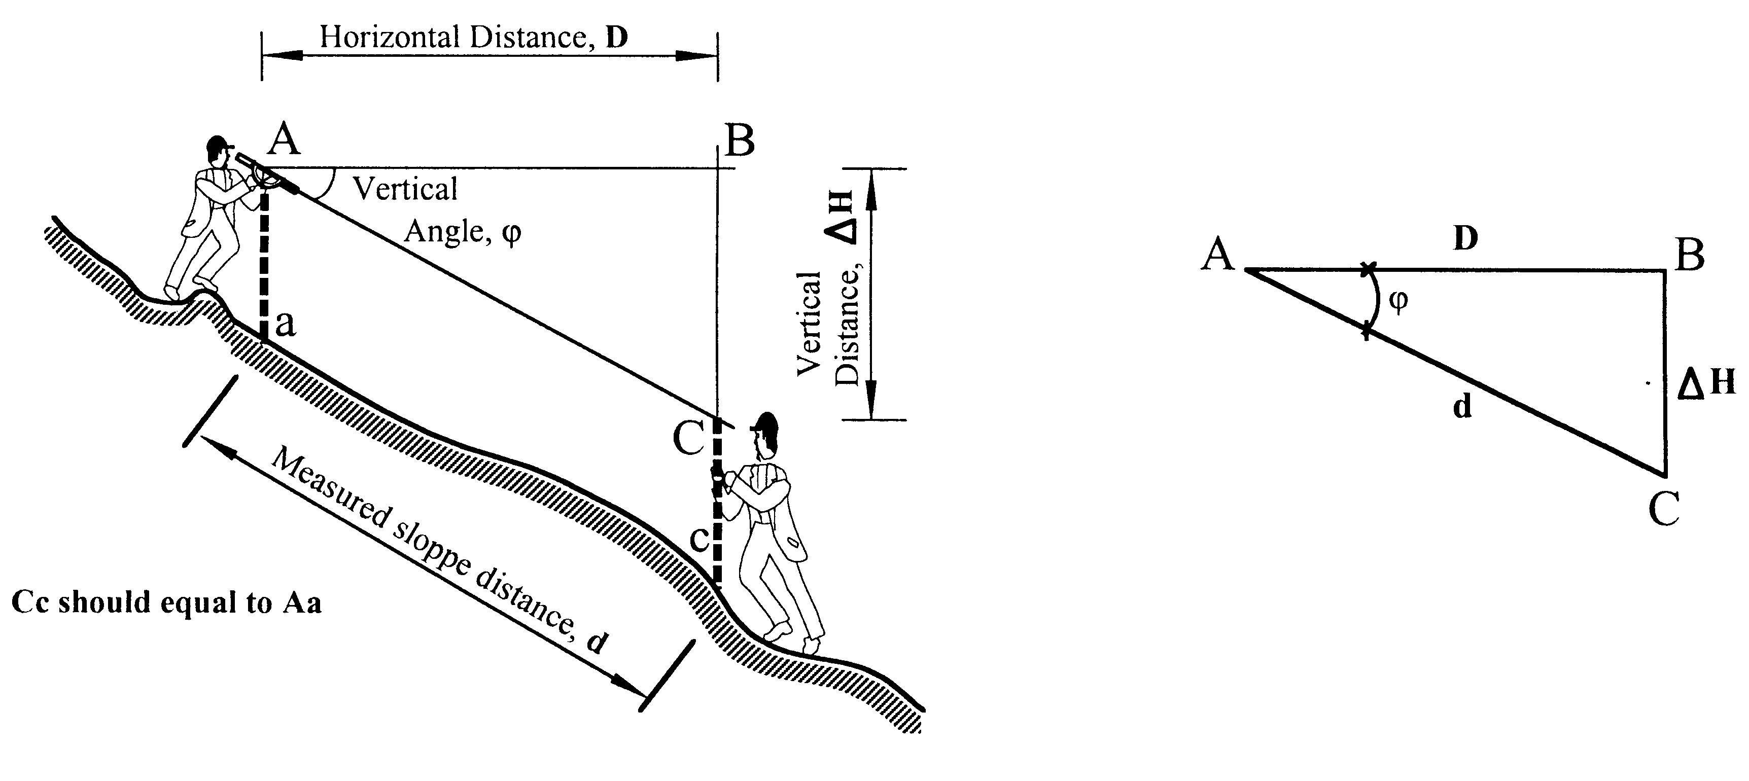

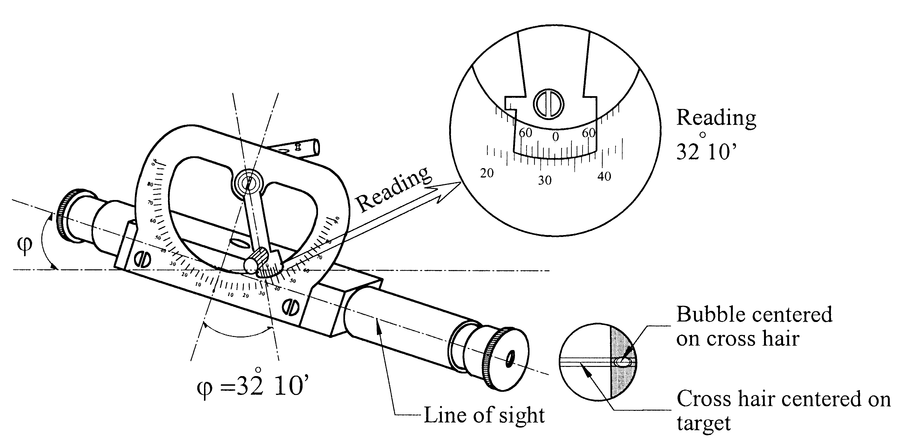

Figure 2.8: Measurement of a vertical angle by Abney Level.

The Procedure of measurement is as follows:

1. The Surveyor stands at point A with the Abney level.
2. The Assistant stands at the target point C with a stick (or ranging rod). The target mark at the stick, which the Surveyor sights must be at the same height above the ground as the Abney Level. For this, the height of the ranging rod should be equal to height up to Surveyor’s eye level.
3. The Surveyor holds the Abney Level to the eye and sights towards the target at point C, centering the cross hair against the target.
4. The index arm is then adjusted until the bubble is centered against the target and cross hair.
5. When the bubble is centered horizontally and the cross hair is aligned with the target, read the vertical angle on the arc.

Measurement of Slope Distance d:
The slope distance d between the survey points is measured with a measuring tape. Distances larger than 30m should be divided into sub-distances. The total distance can then be calculated by adding the sub-distances. Slope distances should be measured twice and the mean value should be taken as the accurate slope distance.

Calculation of Horizontal and Vertical Distance and Elevations of Survey Points:

Horizontal distance D between a and c D = d x cos ϕ
Vertical distance ΔH between a and c ΔH = d x sin ϕ
Elevation of c H = Elevation of a ± ΔH
Add +ΔH, if sighting is upward and subtract -ΔH, if sighting is downward.

d = slope distance from a to c
ϕ = vertical angle from a to c

To take the profile along the bridge axis, the Surveyor should first set the exact centerline as described in chapter 2.5.2. There are two methods of setting the centerline.
- By Nylon Rope and Plumb Bob:
This method is accurate only for spans up to 50m. Survey points along the bridge centerline are fixed with the help of a nylon rope and plumb bob.
The Nylon rope is stretched along the axis point A of the left bank and B of the right bank. Care should be taken that the tape or nylon rope is hanging freely and does not touch any obstacles. The survey points are then fixed along this rope with the plumb bob as per the procedures shown below (Figure 2.9).
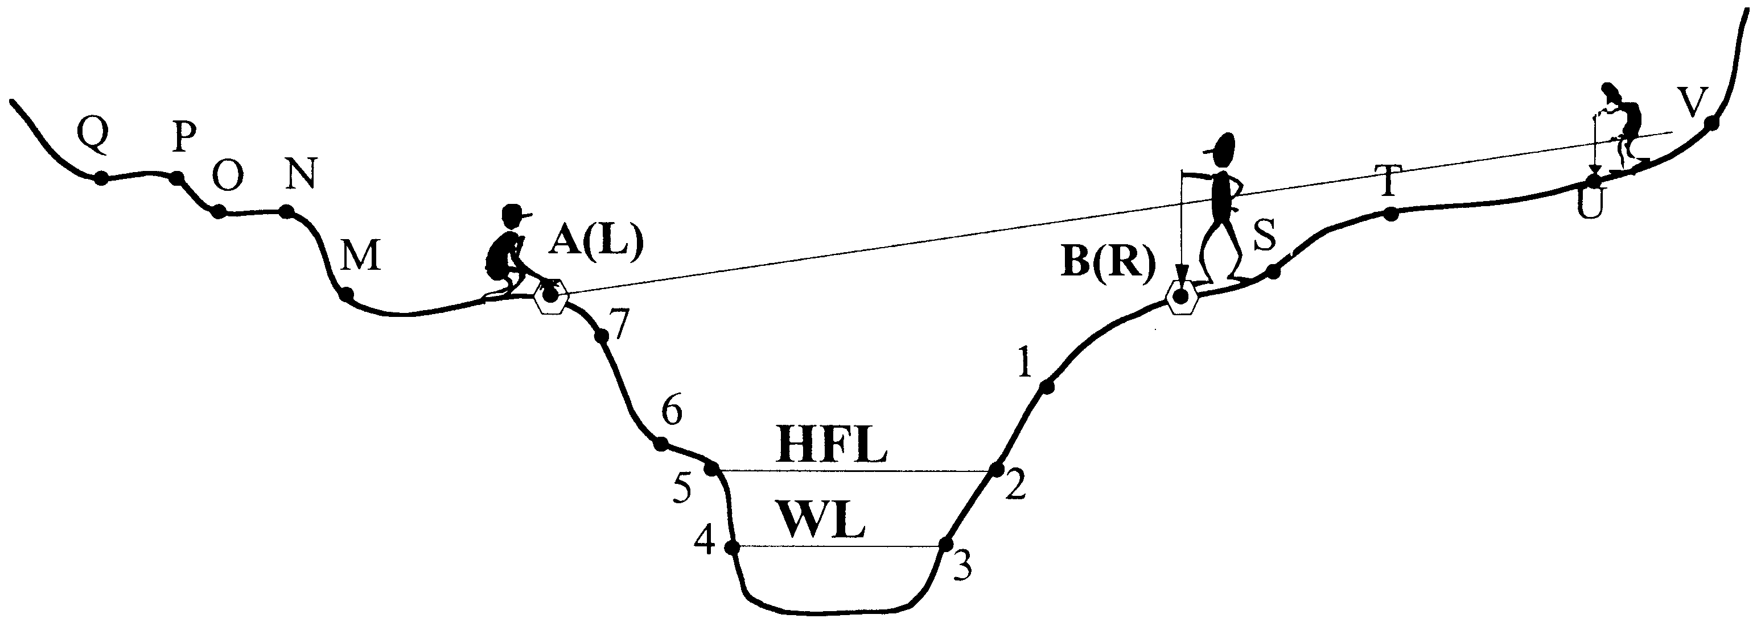

Figure 2.9: Fixing the bridge profile using Nylon rope and a Plumb bob.

- By Bamboo or Wooden Sticks or Ranging Rods:
This method is applied for span above 50m. In this method the survey points along the bridge centerline are fixed with the help of Bamboo or Wooden Sticks or Ranging Rods. Fix Stick at each axis point A and B in vertical position. Now the surveyor can aim at other points along the bridge centerline line of A and B. By fixing in line additional survey points behind and in front of A and B, more points can be gained along the bridge centerline ranging as per the procedures shown in the sketch below (Figure 2.10).

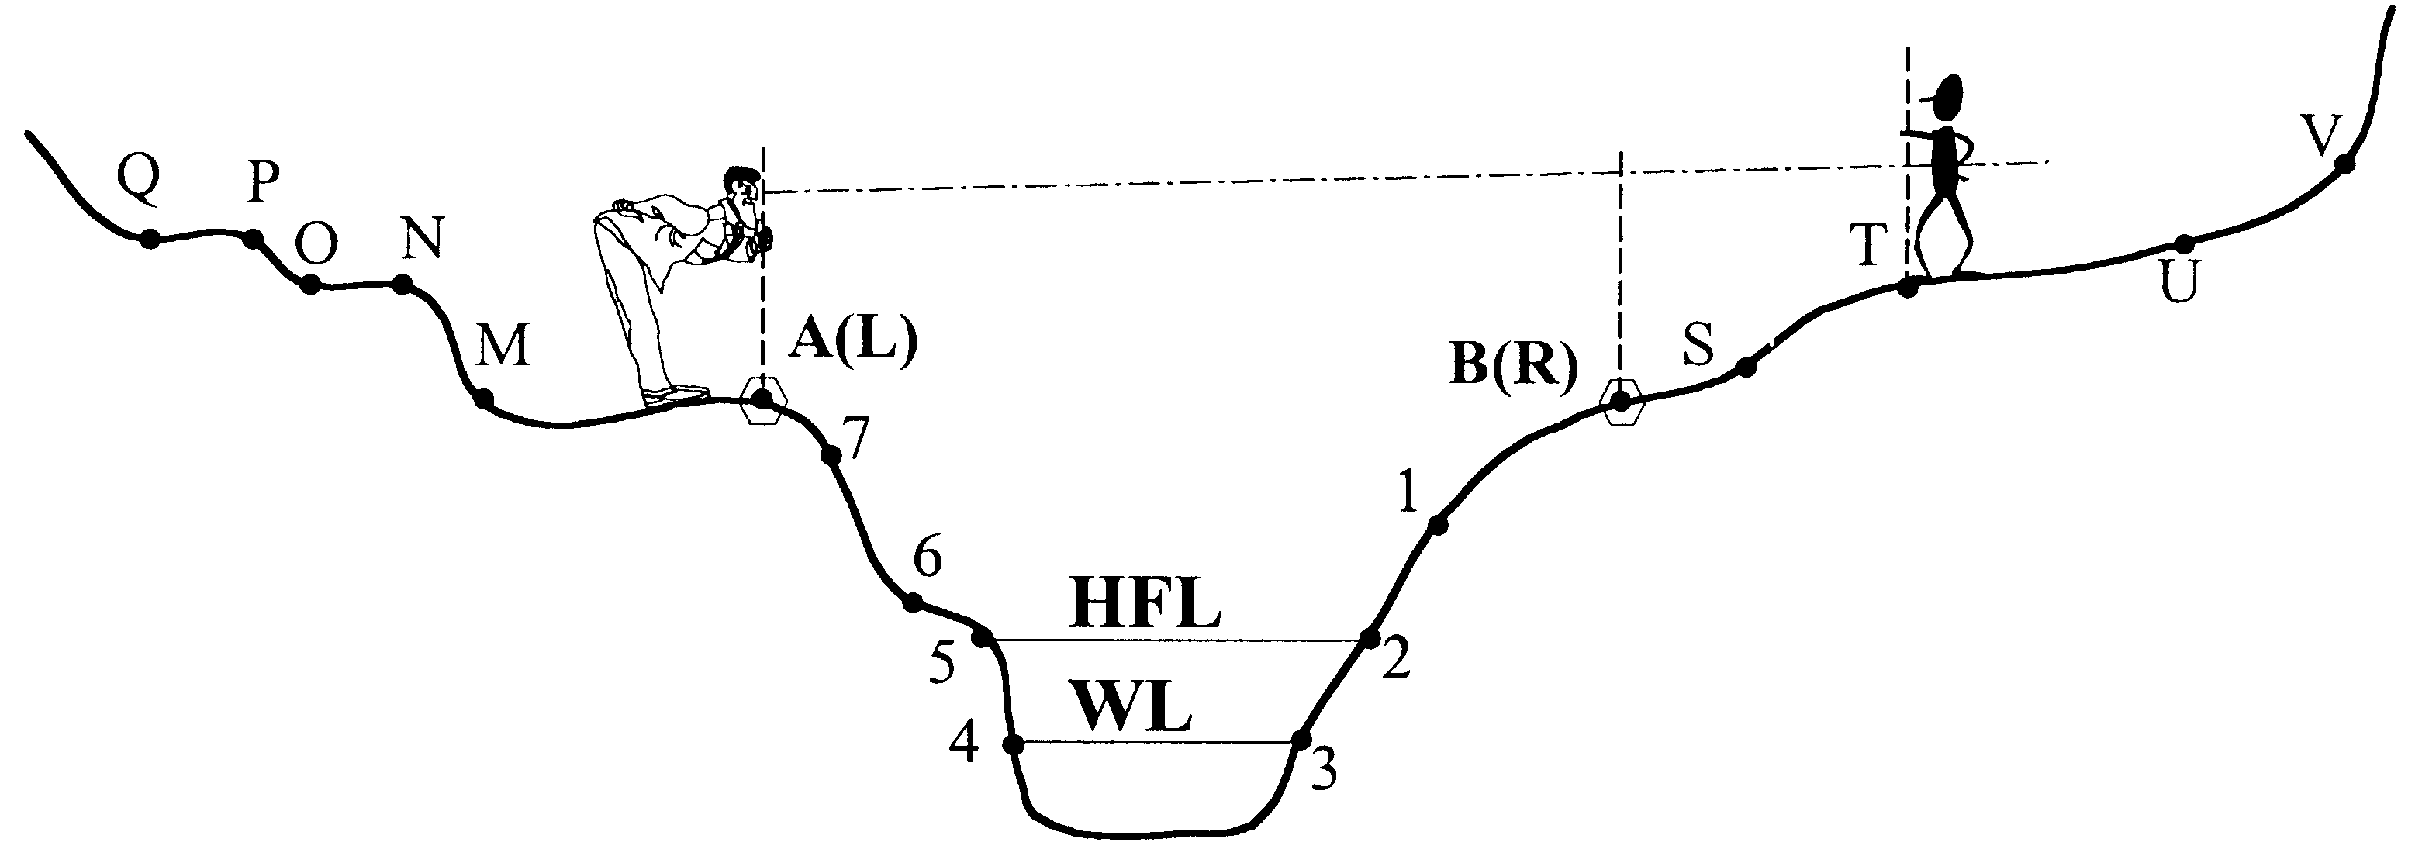

Figure 2.10: Fixing the bridge profile using Bamboo/Wooden sticks/Ranging rods.

Bridge Axis Profile:
Proceed with the survey of the bridge axis profile after having fixed the centerline as per following steps (refer to example on page 31).

- The survey starts from the fixed permanent axis points A or B and proceeds to other survey points M, N, O, P, 1, 3, 4, 5 or S, T, U, V, 4, 5, 6 (refer example sketch of bridge axis profile below)
- Measure the vertical angles and slope distances between these survey points of the centerline. It is important that the sighted target is on the same height above the ground as the Abney Level while taking the readings
- Measure all points M, N, O, P, 1, 2, 3 starting from the permanent axis point A, as described in the second step above
- Similarly, measure all points S, T, U, V, 3, 4, 5, 6 starting from the permanent axis point B
- Measure vertical angles from A to B and B to A to check the accuracy in vertical angle readings

Before calculating the horizontal and vertical distances, it is necessary to determine the accuracy of the measurement of the vertical angles. This can be done by comparing the measured vertical angle from A to B with the vertical angle from B to A. Both angle readings should be equal. Differences in these readings indicate an error in the angle measurements and needs correction.

The error factor ‘ E’ is calculated with the following formula:
E = $\frac{[ϕ\text{ΑΒ}]−[ϕ\text{ΒΑ}]}{2}$ ; Corrected angle ϕ′ = ϕ_{AB} ± E or ϕ′ = ϕ_{BA} E

Example: Error Correction of Measured Vertical Angles

measured vertical angle from A to B ϕ_{AB} = 0°50’ (Downhill sighted)
measured vertical angle from B to A ϕ_{BA} = 1°30’ (Uphill sighted)
error factor E = (1°30’ - 0°50’)/2 = 0°20’
corrected angle ϕ’_{AB} = 0°50’ + 20’ = 1°10’
corrected angle ϕ’_{BA} = 1°30’ - 20’ = 1°10’

All measured vertical angles should be corrected as:
Corrected angle ϕ′ = [ϕ] + E for downhill sighted (-) angles
Corrected angle ϕ′ = [ϕ] - E for uphill sighted (+)angles

Compute the horizontal distances and elevations of the corresponding survey points with the corrected vertical angles as per the following example.

Example: Calculation of Horizontal Distance D and Elevation H of Survey Points:

Elevation of A = 100. 00 m
measured vertical angle from A to M, ϕ_{AM} = +7°0’ (upward sighting)
corrected vertical angle from A to M ϕ’_{AM} = +7°0’- 0°20’ = +6°40’
measured slope distance A to M d = 13.35 m
horizontal distance between A and M D = d x cos ϕ’ = 13.35 x cos 6°40’ = 13.26 m
vertical distance between A and M ΔH = d x sin ϕ’ = 13.35 x sin 6°40’ = +1.55 m
Elevation of M H = Elevation of ‘A’ + ΔH = 100.0 + 1.55
= 101.55 m

Enter the measurements and calculations into the Abney Level survey sheet as per given example.

Measuring the River Width:

In certain cases, it might not be possible to directly measure the river width from one bank to another bank by tape. In such a situation, the river width should be measured by indirect method as described in the following example (Figure 2.11).

How much is the width of the river l = Distance from L to R ?
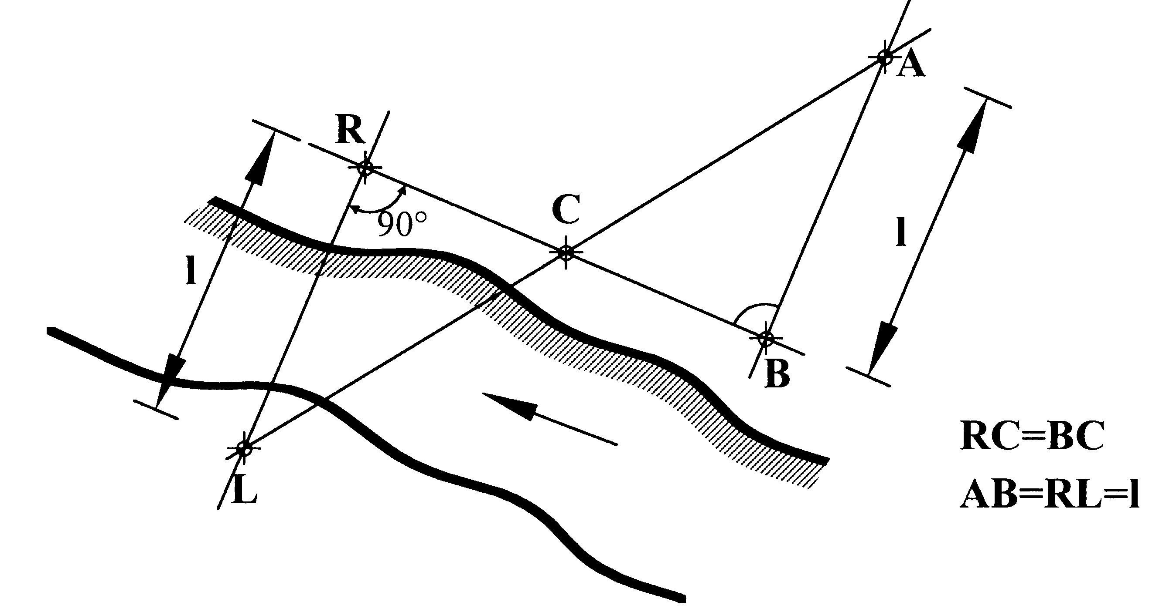

Figure 2.11: Measuring the river width.

The procedure of the measurement is as follows:

- Set a base line R - B perpendicular to the line L - R along the river. This can be done easily by 3-4-5 method (refer below: Setting of a Right Angle).
- On this base line R - B, mark the mid point C so that RC is equal to CB.
- Set again a base line B – A perpendicular to the line R – B similarly to step1.
- Mark exactly point A by ranging through point L – C, so that all these three points lie in the same line of sight.
- Measure length B – A. This length will be equivalent to the river width L - R = l.

Setting of a Right Angle:

One simple method to set a right angle from a point of a base line is the 3-4-5 method. One measuring tape and 3 wooden pegs are needed, as shown in the sketch below (Figure 2.12):

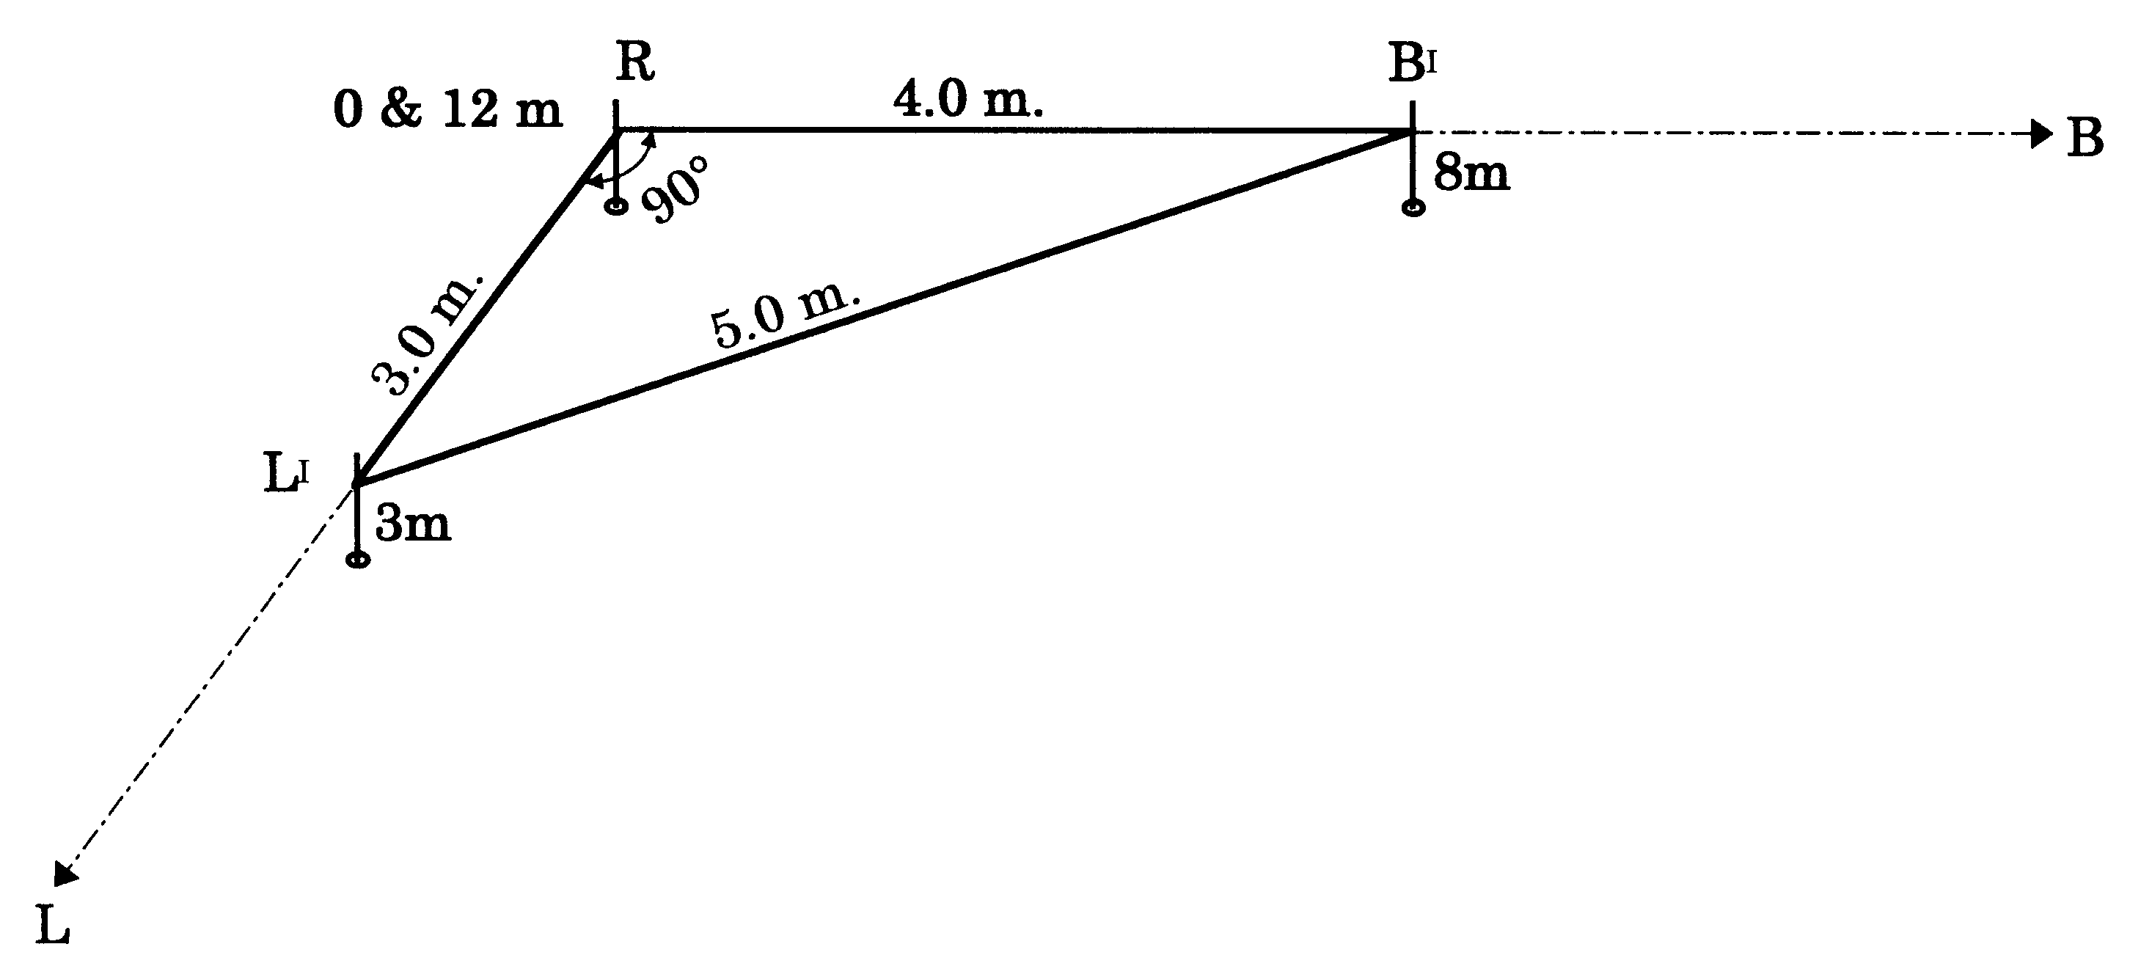

Figure 2.12: Illustration of 3-4-5 methods.

The procedure of the measurement is as follows

- The first person should hold ‘0’ and ‘12’m mark of the measuring tape at point R.
- The second person holds the tape at the 3m mark, and a third person at the 8m mark of the tape. Stretch all these sides of the tape as shown in the sketch above. A right angle triangle will be formed with sides of 3, 4, and 5m.
- Line R – B’ is now perpendicular to the line R – L'.

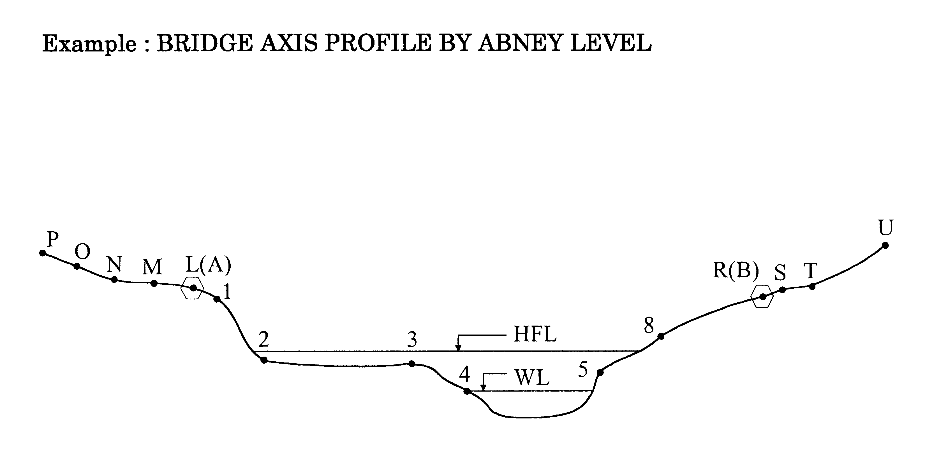

Figure 2.13: Example- bridge axis profile by Abney level.

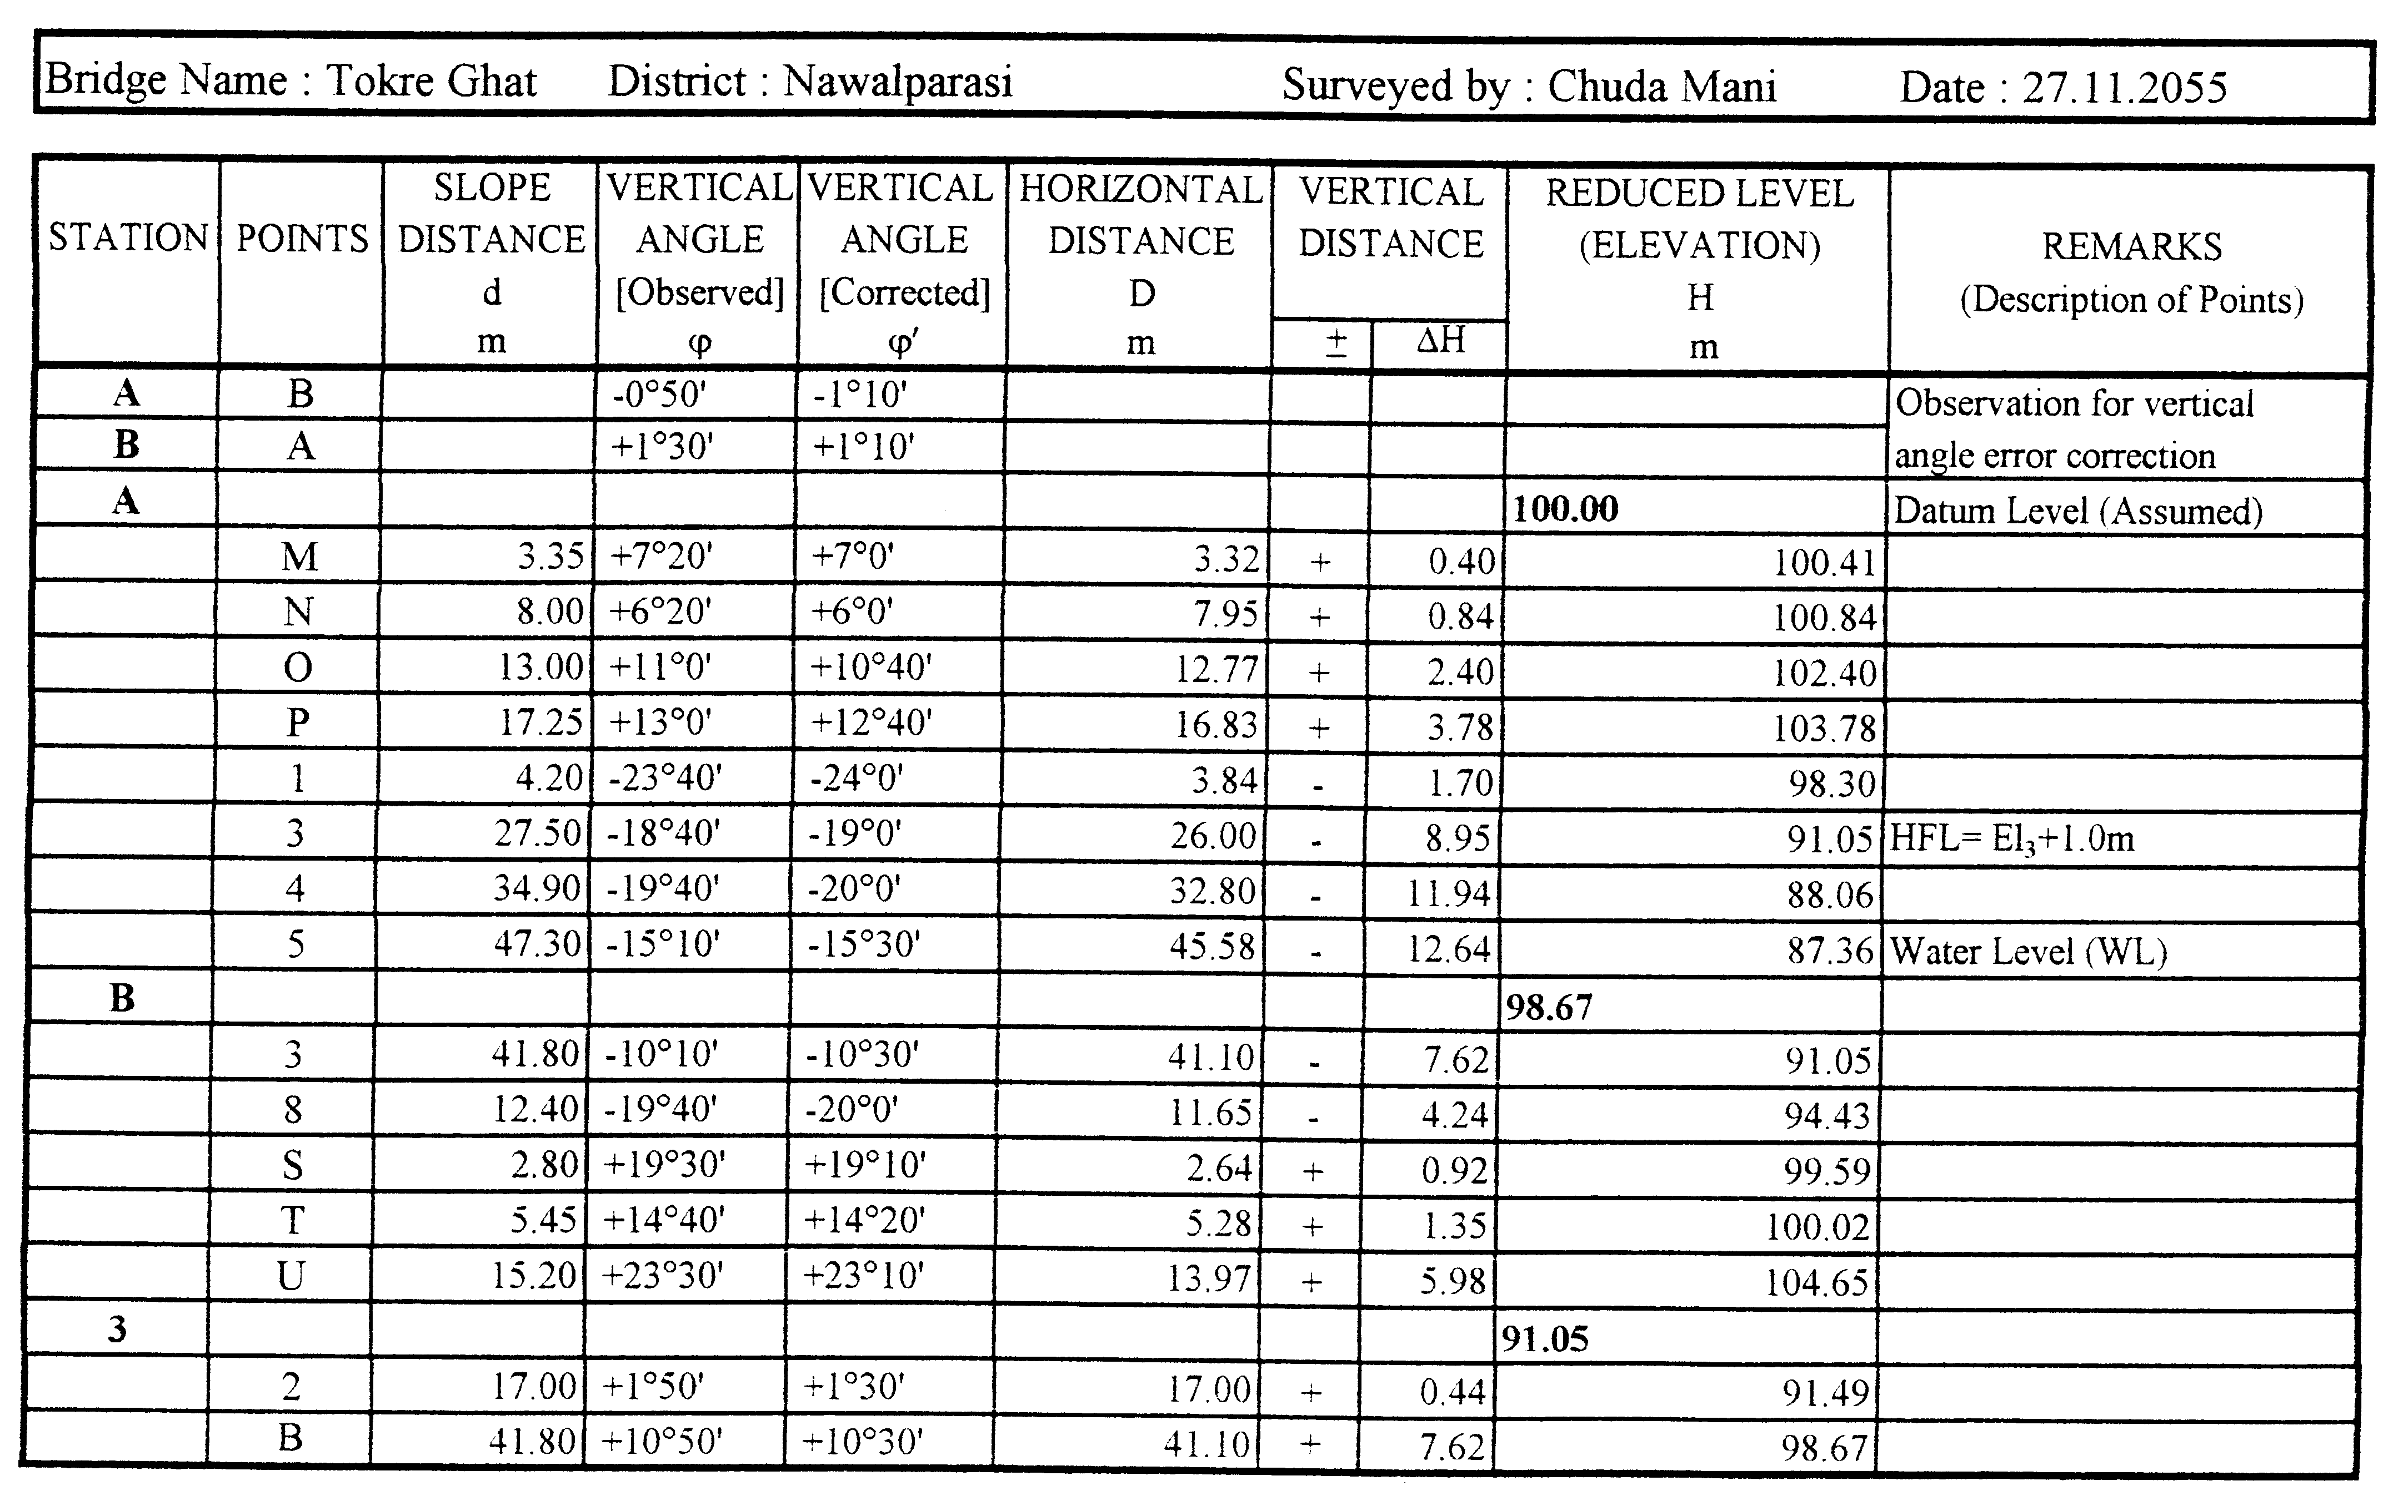

2.5.5 Bridge Profile
As per the field survey data, it is necessary to prepare the following topographic maps in the scale 1:100 or 1:200
- Profile along the bridge axis
- Contour plan of the bridge site in scale (only when a windguy arrangement is necessary)

Profile Along the Bridge Axis:
Plot the profile along the bridge axis as per the following steps:

- Choose the scale of the drawing. The vertical and horizontal scales should be the same.
- Choose the datum level so that the points with the lowest and highest elevations are within the drawing area.
- Choose the position of the axis point A so that most the farthest survey points on the right bank and the left bank from the axis point A are within the drawing area.
- Plot the axis point B as per its elevation and horizontal distance from the axis point A.
- Draw the survey points of the bridge axis according to the horizontal distance and elevations as per the data from the “Bridge Axis Profile by Abney Level” survey sheet or the “Tachometry” survey sheet from axis point A. Refer also to the sketch of the bridge profile prepared during the field survey.
- Similarly, draw the remaining survey points of the bridge axis from axis point B.
- Join all the survey points by straight lines. This will represent the bridge axis profile.
- Draw horizontal lines showing the elevations of the high flood level and the water level at the time of the survey.

Contour Plan of the Bridge Site:
A contour plan represents the overall topography of the bridge site by means of contour lines. A contour line is a continuous line passing through points of equal elevation.
A contour plan is necessary only when a windguy arrangement is to be considered in the bridge design. In cases of short span trail bridges, windguy arrangements will not be necessary, and a contour plan is not required to do the bridge design.
The method of plotting a detailed contour plan is not discussed here. For further information, refer to topographic survey books or the SBD Survey Manual.

2.6 Photographs
Photographs of the bridge site are necessary to support its technical feasibility/topography and facilitate the bridge design.

Take the following photographs:

- An overall view of the bridge site from upstream indicating the approximate location of the bridge foundations and the axis line.
- An overall view of the bridge site from downstream indicating the approximate location of the bridge foundations and the axis line.
- View of the right bank from the left bank with the approximate location of the bridge foundations.
- View of the left bank from the right bank with the approximate location of the bridge foundations.
- An overall top view (if possible).
- A close up view of the axis points and benchmarks.
- A view of the soil test pits at the location of the bridge foundation blocks.
- Other relevant photos

Take the above photographs from the positions as per the sketch below (Figure 2.23). If one picture does not cover the necessary area, take several pictures from the same spot with sufficient overlapping.

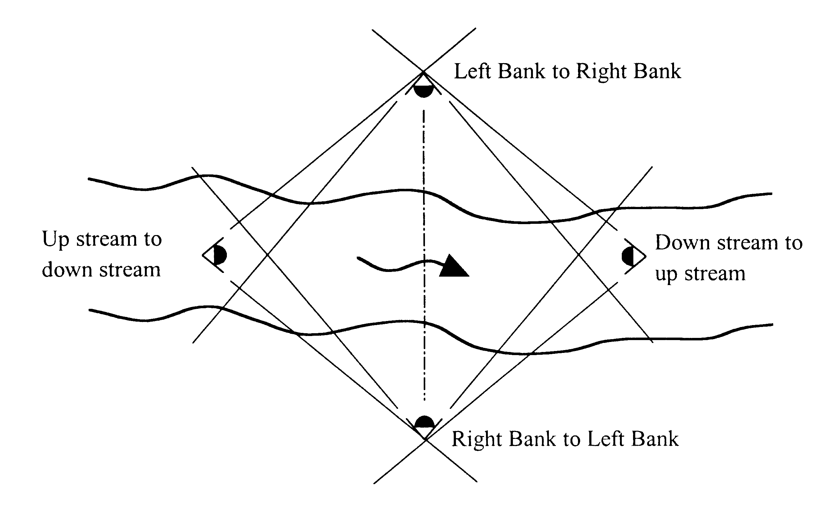

Figure 2.23: Locations for taking photographs.

Present all the photographs systematically with respective captions.

2.7 Survey Report
The technical survey report consists of:

- Filled in Survey Forms and Checklist
- Topographic map

- Profile along the bridge axis in scale
- Contour plan of the bridge site in scale (only if a windguy arrangement is necessary).

2.8 Review Questions

Answer the following questions:

What are the factors to be considered for social feasibility study of a trail bridge project?
Enlist the tools, equipments and accessories necessary for conducting Abney Level survey in a trial bridge project?
Prepare a typical bridge site location map.
Illustrate and state the favorable and unfavorable conditions of the following features in evaluating the bridge site selection:
Bridge span, Space for foundation, Free board and Slope profile
Illustrate and state the favorable and unfavorable conditions of the following features in evaluating the river condition:
Riverbed and River flow.
Illustrate and state the favorable and unfavorable conditions of the following features in evaluating the slope and bank condition:
Bank profile, Bank erosion, River undercutting, Gully erosion and Wedge failure.
State how the bridge site is categorized after completing the site investigation.
State and illustrate in brief the procedure for setting the centerline of the trail bridge.
State and illustrate the procedure to measure the followings;
Vertical angle using Abney Level and River width
List out the photographs needed for support of technical feasibility of the bridge site.

