4. Trail Bridge Construction / ExecutioN

This chapter deals with both the trail bridge construction and execution.

4.1 Bridge Layout
The Bridge Layout is to fix the bridge position and foundations at the site as per the design.

Procedure for General Bridge Layout (refer to the General Arrangement 'GA' Drawing)
(Figure 4.1a & b):

Find the existing pegs and benchmarks.
Measure the horizontal distance between the axis pegs A (L) and B (R) and compare with the measurement given in the General Arrangement.
Check the elevations of the axis pegs A (L) and B (R) and compare with the elevations given in the GA.
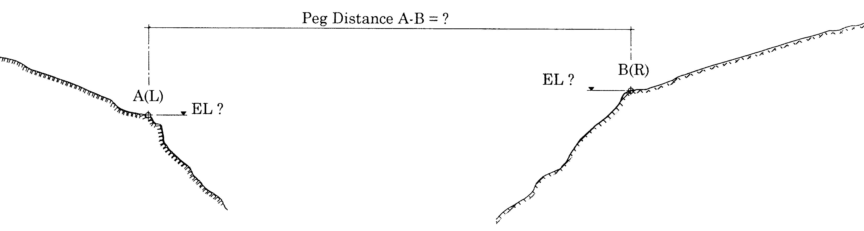

Figure 4.1a: Procedure for general bridge layout

If the horizontal distance between the axis pegs A (L) and B(R) and its elevations do not match the measurements given in the GA, readjust the design according to the actual measurements.
If the horizontal distance between the axis pegs A (L) and B(R) and its elevations are identical to the measurements given in the GA, fix the position of all the foundation blocks as shown in the following sketch and procedure below.
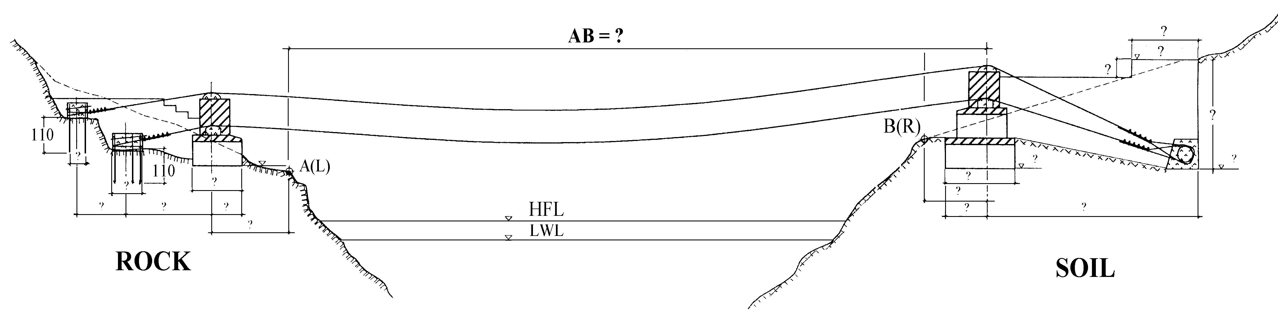

Figure 4.1b: Procedure for general bridge layout

Procedure for Detailed Foundation Layout (Figure 4.2 a, b, c, d, e & f):
Align the centerline of the bridge by joining the permanent points with mason threads or by ranging between the axis pegs 'A' and 'B' as shown in the following sketches.
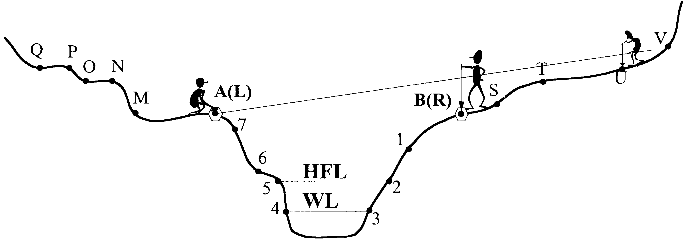
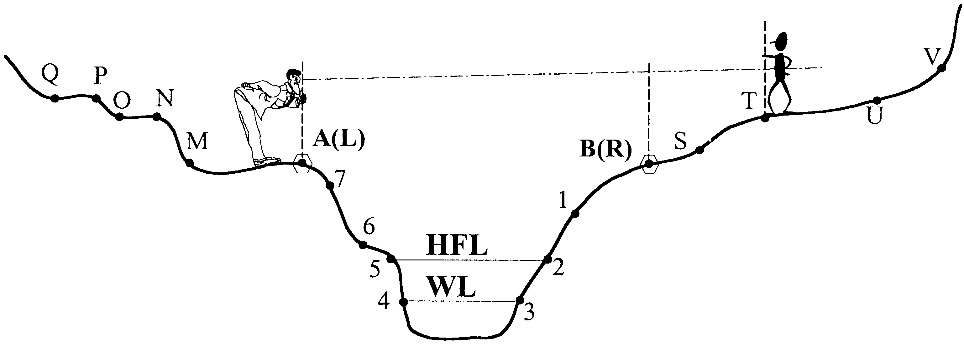
Or

Figure 4.2a:Procedure for detailed bridge layout

- Mark the front of the tower foundation on the bridge centerline (peg 1) with reference to the axis peg. The distance between the front of the tower foundation and the axis peg is given in the GA.
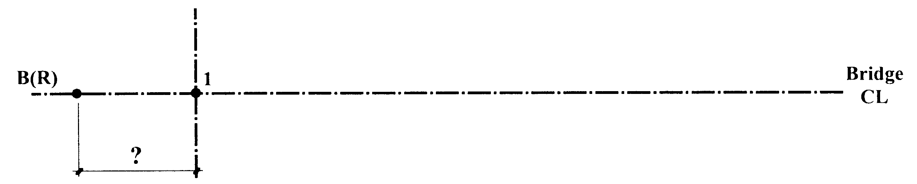

Figure 4.2b:Procedure for detailed bridge layout

- Check the location of the front of the tower to ensure it has sufficient distance (minimum 3 m for soil slope and 1.5m for rock slope) from the bank edge.
- Measure the length of the foundation from peg 1 and fix peg 2. Set up two additional centerline pegs at a safe distance for the excavation works (pegs 3 and 4).

Figure 4.2c:Procedure for detailed bridge layout

- Draw an offset line (right angle) through peg 1 by the 3-4-5 method (refer to Chapter 2.5.4). Starting from peg 1, set out pegs 5, 6, 7, and 8 for the reference line of the front edge.
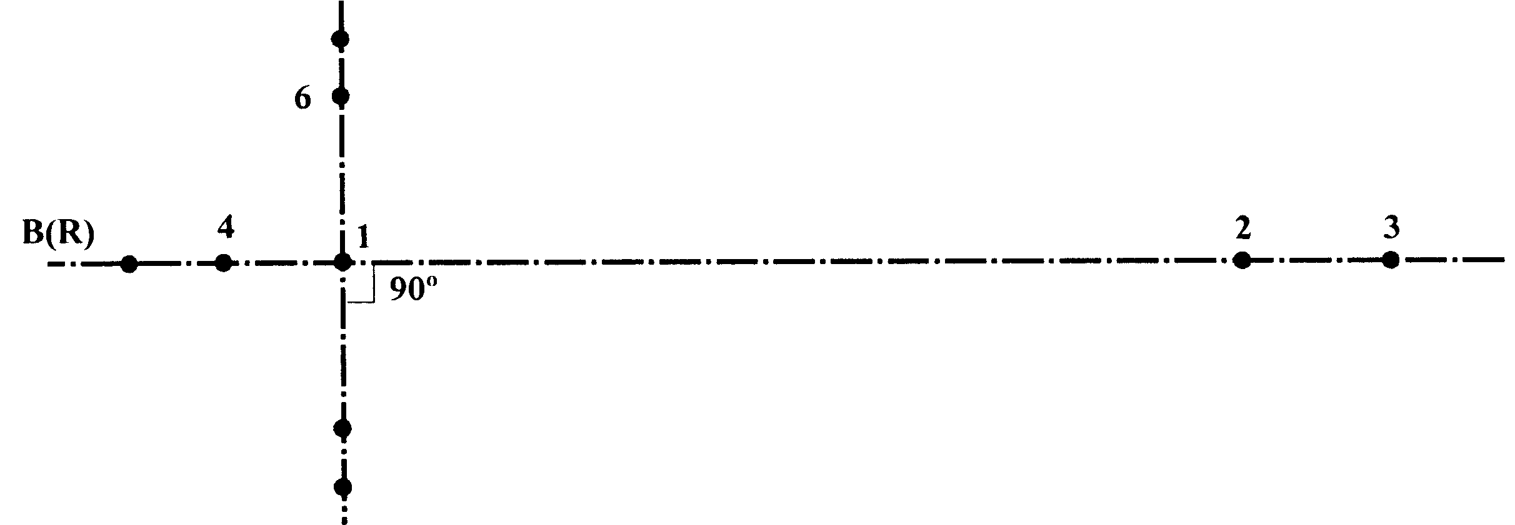
6
7
8
5

Figure 4.2d:Procedure for detailed bridge layout

- Draw an offset line through peg 2 for the reference line of the back edge. Starting from peg 2, fix the pegs 9, 10, 11 and 12. Similarly, fix the reference line of the tower foundation with pegs 13, 14, 15, 16.
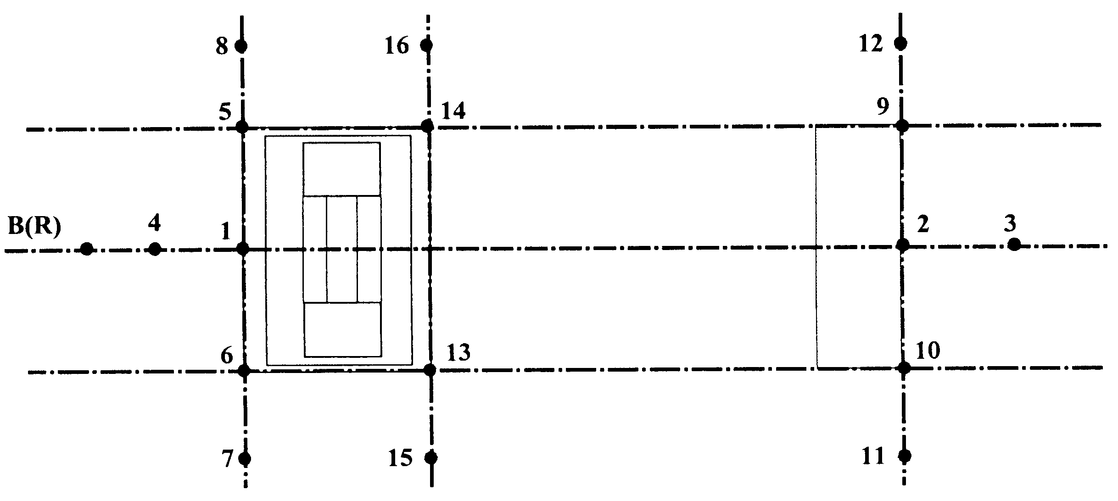

Figure 4.2e:Procedure for detailed bridge layout

- Determine the reference line at the downstream edge with the help of pegs 5 & 9, for the upstream edge, use pegs 6 & 10 (peg 19 & 20).
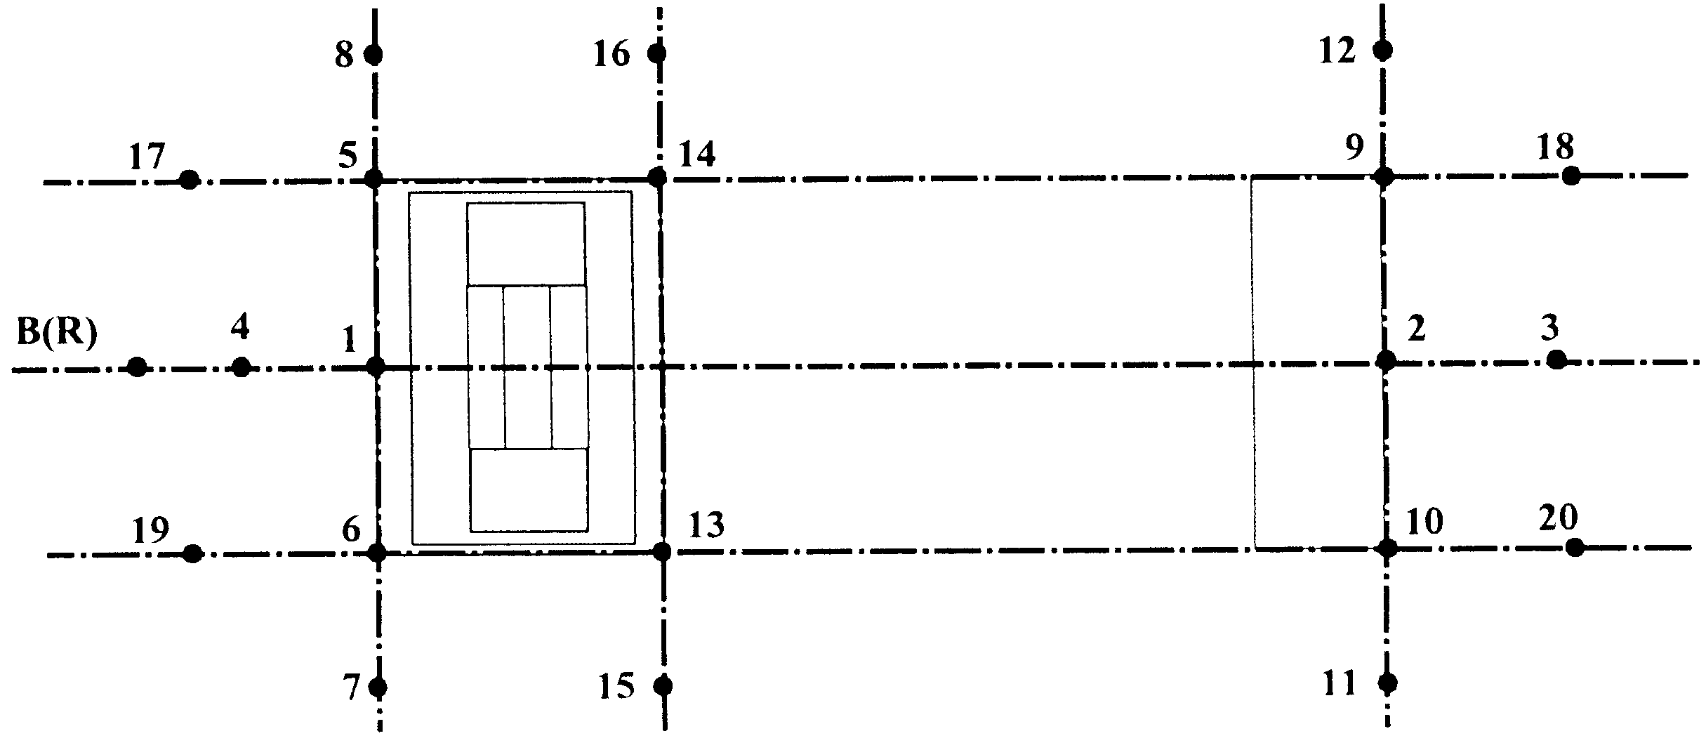

Figure 4.2f:Procedure for detailed bridge layout

- Fix the elevation line (datum level) and indicate the depth of the excavation work for the tower and dead man or drum anchorage as per the elevations shown in the GA and Anchorage Block drawings.

4.2 Foundation Excavation
In Soil (Figure 4.3 a, b, c & d):

Foundations should be excavated with slopes to provide stability of the cut slope. The cut slope in soil should not exceed 3:1 (V:H). The foundation should be excavated stage wise as illustrated below.

- 1st Stage – All excavations as shown in the sketch below.
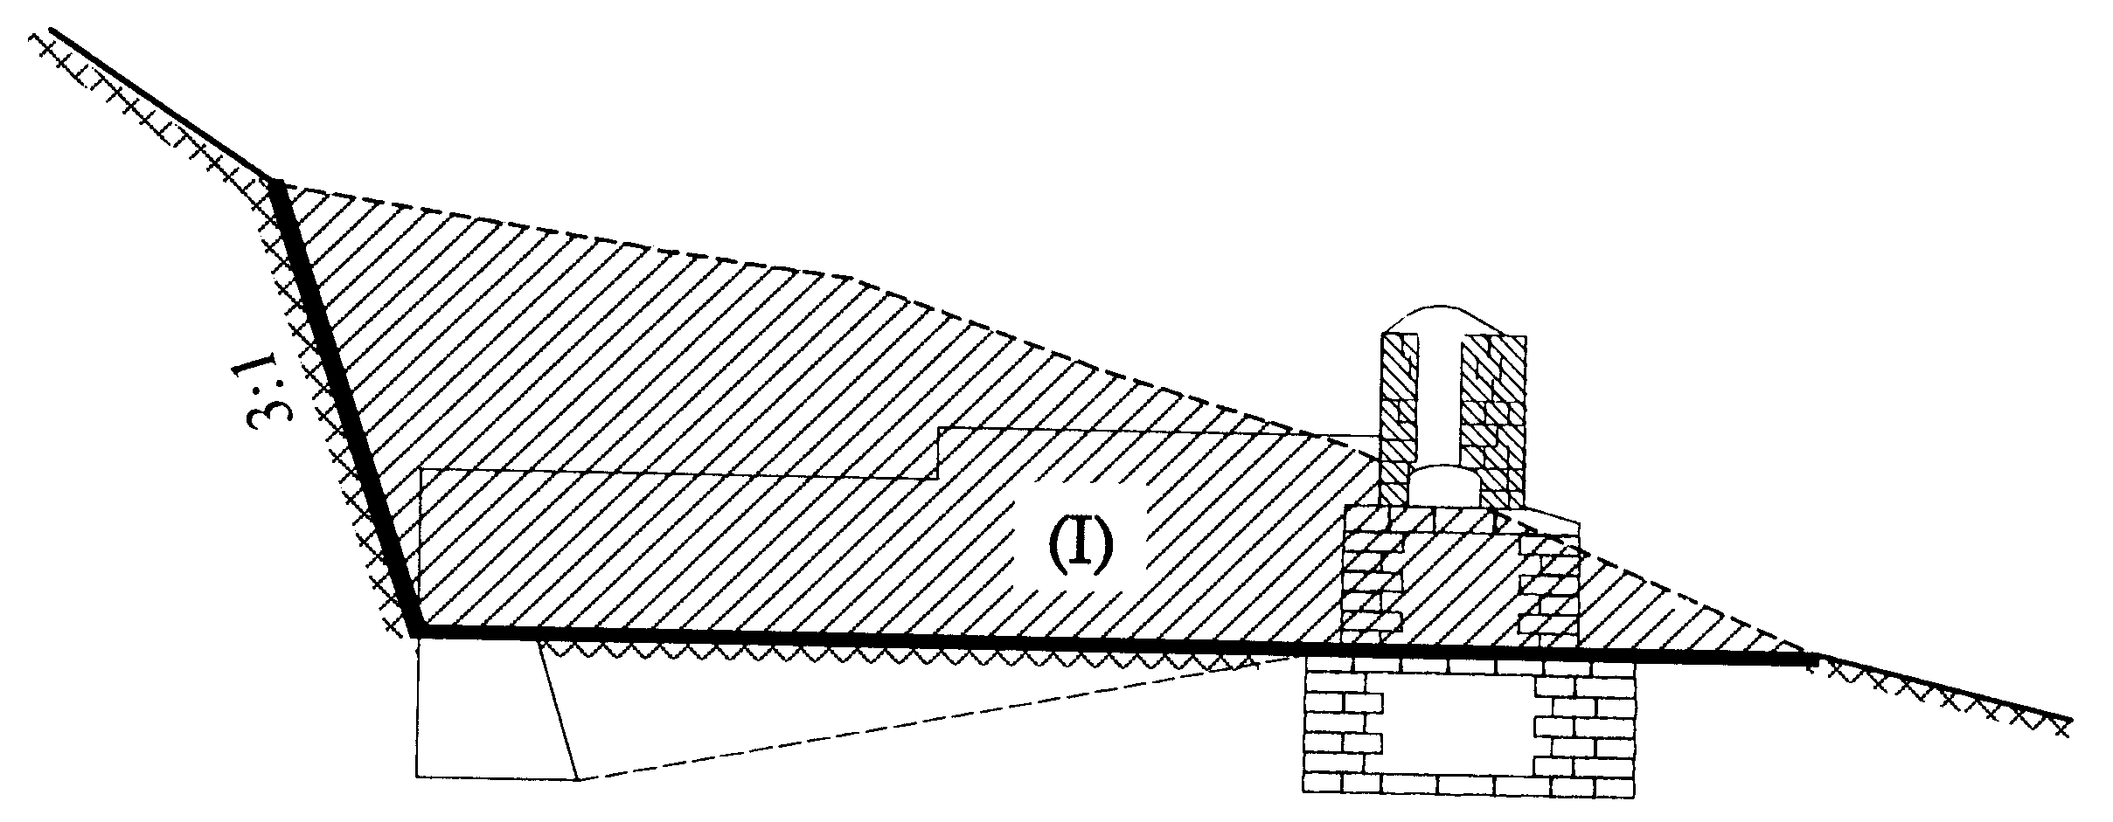

3:1

Figure 4.3a:Foundation excavation in soil- 1st Stage
- 2nd Stage – Foundation excavation for the tower as shown in the sketch below.
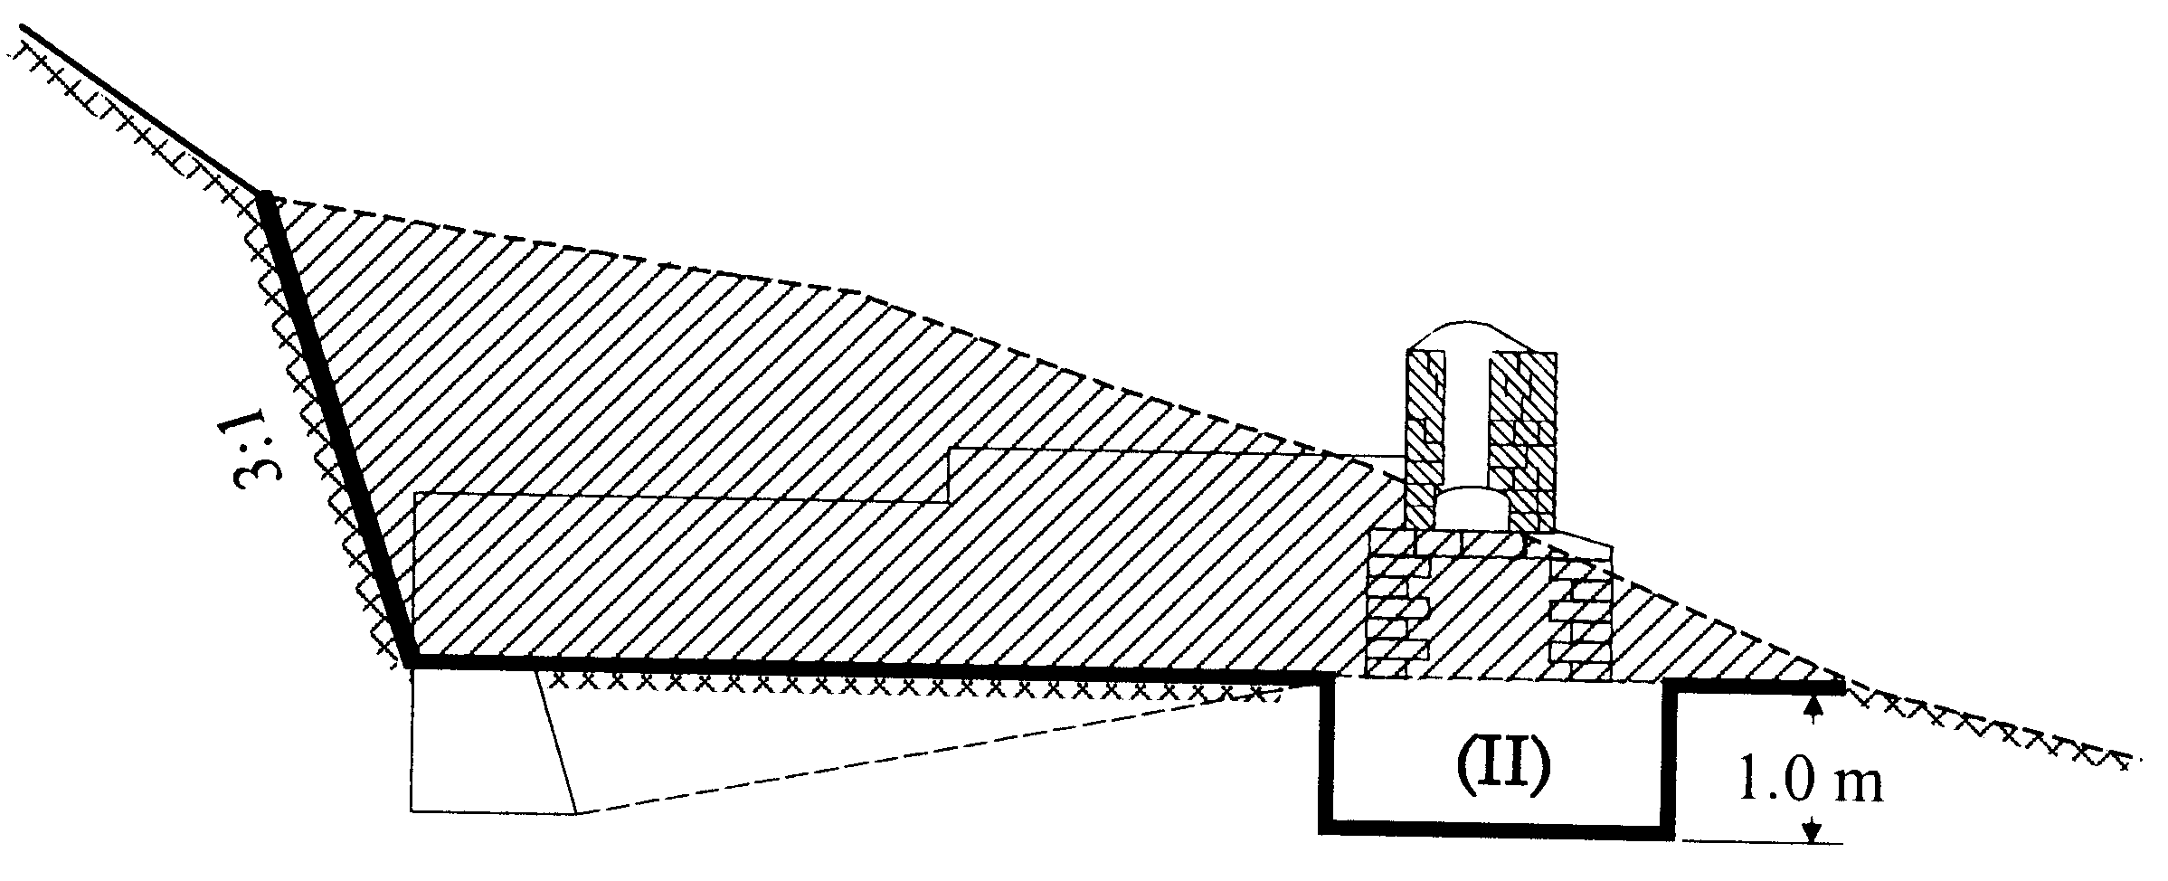

3:1

Figure 4.3b:Foundation excavation in soil – 2nd Stage

- 3rd Stage – Construction of the tower as per the design. Refer also to Chapter 4.5 and 4.6.
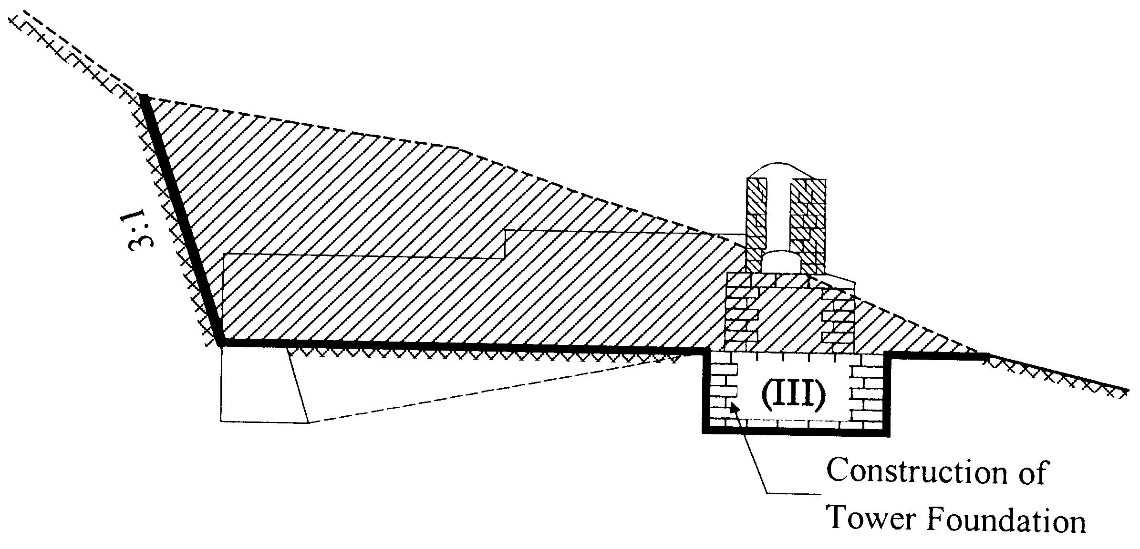

3:1

Figure 4.3c:Foundation excavation in soil – 3rd Stage

- 4th Stage – Final Excavation for the deadman beam as shown in the sketch below.
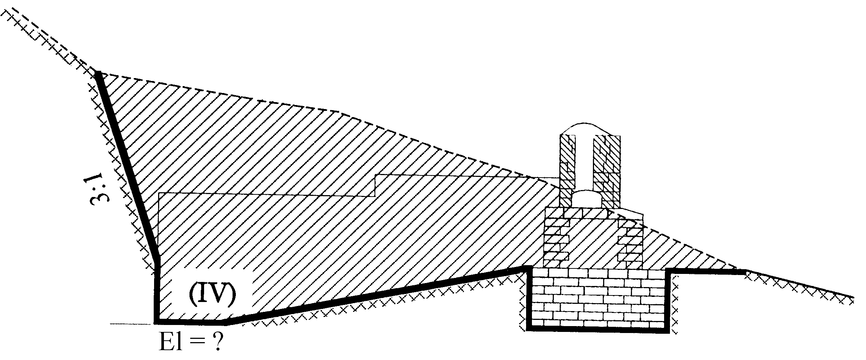

3:1

Figure 4.3d:Foundation excavation in soil – Final Stage

In all of the above excavation stages, the excavation depth should be maintained accurately. For this, establish an elevation line (datum level) and measure the foundation depths with a fixed stick.

All the excavated soils should be safely disposed without damaging the existing vegetation down the hillside, thus not affecting the environment.

In Rock:

Rock excavation is necessary to prepare the platform for the drum anchorage. Rock should be excavated manually without blasting.

Excavation in rock is done by first drilling holes to weaken the rock, and then using crowbars to break up and dig out the rock parts. The cutting can be carried out by forming steps, as shown in the following sketches (Figure 4.4).
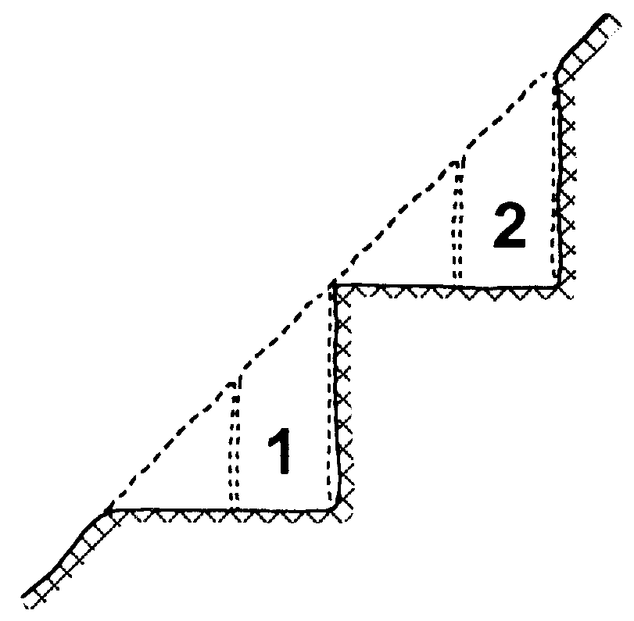
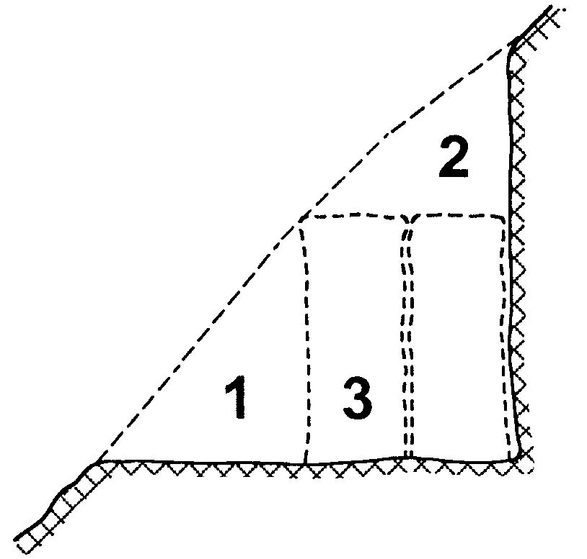

1st Stage 2nd Stage

Figure 4.4:Foundation excavations in rock

4.3 Local Material Collection
The required local materials for the bridge construction are sand, gravel (river gravel or broken aggregate), and stones/boulders.

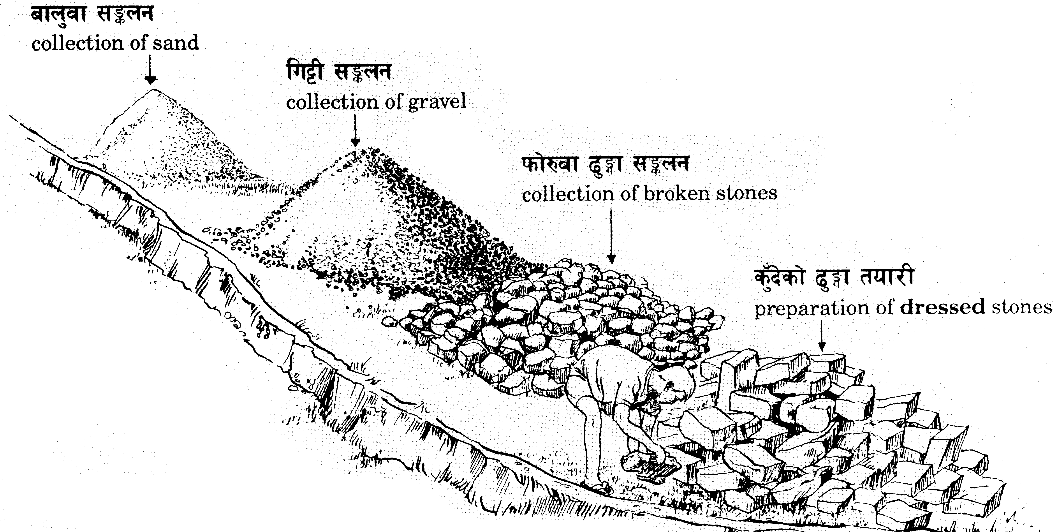

Figure 4.5:Collection of local construction material

4.3.1 Stones/Boulders
The best stone collection is from a rock quarry. The rock should be unweathered, hard and dense with a metallic sound.
In unavoidable cases, boulders can also be collected from the river. However, they can be used only for filling purposes (broken stone filling). In any case, stones from a rock quarry are necessary for masonry works.
Quality requirements for the stones/boulders are further detailed in Chapter 4.5.

4.3.2 Sand
Sand can be collected from river deposits or from a quarry. The quality of the sand should be assessed before sand collection. Check visually for impurities such as mica, clay, loam, mud organic materials, etc. If such impurities are unavoidable, it is recommended that the sand be washed before use. Sand containing significant quantities of mica should be rejected. The grain size of the collected sand should not be too fine.

Fill a bottle with sand and water and shake vigorously and
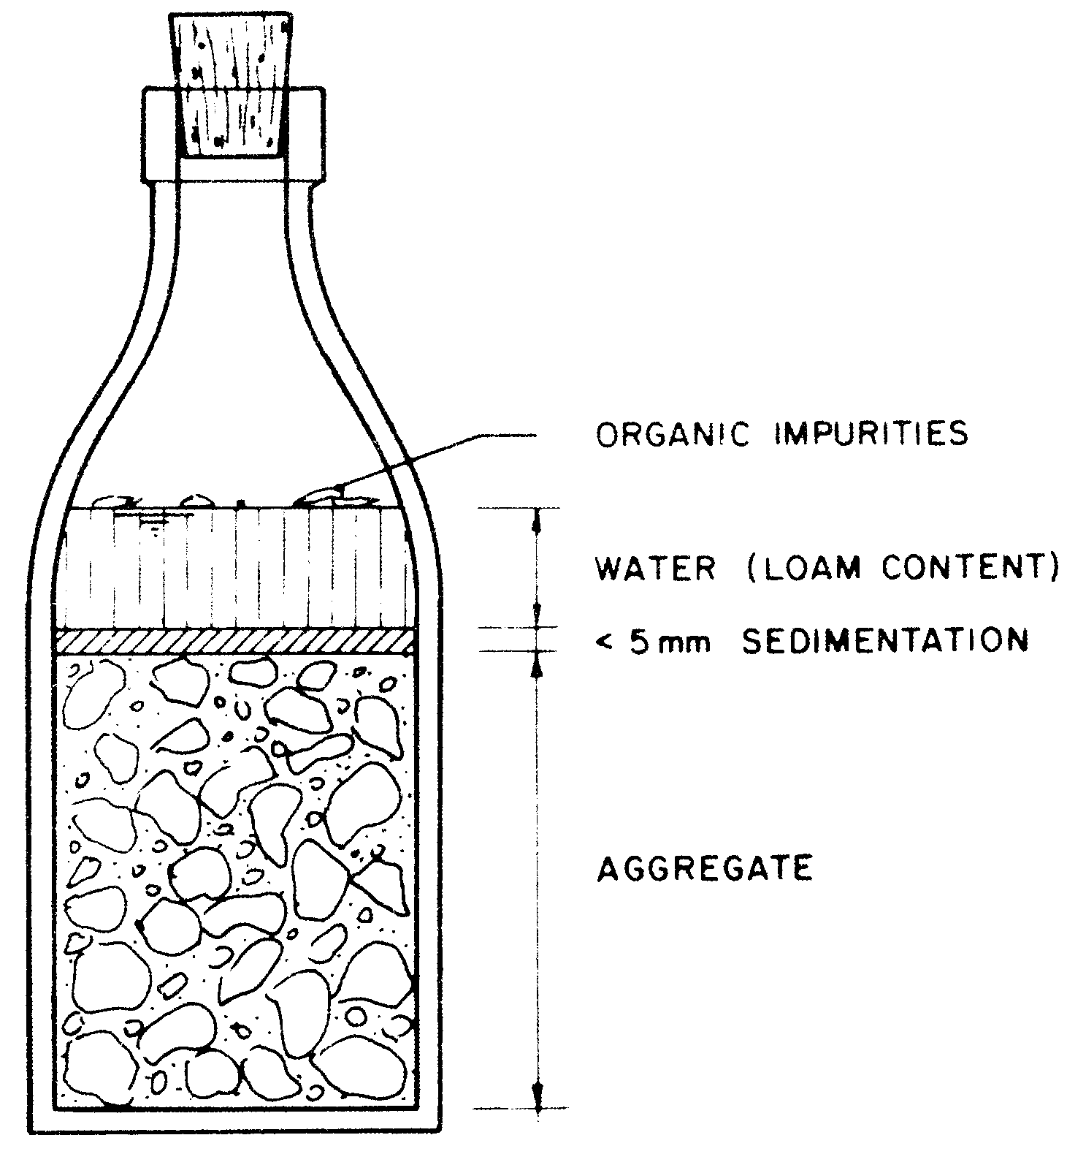
leave to settle. If the sand is clean, the sedimentation will be
less than 5 mm after two hours. And the water above will only be
lightly cloudy. The quality requirements for the sand are further
detailed in Chapter 4.6.1.

Figure 4.6: Quality Testing of Sand

4.3.3 Gravel
Gravel can be collected from river deposits or by breaking boulders into the necessary size. The required sizes and their proportions should be
5 to 20mm - 40%
20 to 40mm - 60%
Gravel should be of hard rock origin. Gravel of unsuitable rock such as mica, marl and sand-stone should be rejected. Likewise, flat and flaky particles should also be rejected. The collected gravel should be free from organic contaminants like clay, loam, mud or stone dust, etc.

Quality requirements for the gravel are further detailed in Chapter 4.6.1.

4.4 Transportation and Storage of the Materials
Material other than local materials has to be transported from road head to the site by porter or other means. These materials are mainly Cement, Steel Parts and Wire Ropes.

4.4.1 Cement Transportation and Storing
Utmost care should be given for transportation and storing of the cement. The prime importance is the proper packing of the cement before transportation to make it watertight and airtight. For this, cement bags as received from the market or factory should be double packed by additional packing with Nylon Bags and a plastic layer inside. Re-opening the bags (especially when transporting by mules) is not permitted before use at the site.
The following conditions must be met for the storing of the cement:
- Cement must always be stored under a roof with adequate protection from rain. A raised plank floor is necessary to prevent cement from damp.
- Storage must be arranged in such a way that the oldest cement can be used first.

4.4.2 Steel Parts Transportation and Storing
There is a great chance of damage to steel parts during loading/unloading and transportation. The most common damage is:
- Deformation of cross beams and steel decks due to mishandling during loading and unloading,
- Deformation of suspenders and reinforcement bars due to mishandling during loading and unloading
The steel parts should be loaded or unloaded carefully to avoid the above damages. Do not allow steel parts to fall from a height. Suspenders should be bound together with the crossbeam.
Similarly, the following conditions must be met for the storing of steel parts to avoid any damage.
- Galvanized and non-galvanized steel parts must always be stored under a roof with adequate protection from rain and should not be in contact with the ground.
- Galvanized steel parts should not be transported and stored together with salt or acid.
- Steel parts should be stacked and stored element/component-wise separately, avoiding the mix up of different elements. Thus, any element or component can be easily located during the bridge erection.
- All fixtures (nut/bolts, washers, thimbles and bulldog grips) should be packed/marked and stored separately according to its sizes.
- Steel parts, particularly suspenders and reinforcement bars, should not be become bent during portering and storage.

4.4.3 Wire Rope Transportation and Storing
It is vital to handle and transport the cables carefully to avoid any defects like kinks, splices and broken strands. Some examples of defects on the cables due to mishandling and improper transportation are shown in the photographs below (Figure 4.7, 4.8a &b).

Also pulling or dragging the cable along the road for transportation is not permitted.
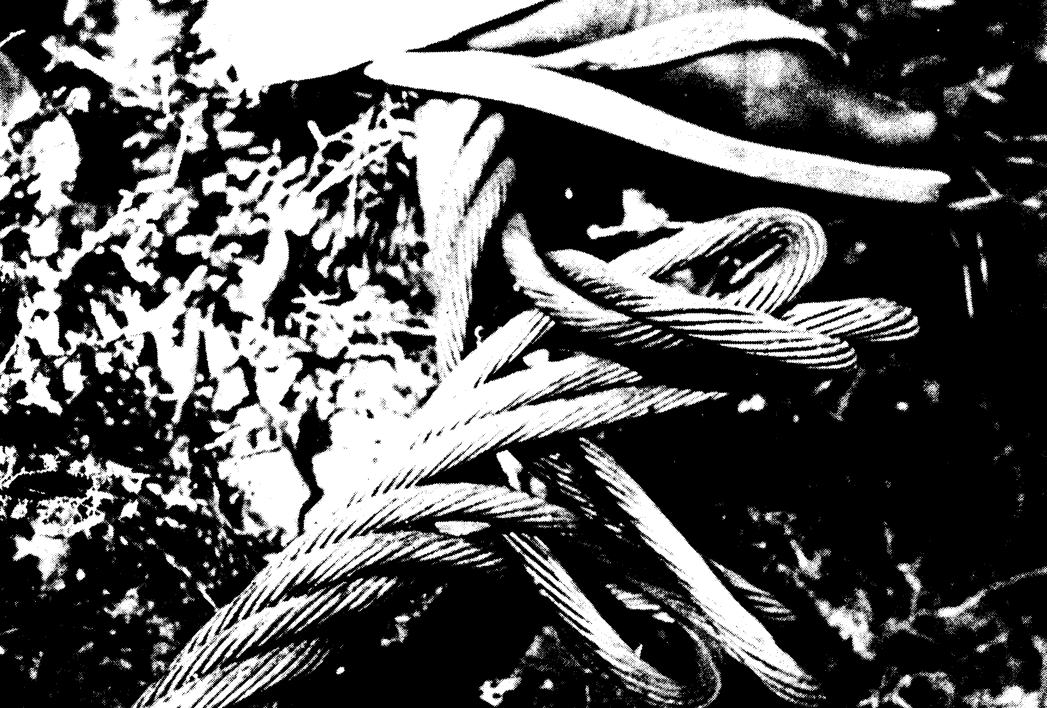
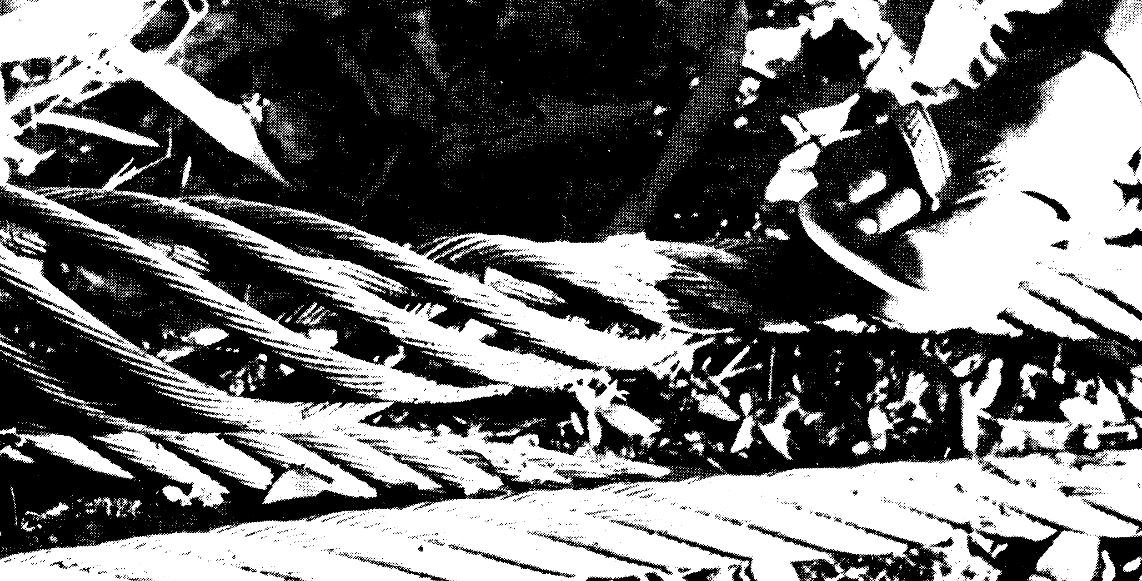

Figure 4.7: Cable transportation

To avoid such defects, follow the handling and transportation methods as described below.

- Method of Unreeling Light Cables with the Help of a Reel Support
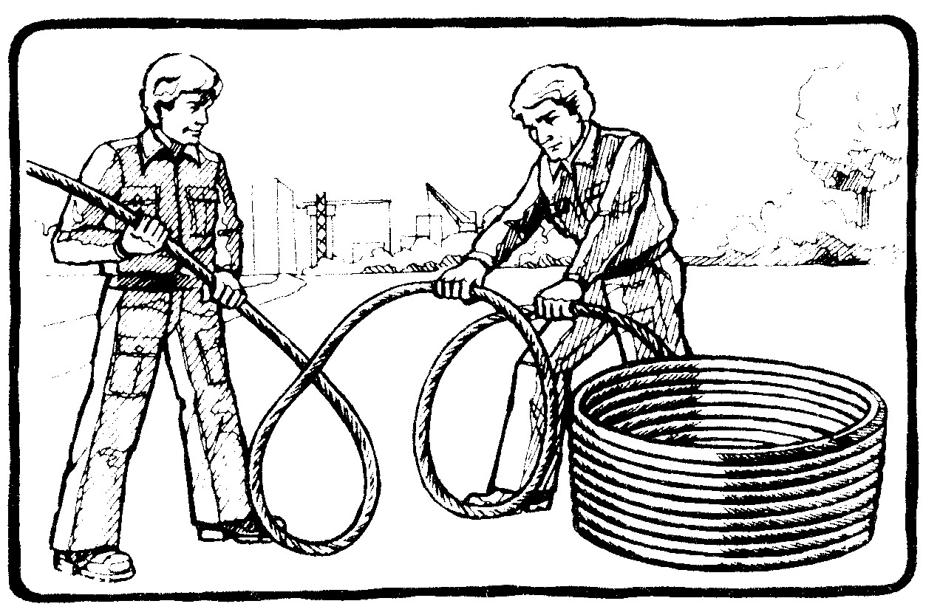
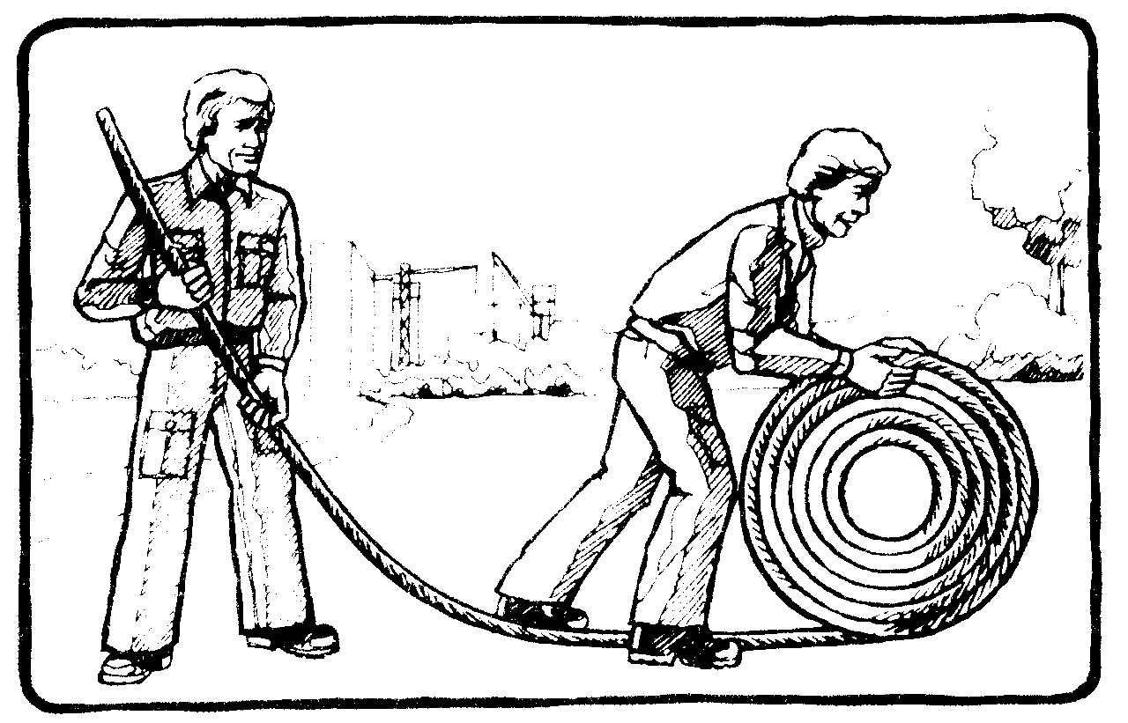
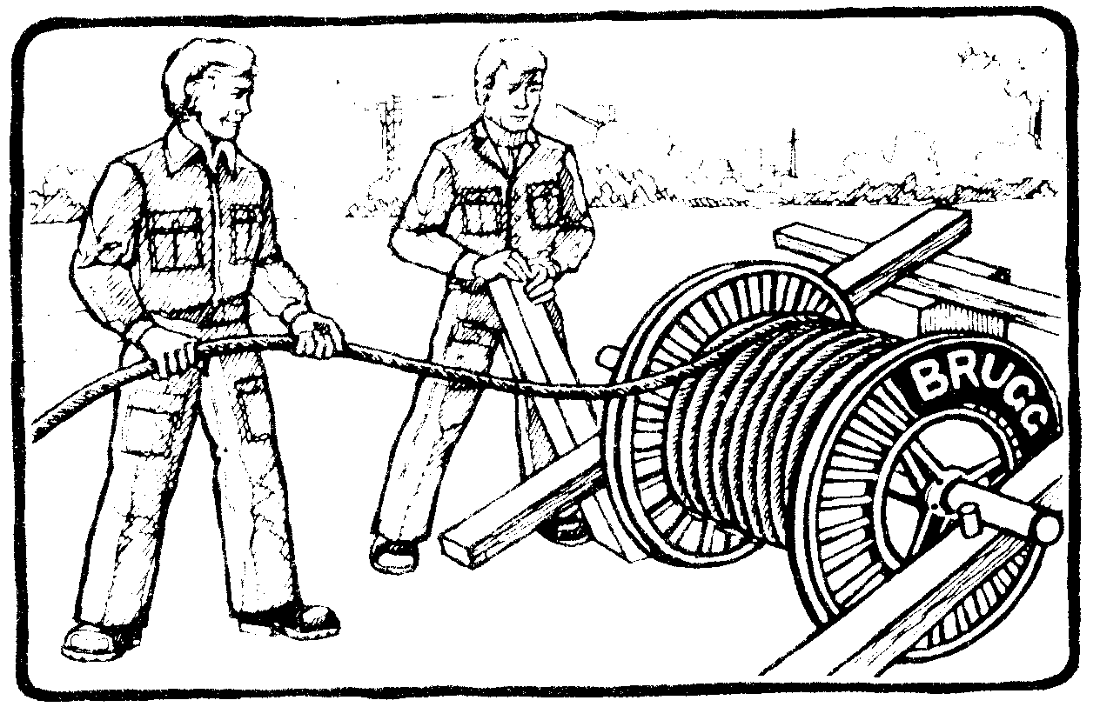

Wrong Correct Correct
Figure 4.8a:Method of unreeling the cable.

- Method of Unreeling Cables by Unrolling. Each Loop Taken from the Reel.
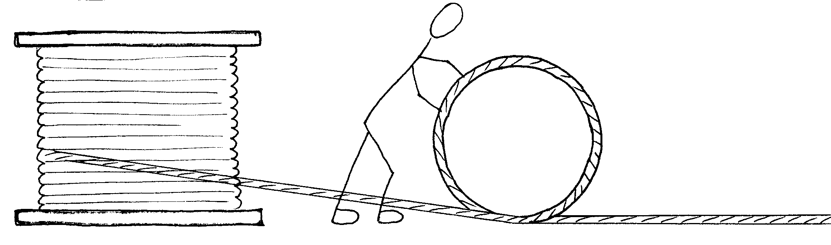

Figure 4.8b:Method of unreeling cable

Before cutting the cable, the cable ends should be tightened with binding-wire (seizing) to avoid loosening of the cable wires as shown in the following sketch (Figure 4.9).
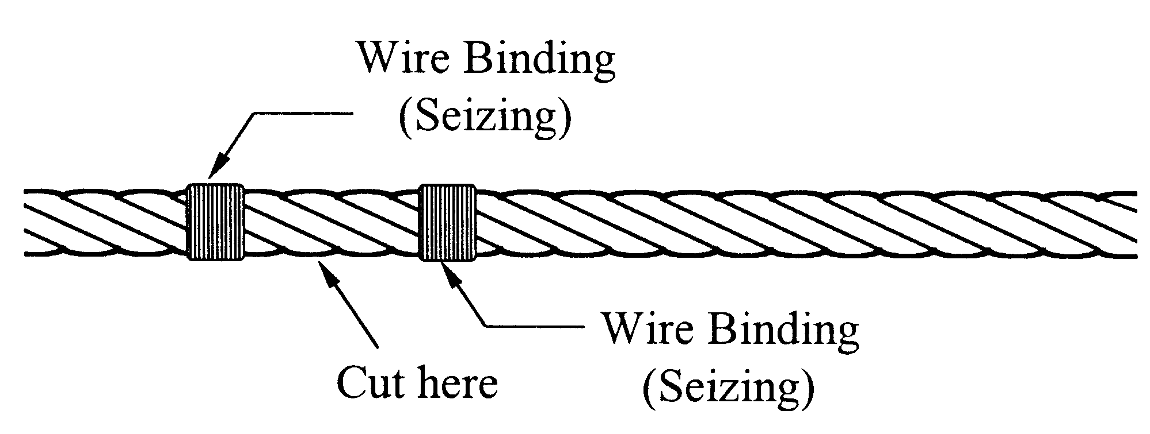

Figure 4.9:Method of cable cutting

- Method of Transportation by Porters

There are mainly two methods of cable transportation as illustrated in the following photos (Figure 4.10 a, b & c).
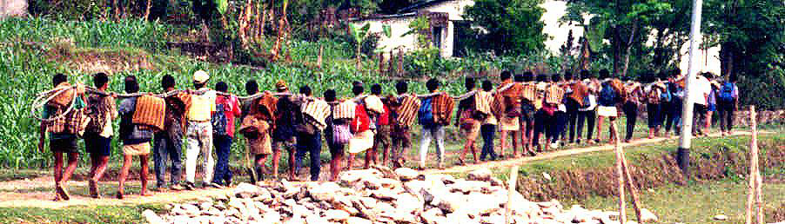

Figure 4.10a: Cable Transportation on the Shoulders (for short distances)

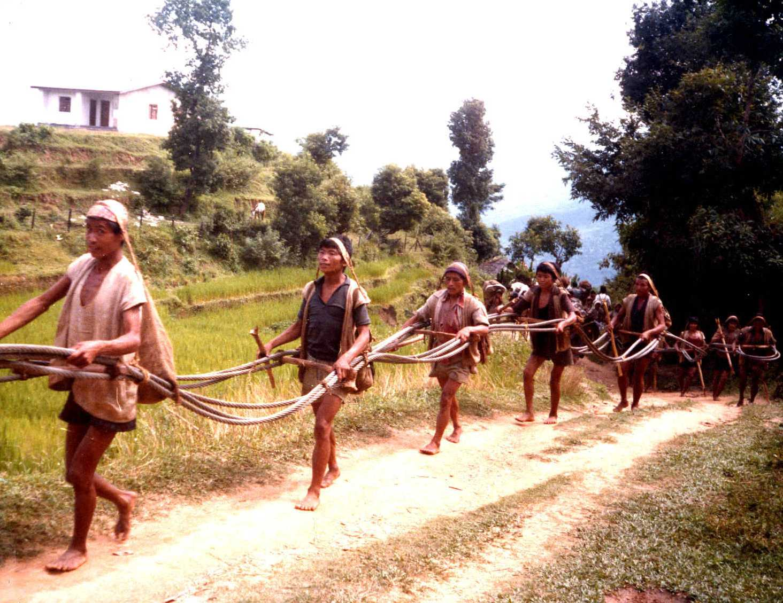

Figure 4.10b: Bundled Cable Transportation (for longer distances)

Cable transportation as shown in the sketch below is wrong and should not be practiced.
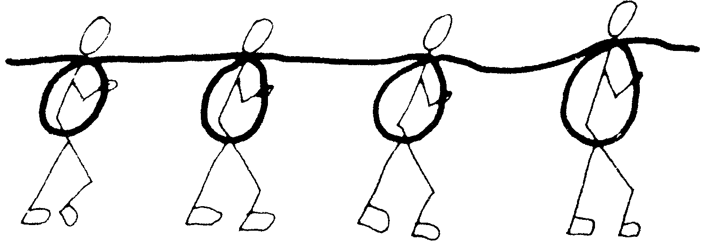

Figure 4.10c:Wrong method of transportation

4.5 Masonry and Stone Dressing Work

4.5.1 Requirements for Building Stones
Building stones must be of high strength, density and durability. A good building stone should be hard, tough, compact grained and uniform in texture and color.

Crystalline stones are superior to non-crystalline stones. Metamorphic rocks are more durable than sedimentary rocks. Sedimentary rocks have been formed by water sediments of clay, sand or gravel, which got cemented together by lime, silica, etc. Originally, metamorphic rocks were either of volcanic or sedimentary origin but have subsequently been formed and shaped by movements of the earth's crust under extreme pressure and heat.

A good building stone absorbs no or very little water and must be free from decay, cracks and sand-holes.

4.5.2 Quarrying
Rocks for stone masonry works should be broken from a quarry by crowbars and wedges. Natural fractures and bedding planes of stratification are the weak features of rock. These natural joints are taken as an advantage to break and separate one block from an other.

It is advised that only when natural joints do not exist that artificial fissure be made by drilling a line of holes in rows along the desired breaking line. By inserting conical wedges and driving them in succession with a hammer, the rock will crack along the face of the holes.

However, it is generally worthwhile to search for quarries with existing natural joints like dominant bedding planes since broken stones are much easier for dressing.

Boulders fallen from rocky slopes can also be used as building stones.

Building stones are first dressed to obtain two parallel planes, then outward faces must be dressed well with the help of the square bottom as shown below (Figure 4.11).
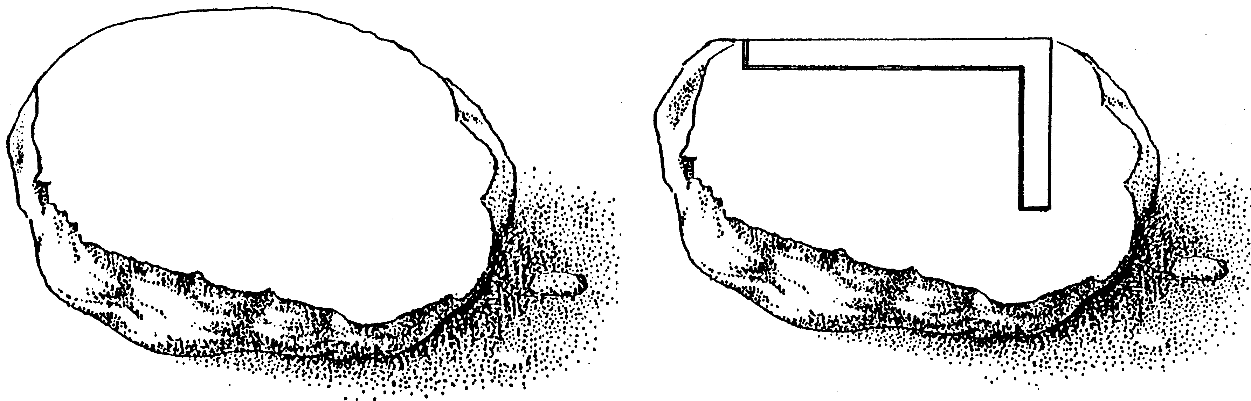

outward face

Figure 4.11: Stone dressing procedure

Stones from the riverbed are generally very hard and durable and can be used as filling stone, but are not suitable for stone dressing.

4.5.3 Stone Dressing
Broken stones from the quarry are to be dressed by hammer or chisel to required sizes. Depending on the function of the stone in stone masonry construction the following types of stones have to be prepared (Figure 4.12):

- Corner Stone: The corner stone is placed at each corner of the stone masonry structure.
Recommended sizes are:
Length : 30 - 85 cm
Width : min. 30 cm
Height : min. 10 cm
- Face Stone: Only one face of this stone faces outside; recommended sizes are:
Length : 30 - 75 cm
Width : min. 30 cm
Height : min. 10 cm
- Bond Stone: Like the face stone only one face is outside, but the bond stone extends to the interiors of the structure. Bond stones, also called through stones, go right through walls of up to 85 cm thick or more. Recommended sizes are:
Length : 45 - 85 cm
Width : min. 30 cm (face side)
Height : min. 10 cm
- Coping Stone: Copingstones are put on top or at steps of stone masonry structures. They should be larger and heavier than the stones below:
Length : as large as possible
Width : as large as possible
Height : min. 10 cm
- Filling Stone: Filling stones do not need to be dressed and are placed in the inner part of the stone masonry structure mainly to gain gravity load.

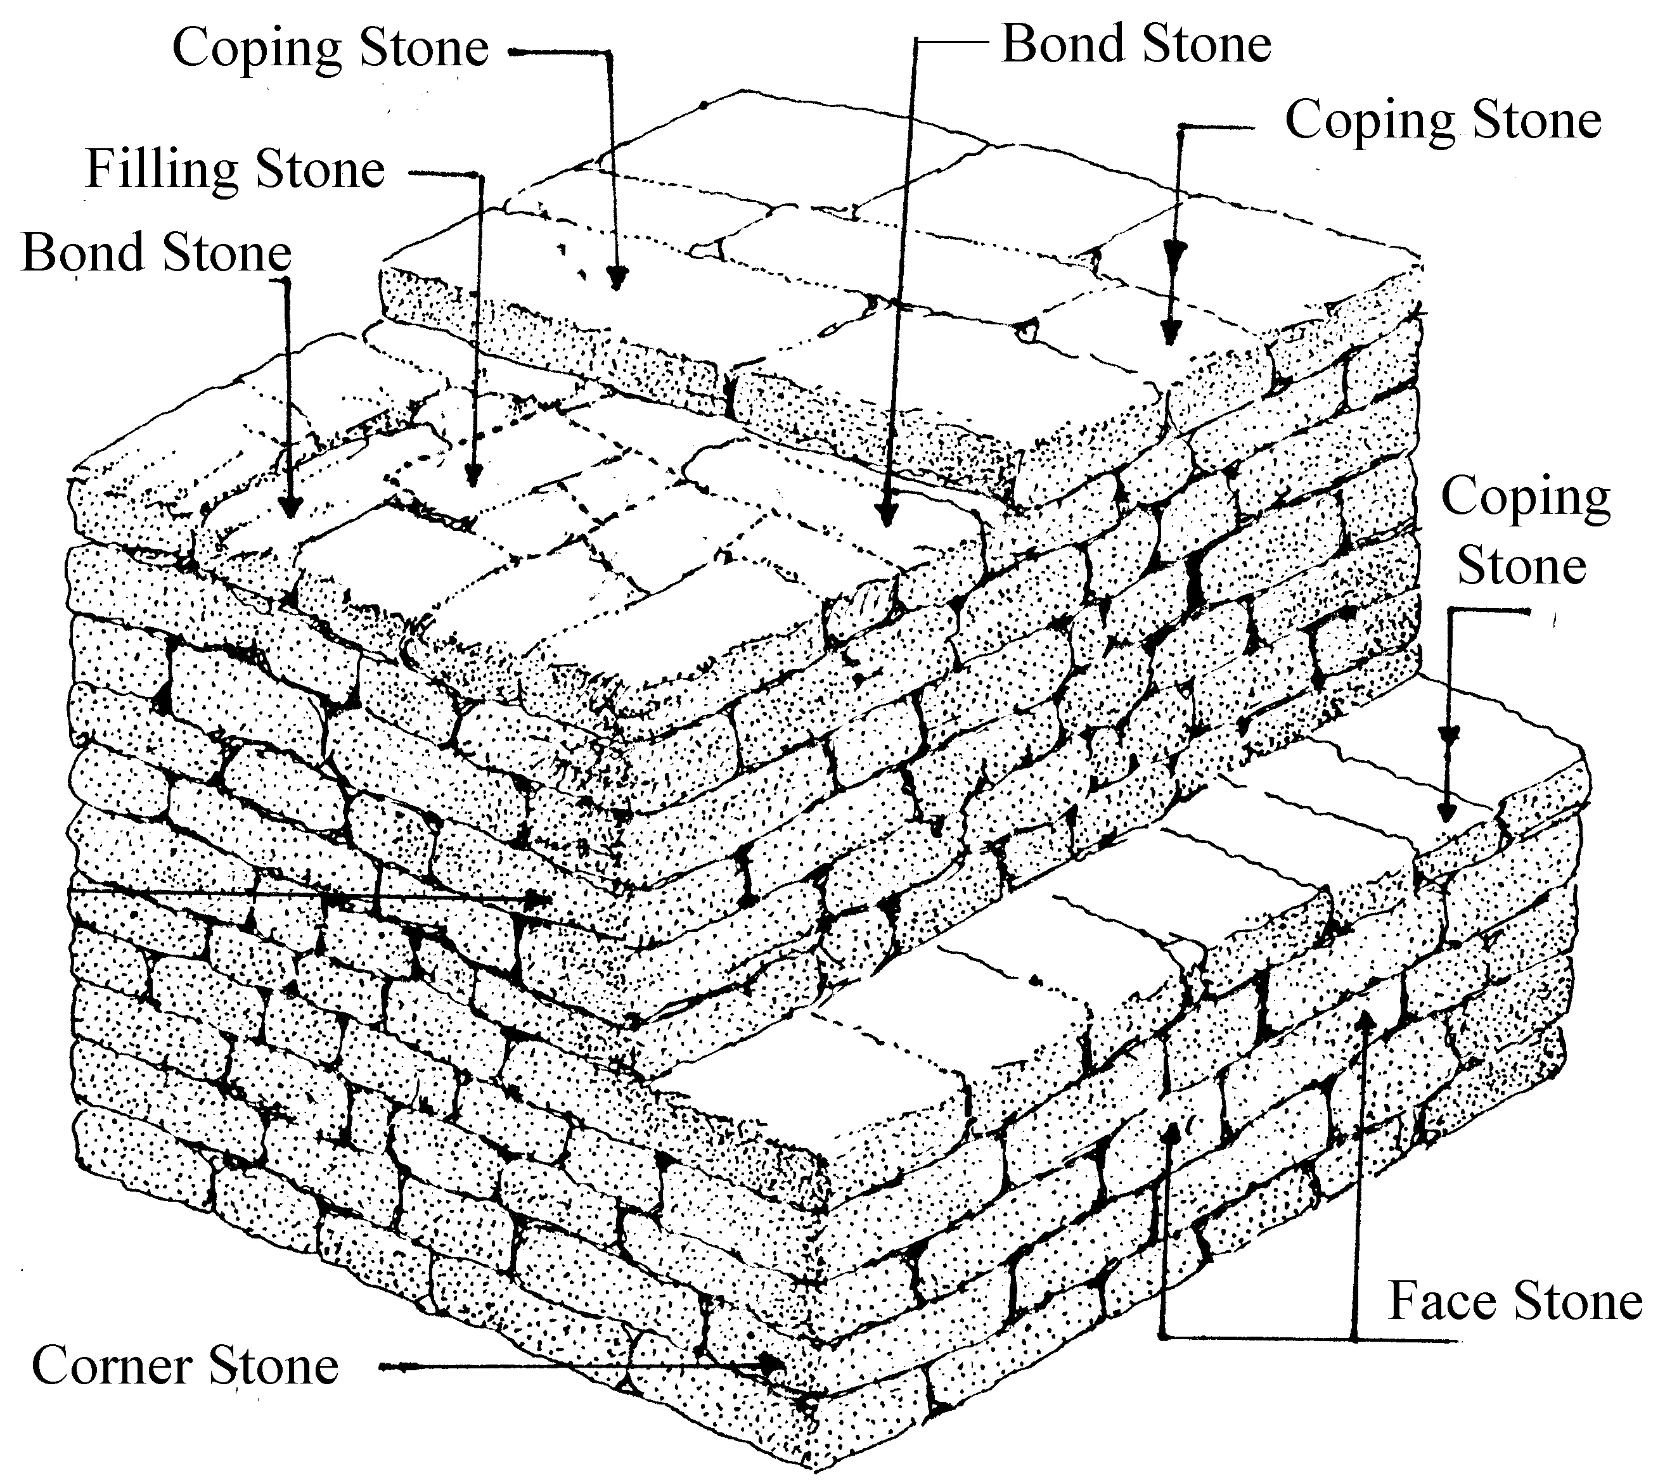
-afWg] 9'+uf_
-e?jf 9'+uf_
-5fFb 9'+uf_
-5fFb 9'+uf_
-afWg] 9'+uf_

-5fFb 9'+uf_

Corner Stone
-;'/sf] 9'+uf_

-k]6] 9'+uf_
-;'/sf] 9'+uf_

Figure 4.12: Stone types and uses.

4.5.4 Stone Masonry Laying
There are many different kinds and types of stone masonries. For constructing anchor blocks and towers, only coursed (in layers of equal height) stone masonry is applied.

There are two types of stone masonry used for bridge constructions:
- Coursed Random Rubble Stone Masonry
The stones are hammer-dressed, except the inside face. The gaps between the beds and joints shall not exceed 12 mm.
All Face Stones tail into the wall twice their height.

Bond Stones running right through the wall are inserted at 150 cm intervals, in the least.
- Coursed Block Stone Masonry
The stones are chisel-dressed on all faces, except the inside face. Joints are dressed at right angles to the face. The gaps between beds and joints should not exceed 6 mm.

All Face Stones tail into the wall twice their height.

Bond Stones running right through the wall are inserted in each course at least at 150 cm intervals.

Course Stone Masonry must be made in layers of equal height. The individual layer heights may vary but should never be less than 10 cm. Alternate joints shall be made between the layers above and below as shown in the following sketch (Figure 4.13).

alternate joints
joints
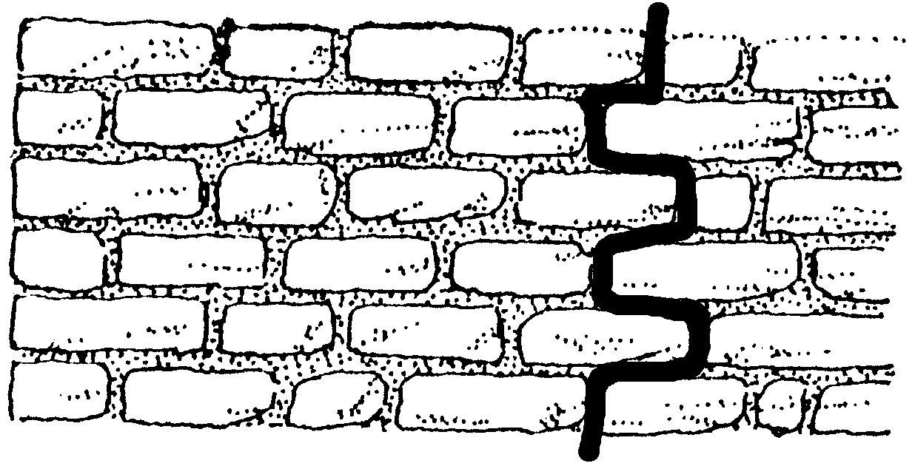

layer

beds

max 150 cm
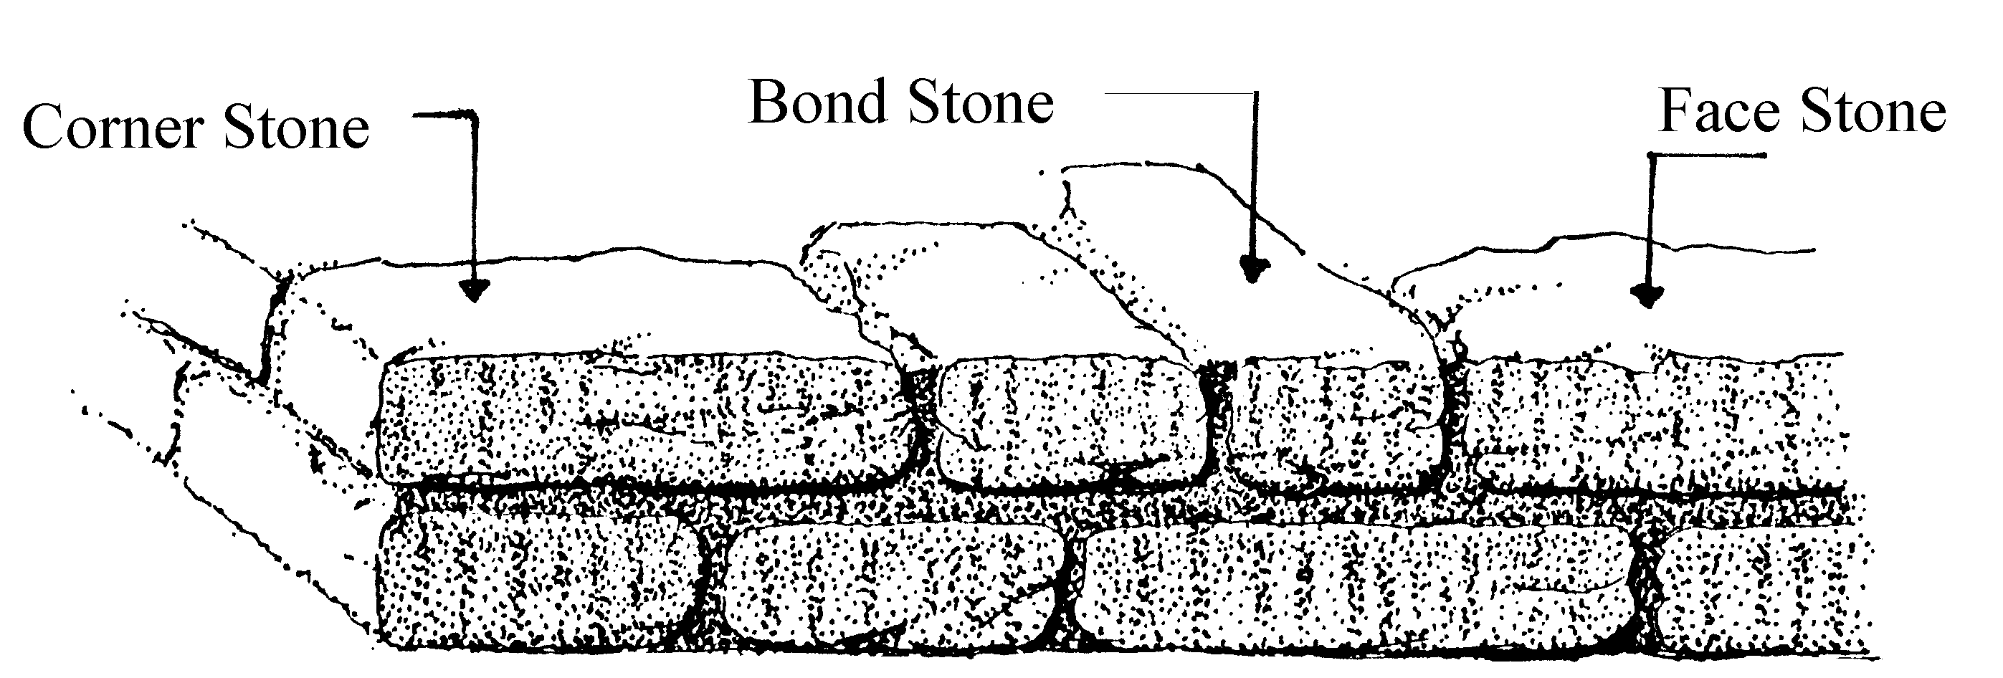

Figure 4.13: Laying of stone for masonry

In a reasonably well made stone masonry the inner friction between the beds amounts to approx. 35°.

The verification of corners as well as faces has to be checked carefully with a plumb-bob (Figure 4.14).
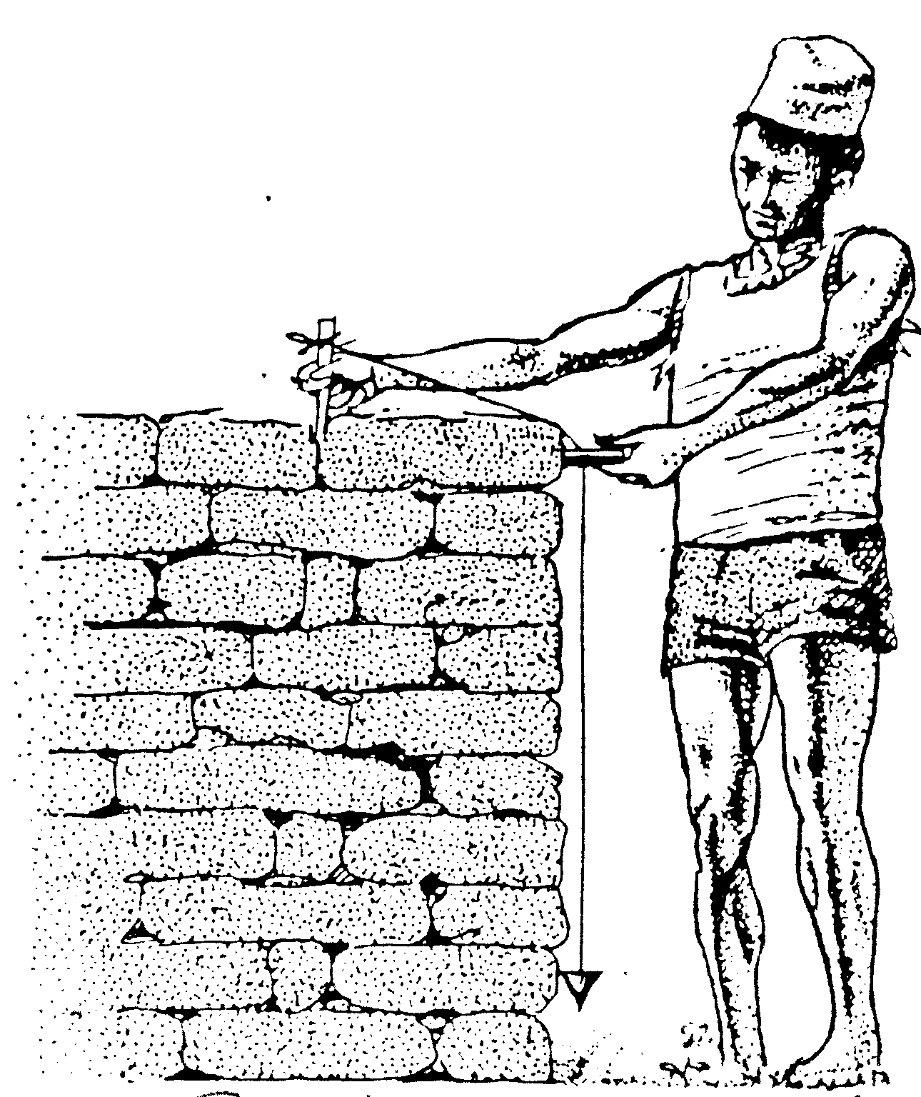
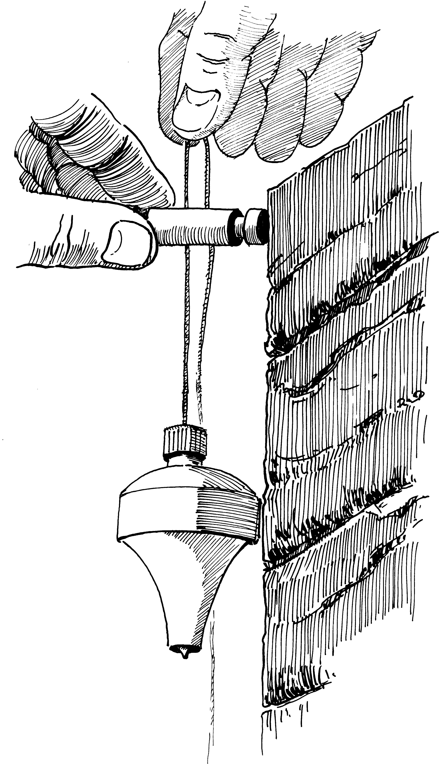

correct use

of

plumb-bob

Figure 4.14: Verification of face and corner of stone masonry works

The Strength of stone masonry structures depends mainly on the qualities shown in the table below (Table 4.1).

Table 4.1: Dependency of strength of stone masonry works

…greater… | The Strength of Stone Masonry is… |  |  | …lower…
…with rectangular stones. |  | Form or  Shape |  | …with irregular stones.
…the less stones are used. |  | Number |  | …the more stones are used.
…the rougher the joints are. |  | Roughness of joints |  | …the smoother the joints are.
…the smaller the beds are. |  | Bed |  | …the bigger the beds are.
…the more  compact the stones are. |  | Height & Width |  | …the slimmer the stones are.
…the better the bond across is. |  | Bond Across  (in plan view) |  | …the worse the bond across is.
…the higher strength of the mortar is. |  | Strength of Mortar |  | …the lower the strength of the mortar is.

4.6 Cement Works

4.6.1 Composition and Mixtures
Cement concrete is a mixture of following four components:
- Cement
- Sand
- Gravel
- Water

Cement is very sensitive to humidity and moisture; therefore it should never be stored for a long time. Ordinary Portland Cement (OPC) is commonly used for general construction works. In the rainy season cement bags have to be packed in additional sealed plastic bags plus additional nylon bags for protecting the cement against water and the plastic bags against damage.

Sand should be clean, sharp, angular, hard and durable. Sand must be well washed and cleaned from mud or any organic material before use. Well-graded sand should be used for cement works. All or most of the sand should pass through a 3 mm sieve or mesh wire. However sand should not be too fine, only max. 15% of the sand can be smaller than 150 microns, which is like dust.

Gravel should be clean, hard, angular and non-porous. Usually riverside gravel makes the best aggregate for preparing concrete. The corn size of gravel should be smaller than 40 mm (1½ inches) but bigger than 5 mm.

Water from rivers or lakes is usually suitable for making cement mixtures. Do not use water from ponds or swamps; this water may contain a lot of organic materials.

The main characteristics of any cement work is given by the mix proportions of their components:

- Cement Mortar = Mix between Cement & Sand
- Cement Concrete = Mix between Cement, Sand & Gravel

Of course, Water is added in both cases, but the mix proportions of cement, sand and gravel give the main characteristics of any cemented work.

Mixing the above components thoroughly is of utmost importance. Hand mixing should be done on a clean watertight platform. Cement and Sand should first be mixed dry, and then gravel added. Now the whole mixture should be turned over 3 times dry. Then mixing should be done for at least 5 minutes by slowly sprinkling water until the concrete is of a uniform color.

The table below (Table 4.2) depicts the most commonly used mix proportions and required quantities:

Table 4.2: Quantities for various Types of Cement Works

Type of  Cement Work | Mix. proportions  Cement : Sand : Gravel | Dry required quantities for one cubic meter wet:
Type of  Cement Work | Mix. proportions  Cement : Sand : Gravel | Cement bags @ 50 kg | kg | Sand [m³] | Gravel[m³] | Stones or Boulders [m³]
Cement  Mortars | 1 : 1 -  1 : 2 -  1 : 3 -  1 : 4 -  1 : 6 - | 20.4  13.6  10.2  7.6  5.0 | 1020  680  510  380  250 | 0.71  0.95  1.05  1.05  1.05 | -  -  -  -  - | -  -  -  -  -
Cement Plaster  (20 mm includes 12% waste) | 1 : 4 -  1 : 6 - | 0.18  0.12 | 9  6 | 0.024  0.024 | -  - | -  -
Cement Stone Masonries | 1 : 4 uncoursed  stone  1 : 6 masonry | 2.66  1.75 | 133  87.5 | 0.37  0.37 | -  - | 1.2  1.2
Cement Stone Masonries | 1 : 4 coursed  stone  1 : 6 masonry | 2.28  1.50 | 114  75 | 0.32  0.32 | -  - | 1.25  1.25
Cement  Concretes  (plain or  reinforced) | 1 : 4 : 8  1 : 3 : 6 (M10)  1 : 2 : 4 (M15)  1 : 1½ : 3 (M20) | 3.4  4.4  6.4  8 | 170  220  320  400 | 0.47  0.46  0.45  0.42 | 0.94  0.92  0.90  0.84 | -  -  -  -
"Plum" Concrete | 1 : 3 : 6  with 50% boulders | 2.64 | 132 | 0.28 | 0.54 | 0.50
Source: Indian practical Civil Engineers' Handbook, Section 20

The amount of Water should be about 50% or half the volume of cement. One 50 kg bag of cement has a volume of approx. 35 liters, which is equal to approx two kerosene tins.

Concrete and Mortars should be placed in its final position within one hour! After placing it should be well compacted by rods in order to remove any air pockets. For a concrete of high quality good compaction is essential. This may mean extra work during placing, but on no account should more water be added for reducing compacting work. Concreting should never be done if it is raining.

Curing means keeping completed cement works wet until its setting process is completed. If concrete works are not continuously kept wet during its setting process, cement mortars, cement stone masonry work and especially concrete does not develop its full strength. Curing should be done for at least 28 days.

For increasing the strength of concrete, ripped Tor-Steel bars are added which makes Reinforced Cement Concrete or RCC.

4.6.2 Concrete Work for Cement Stone Masonry (CSM) Towers
The CSM Towers or Limb Walls are concreted together to form one solid unit (See Drawing Nos. 20Dcon70 & 20Dcon106). The core and the connection of both the towers are made in R.C.C 1:2:4, whereas the limb walls are made in CSM 1:4 (Figure 4.15).

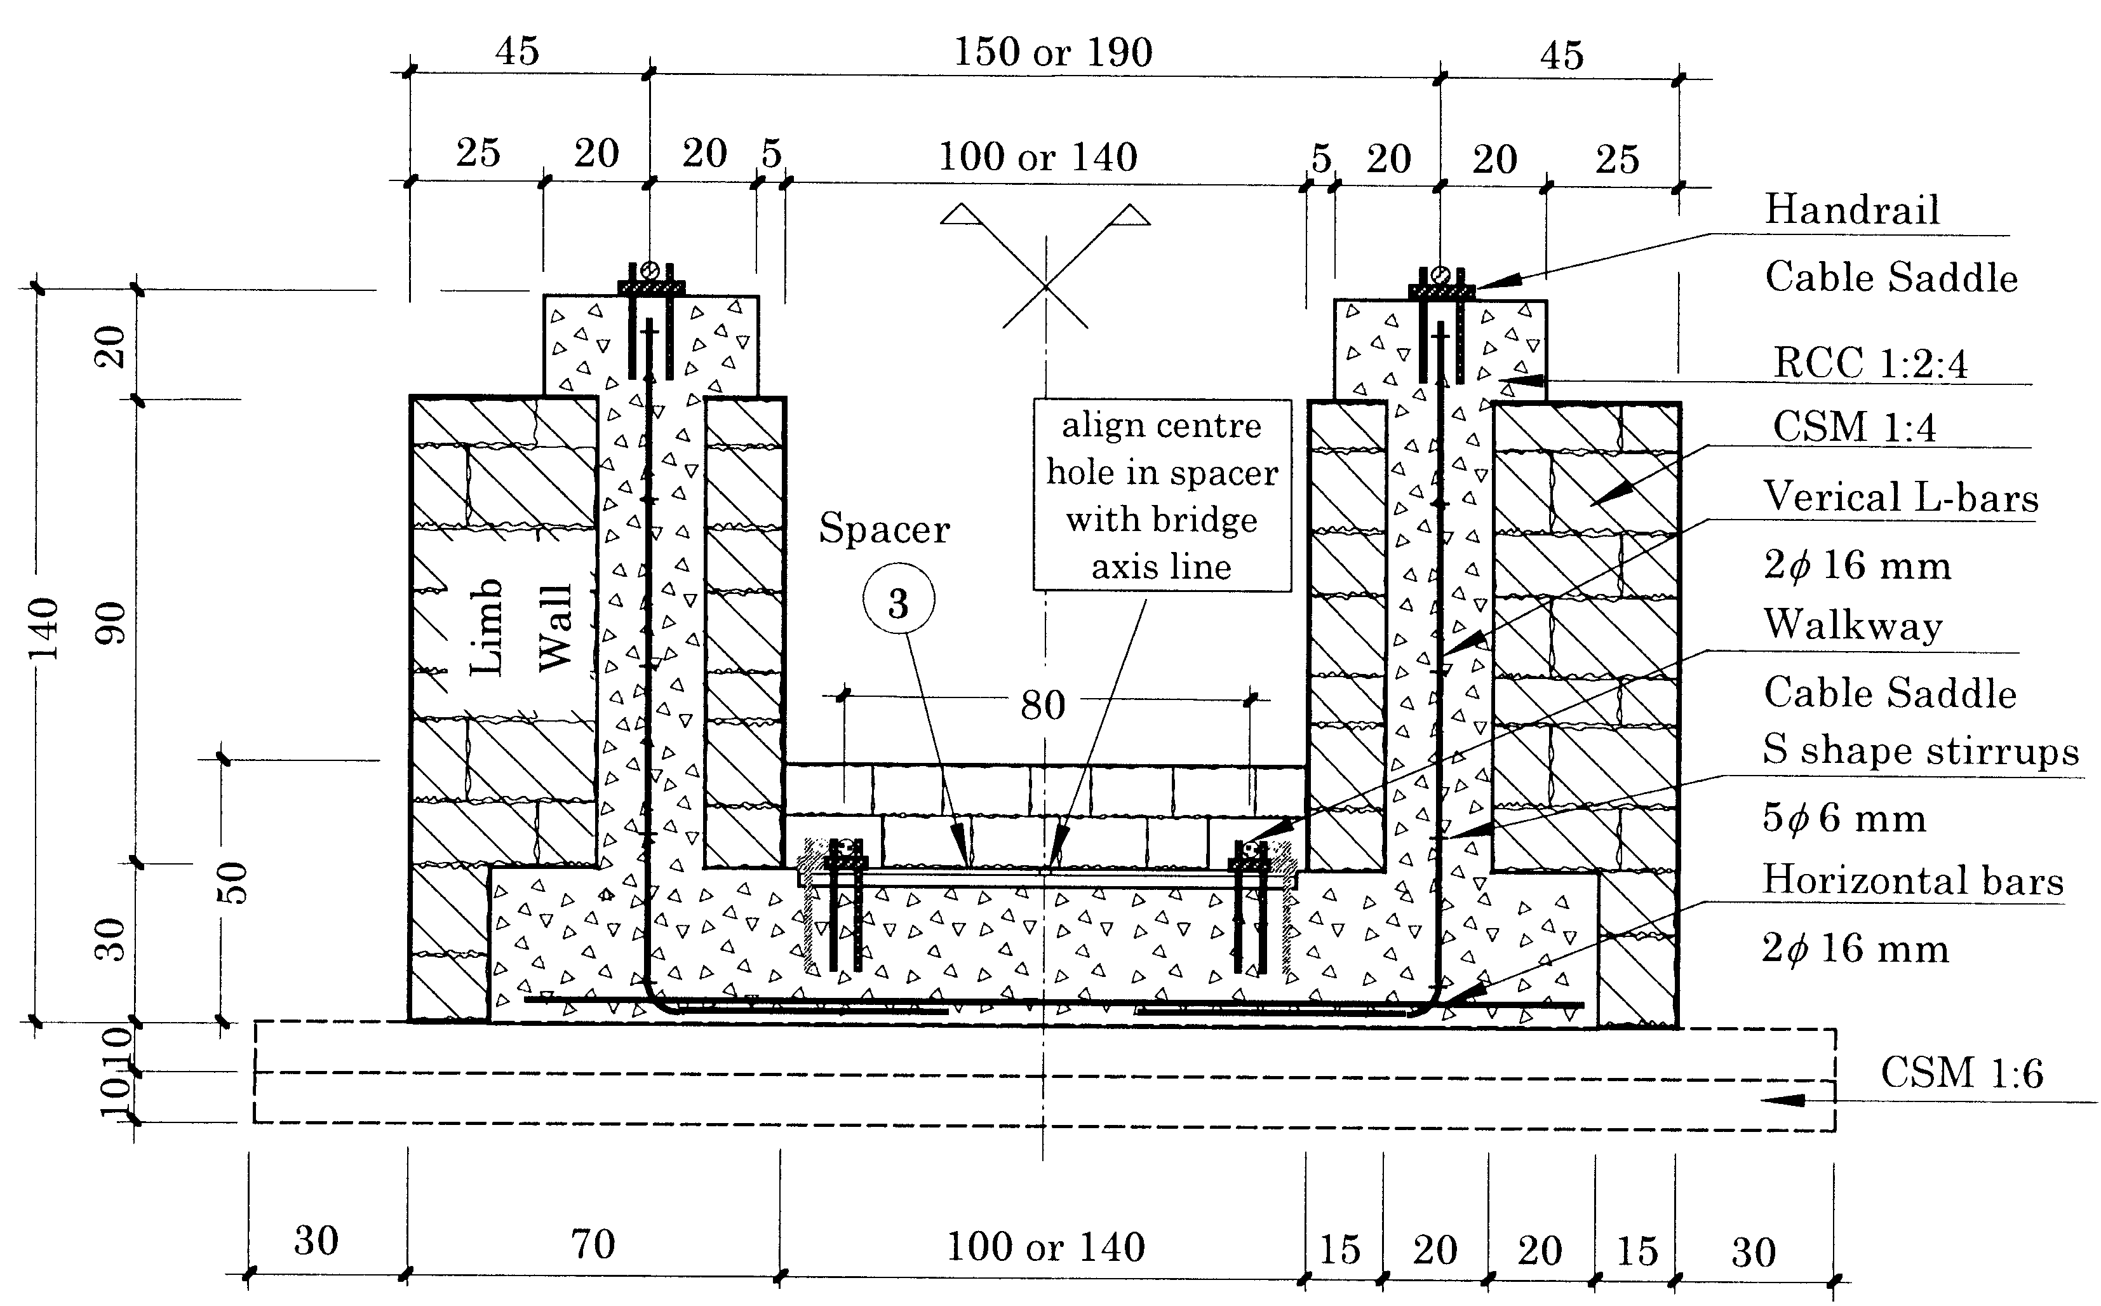
Figure 4.15: Section through CSM Tower (Bridge Entrance)

- Placing the Saddles for the Walkway Cables
The saddles for the walkway cables are to be placed in between the towers. The position of the saddles has to be checked thoroughly and the levels can be controlled with the help of a transparent plastic pipe filled with water (Level Pipe) (Figure 4.16a &b).

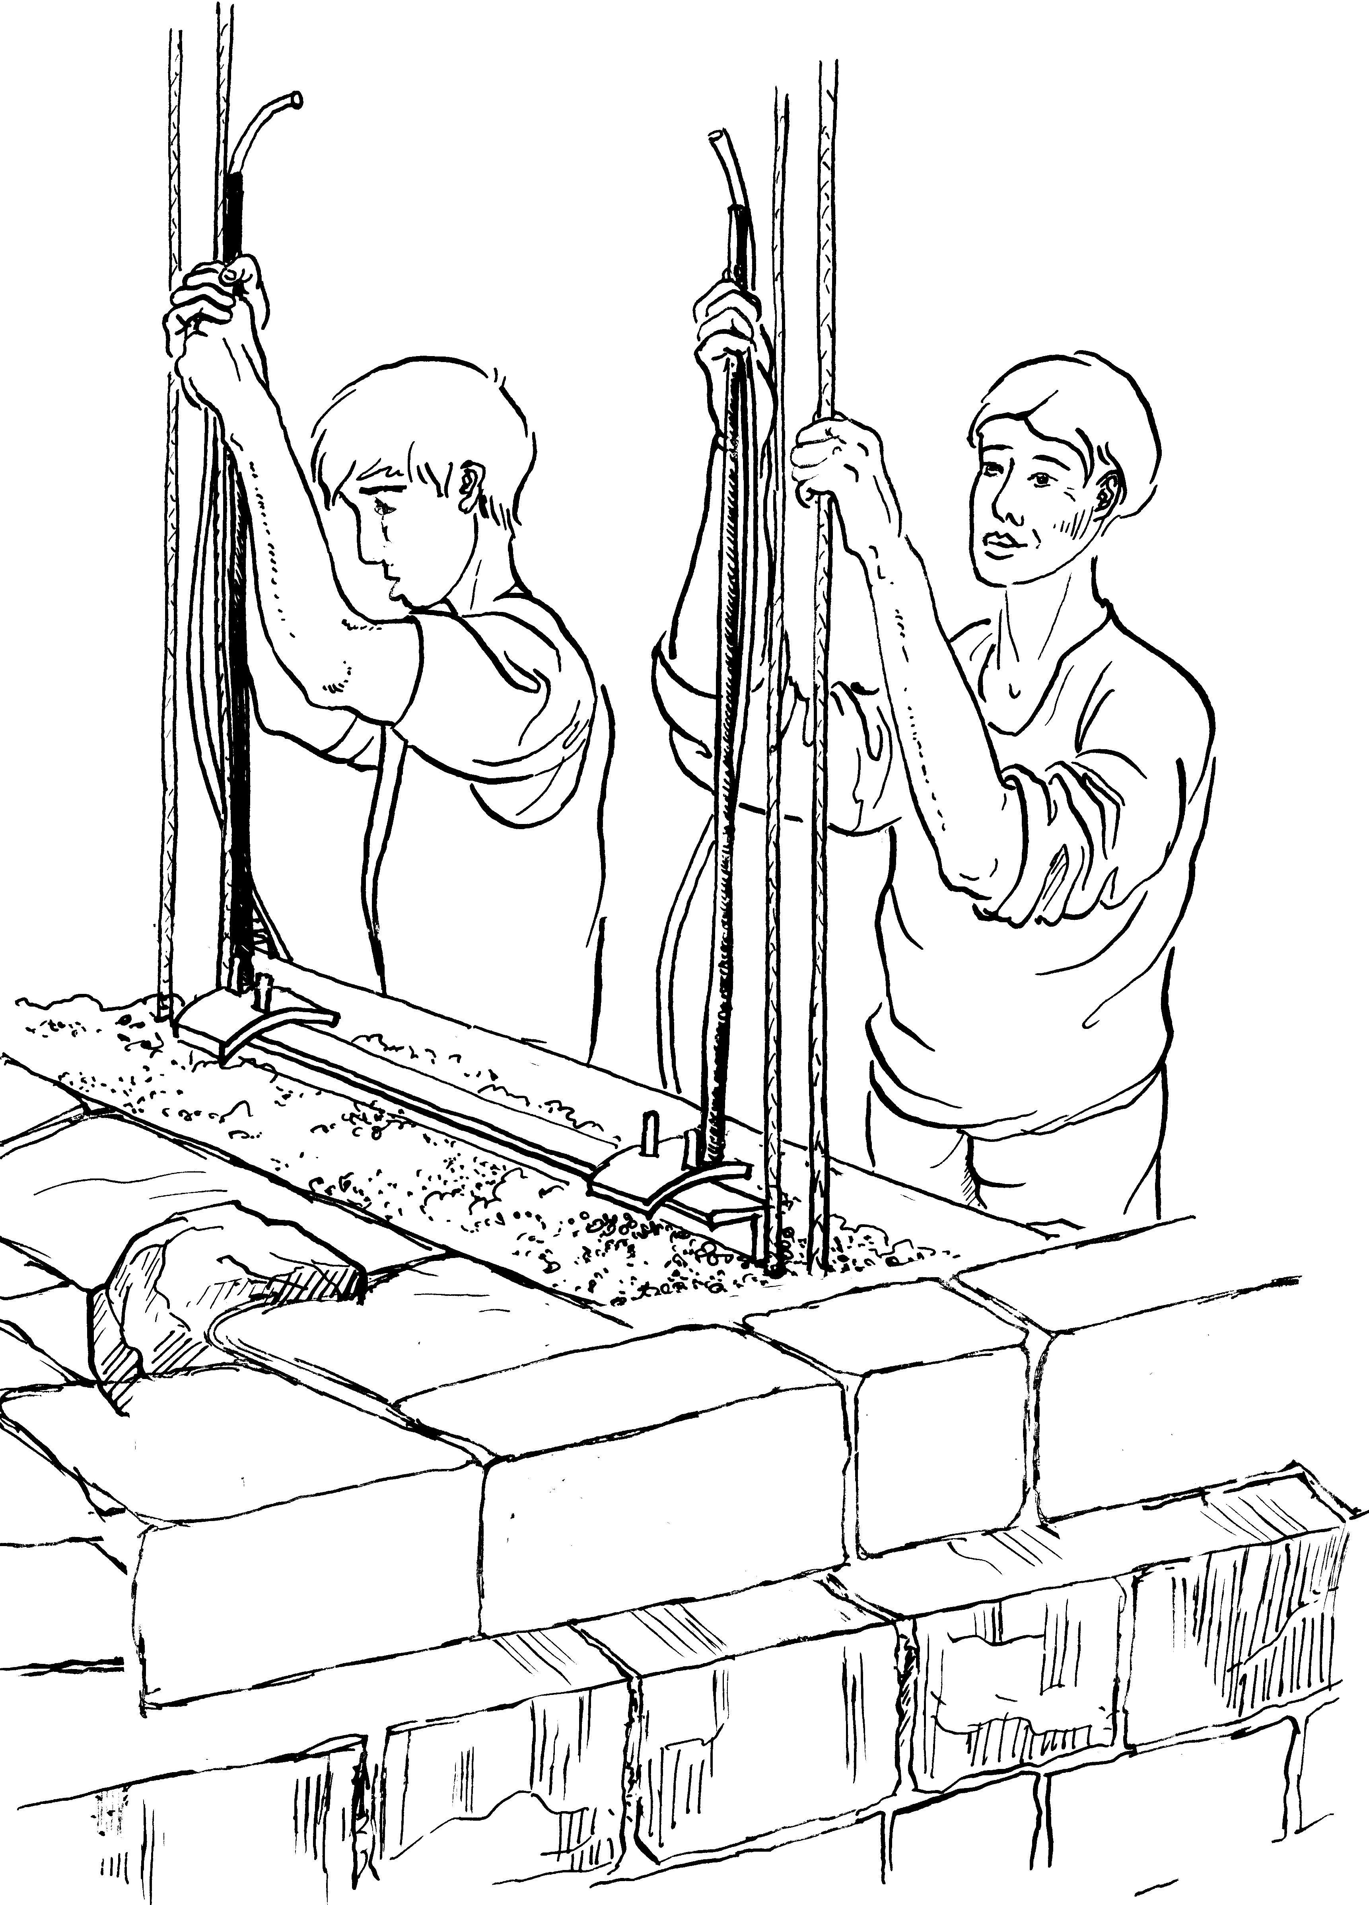
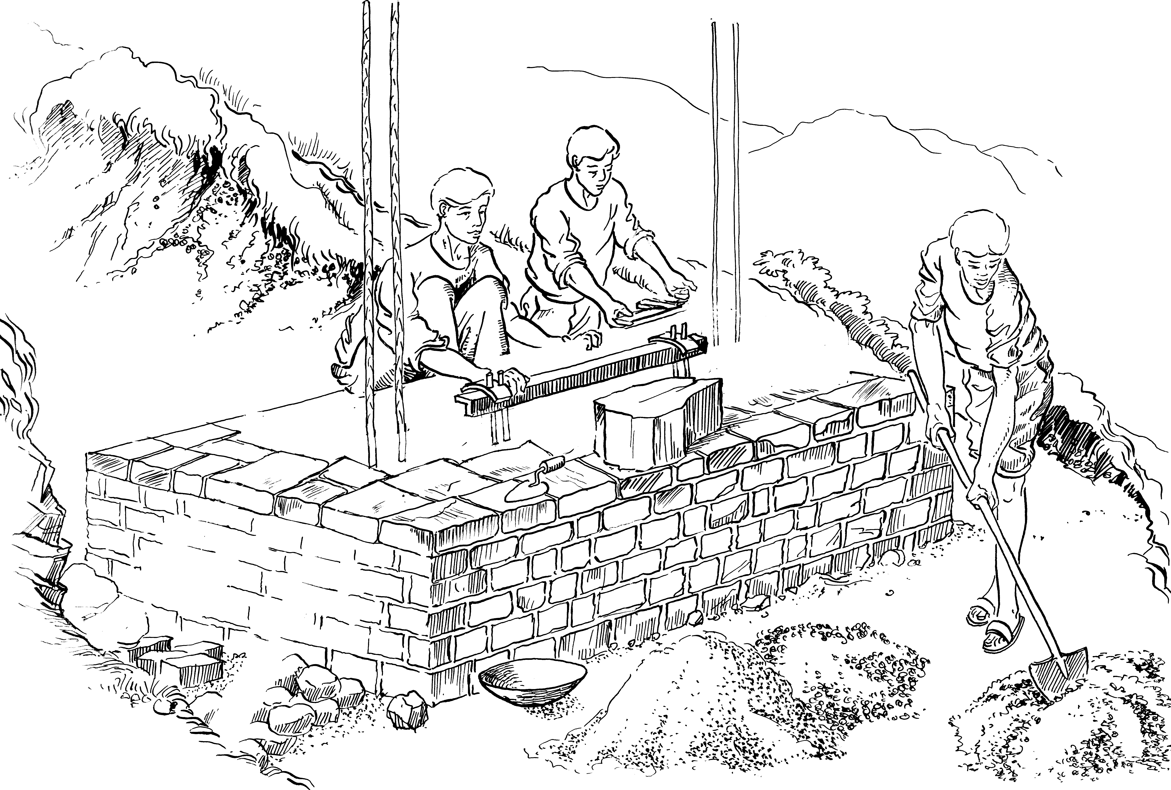

4.16a: Concreting Work for CSM Tower 4.16b: Checking Level of Walkway Cable Saddle

- Construction of Towers and Placing Saddles for Handrail Cables
The Towers or Limb walls support the handrail cables. The limb walls are made out of cement stone masonry 1:4 with a R.C.C. core (Figure 4.17).

The handrail cable saddles are to be placed on top of the "hump" of the limb wall. Make sure that the position and shape of the "hump" is correct so that the handrail cable touches the saddle plate only.

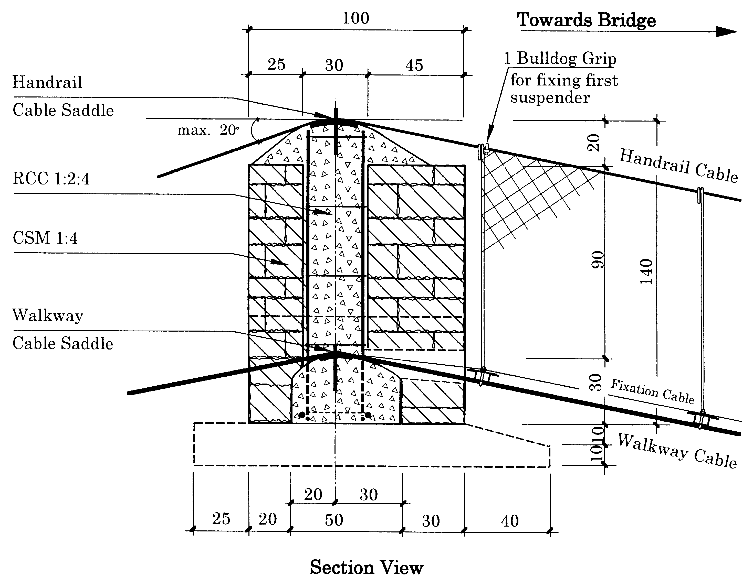
Figure 4.17: Section view of the tower

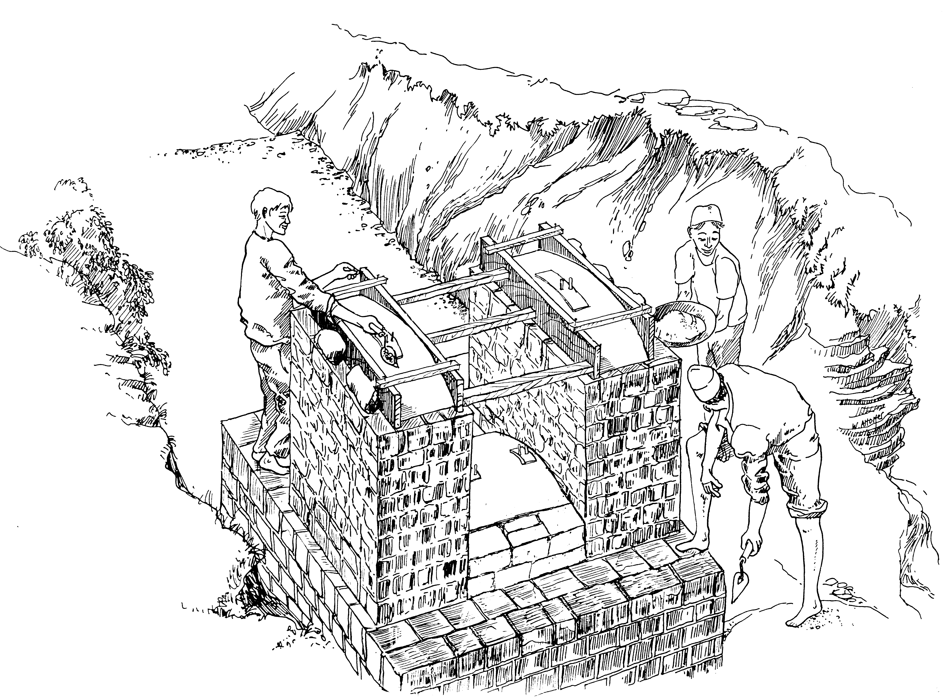

Figure 4.18: Finishing off the CSM Tower

4.6.3 Constructing the Deadman Beam
The Deadman Beam is a soil anchor cast in reinforced cement concrete R.C.C that lies buried under the gravity structure. The handrail and walkway cables are placed around the reinforcement bars before concreting the beam. At one bank the cables are inserted into a polyethylene (PE) pipe, so that the cables can still be moved when the sag setting (See Chapter 4.7). The tensioning cable must be tightened with the bridge of the bulldog grip. Use leftover plastic or cloth from cement bags to cover open parts of the pipe so that no concrete can flow into the pipe (figure 4.19a,b &c).
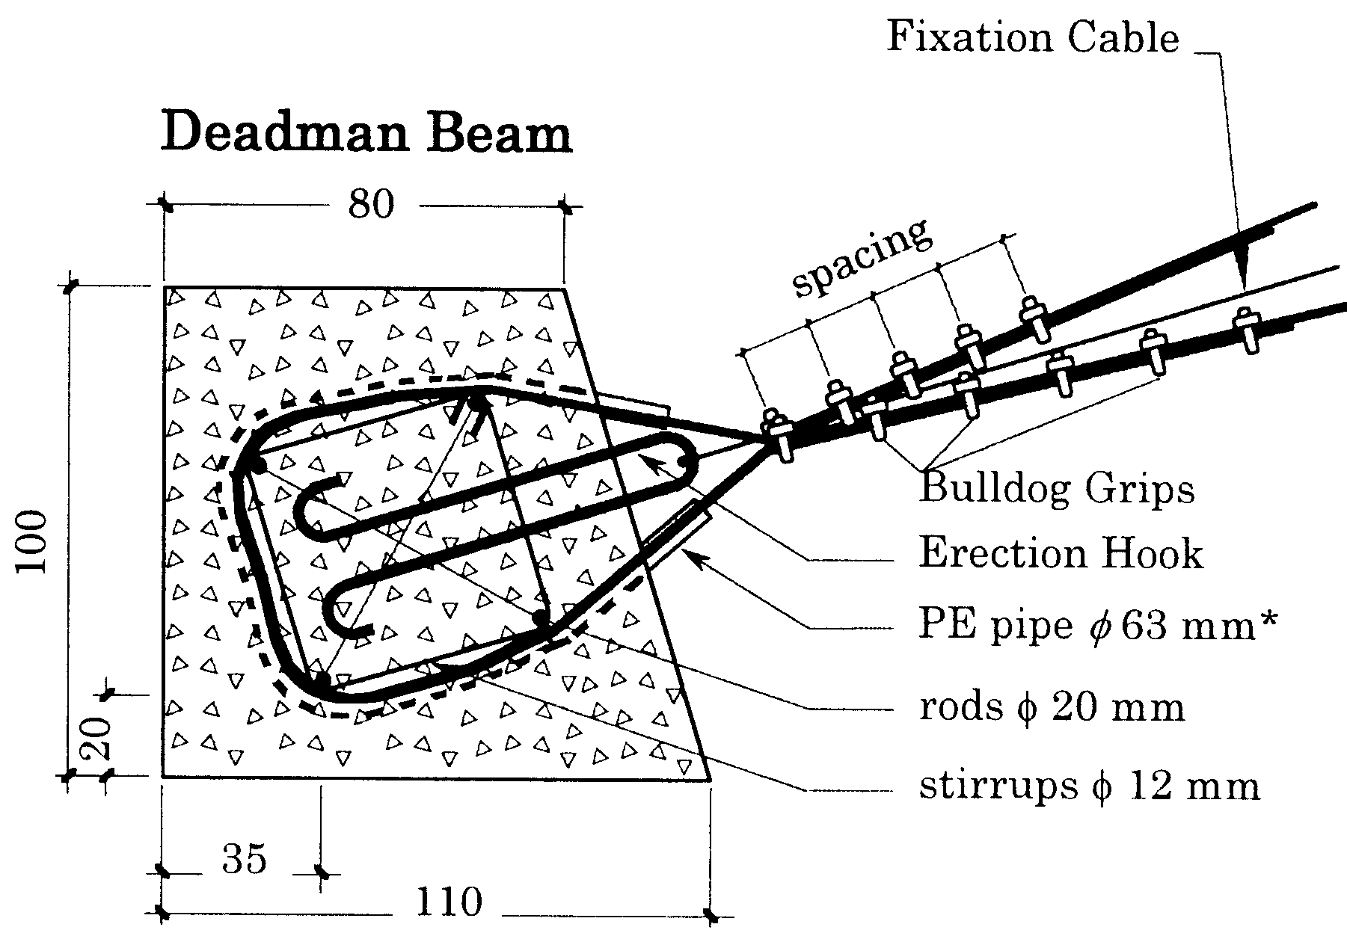

The PE pipe has to be cut by two thirds
at several places so that it can easily
be bound around the reinforcement bars.

The PE pipe can also be bent by
Preheating it before bending. Figure 4.19a: Construction of deadman beam

Nos & spacing of Bulldog Grips
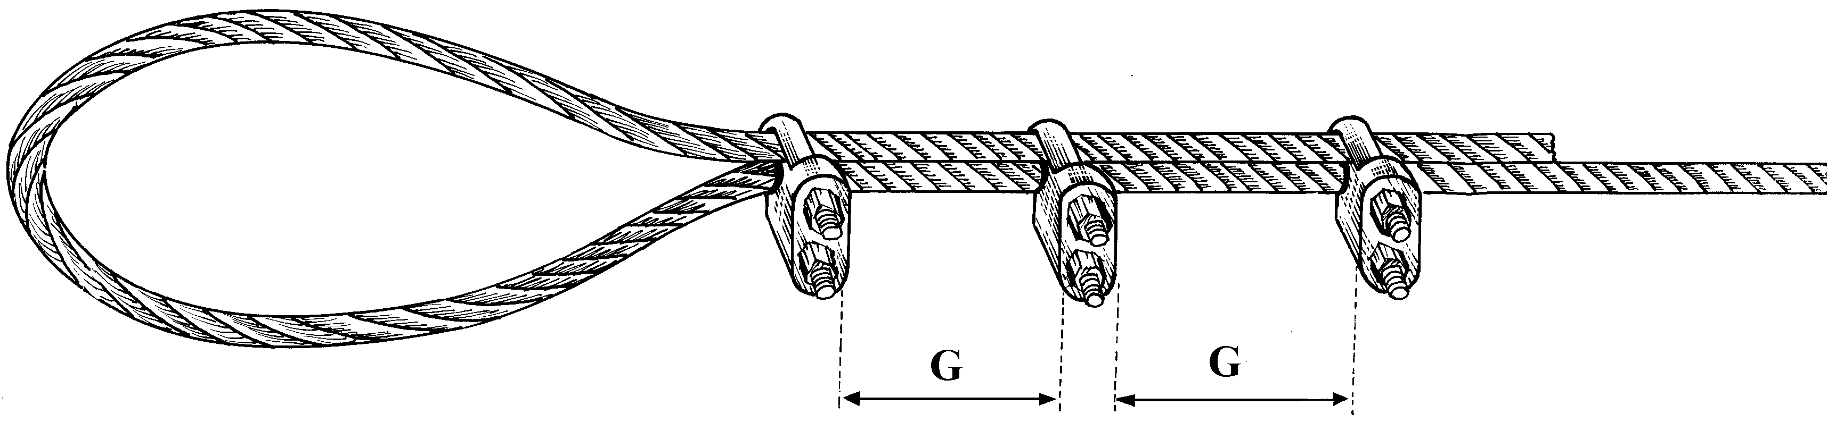
Cable  mm | Nos | G
13  26  32 | 3  5  6 | 10 cm  15 cm  20 cm

Figure 4.19b: Cable terminal with Buldog grips.

Place and Fix Reinforcement Bars, Stirrups and Erection Hooks as Shown in Respective Drawings.
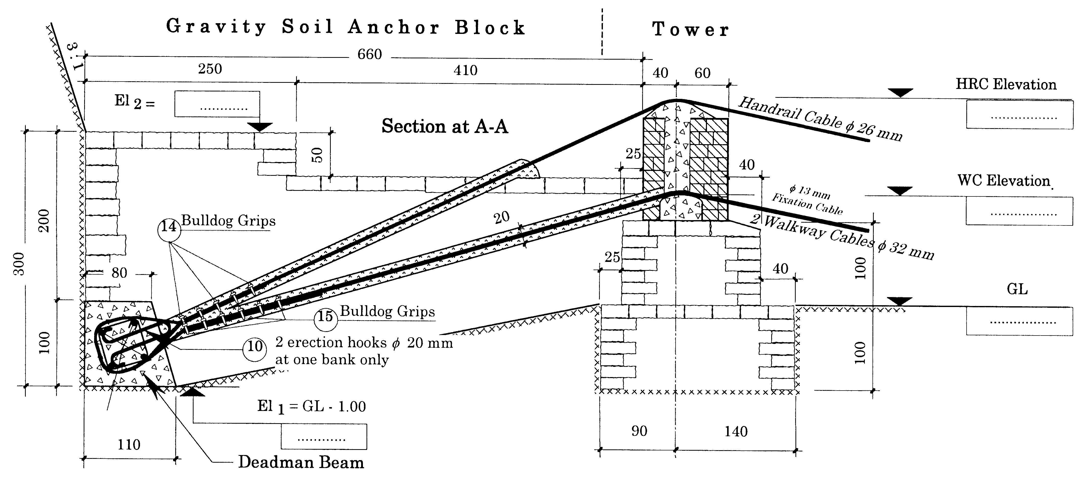
14
15
10
The Deadman Beam is cast in concrete 1:2:4

Figure 4.19c: RCC Deadman and Gravity Anchor Block.

The fixation cable can be anchored at the temporary erection hook or fixed at one of the walkway cables.

4.6.4 Constructing Drum Anchorages in Rock
There are two types of Drum Anchorages in Rock (Figure 4.20):
- R.C.C Drum Anchor in Hard Rock
- R.C.C Drum Anchor in Soft or highly fractured Rock

Drum Anchorages in Hard Rock are made by drilling holes of 32 mm diameter ( = diameter of crowbar) into the rock. Clean the boreholes of dust and debris by flushing them with water.

Fill the holes with cement mortar 1:1 before the anchor rods are inserted.

The formwork for the drum is made by a chitra (bamboo mat) or plain G.I. sheet inside lined with a plastic sheet.

Use binding wire around the chitra to prevent the bamboo mat bulging during concreting.

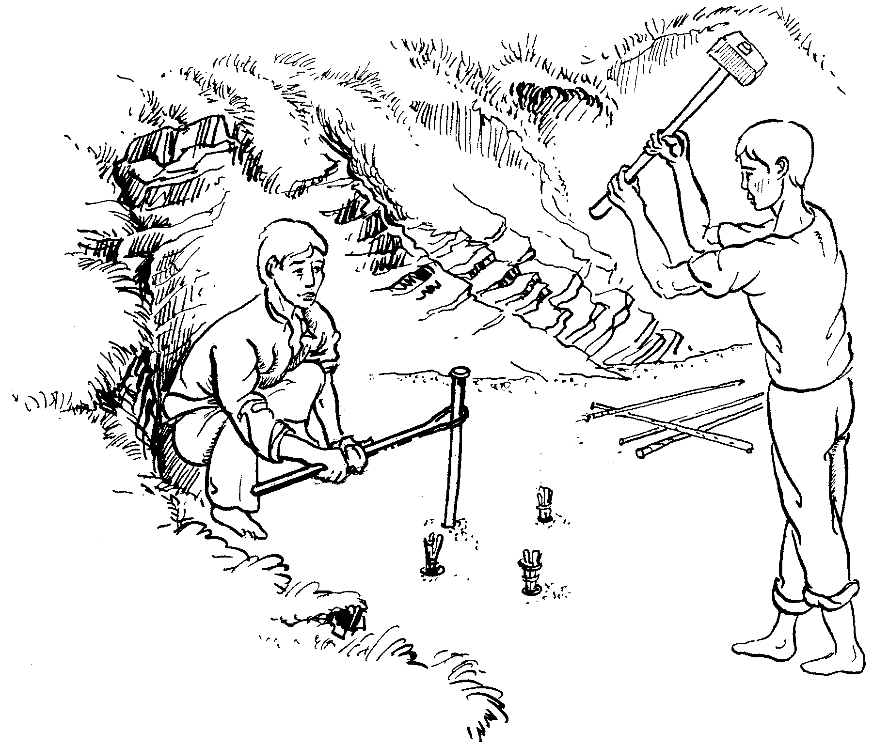

Drilling starter holes (up to 1 foot) for Anchor Rods of a Drum Anchorage in Hard Rock.

Rotate chisel from time to time.

Use crow bar for making holes deeper.

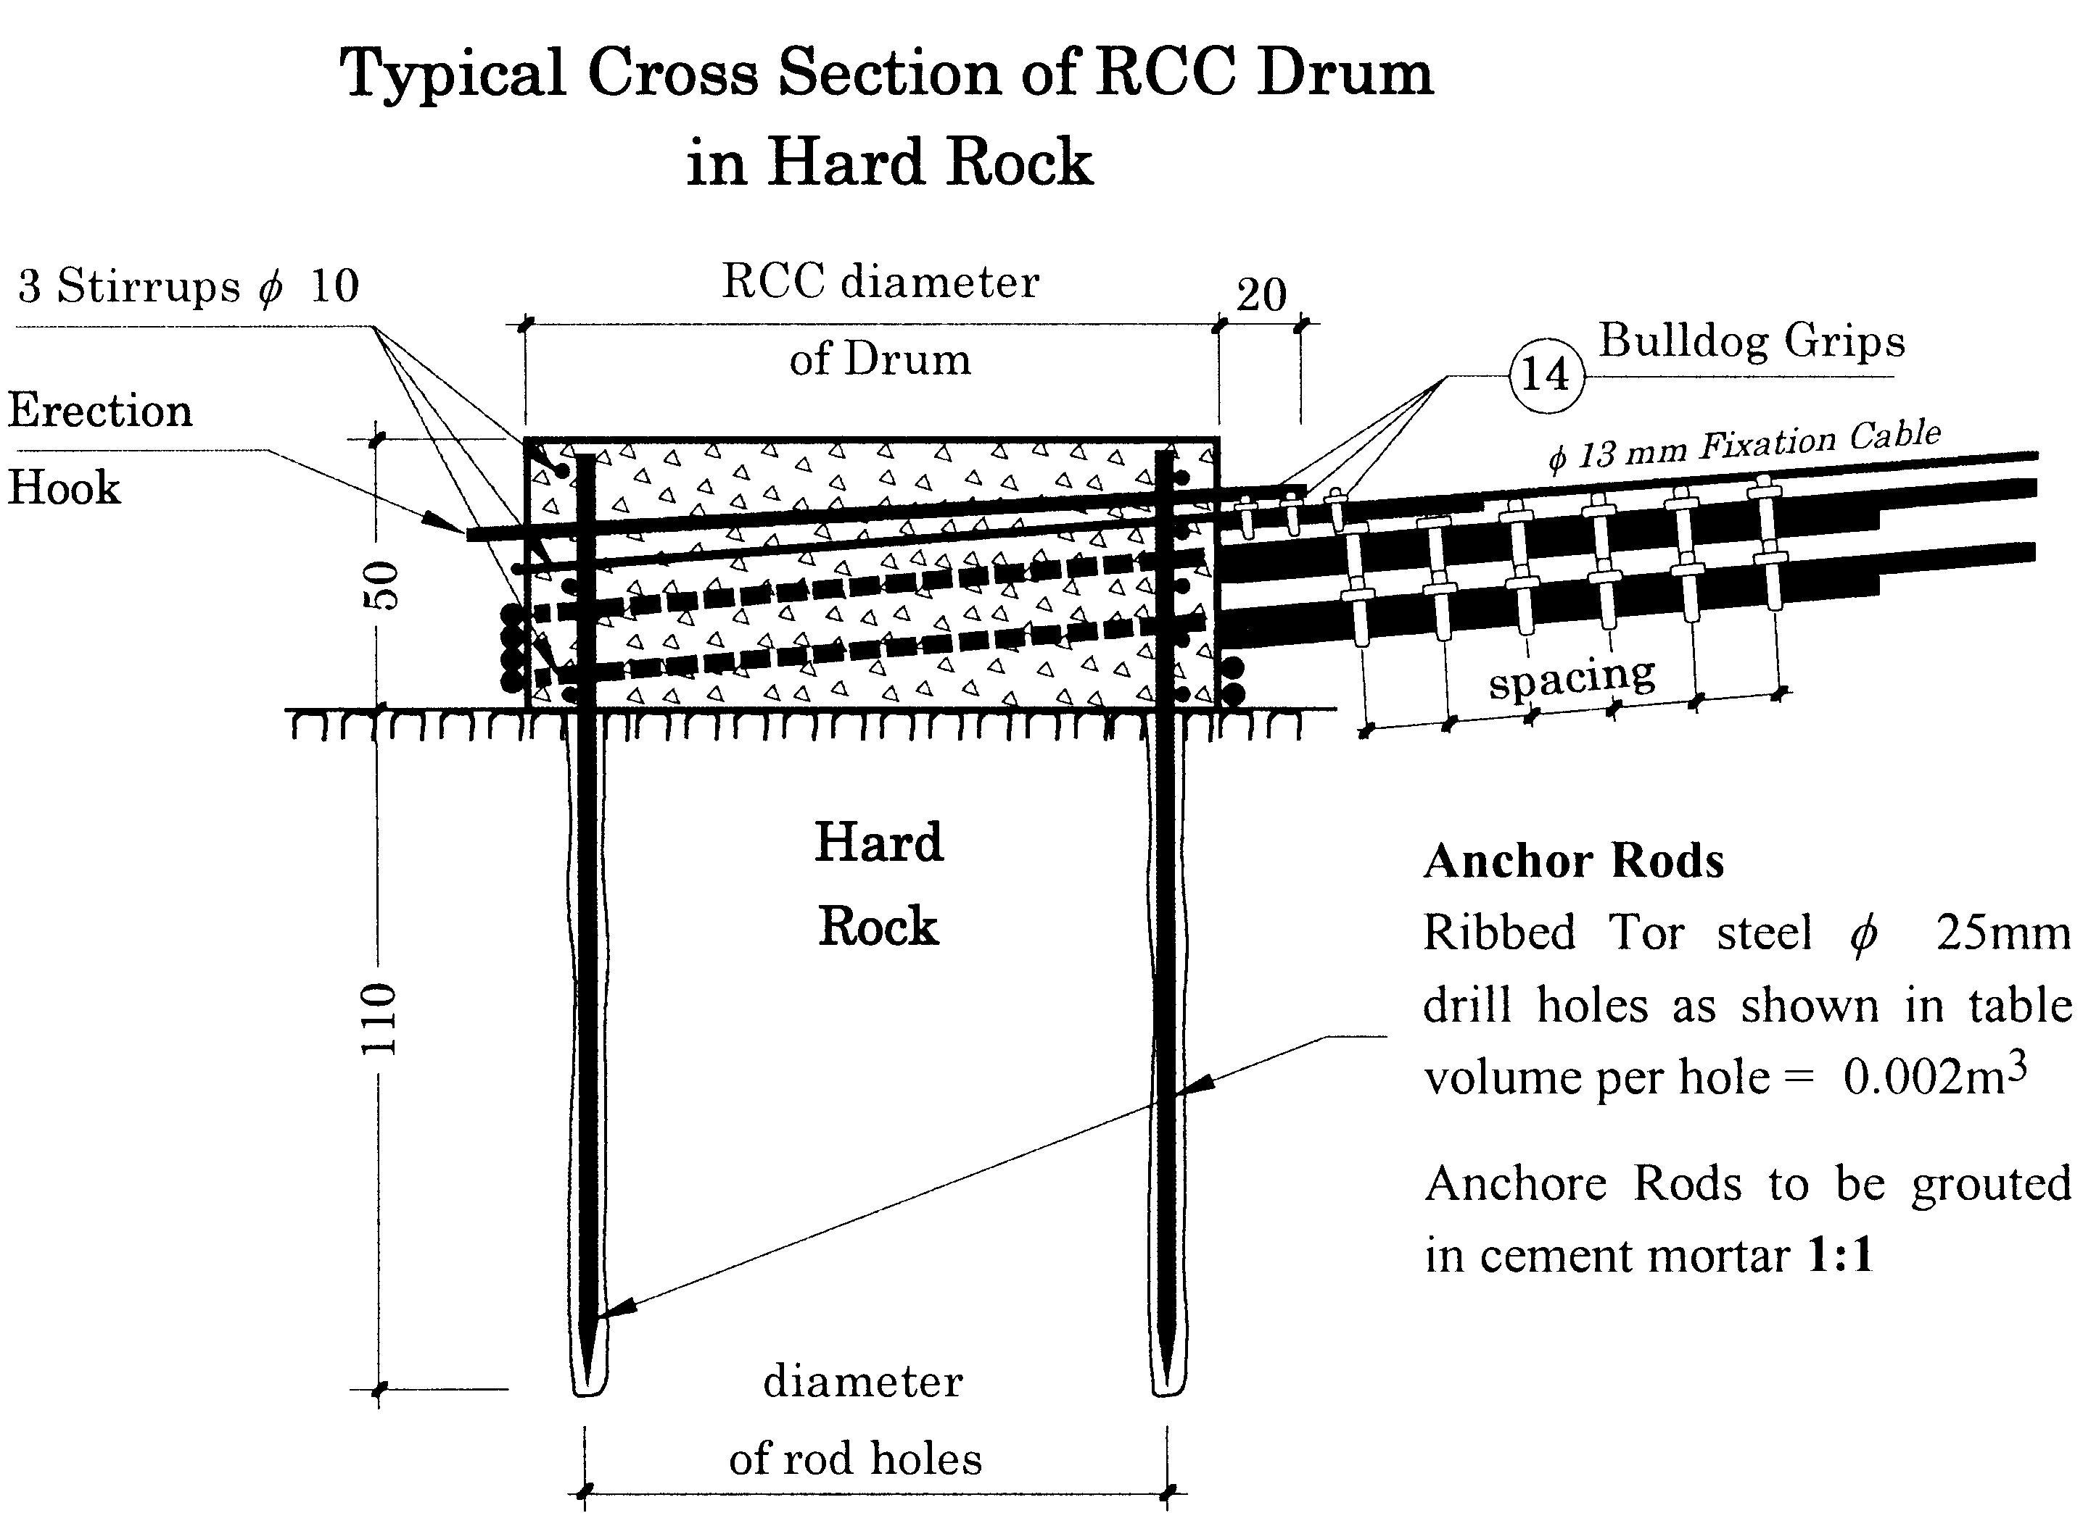

Figure 4.20:Anhor holes & Construction of drum anchorages

Drum Anchorages in soft or fractured Rock are not done by drilling holes but by excavating a round pit instead. The Anchor Reinforcement has to be placed into the pit and is fixed with the help of stirrups. The excavated pit is then filled and well compacted with concrete 1 : 2 : 4 up to the ground level. At this stage, the anchor rods should protrude (stand out) by approx. 40 cm. The formwork for the drum is made by a CHITRA (bamboo mat) inside lined with a plastic sheet bound together with binding wire.
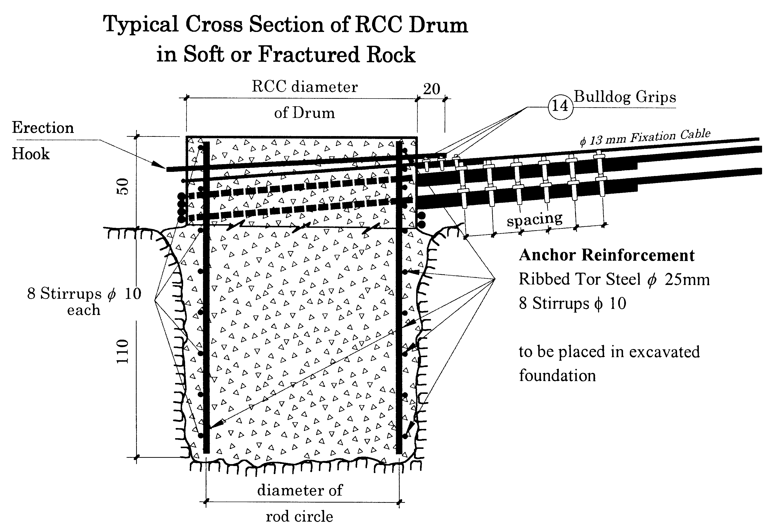

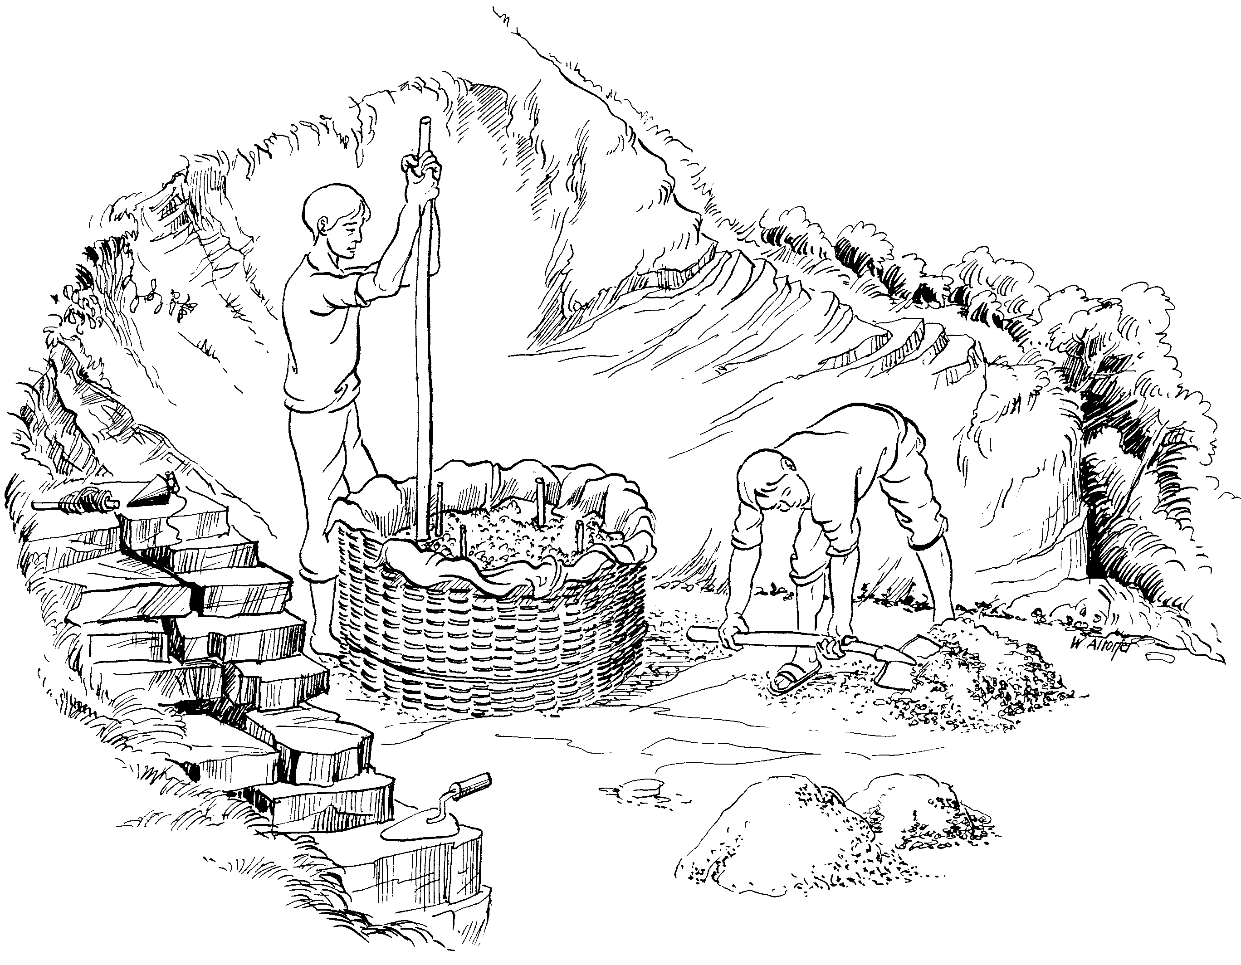

Concreting of a Drum Anchorage

Figure 4.21: Drum anchorage in soft or fractured rock: Typical section and concreting

4.7 Cable Hoisting and Sag Setting
Cables are hoisted and the prescribed sag set after the Deadman Beams (see 4.6.3) or the Drum Anchors (see 4.6.4) have been concreted. Please note that it takes 4 weeks until cast concrete develops its full strength. Therefore, the final cable pulling is done after a minimum of 4 weeks.

4.7.1 Calculation of Hoisting Sag
Before starting any hoisting work, the actual span l from saddle to saddle of the bridge and the actual difference of elevation h between the walkway cable saddles have to be measured first and filled into Form No. 2 Chapter 1D in the Volume II of this manual:

Calculation of Hoisting Sag (Figure 4.22 and Table 4.3).

Mark
Lowest Point

of Cable
f min
h
f max
E
Walkway Cable
Span 
Elevation of Cable
Hoisting Sag
Line of Sight
Eh

Figure 4.22: Calculation of hoisting sag

Table 4.3: Calculating Elevation of Low Point for Cable Hoisting
1. Actual Span measured in the Field l = …………… m
2. Saddle Elevation of the Walkway Cable on the higher side E_{h} = …………… m
3. Saddle Elevation of the Walkway Cable on the lower side E_{i} = …………… m
4. Difference in Elevation h = E_{h} - E_{l} = h = …………… m
5. Dead Load Sag
For Span up to 80 meters: b_{d} = $\frac{ℓ}{\text{20}}$ = b_{d} = …………… m
For Span over 80 meters: b_{d} = $\frac{ℓ}{\text{22}}$ = b_{d} = …………… m
6. Hoisting Sag b_{h} = 0.95 x bd = b_{h} = …………… m
7. f _{min} in hoisting case f_{min} = $\frac{(4⋅b_{h}−h)^{2}}{\text{16}⋅b_{h}}$ = f_{min} = …………… m
8. f _{max} in hoisting case f_{max} = f _{min} + h = f_{max} = …………… m
9. Elevation of Cable low point in hoisting case = E_{l} - f _{min} = _______________ m
- Mark the calculated elevation of the cable hoisting sag (low point) on a prepared stick, tree or at the tower foundation.
- Now set up the Abney Level or Leveling Instrument at the Elevation of the cable hoisting sag so that the line of sight can easily see the mark and the low point of the cable. Setting up the Leveling Instrument at the calculated Elevation has to be done by trial and error and may take several attempts.

4.7.2 Cable Hosting
Cables are first pulled by hand and for final sag setting with the help of the cable pulling machine or tirfor, which is fixed at the erection hook.
- Pull the cable until it reaches a level of about 20 cm higher than the calculated Elevation. Each cable should be left in this "over-pulled" position for at least 12 hours. "Over-pulling" is done to prevent any later relaxation of the cable, which may lead to a tilted walkway.
- For actual and precise sag setting first firmly clamp the special cable belonging to the Tirfor machine to the backstay portion of the cable to be pulled. Then fix the Tirfor machine at the erection hook and insert the special cable through the cable-pulling machine. Now apply force until the special cable is firmly under tension. Now loosen, do not remove, the bulldog grips. The cable should now be held by the Tirfor machine only. Slowly release some force by carefully moving the lever of the cable-pulling machine until the desired pre-calculated Elevation has been reached. When this is the case immediately retighten the bulldog grips, then completely release the tension applied by the tirfor machine.

The cable should now hang in proper hoisting position. If the low point has gone below the hoisting elevation the whole process has to be repeated.

That means the cable has again to be over-pulled and then slowly released.

Check also that parallel cables have equal hoisting sag.

4.8 Finalizing the Cable Anchorage
After the cables have been pulled and the hoisting sag is firmly set the Cable Anchorage has to be fully completed before any fitting works for the walkway can start.

4.8.1 Rust Protection for the Cable
To achieve optimal rust protection, paint the cables in the gravity structure with coal tar and then cover with 20 x 20 cm cement concrete 1:3:6. Before painting, the bulldog grips need to be checked and retightened if required.

4.8.2 Completing the Gravity Structure
The actual gravity structure on top of the Dead Man Beam or Drum Anchors is constructed according to the respective construction drawing given in Volume III. The side and back walls as well as the top are made of coursed cement stone masonry 1:6, whereas the inside is filled with broken stones. The cement stone masonry work for the walls has to be made with hammer dressed stones of equal layer height. The broken stones for filling the inside should not be thrown but laid and interlocked as for as possible. (Refer also to chapter 4.5 Masonry and Stone Dressing Work).

Only after the gravity structure is completed can fitting work for the walkway structure start.

4.9 Walkway Fitting
The fitting work for the walkway must only starts after the gravity structure of the cable anchorage have been completed. Walkway fitting is simple and self-explanatory. Refer also to the construction Drawings No. 19Dcon70 or 19Dcon106 respectively.

Following points must be observed (Figure 4.23):

- Start fitting from one bank only
- First fit crossbeam, steel panels or wooden planks as close as possible to the bridge entrance.
- Always start fitting walkway deck with a "Half Panel" then continue with "Standard Panels" only.
- Fix J-bolts at crossbeams first loosely and hang pre-bent suspender over handrail cable.
- Avoid accidents by bolting panels loosely immediately after placing.
- Maintain equal vertical distance between handrail and walkway cable by using a support guide ("Tokche") made of wood or bamboo.
- Always finish walkway fitting with "Special Panels" and cut off extra length by hacksaw.

- Check and retighten all Nuts and Bolts after completion of walkway fitting.
- If wood is used for the bridge deck, the planks should be 2 meter long and min. 4 cm thick and should be fitted in staggered way. Use washers below Bolt Heads. Distance between Crossbeams is 1 meter.
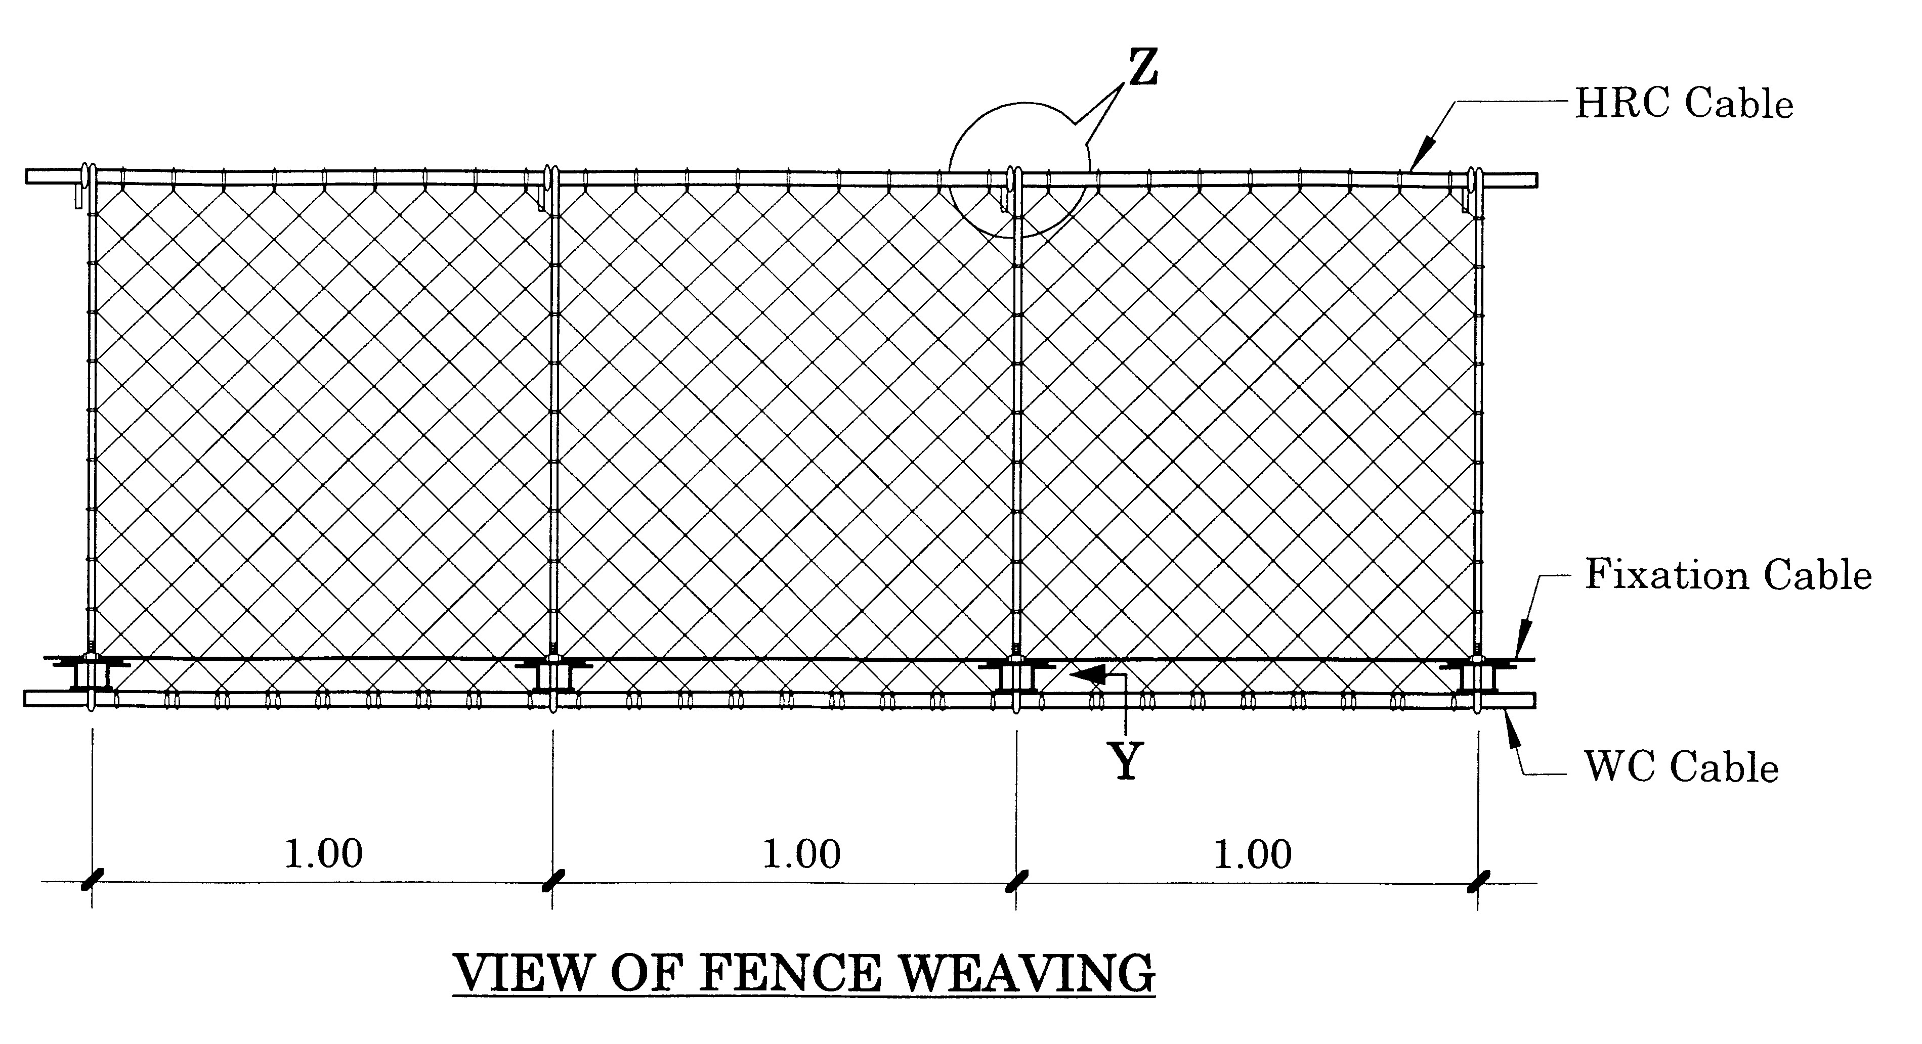
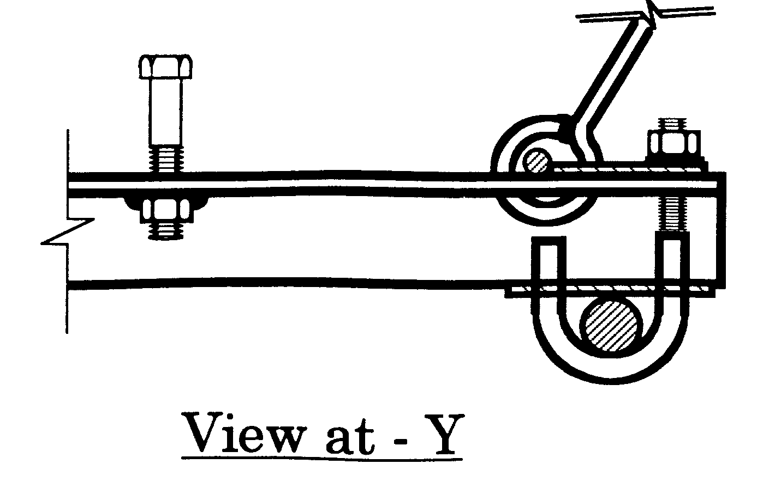

Figure 4.23: Walkway fitting

Fencing is woven on the spot with gabion wire (12SWG) between the handrail cable and the fixation cable. First fix the fixation cable by pulling it through the bottom eye of the suspender along either side of the walkway, and then join it with the short piece at the other end of the bridge (Figure 4.24a & b)).
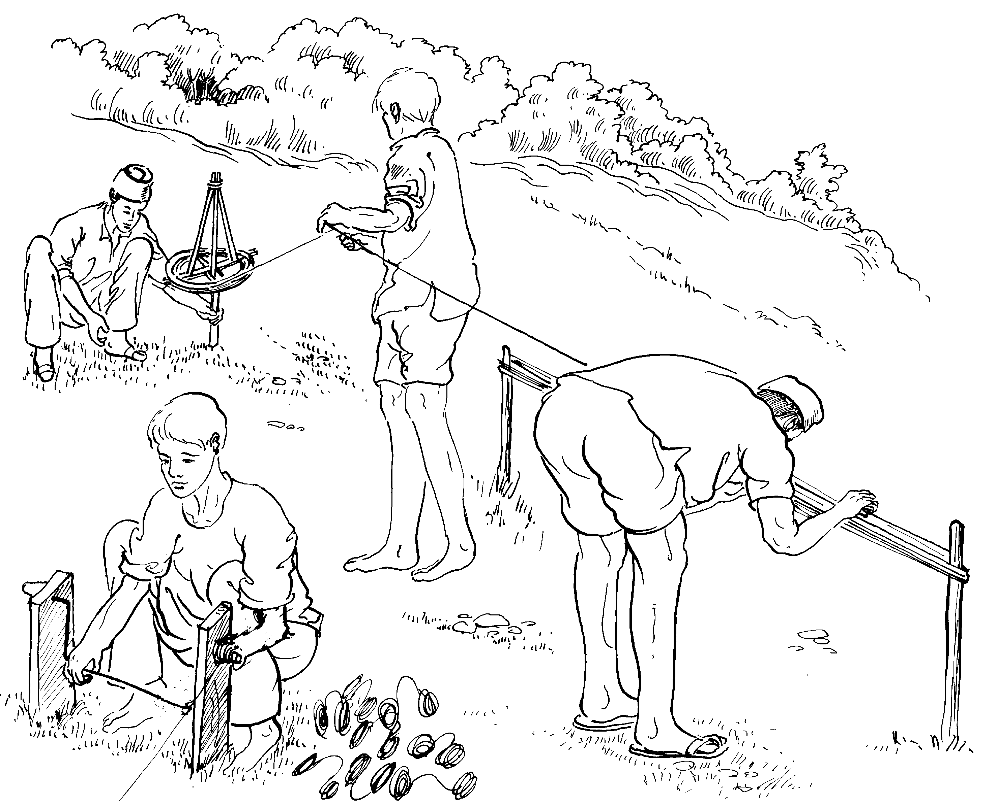

Preparing Coils

Cutting Length is 4.20 Meters

Figure 4.24a: Preparation of Gabion wire coils for Fence weaving.
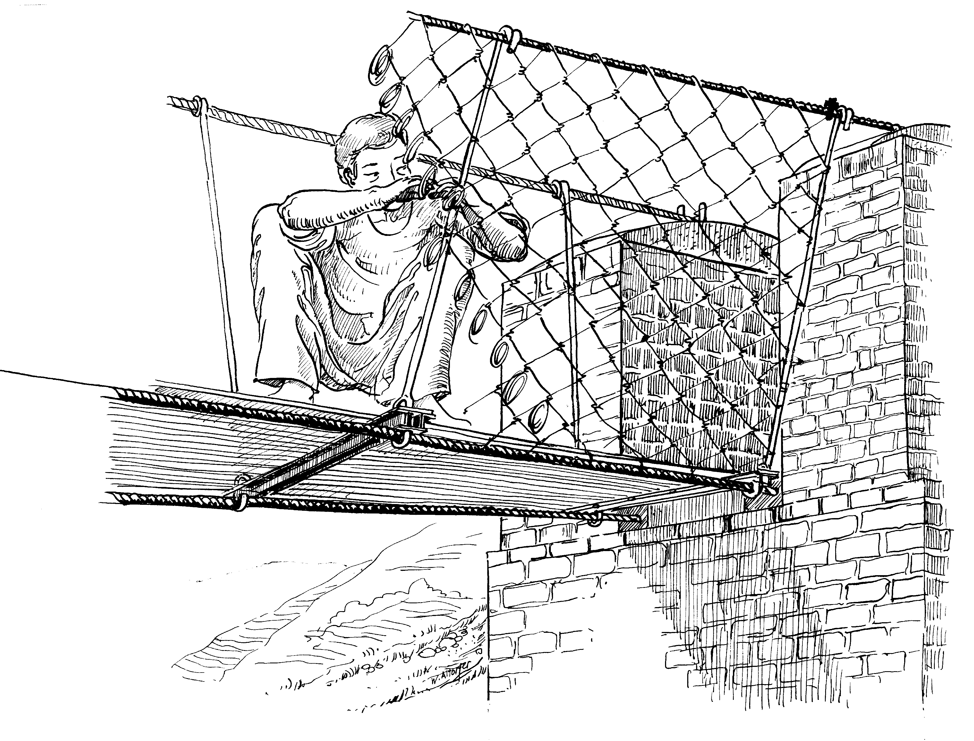

…for Fence weaving
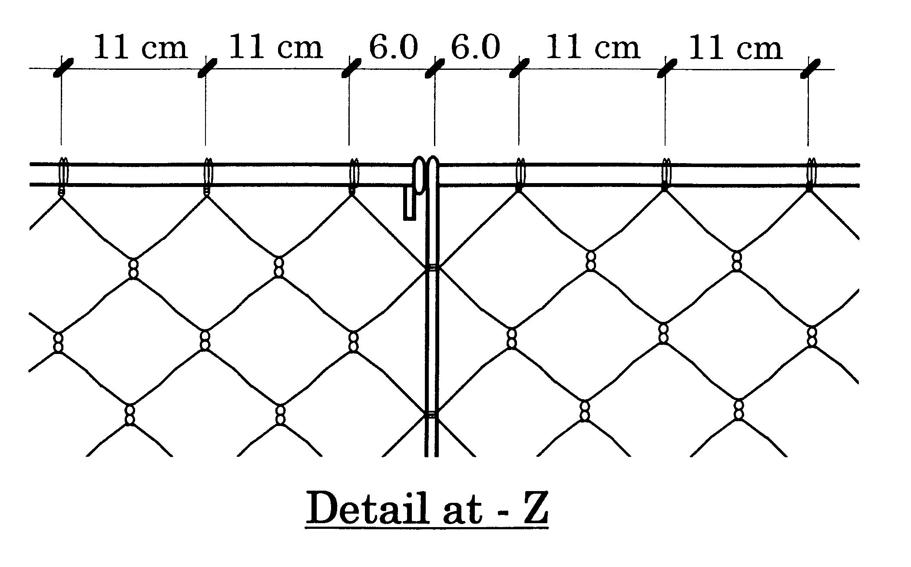

Figure 4.24b: Gabion wire fence weaving

4.10 Water Management, Backfilling and General finishing Works

4.10.1 Water Management
The life expectancy of the bridge largely depends on proper water management.

Any water seepage encountered during excavation should be intercepted as close as possible to its origin and channeled safely to a nearby watercourse. Especially vulnerable is the place behind the Deadman Beam! If in doubt, or in case of unusual humidity of water seepage, provide a drain behind the Deadman Beam with side outlet. Sometimes water seepage occurs during rainy season only. Inquire with the local people.

Divert surface water and provide drainage channels as necessary. Do not hamper existing irrigation channels, rather improve and adjust them with some cement works. Discuss solutions with local people and decide on the spot.

As a general rule divert water as far away from bridge foundations as possible.

For managing surface water well, also fill the gaps around completed anchor blocks well above the existing surface. Back filling prevents surface water to flush out excavations.

4.10.2 Finishing Work
Provide finishing structures like retaining walls, staircases, small trail improvements, adjustments to nearby houses etc., if it adds functional value to the bridge.

Never do cement pointing or other non-functional works.

Also check the vegetation and plant life in the vicinity of the bridge. Plant some new trees if possible, especially if some had to be cut for bridge construction.

4.11 Review Questions
Answer the following questions:

Illustrate the procedure for general bridge layout.
Illustrate the procedure for foundation excavation in soil.
Prepare the list of local material and their required quality for suspended bridge construction.
What are the conditions for storing cement and steel parts to avoid any damage?
State how the strength of stone masonry works varies depending upon the forms/shape, bed and bond across.
Distinguish between the deadman beam and drum anchorages.
What do you mean by sag?
What points must be observed in fitting the walkway?

