A Course MANUAL

ON
TRAIL BRIDGE CONSTRUCTION
FOR
Civil Sub-Overseer
(Pre & Post SLC)
VOLUME I: MANUAL

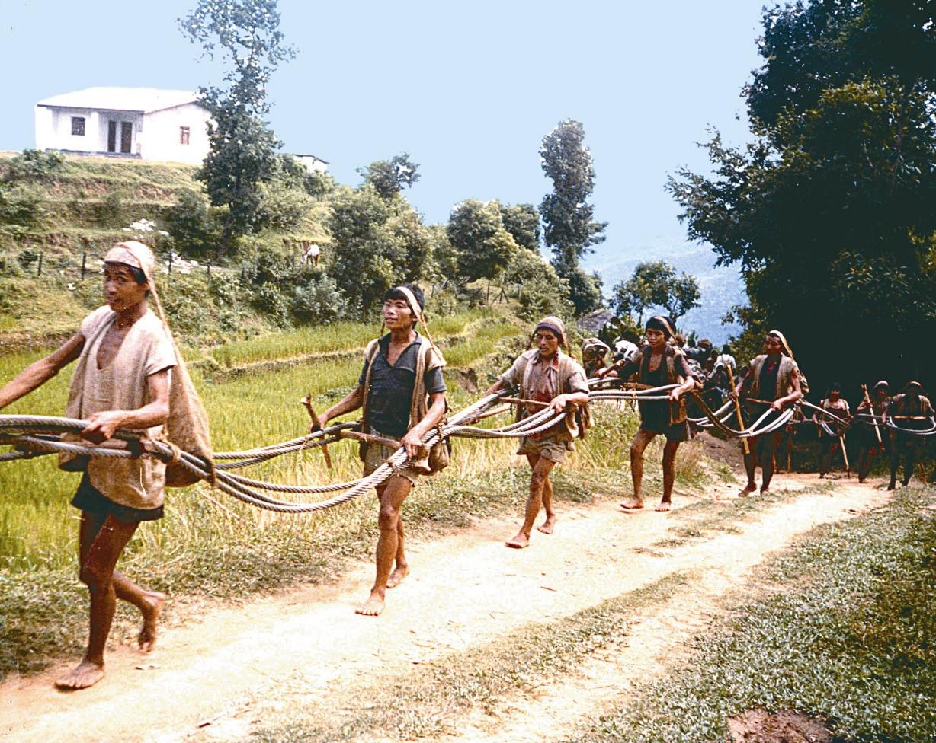
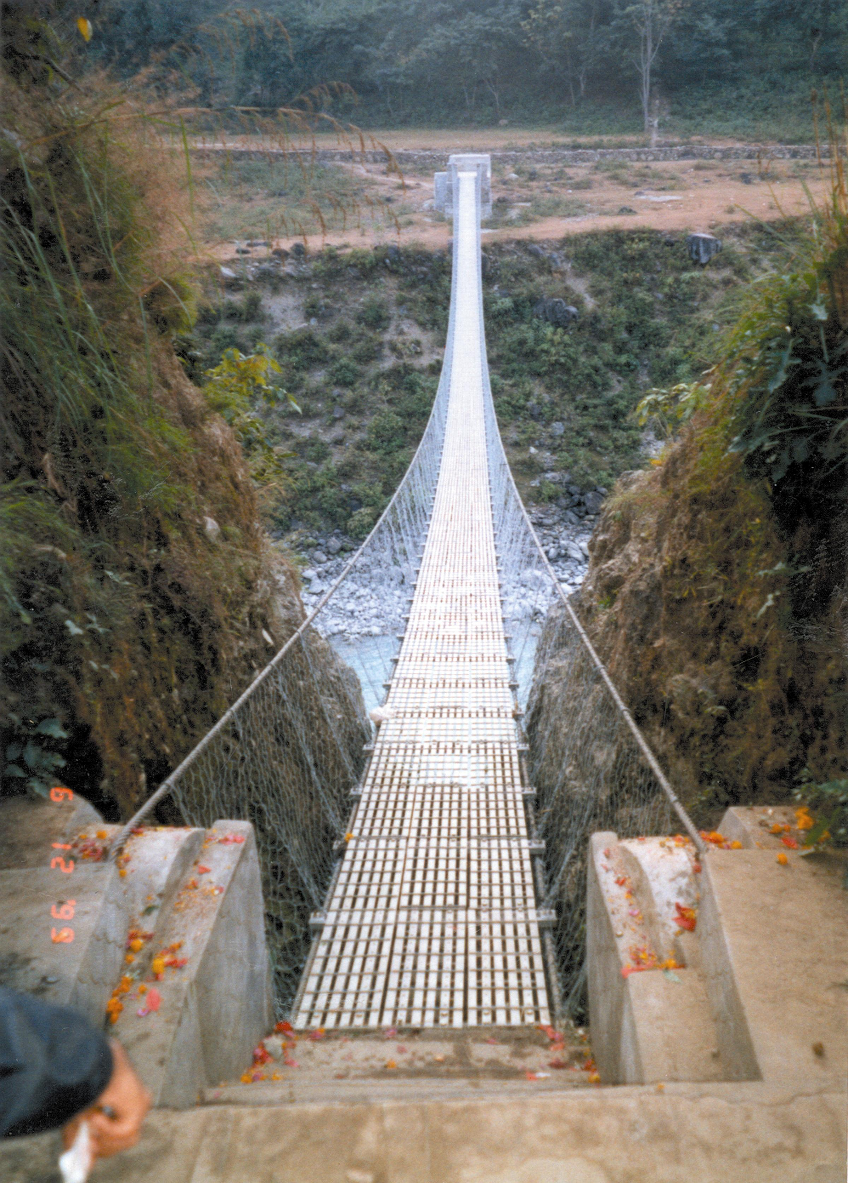
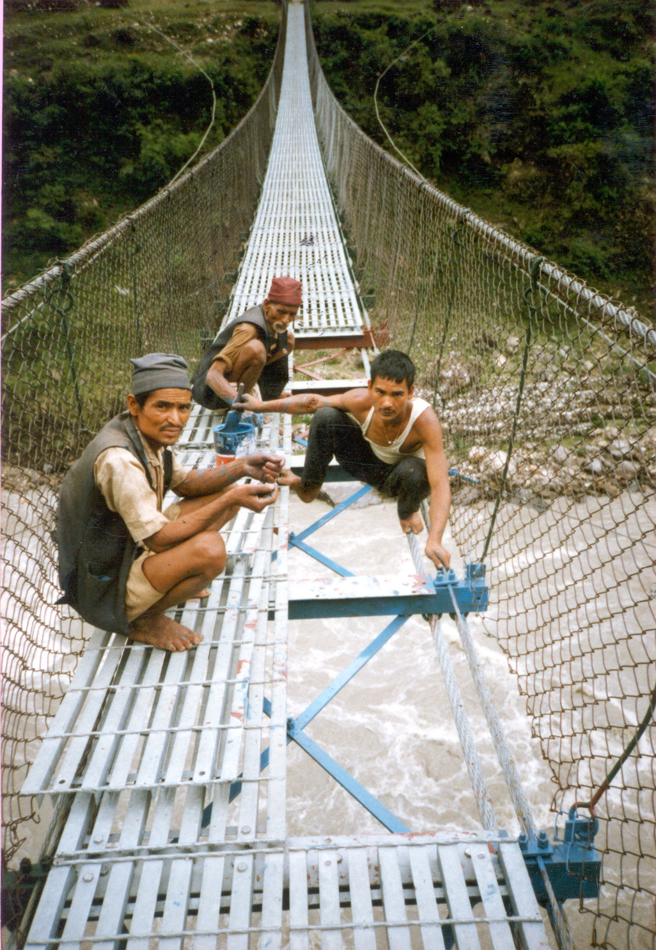

Curriculum Development Division
Council for Technical Education and Vocational Training (CTEVT)
Sanothimi, Bhaktapur
First Edition 2003 (2060)

