10. Special Design

Table of Contents

10.1 Special Suspended Bridge 233
10.1.1 Combined Main Foundation with a Staircase 233

10.2 Special Suspension Bridges 234
10.2.1 Suspension Bridge with One Tower 234
10.2.2 Without a Tower 240
10.2.3 With a Loaded Side span 240
10.2.4 Double Span Bridge 240
10.2.5 With the Different Walkway / Tower Foundation Elevations 240
10.2.6 With Different Tower Heights 240

10.3 Special Windguy Arrangement 241
10.3.1 Windguy Stay Strut 241
10.3.2 Bridges without a Windguy Arrangement 243

10.4 Design of Deadman Anchorage Foundation 244
10.4.1 Introduction 244
10.4.2 Related Symbols 244
10.4.3 Basic Calculation Principle 245
10.4.4 Limits 245
10.4.5 Initial Layout Data 246
10.4.6 Calculation Procedure 246

10.1 Special Suspended Bridge

10.1.1 Combined Main Foundation with a Staircase

Design the combined main foundation with a staircase according to the procedures given in Chapter 6 and 7.

For calculation of the loads acting on the foundation, two load combinations must be taken into consideration.

Load case [A] : Dead load case + full wind load
Load case [B] : Full load case + 1/3 wind load

Wind load: w = 1.0 kN/m²

Wind load acting on the walkway:
– for bridges without a windguy arrangement H_{W} = 0.5 l · w kN
– for bridges with a windguy arrangement H_{W} = 0

Wind load on exposed area A: P_{WA} = w. A kN

Calculate the stresses created in the base plate (in section 1 – 1 of the base plate):

σ_{t} ≤ σ_{t perm} kN/mm²
σ_{c} ≤ σ_{c Perm} kN/mm²

Related special design drawing (design example)

Drawing Number 60/4: Staircase combined with main foundation
2 main cables (related drawings 60 and 63)

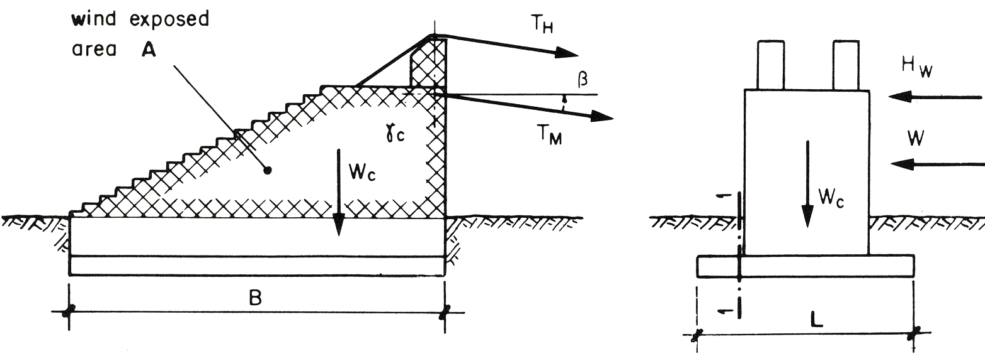
10.2 Special Suspension Bridges

10.2.1 Suspension Bridge with One Tower

A) Layout
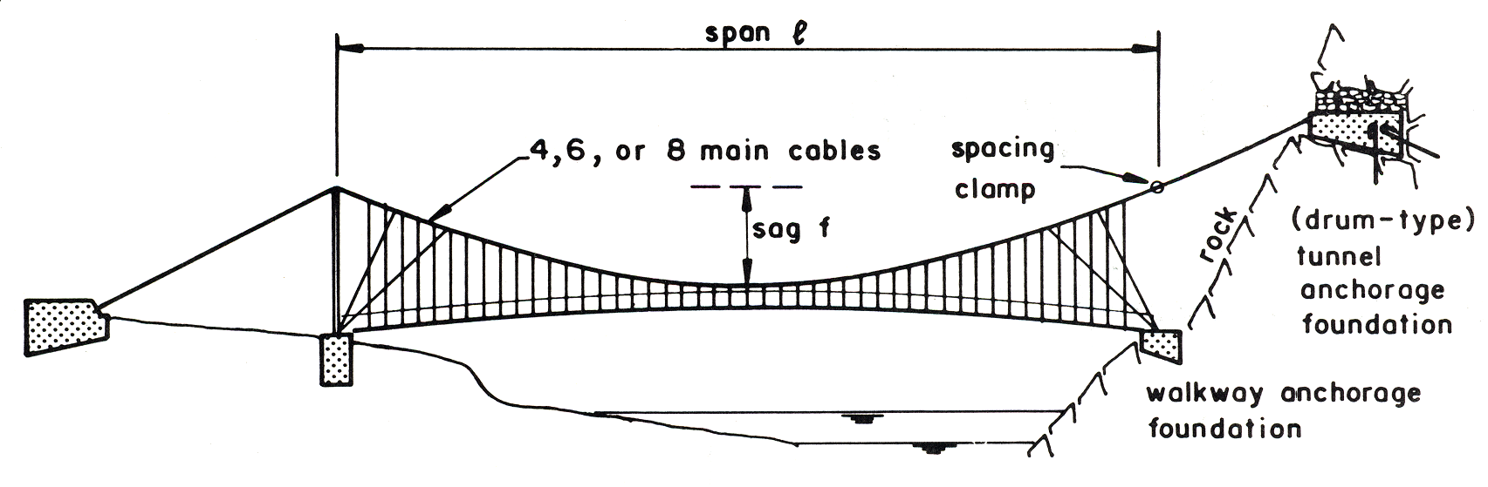

B) Introduction
The following procedure has the provision for a windguy arrangement (refer to Chapter 9). It is assumed that the full wind load, acting on the walkway up to the handrail cable, can be borne by this system only. The wind load acting on the main cables and suspenders has to be born by the tower (tower/walkway foundation) on one side and by the main (anchorage) foundation on the other side where no tower is provided.

The layout and the Initial loading are based on the structure under dead load.
The freeboard has to be maintained for any cable alignment (including windguy cables) at dead load case.

As an approximation, the calculations can be made in the same way as for the system with two towers (refer to Chapter 8).

C) Related Symbols
(Refer to Chapter 8)

D) Geometrical Parameters and Calculation Procedure
The maximum backstay distance, D_{R} (or D_{L}), is limited to ≈ 0.2 l.
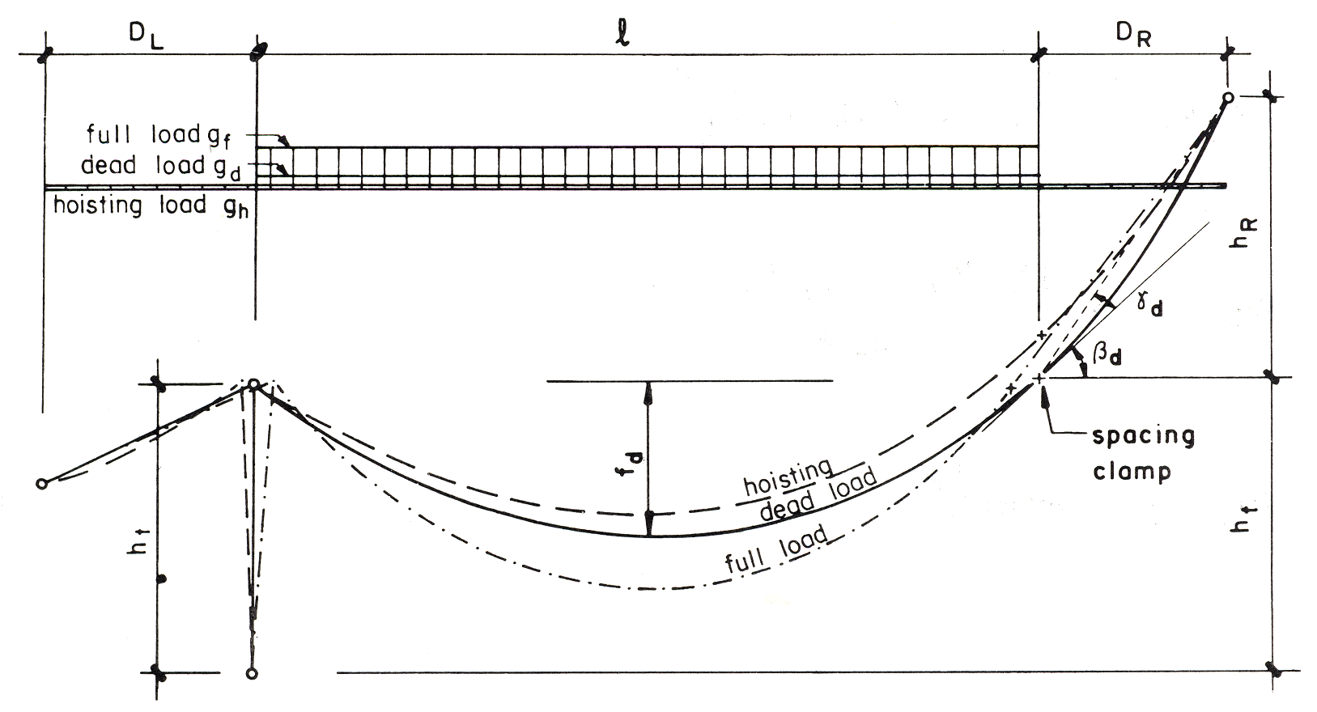

1) Analysis for the Backstay Cable behind the Spacing Clamp at Dead Load Case

The spacing clamp is situated vertically over the walkway foundation. Thus, the span of the bridge is given by the length of the walkway which corresponds to the loaded length of the bridge. Therefore, the spacing clamp represents a fictitious tower top. The dead load case must be fixed first. The cable geometry and the cable force are given by the well-known formulas (1) and (2).

1. T_{d} = $\frac{gd⋅ℓ^{2}}{8\text{ f}d}$ $\sqrt{1+\text{16}{\left(\frac{fd}{ℓ}\right)}^{2}}$ kN

2. β_{d} = arctan deg

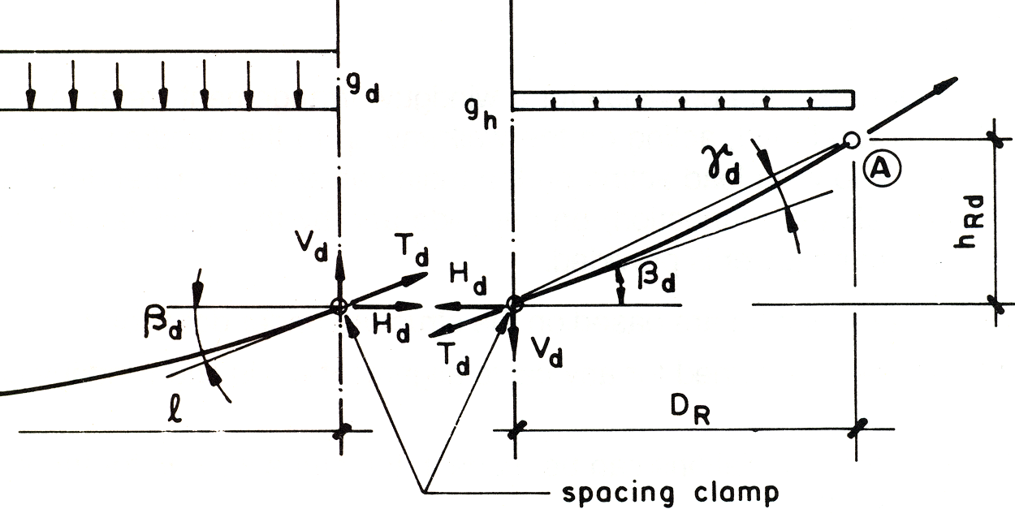

A simple condition for the equilibrium of the moment at point A gives the location of the anchorage for the backstay cable. The backstay distance, D_{R} , is previously defined and the height of the anchorage point is solved out of the equilibrium condition (3). The condition of the angles, β_{d} and γ_{d} , and the backstay distance, D_{R} and h_{R} , is given with formula (4).

3. M_{Ad} = V_{d}·D_{R} + gh·- H_{d}·h_{Rd} = 0 kNm

With V_{d} = and H_{d} = kN

3a. h_{Rd} = m

4. (β_{d} + γ_{d}) $=\text{ arctan }\frac{h\text{RD}}{DR}$ deg

2) Hoisting Load Geometry

The assumptions made to set up the procedure for determining the hoisting load geometry from the dead load geometry are given below.

– The horizontal movement of the tower top, DDL (or DDR), is neglected. The magnitudes of these two values are low with respect to the change in cable geometry caused by the change of load and with respect to the different elongation of the cable caused by a change of the applied load (e.g., change from dead load case to hoisting load case, or change from dead load case to full load case

– The dead load geometry of the cable between the spacing clamp and the anchorage point is taken as a straight line without local sag. The dead load length from the spacing clamp to the anchorage point is determined as

L_{d} ≈ m

– The dead load cable length between the one tower and the main cable anchorage foundation is given with the formula

L_{d} ≈ l_{d}·$\left[1+\frac{8}{3}{\left(\frac{fd}{ld}\right)}^{2}\right]$ + . m

The known values on which to base the calculations are:
– Dead load g_{d},
– dead load span of the bridge l_{d},
– dead load sag f_{d},
– backstay distance D_{R},
– hoisting load g_{h}

The geometry of the main cable for a hoisting load situation is equivalent to the geometry for the cable of a suspended bridge with anchorage points at different elevations. All the formulas for cable geometry, given in 7.3, are very useful.

An iteration leads to the geometry of the hoisting loaded cable. The span of the hoisting loaded cable is enlarged from the original dead load span, l_{d}, to the hoisting load span

l_{h} ≈ l_{d} + D_{R} m

To start the iteration the value for the cable force, T_{h} , caused by the hoisting load, has to be assumed first. A good initial value for the cable force, T_{h} , can be approximately 15% of the dead load value, T_{d} : preliminary T_{h} ≈ 0.5 T_{d}

Once the hoisting load geometry is calculated, the cable length from the spacing clamp to the anchorage point, L_{ch}, can be determined. The general formula, y = a x² + bx + c , has to be changed to fit in with the value, l_{h}, b_{h} , and h_{R}.
The iteration procedure is shown below.

1 Cable length L_{h} ≈ L_{d} - $\frac{|Td−Th|⋅Ld}{E⋅AM}$ = L_{d} + $\frac{(Th−Td)⋅Ld}{E⋅AM}$ m

2. Sag of b_{h} ≈ l_{h} ·$\sqrt{\frac{3}{8}\left[\frac{Lh}{lh}−\frac{1}{2}{\left(\frac{hR}{lh}\right)}^{2}−1\right]}$ m

3. Cable force H_{h} = $g\frac{h⋅lh^{2}}{\text{8b}h}$ kN

with tanβ_{h} ≈ $\frac{4bh+hR}{lh}$ /

and T_{h} ≈ $\frac{Hh}{\text{cos}βh}$ kN

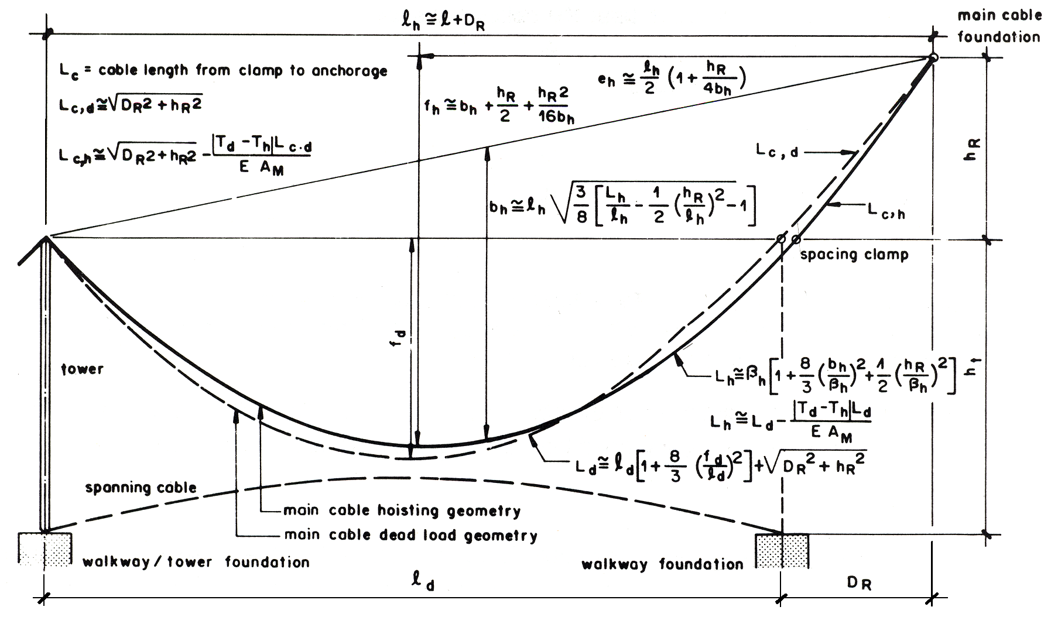

3) Full Load Geometry

The length of the cable from the spacing clamp to the anchorage point can be calculated by:

L_{C f} ≈ $\frac{(Tf−Td)⋅L\text{cd}}{E⋅AM}$ m

The full load geometry can be calculated using the dead load formulas (3), (3a), and (4).
Instead of the dead load, g_{d} , the full load, g_{f} , has to be introduced. The output of formula (3a) then gives the new vertical location of the spacing clamp, h_{R} _{f}.

The cable between the spacing clamp and the anchorage point is assumed to be straight. The horizontal location of the spacing clamp is then defined with L_{c} _{f} and H_{R f}

E ) Main Cable Anchorage Foundation (Drum-type)

The lateral horizontal wind load, H_{w} , has to be taken into consideration., as there is no tower to bear this load (refer to 8.4.9 C1). Analyze for both loading cases [A] and [B].

For the calculation refer to Chapter 6, Design of Bridge Foundation and 7.4, Design of Main Anchorage Foundation of Suspended Bridges (calculate with T_{H} = 0 ). Additional anchorage rods may be required to stabilize the rock (refer to 6.3).

Related special design drawing (design example)

Drawing Number 60/3: Main cable tunnel foundation
2 main cables

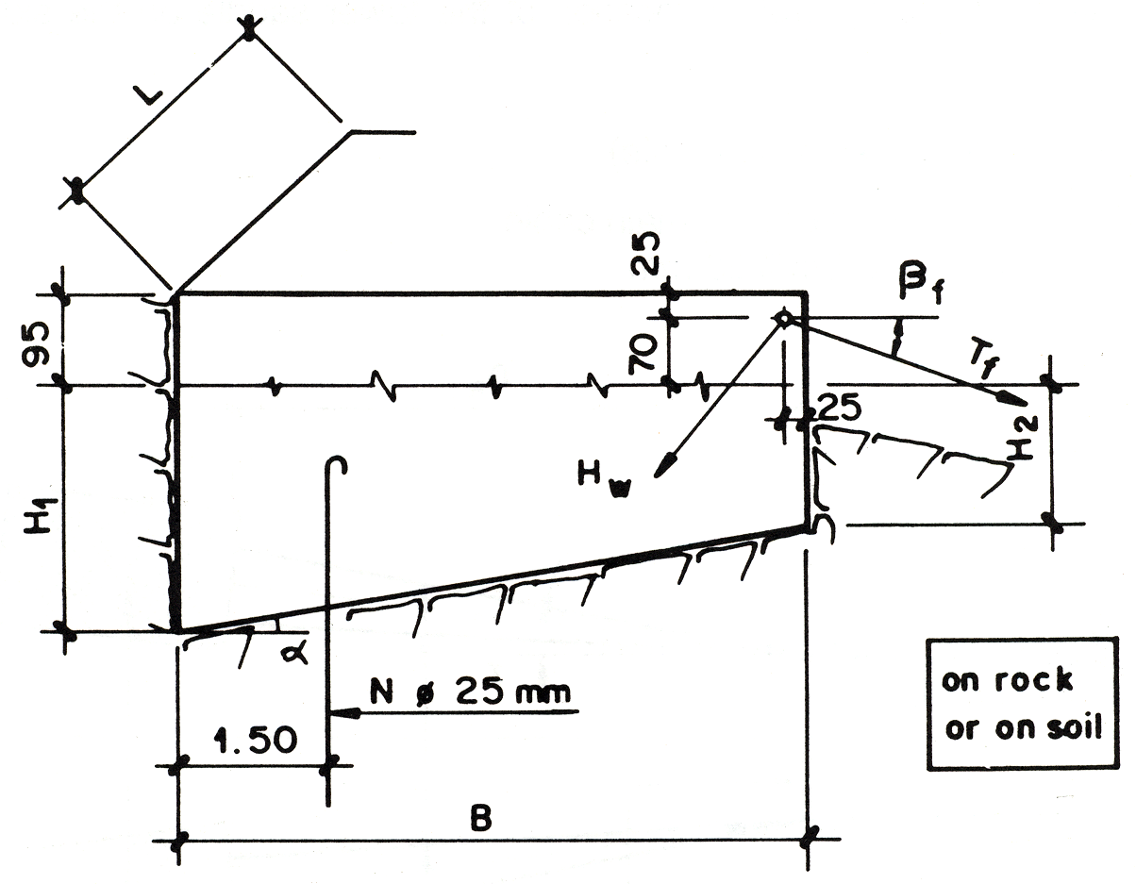

F) Walkway Anchorage Foundation

For calculating the tension in the spanning cable refer to 8.4.9 C3. The lateral force that must be considered (refer to 8.4.9 C2) consists only of

P_{H} = $\frac{P\text{s1}⋅l}{2}$· sinα₁ KN

For the calculation procedures refer to Chapter 6, Design of Bridge Foundation. Anchorage rods may be required to stabilize the rock (refer to 6.3).

Related special design drawing (design example)

Drawing Number 91/3: Walkway Foundation
Spanning cable φ 32 mm
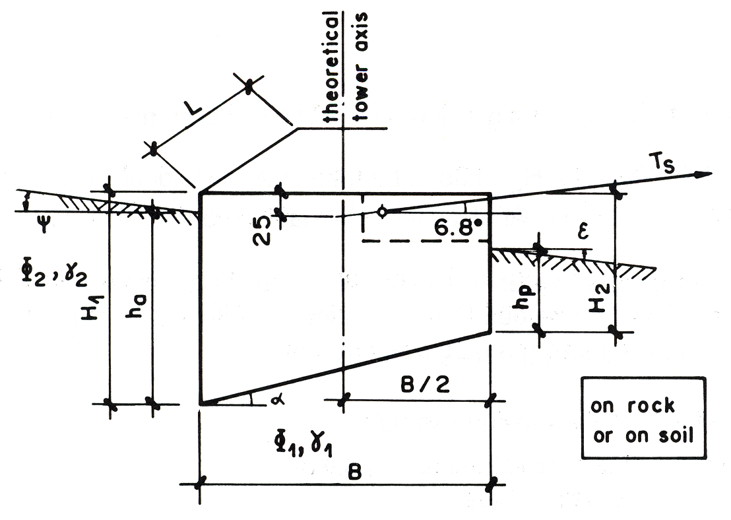

G) Spacing Clamp for Main Cables

Provide a spacing clamp at the theoretical location of the tower saddle on the side without a tower.

Related special design drawing (design example)

Drawing Number 28: Spacing clamp for main cable
4 main cableφ 32 mm
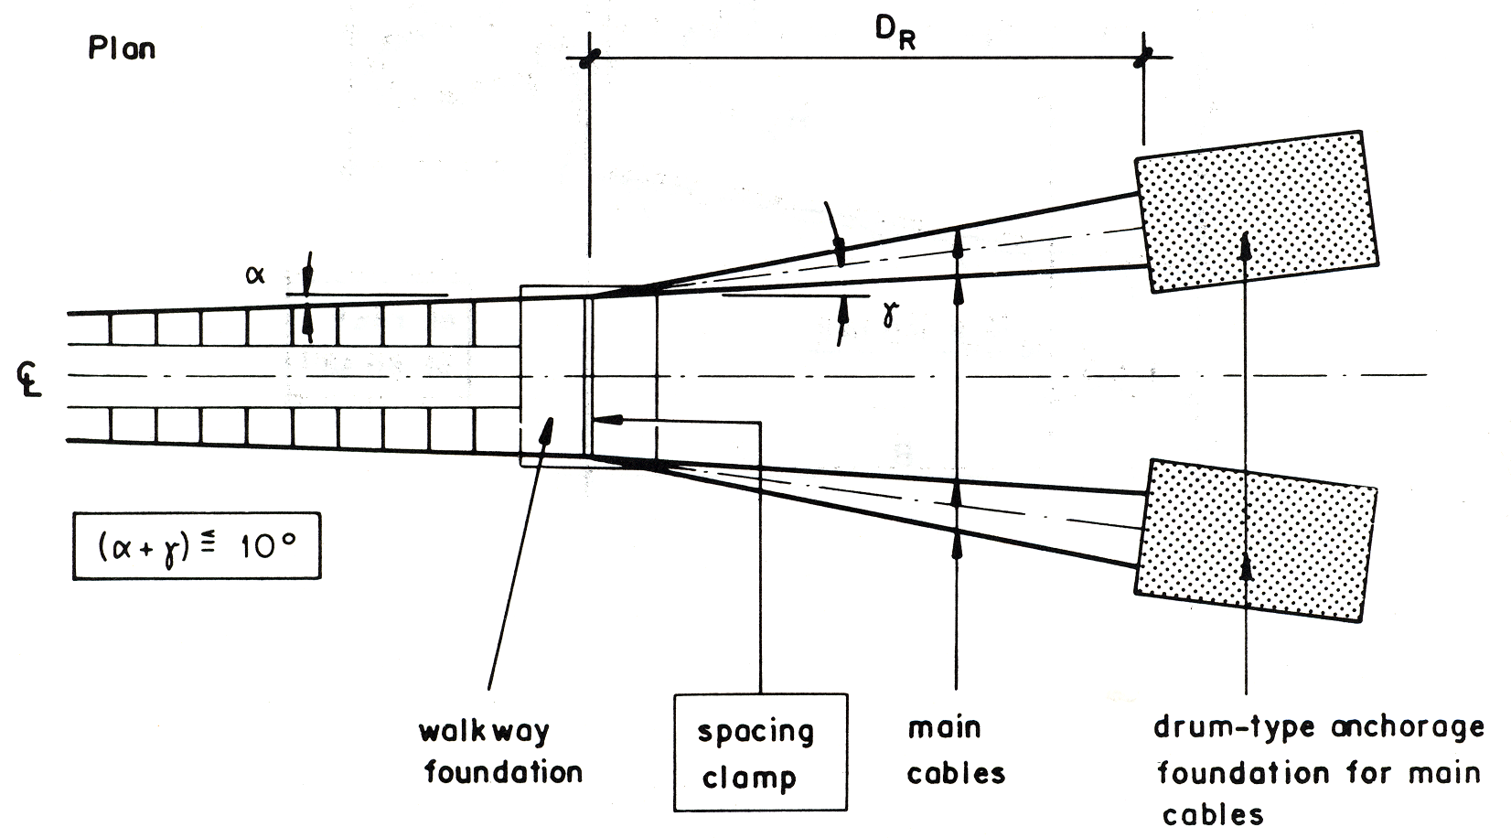

10.2.2 Without a Tower

For structural calculation, anchorage and foundation design, spacing clamps, proceed according to 10. 1.

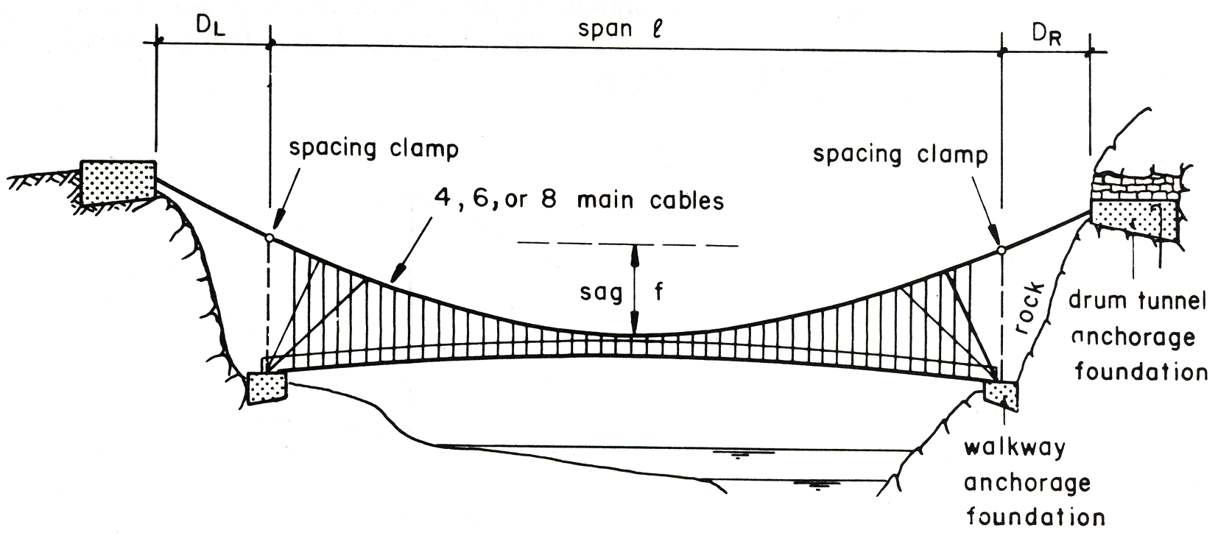

10.2.3 With a Loaded Side span

The design of this type of bridges is more complex. Additional cables between the tower tops are required for the stability of the bridge in compare to the standard suspension bridge. The design of such bridge has to be made in detail for a specific site and can not be standardized. Therefore, this bridge type is not considered in the present handbook.

10.2.4 Double Span Bridge

Additional cables between the tower tops are required for the stability of the bridge in compare to the standard suspension bridge. This type of bridge also not considered in this handbook due to the same reason as explained in 10.2.3.

10.2.5 With the Different Walkway / Tower Foundation Elevations

Suspension bridges with two towers, one, or even without a tower, with the different walkway/tower foundation elevations are not recommended.

10.2.6 With Different Tower Heights

In designing standard towers, the height of the tower is calculated as a function of the Span (load). The smaller tower, in particular, cannot be designed as a standard tower but must be designed according to the effective loads.

10.3 Special Windguy Arrangement

10.3.1 Windguy Stay Strut

On flat river banks where walkway/tower foundations are constructed high above the ground level, the windguy cables can be supported at the walkway/tower foundation by windguy stay struts and anchored to the main cable foundation.

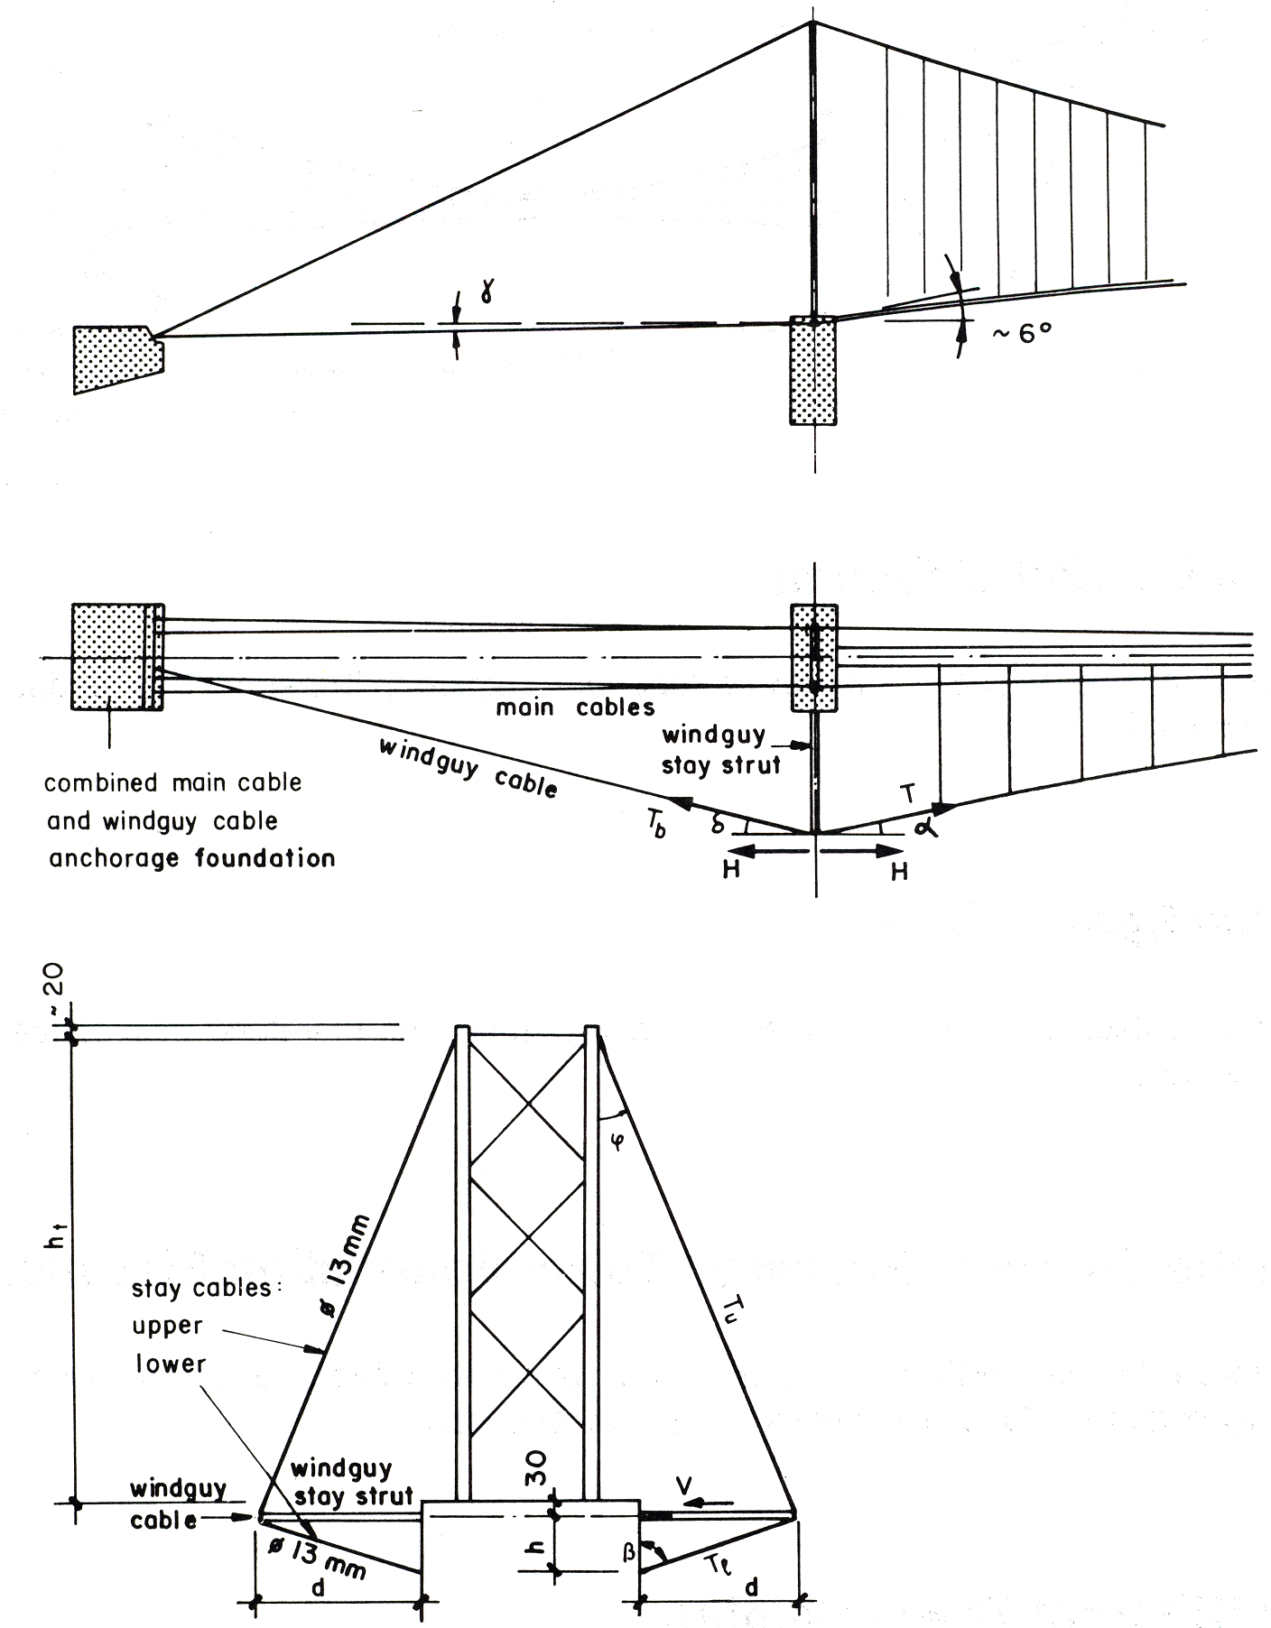

Side
elevation

Plan

Front
elevation

Windguy Cable | Ø 26 mm | Ø 32 mm | Ø 36 mm
h min m | 3.00 | 3.00 | 3.00
d m | 4.50 | 6.50 | 8.30
V_{perm} kN | 70.00 | 100.00 | 130.00
Table 10. 5.1: Layout Data for Windguy Stay Strut
Refer to Chapters 8 and 9 for general outline, calculation procedures, symbols, formulas, etc.

For windguy arrangements with windguy stay struts, calculate, in addition, for full wind load:

– the tension in windguy backstay cable:
T_{b} = kN

– the safety factor calculated as:
F = ≥ 3

– the load on windguy stay strut:
V = H·(tanα + tanδ) + T_{u} · sin ϕ + T_{l} · sinβ ≤ V_{perm} kN

– the tension in stay cables:

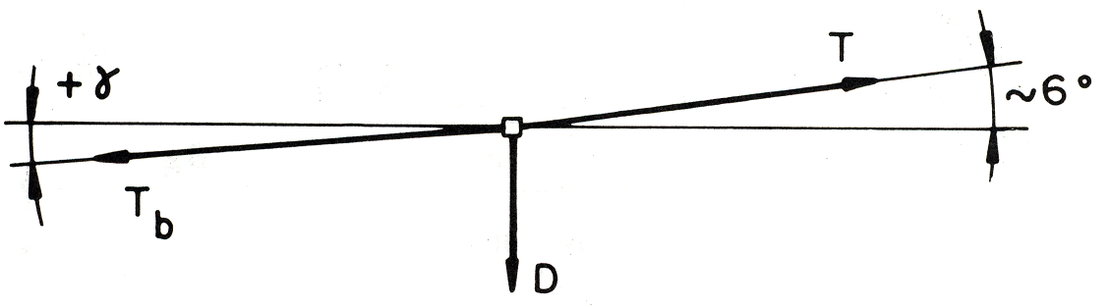

D = T · sin 6° – T_{b} ⋅ sinγ = force of deviation kN
if D > 0: the lower stay cable is loaded T_{l} = ≤ 30 kN

if D < 0: the upper stay cable is loaded T_{u} = $\frac{|D|}{\text{cos}ϕ}$ ≤ 30 kN

Calculate the main cable foundation according to the procedures given in 8.7 for full load with an additional tension, T_{b}, in one windguy cable, determined for w > 0.17 kN/m (¹/₃ wind load).

Related special design drawings

Drawing Number: 175,175/1 Windguy stay strut for windguy cable Ø 26 mm
176,176/1 Windguy stay strut for windguy cable Ø 32 mm
177,177/1 Windguy stay strut for windguy cable Ø 36 mm
49/3 Combined main cable and windguy cable foundation
4 main cables, 2 windguy cables (design example)

10.3.2 Bridges without a Windguy Arrangement

It is acceptable to follow the standard procedure if the safety factors (foundation design) are at least 1.0 above the minimum required factors, i.e., F > F_{min} + 1.0

If the safety factors are less than 1.0 above the minimum safety factors, the design must be calculated with the actual loadings for all structures.

Load case [A] : Dead load case + full wind load
Load case [B] : Full load case + 1/3 wind load

Wind load: w = 1.0 kN/m²

A) Suspended Bridge

The lateral wind load which must be taken into consideration for the design of the main anchorage foundations may be calculated as follows:

– for load case [A]: P_{H} = 0.5 l ⋅ w kN

– for load case [B]: P_{H} = ¹/₃ ⋅ ( 0.5 l · w ) kN

B) Suspension Bridge

The procedure can be followed according to 8.4, but the lateral load, w_{b} , must be increased by, w_{ww ,} the wind load acting on the walkway and calculated as follows:

– for load case [A]:
w_{b} = w_{ww} + w_{M} + w_{susp} = 0.5 + 0.125 + 0.0038 (h_{t} - 2.4)
= 0.616 + 0.0038 h_{t} kN/m

– for load case [B]
w_{b} = 1/3 ( w_{ww} + w_{M} + w_{susp} ) = ¹/₃ ( 0.616 + 0.0038 h_{t}) kN/m

Note: The procedure given in 8.4 is a statical analysis only. Owing to the dynamic behavior of the bridges (especially bridges without a windguy arrangement), the horizontal deflection, x, and the tension in the spanning cable, p_{s1} , may increase up to double the value.

10.4 Design of Deadman Anchorage Foundation

10.4.1 Introduction

The scope of this section is to determine the dimensions of the deadman anchorage foundation based on the results of the cable structure analysis, on the soil and rock parameters, and on prescribed safety factors. This type of anchorage foundation is a very economical main cable anchorage for suspension bridges.

It is important to note that the design philosophy and methodology is limited to shallow foundations (near ground surface) in granular soil.

The principal is to make use of the earth resistance (passive earth pressure) of the soil in front of the foundation. Therefore this type of foundation needs special care:

a) during excavation: as far as possible the soil in front of the foundation must not be disturbed; and if it is (e.g., because of the excavation for the cables), the backfilling soil must be well compacted, and

b) after construction: a prescribed area of the soil in front of the foundation must be protected (e.g., with gabion mattress).

The basic principles concerning earth pressure are given in Chapter 6, Foundation Design.

10.4.2 Related Symbols

B Open dimension of the foundation, (part of) width m
C Back toe, part of height m
E Back toe, part of width m
H Open dimension of foundation, (part of) height m
H_{ult} Ultimate capacity of the foundation, horizontal component kN
L Open dimension of the foundation, length m
PL Length in front of the foundation to be protected m
W_{C} Weight of foundation kN
W_{E} Weight of the earth above the foundation kN

For all other symbols used, refer to Chapter 6, Design of Bridge Foundation, and to Chapter 8.7, Design of Main Cable Foundation.

10.4.3 Basic Calculation Principle

A) Layout
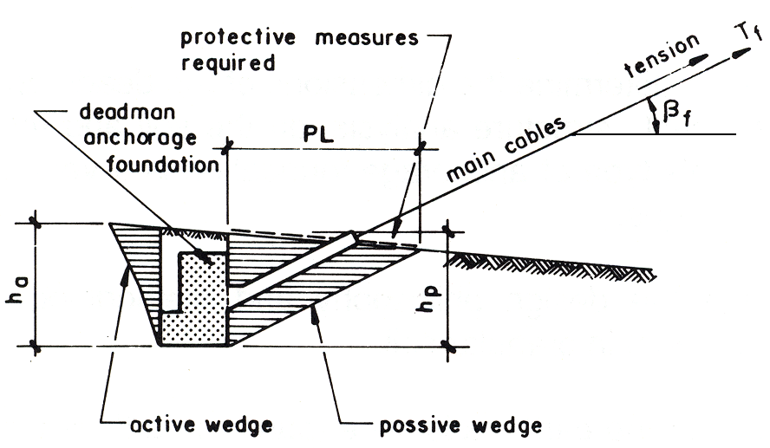

B) Ultimate Capacity

Calculating the ultimate capacity involves taking into consideration the passive earth pressure in front, the active earth pressure at the back, and the earth pressure at rest, acting laterally on the foundation.

H_{ult} = E_{ph} – E_{ah} + 2 E_{oL} kN

For determining the magnitude of E_{ph} and E_{ah} , refer to 6.2.3.
The earth pressure at rest, acting laterally on the foundation, is calculated as:

2 E_{oL} = λ_{o} · γ₁ ·h_{p}³ ··tanΦ₁ · kN
λ_{o} = 1 - sinΦ₁ /

10.4.4 Limits

A) Depth of Soil on Top of the Deadman Foundation

The depth of soil on top of the deadman foundation must not exceed
h < ¹/₃ h_{p} to 1/2 h_{p} m

B) Length in Front of the Foundation to be Protected

The length in front of the foundation to be protected with precautionary measures to ensure adequate safety after completion of construction, is calculated as

PL = h_{p ⋅} m

C) Safety against Sliding Failure

In order to reduce the movement of the foundation towards the soil in front of it, a high safety factor is required

F_{SL} ≥ 3.50

10.4.5 Initial Layout Data

Refer to 8.7.5.

10.4.6 Calculation Procedure

Refer to 8.7.5 .

Calculation example:
The calculations are taken from examples of a foundation with a back toe and without groundwater.

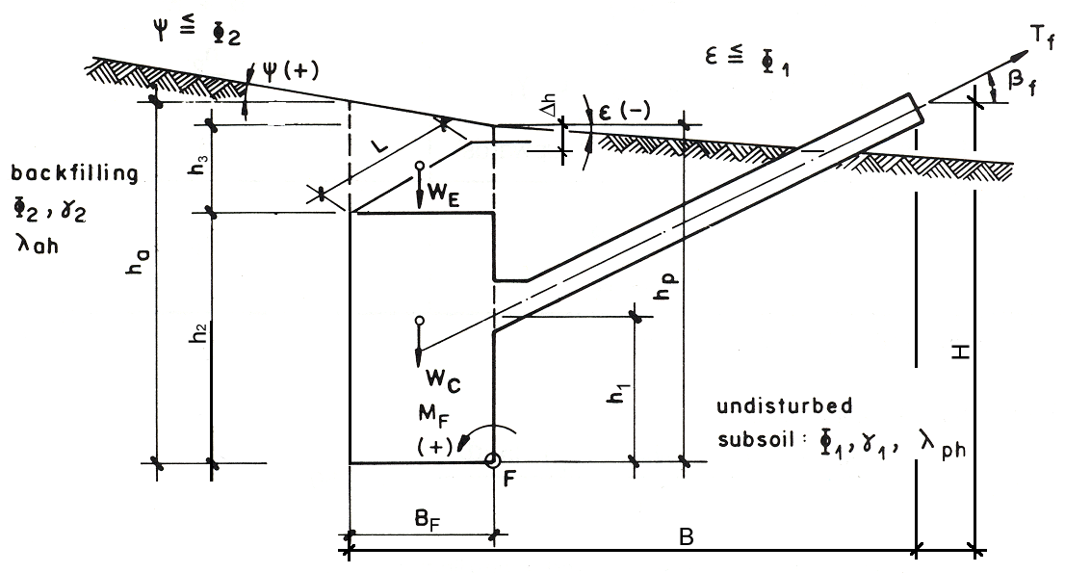

1. Calculate the components, inclination, and location of the -resultant loading force

Loading Forces | Lever Arm (m) for M_{F}
Weights (kN):
W_{F} = h₂ ⋅ B_{F} ⋅ L ⋅ γc | B_{F}/2
W_{E} = B_{F} ⋅ L ⋅ h₃ ⋅ γ₂ | B_{F}/2
Load on Top (kN):
A = (refer to 6.2.4) | a
Earth Pressure (kN):
– back: E_{ah} (back) = λ_{ah} [Φ₂,ψ] · · L · γ₂
E_{av} (back) = E_{ah}· tan | B
– front: E_{ph} (front) = λ_{ph} [Φ₁, ε] · · L · γ₁
E_{pv} (front) $=\text{ E}\text{ph}⋅\text{ tan }(−\frac{1}{2}⋅Φ1)$ (upwards) | 0
Loads (kN):  T_{f h} = T_{f} ⋅ cosβ  T_{f v} = T_{f} ⋅ sinβ | h₁  0

MF = sum of all statical moments in F kNm

– Safety against sliding failure

F_{SL} $= \frac{H\text{ult}+(WF+\text{ W}E\text{ - T}\text{fv})⋅\text{ tan}Φ1}{T\text{fh}}$ ≥ 3. 50 /

2. For other possible failure modes proceed according to Chapter 6.

Related special design drawing (design example)
Drawing Number 49/2: Main cable deadman anchorage foundation
Capacity 1220 kN, c/c₁ = 4.00 m
4 main cables (related drawing 49)
Drawing Number 50/2: Main cable deadman anchorage foundation
Capacity 1830 kN, c/c₁ = 4.00 m
6 main cables (related drawing 50)
Drawing Number 51/2: Main cable deadman anchorage foundation
Capacity 2440 kN, c/c₁ = 4.00 m
8 main cables (related drawing 51)

