12. Appendix

Table of Contents

12.1 Cable Statics 269
12.1.1 Parabolic Cable 269
12.1.2 Catenary 270

12.2 Geometry of the Parabola 271
12.2.1 General Case 271
12.2.2 Vertex at the0Intersection of the Coordinate Axes 271

12.3 List of Standard Drawings 272
12.3.1 Standard Working Assembly Drawings 272
12.3.2 Standard Structural Drawings 273
12.3.3 Special Design Drawings 275

12.4 Design Examples 276
12.4.1 Suspended Bridge 276
12.4.2 Suspension Bridge 276

12.5 Cost Estimate Norms/Formats (21 Pages)

12.6 Survey Form and Checklist (42 Pages)
12.1 Cable Statics

12.1.1 Parabolic Cable
A cable hanging between the supports A and B, carrying a load uniformly distributed along the horizontal, will form a parabola. Cables of suspension bridges may be assumed to be loaded in this way, since the weight of the cables is less than the weight of the walkway. Denote by q , the load per unit length (measured horizontally) and express in kN/m . Choosing coordinate axes originating at the lowest point, C , of the cable, the magnitude, W , of the total load carried by the portion of the cable, extending from C to the point, D , of coordinates x and y , can be expressed as:

W = q ⋅ x kN

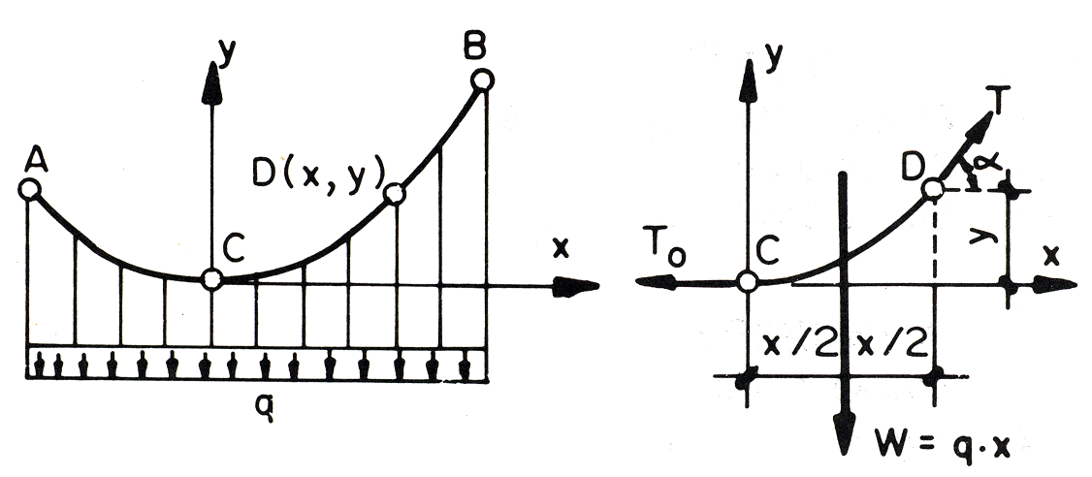

Drawing the corresponding force triangle, the following relations can be obtained

T· cosα = T_{o} T·sinα = W kN
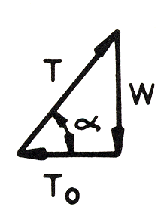

T = kN

a = arctan $\frac{W}{To}$ deg

The relationship defining the magnitude and direction of the tension force at D become

T = kN

α = arctan $\frac{q⋅x}{To}$ deg
The distance from D to the line of action of the resultant W is equal to half the horizontal distance from C to D. To sum up the moments about D:

∑M_{D} = 0 ------- > q · x · – T_{o} · y = 0 kNm
and solving for y, y = · x² m

This is the equation for a parabola with a vertical axis and its vertex at the origin of coordinates.

The curve formed by cables loaded uniformly along the horizontal is thus a parabola.
The length of the cable from its lowest point, C , to its support, B , may be obtained by differentiating the Integral of the arc and using the binomial theorem, resulting in the formula:

l_{B} = x_{B} · [ 1 + ( )² – ( )⁴ + . . .]

The series converges for values of the ratio, y_{B} / x_{B} , less than 0.5 ; in most cases, the ratio is much lower than this and only the first two terms of the series need be taken into consideration.

12.1.2 Catenary

A cable hanging between the supports A and B, carrying a load uniformly distributed along the cable itself, will form a catenary. Cables hanging under their own weight are loaded in this way. Denote by q the load per unit length (measured along the cable) and express it in kN/m. The magnitude, W , of the total load carried by a portion of cable of length, s , extending from the lowest point, C , to a point D is:

W = q · s kN

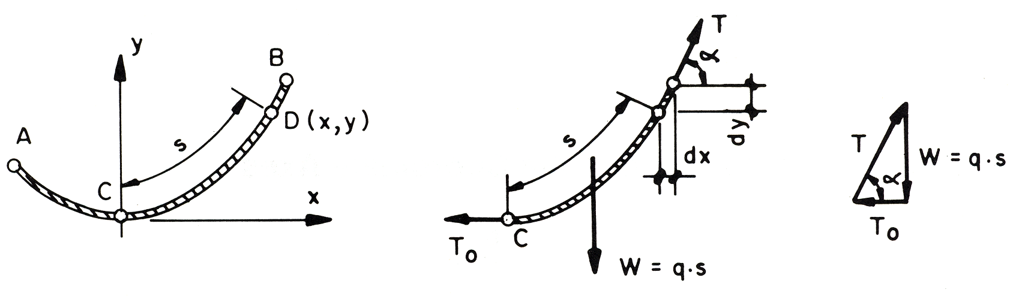

The relationship defining the magnitude of the tension force at D become

T = kN

The distance from D to the line of action of the resultant, W , is not known, as the distance , s , is measured along the cable itself. Refer to the technical literature for the complete formula of the catenary.

The error introduced, by assuming a parabolic shape for cables hanging under their own weight, is small if the cable is tightly stretched.

For the calculation of standard bridges, sufficient accuracy can be achieved by using the formula for the parabola instead of the formula for the catenary.
12.2 Geometry of the Parabola

12.2.1 General Case
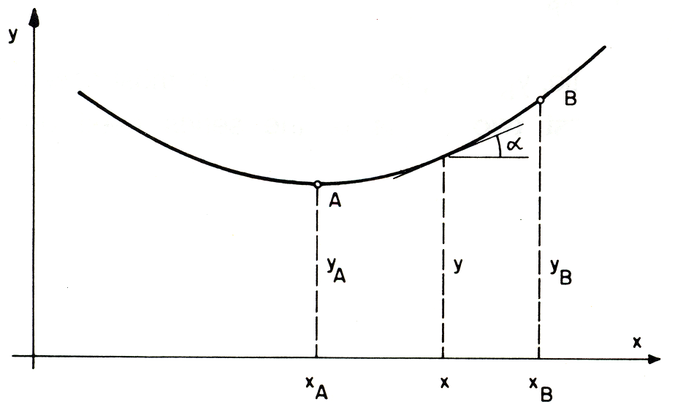

A: Vertex (horizontal tangent)

General formula : y = a · x² + b · x + c
tangent in x : tanα = = 2 a ⋅ x + b

Given: Vertex A (x_{A} , y_{A}) and point B (x_{B}, y_{B})
Determine a, b, and c with:
y_{A} = a · x_{A}² + b · x_{A} + c
y_{B} = a · x_{B}² + b · x_{B} + c
tanα = 2 a ⋅ x_{A} + b = 0

12.2.2 Vertex at the Intersection of the Coordinate Axes
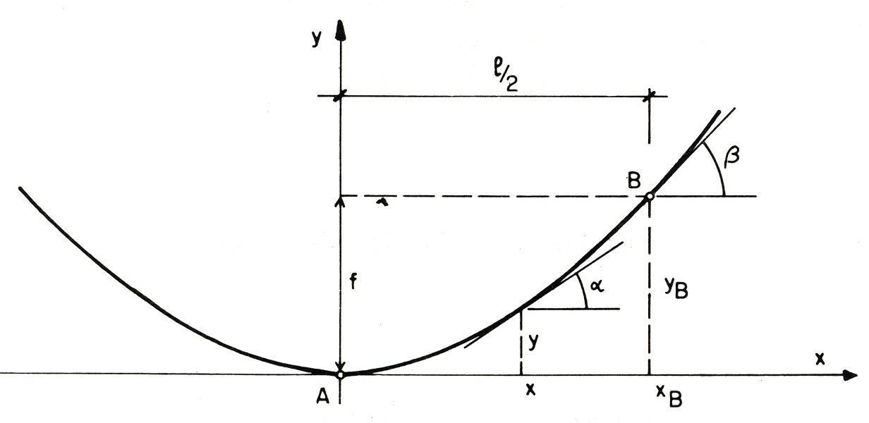

A : Vetex (horizontal tangent) Example: x_{B} = l/2, and y_{B} = f
General formula : y = a · x² a =
tangent in x : tanα = 2 a · x y = · x²
Given : Point B (x_{B} , y_{B}) , and tanα = · x
a = tanβ =

12.3 List of Standard Drawings

12.3.1 Standard Working Assembly (Steel) Drawings

Drawing Title  (Bridge type) | Drawing Number | Specifications
Walkway (support) | 01 | For 4 main cables, suspended bridge
Walkway (support) | 02 | For 6 main cables, suspended bridge
Walkway (support) | 03 | For 8 main cables, suspended bridge
Walkway (support) | 04 | For 10 main cables, suspended bridge
Walkway (support) | 05 | For 12 main cables, suspended bridge
Walkway (support) | 07 | For suspension bridge
Walkway  Steel Deck | 06 | Steel walkway deck for suspended bridge
Walkway  Steel Deck | 0D_{M} | Steel walkway deck for suspended bridge  (Maintenance)
Walkway  Steel Deck | 08 | Steel walkway deck for suspension bridge
Walkway  Steel Deck | ON | Steel walkway deck for suspension bridge  ((Maintenance)
Windties | 10 | For windguy cable Ø 26 mm
Windties | 11 | For windguy cable Ø 32 mm
Windties | 12 | For windguy cable Ø 36 mm
Windties | 13 | For windguy cable Ø 40 mm
Windties | 14 | For double windguy cable Ø 32 mm
Windties | 15 | For double windguy cable Ø 36 mm
Windties | 16 | For double windguy cable Ø 40 mm
Windguy Cable Clamp | 17 | For cable Ø 32 mm
Windguy Cable Clamp | 18 | For cable Ø 36 mm
Windguy Cable Clamp | 19 | For cable Ø 40 mm
Diagonal Stabilizer (Suspension) | 20A | For 4 main cables
Diagonal Stabilizer (Suspension) | 20 | For 6 main cables
Diagonal Stabilizer (Suspension) | 21 | For 8 main cables
Stabilizing Cable  Clamp  (Suspension) | 22 | For 4 main cables
Stabilizing Cable  Clamp  (Suspension) | 23 | For 6 main cables
Stabilizing Cable  Clamp  (Suspension) | 24 | For 8 main cables
Suspenders  (Suspension) | 31 | For 2 main cables
Suspenders  (Suspension) | 32 | For 4 main cables
Suspenders  (Suspension) | 33 | For 6 main cables
Suspenders  (Suspension) | 34 | For 8 main cables
Sidestay Cable An- chorage (Suspension) | 40 | For 1 sidestay cable Ø 26 mm, capacity 130 kN
Windguy Cable Anchorage | 41 | For 1 windguy cable Ø 26 mm, capacity 130 kN
Windguy Cable Anchorage | 42 | For 1 windguy cable Ø 32 mm, capacity 195 kN
Windguy Cable Anchorage | 43 | For 1 windguy cable Ø 36 mm, capacity 305 kN
Windguy Cable Anchorage | 44 | For 2 windguy cables Ø 32 mm, capacity 390 kN
Windguy Cable Anchorage | 45 | For 2 windguy cables Ø 36/40 mm, capacity 610 kN

Drawing Title  (Bridge type) | Drawing Number | Specifications
Main Cable Anchorage  (Suspension) | 48A | For 4 main cables Ø 26/32 mm,  capacity 520 / 780 kN, c/c₁ = 3.50 m
Main Cable Anchorage  (Suspension) | 48B | For 4 main cables Ø 36/40 mm,  capacity 1220 kN, c/c₁ = 3.50 m
Main Cable Anchorage  (Suspension) | 49 | For 4 main cables Ø 36/40 mm,  capacity 1220 kN, c/c1 = 4.00 m
Main Cable Anchorage  (Suspension) | 50 | For 6 main cables Ø 36/40 mm,  capacity 1830 kN, c/c₁ = 4.00 m
Main Cable Anchorage  (Suspension) | 51 | For 8 main cables Ø 36/40 mm,  capacity 2440 kN, c/c₁ = 4.00 m
Tower -stay Cable | 52 | For tower erection
Main Cable Anchorage  (drum-type)  (Suspended) | 60 | For 2 main cables, capacity 610 kN (For Suspension)
Main Cable Anchorage  (drum-type)  (Suspended) | 61 | For 4 main cables, capacity 1220 kN
Main Cable Anchorage  (drum-type)  (Suspended) | 62 | For 6 main cables, capacity 1830 kN
Handrail Cable  Anchorage (Suspended) | 63(26) | For 2 handrail cables Ø 26 mm, capacity 260 kN
Handrail Cable  Anchorage (Suspended) | 63(32) | For 2 handrail cables Ø 32 mm, capacity 390 kN
Handrail Cable  Anchorage (Suspended) | 63(36) | For 2 handrail cables Ø 36 mm, capacity 495kN
Main Anchorage  (open-type)  (Suspended) | 64 | For 8 main cables and 2 handrail cables Ø 40 mm, capacity 2440 and 610 kN
Main Anchorage  (open-type)  (Suspended) | 65 | For 10 main cables and 2 handrail cables Ø 40 mm,  capacity 3050 and 610 kN
Main Anchorage  (open-type)  (Suspended) | 66 | For 12 main cables and 2 handrail cables Ø 40 mm,  capacity 3660 and 610 kN
Main Anchorage  (open-type)  (Suspended) | 67 | Saddle and Accessories for 8 main cables
Main Anchorage  (open-type)  (Suspended) | 68 | Saddle and Accessories for 10 main cables
Main Anchorage  (open-type)  (Suspended) | 69 | Saddle and Accessories for 12 main cables
Cable Rock  Anchorage | 70 | For 1 windguy cable Ø 26 mm, capacity 90 kN
Cable Rock  Anchorage | 71 | For 1 windguy cable Ø 32 mm, capacity 180 kN
Cable Rock  Anchorage | 72 | For 1 windguy cable Ø 36/40 mm, capacity 280 kN
Walkway/Tower  Anchorage  (Suspension) | 90 | For spanning cable Ø 26 mm, capacity 260 kN,  c/c₁ = 3.50 m, c/c₂ = 38.3 cm
Walkway/Tower  Anchorage  (Suspension) | 91 | For spanning cable Ø 32 mm, capacity 390 kN,  c/c₁ = 3.50 m, c/c₂ = 48.8 cm
Walkway/Tower  Anchorage  (Suspension) | 92 | For spanning cable Ø 32 mm, capacity 390 kN,  c/c₁ = 4.00 m, c/c₂ = 55 cm
Walkway/Tower  Anchorage  (Suspension) | 93 | For spanning cable Ø 36/40 mm, capacity 610 kN,  c/c₁ = 4.00 m, c/c₂ = 56.6 cm
Tower  (Suspension) | 100 - 107 | Tower base element
Tower  (Suspension) | 110 - 117 | Tower intermediate element
Tower  (Suspension) | 120 - 130 | Tower top element
Tower  (Suspension) | 135 - 138 | Tower saddle
Tower  (Suspension) | 140 | Guide to LSTB standard towers
Tower  (Suspension) | 145 - 160 | Assembly of tower

12.3.2 Standard Structural (Construction) Drawings

Drawing Title  (Bridge type) | Drawing  Number |  | Specifications
Sidestay Cable Foundation (Suspension) | 40/1 |  | 1 cable 0 26 mm
Windguy Cable  Foundation | 41/1 |  | 1 cable Ø 26 mm, on soil
Windguy Cable  Foundation | 41/2 |  | 1 cable Ø 26 mm, on rock
Windguy Cable  Foundation | 41/3 |  | 1 cable Ø 26/32/36 mm, on soil (with foot)
Windguy Cable  Foundation | 42/1 |  | 1 cable Ø 32 mm, on soil
Windguy Cable  Foundation | 42/2 |  | 1 cable Ø 32 mm, on rock
Windguy Cable  Foundation | 43/1 |  | 1 cable Ø 36/40 mm, on soil
Windguy Cable  Foundation | 43/2 |  | 1 cable Ø 36/40 mm, on rock
Windguy Cable  Foundation | 44/1 |  | 2 cables Ø 32 mm, on soil
Windguy Cable  Foundation | 44/2 |  | 2 cables Ø 32 mm, on rock
Windguy Cable  Foundation | 45/1 |  | 2 cables Ø 36/40 mm, on soil
Windguy Cable  Foundation | 45/2 |  | 2 cables Ø 36/40 mm, on rock
Main Cable  Foundation  (Suspension) | 48A/1 |  | 4 main cables Ø 26/32 mm, c/c1 = 3.50
Main Cable  Foundation  (Suspension) | 48B/1 |  | 4 main cables Ø 36/40 mm, c/c1 = 3.50
Main Cable  Foundation  (Suspension) | 49/1 |  | 4 main cables Ø 32/36/40 mm, c/c1 = 4.00
Main Cable  Foundation  (Suspension) | 50/1 |  | 6 main cables Ø 36/40 mm, c/c1 = 4.00
Main Cable  Foundation  (Suspension) | 51/1 |  | 8 main cables Ø 36/40 mm, c/c1 = 4.00
Main Cable Deadman  Foundation  (Suspension) | 48A/2 |  | 4 main cables Ø 26/32 mm, c/c1 = 3.50
Main Cable Deadman  Foundation  (Suspension) | 48B/2 |  | 4 main cables Ø 36/40 mm, c/c1 = 3.50
Main Cable Deadman  Foundation  (Suspension) | 49/2 |  | 4 main cables Ø 32/36/40 mm, c/c1 = 4.00
Main Cable Deadman  Foundation  (Suspension) | 50/2 |  | 6 main cables Ø 36/40 mm, c/c1 = 4.00
Main Cable Deadman  Foundation  (Suspension) | 51/2 |  | 8 main cables Ø 36/40 mm, c/c1 = 4.00
Tower-stay cable Foundation for Tower Erection (Suspension) | 52/1 |  | 1 cable on one side for tower height ≤ 25.23 m
Tower-stay cable Foundation for Tower Erection (Suspension) | 52/2 |  | 2 cables on two sides for tower height ≤ 25.23 m
Tower-stay cable Foundation for Tower Erection (Suspension) | 52/3 |  | 2 cables on one side for tower height ≥ 27.73 – 35.21m
Main Foundation  (drum-type)  (Suspended) | 61/1(26) |  | 4 main cables Ø 32/36/40 mm and 2 handrail cables Ø26 mm on soil, related drawings 61 & 63(26)
Main Foundation  (drum-type)  (Suspended) | 61/2(26) |  | 4 main cables Ø 32/36/40 mm and 2 handrail cables Ø26 mm on rock, related drawings 61 & 63(26)
Main Foundation  (drum-type)  (Suspended) | 61/1(32) |  | 4 main cables Ø 32/36/40 mm and 2 handrail cables Ø32 mm on soil, related drawings 61 & 63(32)
Main Foundation  (drum-type)  (Suspended) | 61/2(32) |  | 4 main cables Ø 32/36/40 mm and 2 handrail cables Ø32 mm on rock, related drawings 61 & 63(32)
Main Foundation  (drum-type)  (Suspended) | 62/1(26) |  | 6 main cables Ø 36/40 mm and 2 handrail cables Ø 26 mm on soil, related drawings 62 & 63(26)
Main Foundation  (drum-type)  (Suspended) | 62/2(26) |  | 6 main cables Ø 36/40 mm and 2 handrail cables Ø 26 mm on rock, related drawings 62 & 63(26)
Main Foundation  (drum-type)  (Suspended) | 62/1(32) |  | 6 main cables Ø 36/40 mm and 2 handrail cables Ø 32 mm on soil, related drawings 62 & 63(32)
Main Foundation  (drum-type)  (Suspended) | 62/2(32) |  | 6 main cables Ø 36/40 mm and 2 handrail cables Ø 32 mm on rock, related drawings 62 & 63(32)
Main Foundation  (drum-type)  (Suspended) | 62/1(36) |  | 6 main cables Ø 36/40 mm and 2 handrail cables Ø 36 mm on soil, related drawings 62 & 63(36)
Main Foundation  (drum-type)  (Suspended) | 62/2(36) |  | 6 main cables Ø 36/40 mm and 2 handrail cables Ø 36 mm on rock, related drawings 62 & 63(36)
Drawing Title  (Bridge type) |  | Drawing Number |  | Specifications
Main Foundation (open-type) (Suspended) |  | 64/1 |  | 8 main cables, on soil, related drawings 64 & 67
 |  | 64/2 |  | 8 main cables, on rock, related drawings 64 & 67
 |  | 65/l |  | 10 main cables, on soil, related drawings 65 & 68
 |  | 65/2 |  | 10 main cables, on rock, related drawings 65 & 68
 |  | 66/1 |  | 12 main cables, on soil, related drawings 66 & 69
 |  | 66/2 |  | 12 main cables, on rock, related drawings 66 & 69
Walkway/Tower  Foundation  (Suspension) |  | 90/1 |  | Spanning cable Ø 26 mm, without foot,  c/c₁ = 3.50, c/c₂ = 38.3 cm
 |  | 90/2 |  | Spanning cable Ø 26 mm, with foot,  c/c₁ = 3.50, c/c₂ = 38.3 cm
 |  | 91/1 |  | Spanning cable Ø 32 mm, without foot,  c/c₁ = 3.50, c/c₂ = 48.8 cm
 |  | 91/2 |  | Spanning cable Ø 32 mm, with foot,  c/c₁ = 3.50, c/c₂ = 48.8 cm
 |  | 92/1 |  | Spanning cable Ø 32 mm, without foot,  c/c₁ = 4.00, c/c₂ = 55.0 cm
 |  | 92/2 |  | Spanning cable Ø 32 mm, with foot,  c/c₁ = 4.00, c/c₂ = 55.0 cm
 |  | 93/1 |  | Spanning cable Ø 36/40 mm, without foot,  c/c₁ = 4.00, c/c₂ = 56.6 cm
 |  | 93/2 |  | Spanning cable Ø 36/40 mm, with foot,  c/c₁ = 4.00, c/c₂ = 56.6 cm
Staircase  (Suspension) |  | 94/1 |  | For medium to unfavorable soil conditions
 |  | 94/2 |  | For good soil conditions

12.3.3 Special Design Drawings

Drawing Title  (Bridge type) | Drawing  Number | Specifications
Windguy Clamp for Direct Windguy Cable | 25 | For windguy cable Ø 26 mm, main cable Ø 36/40 mm  (Working and Assembly Drawing)
Spacing Clamp for Main Cables (Suspension) | 28 | For 4 main cables Ø 32 mm  (Working and Assembly Drawing)
Combined Main Cable and Windguy Cable Foundation (Suspension) | 49/3 | 4 main cables Ø 32/36/40 mm, c/c₁ = 4.00 m,  2 windguy cables Ø 36/40 mm, c/c₁ = 2.00 m,  (Structural Drawing), related drawings: 49 and 45
Main Cable Tunnel Foundation (Suspension) | 60/3 | 2 main cables (Structural Drawing),  related drawing : 60
Staircase Combined with Main Foundation (Suspended) | 60/4 | 2 main cables (Structural Drawing),  related drawings: 60 and 63
Walkway and Tower Foundation | 90/3 | Structural Drawing
Walkway Foundation (Suspension) | 91/3 | Spanning cable Ø 26/32 mm (Structural Drawing)
Walkway and Windguy Cable Anchorage | 91/4 | For Spanning cable Ø 32 mm and windguy cable Ø 32 mm (Structural Drawing)
Windguy Stay Strut  (Working and  Assembly Drawings) (Suspension) | 175-175/1 | Length 4.50 m, for windguy cable Ø 26 mm,
 | 176-176/1 | Length 6.50 m, for windguy cable Ø 32 mm
 | 177-177/1 | Length 8.30 m, for windguy cable Ø 36 mm
12.4 Design Examples

On the following pages, two design examples, are compiled.
One for a suspended bridge, refer to

12.4.1 Suspended Bridge

and, one for a suspension bridge, refer to

    - Suspension Bridge

The calculations have been carried out according to the procedures given in this manual. In cases where similar calculation has to be carried out several times, they are presented for one example only. E.g., the calculation of the windguy arrangement is only carried out for the suspended bridge. Reference has to be made to this example for the windguy arrangement of the suspension bridge. The "General Arrangements" related to the two design examples are contained in:

LSTB Technical Manual Volume C, Standard Design Drawings, Design Examples.

  - Cost Estimate Norms/Formats

12.6 Survey Form and Checklist

