3. Basic Design Concept

Table of Contents

3.1 Loadings 25
3.1.1 Live Load 25
3.1.2 Dead Load 26
3.1.3 Wind Load 26
3.1.4 Snow Load 26
3.1.5 Temperature Effects 26
3.1.6 Seismic Load 27

3.2 Design and Statical Analysis, Safety Factors 28
3.2.1 General 28
3.2.2 Cable Structure 28
3.2.3 Steel Structure (Tower and Steel Parts) 28
3.2.4 Walkway Structure 29
3.2.5 Foundations 30
3.1 Loadings

For designing a bridge structure, a number of different loadings, such as live load, dead load, wind load, snow load, temperature effects, and seismic loads, etc, may be relevant.
Suspended and suspension bridges are typical examples of cable-supported structures. These structures show statically very good behavior, although their analysis is quite complicated because of the predominant influence of the deformation of the soft cable structure. The trail suspended and suspension bridges have low stiffness in all directions, i.e., stabilizing gauges are required to guarantee serviceability, durability, and, to a minor degree, the longtime safety of the structure. Under live and Wind load, cable-supported systems exhibit dynamic behavior. Thus stabilizing measures (windguy cables, stabilizing cables, etc) are needed to reduce vibrations in the structure as well as to carry loadings in a lateral direction (e.g., wind).

The standardized procedure, as described in Chapter 2, forms an integral part of the basic design concept and includes some simplifications in comparison to normal designs. Besides dead and live loads, only wind loads perpendicular to the bridge axis need to be considered in the design. Vertical wind loads, snow loads, seismic loads, and temperature effects may be omitted. This procedure for the standard design has been checked and is considered to be adequate and safe.

3.1.1 Live Load
The live load for a trail suspended and suspension bridge in Nepal was determined by undertaking a thorough investigation of a number of international loading codes.

The agreement that LSTB suspended and suspension bridges, designed and executed according to this standard design, be constructed along the main trails or on strategic crossings throughout Nepal is the basis for this decision. These bridges have to fulfill high requirements with regard to safety, durability, and serviceability standards, and this leads to the determination of a live load within the range of international standards. Reductions in the case of longer span bridges consider the lower possibility of extreme overloading for long span compared to short span bridges. Because of the impossibility of assessing the probability of a crowd loading for a specific site, a difference between a design with crowd load or without crowd load, as allowed, e.g., by the Indian Standard, is omitted. Extreme loadings for short span bridges, as foreseen, e.g., by British or Canadian Standards, are considered irrelevant for flexible structures such as suspended and suspension bridges.

For span, l ≤ 50m, live load, p = 4 kN/m²
For span, l > 50, live load , $p=$ $3+\frac{\text{50}}{ℓ}$ kN/m²
Figure 3.1: Live load, p, for suspended and suspension bridges (both SSTB and LSTB)
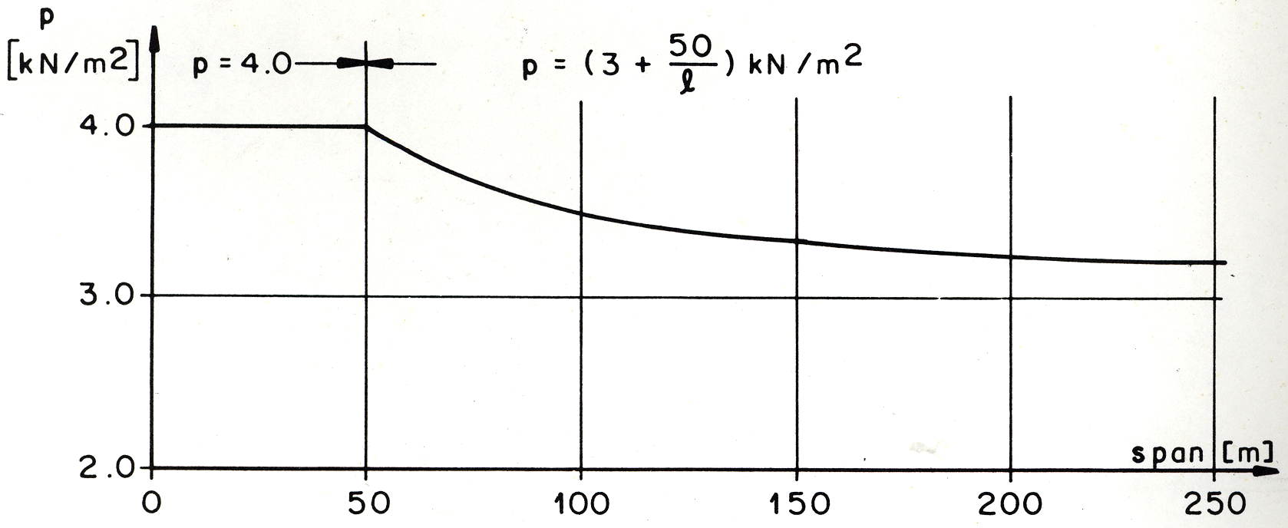

3.1.2 Dead Load

The dead load includes the weight of all permanent components of the bridge structure and is calculated according to a procedure that is in practice worldwide. Care must be taken that the mass (kg, ton) is properly converted into the force unit (N, kN) according to the "International System of Units".

For LSTB standard suspended type bridge, dead load without weight of Handrail and Walkway (main) cables is around 76.6 kg per meter span (inclusive of wind-guy system).

For LSTB standard suspension type bridge, dead load without weight of Main / Walkway (spanning) cables and excluding pretension in spanning cables is around 111.6 kg per meter span (inclusive of wind-guy system). The pretension in spanning cable is dependent of camber and pulling tension in walkway (spanning) cables.

3.1.3 Wind Load

High wind speeds and gorge effects are often encountered in the valleys of Nepal and bridges of different heights above ground level are common. The design wind load, given as a uniformly acting linear load or uniformly distributed load respectively, considers these factors. Although wind loading on to suspended and suspension bridges may have a horizontal as well as a vertical load component the effect of the latter is considered irrelevant to the design and is, therefore, neglected in the standard design.

The design wind load is taken 0.50 kN per meter span, corresponding to 160 km/hr wind speed. This wind speed of 160 km/hr exerts 1.3 kN/m² wind pressure. The blunt area of the walkway system is calculated 0.3 m² per meter span and with a coefficient of 1.3, the wind stagnated on the area gives 0.5 kN/m lateral load to the bridge (refer to Report on Windguy Arrangement for Suspended and Suspension Standard Bridges,
Dr. Heinrich Schnetzer, WGG Schnetzer Puskas Ingenieure AG, Switzerland, 2002).

3.1.4 Snow Load

Snow doesn't appear in large quantities in the mid-hills of Nepal, where most of the bridges are located. Because of the high live load and the low probability of a full live load occurring on a bridge loaded by snow, it is taken for granted that the snow load is already covered satisfactorily by the live load '. However, for bridges located at an altitude above about 3500m (outside Nepal it may even be below), investigations on snow loads must be carried out during the survey.

3.1.5 Temperature Effects

A difference in temperature causes a change in the cable length. Changes in cable length cause changes in the sag and therefore of cable forces also. This effect is omitted in the standard design because it is not considered to be relevant.

3.1.6 Seismic Load

Earthquakes are common in the seismically active zone of the Himalayan Mountains. The effect of earthquakes of the kind of magnitude occurring in Nepal on suspended and suspension bridge structures was checked for the revision. Because of the high live load and the low probability of a full live load occurring simultaneously with an earthquake, it is taken for granted that the seismic load is already covered satisfactorily by the live load. Therefore a separate loading combination with seismic loads need not be taken into consideration. Nevertheless, it has to be emphasized that the stability of the slopes may be affected by seismic effects and subsequently cause damage to the bridge structure.
3.2 Design and Statical Analysis, Safety Factors

3.2.1 General

The procedure for statical analysis follows the principles of the traditional system with admissible stresses, and these are compared with the calculated stresses in the structure caused by specified loadings. These loadings represent the effective loadings.

The introduction of the modern system which analyses the structure on the failure level, considering loads multiplied with a loading factor, would result in a completely new procedure. It was not considered to be of sufficient advantage for the time being to justify this change in the revised version, Volume A.

As site conditions (e.g., span, subsoil conditions) for suspended and suspension bridges vary from site to site, individual designs are necessary for the foundations and the cable structure. The procedure to be followed is standardized. Steel parts, towers, and the walkway structure do not depend on conditions that vary from site to site. Therefore, these elements are standardized and, depending upon the calculated forces, the elements are chosen from tables given within the manual; no further design work is required.

3.2.2 Cable Structure

Main cables, spanning cables, and windguy cables are supposed to demonstrate parabolic geometry. Thus the cable force is calculated with the simple formula H =
----> the bending moment " M = . " divided by the sag "b" of the cable,
(b = f, for suspension bridges).

To prevent the cables breaking, a minimum factor of safety (linear approach) is required of γ_{s} = 3.0 for all cables, regardless of the type of terminal.

3.2.3 Steel Structure (Tower and Steel Parts)

Six independent loading cases have been considered in designing all towers. The design shows a minimum safety factor of γ_{s} = 1.6 against the worst case with respect to buckling and yielding of the most critical element of each tower. All other steel parts meet the same requirements. The tower design is based on the Swiss Steel-Code, SIA 161 (1979).

3.2.4 Walkway Structure

Steel parts : The walkway structure (walkway deck, cross-beams) is designed to meet the safety requirements given in paragraph 3.2.3.

The dominant local loadings are shown in figures 3.2 and 3.3 below with the concentrated load
P = 1.5 kN on an area of 0.01 m² at the most unfavorable position on any member.

Figure 32: Two porters passing each other (P = 1.5 kN)

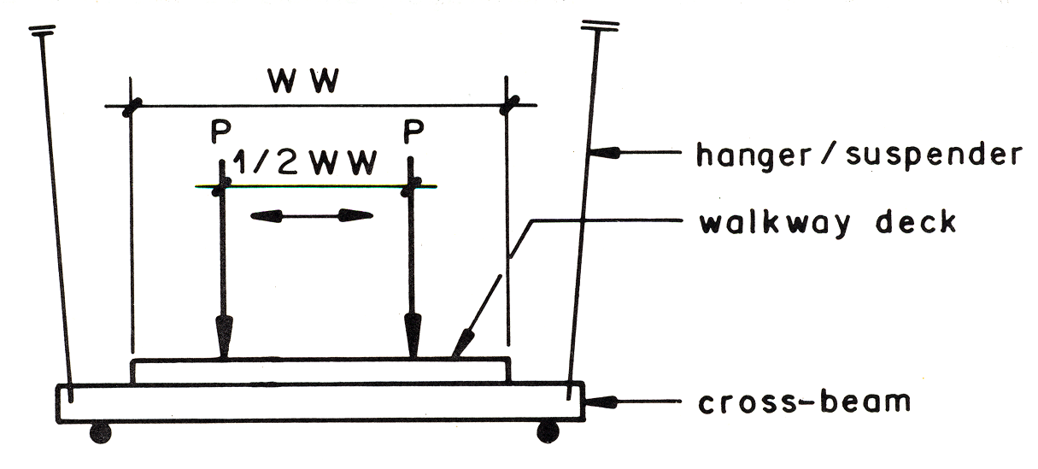

Figure 3.3: Porters standing in a row (P = 1.5 kN)

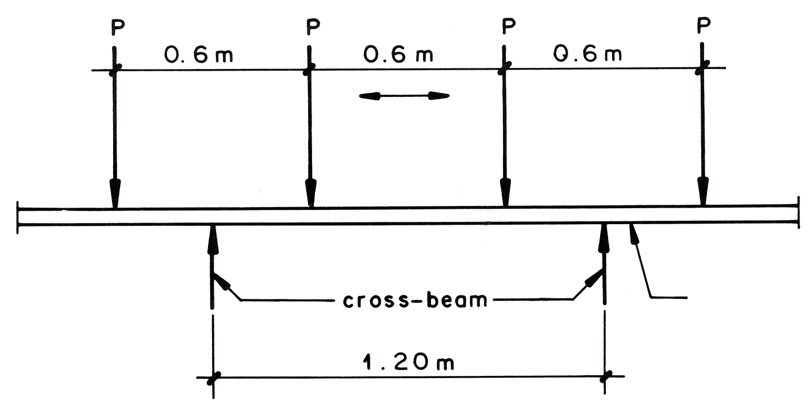

3.2.5 Foundations

Foundation design follows the traditional procedure of soil mechanics. Locally relevant soil parameters are determined by a survey campaign and following soil testing in the laboratory. For all foundations, the safety factor has to be shown against the well-known failure modes such as sliding (FSL ≥ 1.5), ground shear failure (FBC ≥ 2.0), Bearing Capacity of soil/Rock (σ_{ult} ≤ σ_{perm}), and toppling (FT ≥ 1.5). To meet serviceability requirements the eccentricity of the resultant force in the foundation base is restricted. Additionally the stability of slopes affected by the bridge foundation should be checked. The relevant safety factor should be chosen according to the method used for slope stability calculation (F_{Slope} ≥ 1.3 to 1.5, depending upon the method used for analysis).

To improve the sliding safety of the main foundation of suspended bridges on rock, rock anchorage may be used. In such cases a reduced safety factor against sliding
(FSL ≥ 1.3) and toppling (FT ≥ 1.2), neglecting these rock anchorages, should be shown in addition to the normal procedure.

