4. Material Specifications

Table of Contents

4.1 General 32
4.1.1 Standards 32
4.1.2 International System of Units 32

4.2 Cable Structures 33
4.2.1 Steel Wire Ropes 33
4.2.2 Cable Terminals 34
4.2.3 Cable Connections 36

4.3 Steel Structures 37
4.3.1 Structural Steel 37
4.3.2 Fasteners 38
4.3.3 Reinforcement Steel 38
4.3.4 Increase of Permissible Stresses 39
4.3.5 Rust Prevention 39

4.4 Civil Structures 40
4.4.1 Concrete 40
4.4.2 Masonry 41
4.4.3 Gabion 42
4.4.4 Timber

4.5 Unit Weight of Construction Material 43
4.1 General

4.1.1 Standards

The material specifications and permissible stresses for construction materials used for standard trail bridges are based on the latest Indian Standards (IS) available. Where IS were not available, other standards, such as DIN (German) Standards, British Standards, or SIA (Swiss) Standards, were considered.

4.1.2 International System of Units

The International System of Units (SI Units) has been introduced in this revised version according to IS 10005 - 1985.

Quantity | SI Unit | Multiples
Angle¹⁾ | – deg (degree, 360⁰)  – grade (or gon 400⁹) | degree, minutes, seconds  decimals
Length | m (meter) | (cm), mm
Area | m2 | (cm2), mm2
Volume | m3
Mass | kg (kilogram) | t (tonne)
Force | N (Newton) | kN (kilo Newton)
Moment of Force | Nm | kNm
Note: ¹⁾ The angle mode for the design analysis has been chosen to the degree unit (360⁰). Whereas for the survey, and the inclination of anchorage rods, it depends on the instruments used.
Table 4.1.1: Selection of Common SI Units

Conversion of mass into force:

Force is the effect of gravitation $\left(g=9\text{.}\text{81}\frac{m}{s^{2}}\right)$on mass, therefore,

Force = 1 kg · g = 1 kg · 9.81 $\frac{m}{s^{2}}$= 9.81 $\frac{\text{kg}⋅m}{s^{2}}$9.81 N ≈ 10 N.

For practical use, I kg is considered to be equal to 10 N (1 tone = 10000 N = 10 kN).
4.2 Cable Structures
4.2.1 Steel Wire Ropes

A) Specifications
Steel wire ropes should comply with all the requirements for:
IS 1835 – 1977 Steel Wire for Ropes
IS 6594 – 1977 Technical Supply Conditions for Wire Ropes and Strands
IS 9282– 1979 Specification for Wire Ropes and Strands for Suspension Bridges
IS 9182 – 1979 Specification for Lubrications for Wire Strands and Ropes

B) Rope Particulars
Nominal diameters: 26, 32, 36, 40 mm
– Construction: 7 x 19 (12/6/1)
– Lay: RHO, Right Hand Ordinary lay
– Core: WSC, Wire Strand Core
– Tensile strength of wire: 1570 N/mm²
– Preforming: Preformed
– Coating: Galvanized “A” Heavy
– Impregnation: Non-drying and non-bituminous type
– Elongation: Pre-stretched
Nominal diameter: 13 mm
– Construction: 7x7(6/1)
– Lay: RHO
– Core: WSC, Wire Strand Core
– Tensile strength of wire: 1570 N/mm²
– Preforming: None
– Coating: Galvanized "A” Heavy
– Impregnation: Non-drying and non-bituminous type

C) Compiled Data

Nominal  Diameter  (mm) | Approximate  mass  (kg/m) | Approximate  Load  (kN/m) | Metallic  Area  (mm2) | Minimum  Breaking Load  (kN) | Permissible  Load  (kN)
13 | 0.64 | 0.0064 | 73 | 103 | 34
26 | 2.51 | 0.0251 | 292 | 386 | 129
32 | 3.80 | 0.0380 | 442 | 585 | 195
36 | 4.81 | 0.0481 | 560 | 740 | 247
40 | 5.94 | 0.0594 | 691 | 914 | 305
Mean Value of Modulus of Elastic E = 110'000 N/mm2 = 110 kN/mm2
Table 4.2.1: Compiled Data of Steel Wire Ropes and Modulus of Elasticity
(including Safety Factor γ_{s} = 3.0 for all cables and cable ending terminals)
4.2.2 Cable Terminals

A) Terminals with Drums in Concrete

Cables may be anchored directly into the foundations with the help of bollards (drums made out of steel) and secured with cable clamps. The cables should be wound 3 times around the drum in order to reduce the tensile force to be secured. The minimum diameter of the drums should be 0.95 m.

The friction factor between the cable and steel is taken to be μ = 0. 1.

B) Terminals with Sockets

Sockets should be manufactured from steel conforming to IS 226-1975, specifications for Structural Steel (Standard Quality) with a tensile strength of σ_{u} = 420 to 540 N/mm², normalized after the completion of machining operations and hot-dip galvanized.

Socketing should be made with pure zinc according to IS 3937-1974 (Part 1), Recommendations for Socketing of Wire Ropes.

Sockets can be used as an alternative to thimbles and bulldog grips for all cable anchorages except for those having diameters of 13 mm.

At present socketing is not used in Nepal.
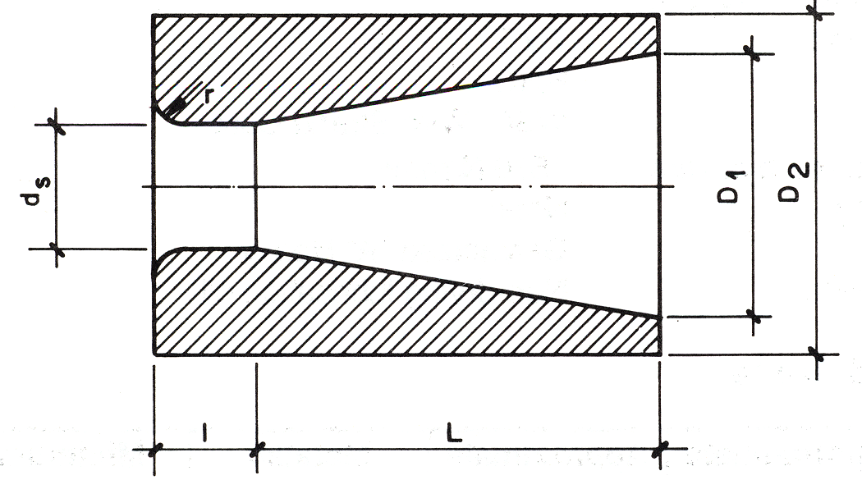

Nom. Diameter of Rope (mm) | d_{s}  (mm) | l  (mm) | L  (mm) | D₁  (mm) | D₂  (mm) | r  (mm)
26 | 30 | 24 | 105 | 63 | 82 | 6.0
32 | 37 | 30 | 130 | 78 | 102 | 7.5
36 | 42 | 34 | 148 | 88 | 115 | 8.5
40 | 46 | 37 | 162 | 97 | 127 | 9.0
Table 4.2.2: Dimensions for Sockets
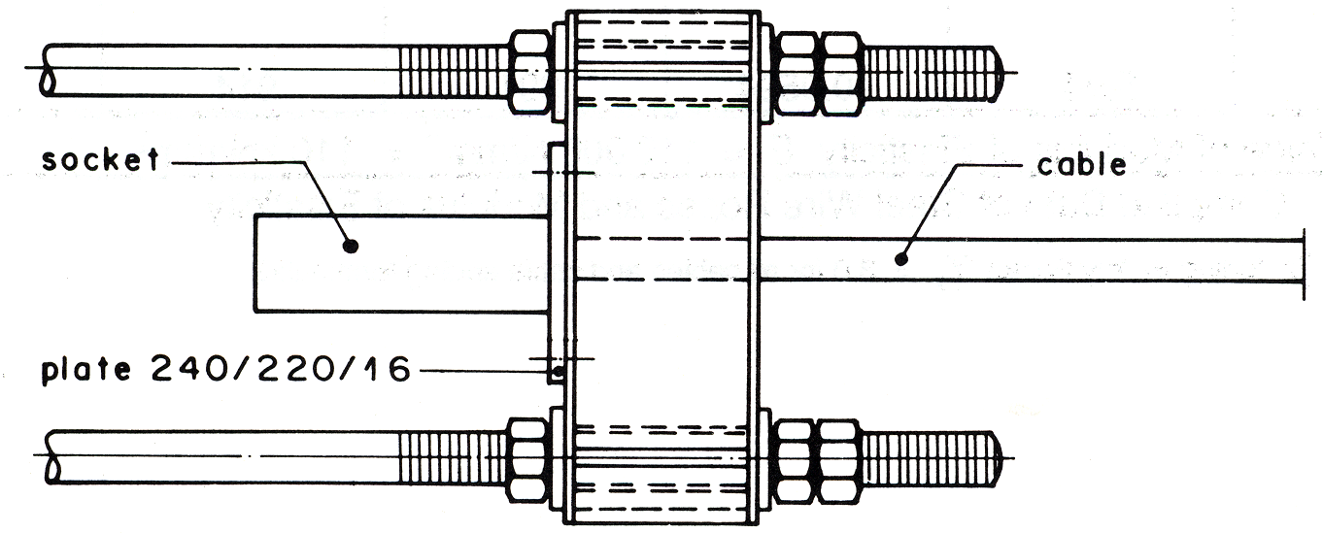

C) Terminals with Thimble and Bulldog Grips

Bulldog grips should conform to IS 2361-1970, Specifications for Bulldog Grips. The bridges must be drop-forged and suitably scored to grip a round strand rope of right-hand lay having six strands. Bridges, U-bolts, and nuts should be hot-dip galvanized with minimum zinc coating of 40 µm.

Nom Diameter of Rope (mm) | A  (mm) | B  (mm) | C  (mm) | D  (mm) | E  (mm) | F  (mm) | G  (mm) | H  (mm) | I  (mm) | Approximate Weight (kg)
13 | M 12 | 64 | 27 | 32 | 15 | 51 | 12 | 28 | 22 | 0.28
26 | M 20 | 118 | 51 | 57 | 31 | 91 | 20 | 46 | 36 | 1.10
32 | M 20 | 124 | 54 | 59 | 34 | 94 | 20 | 46 | 36 | 1.30
36 | M 22 | 142 | 63 | 67 | 41 | 107 | 22 | 51 | 40 | 1.85
40 | M 25 | 157 | 69 | 75 | 44 | 119 | 25 | 58 | 45 | 2.40
Table 4.2.3: Dimensions and Weights for Bulldog Grips.
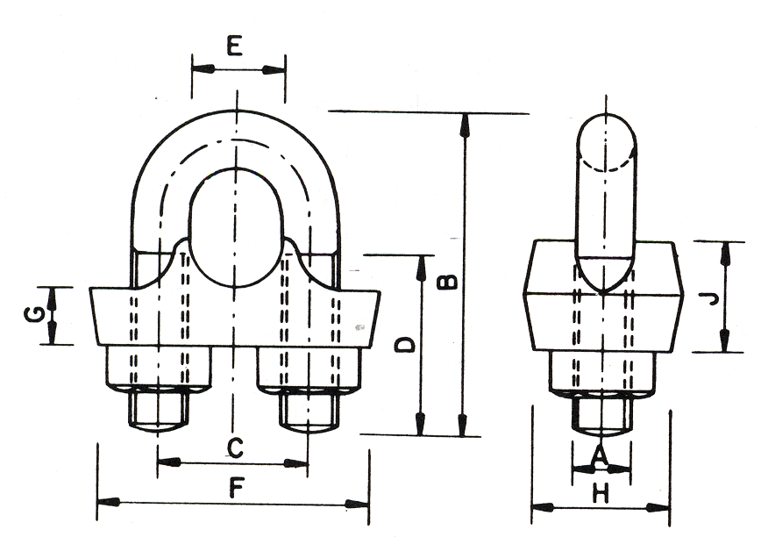

Bulldog grips, when properly applied, afford a simple and effective mechanical means of securing the ends of wire ropes, but have to be inspected after some loadings.

Thimbles are of open type, conforming to IS 2315 - 1978, Specifications for Thimbles for Wire Ropes. They must be forged and hot-dip galvanized with minimum zinc coating of 40 µm.

Nom. Diameter of Rope (mm) | A (mm) | C (mm) | D (mm) | F (mm) | G (mm) | K (mm) | r (mm) | R (mm) | Approximate Weight (kg) | P (mm)
13 (14) | 41 | 19 | 68 | 15 | 9 | 12 | 7.5 | 9.5 | 0.12 | 38
26 (29) | 82 | 39 | 135 | 31 | 17 | 23 | 15.0 | 19.5 | 0.75 | 79
32 (32) | 92 | 43 | 152 | 34 | 19 | 26 | 17.0 | 21.5 | 1.85 | 89
36 (38) | 110 | 52 | 185 | 41 | 23 | 32 | 20.5 | 26.0 | 2.75 | 107
40 (41) | 124 | 47 | 208 | 44 | 26 | 36 | 23.0 | 28.5 | 3.20 | 121
Table 4.2.4: Dimensions and Weights for Thimbles (Nominal size of thimbles in b rackets)
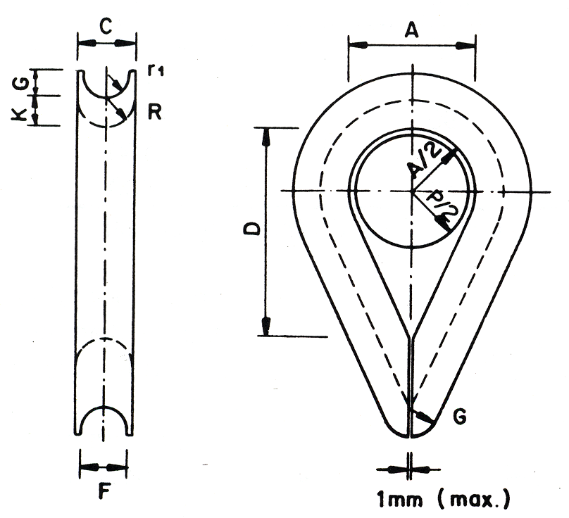

Thimbles are necessary to give lateral support to the strands of the cable at the bend, and the pin must support the thimble.
P ≈ A - 3mm

Method and Specifications for Applying Bulldog Grips to Wire Ropes

Nominal Diameter of Rope (mm) | Required Number, n, of Bulldog Grips | Gap "G" (mm) | Overlapping Length "L" (mm)
13 | 3 | 80 | 550
26 | 5 | 155 | 1250
32 | 6 | 190 | 1700
36 | 7 | 215 | 2100
40 | 8 | 240 | 2550
Table 4.2.5: Terminals: Number of Bulldog Grips, Gap, Overlapping Length

The bridge of the grip must be fitted on to the working part of the rope and the U-bolt on to the rope tail. The first grip must be fitted as close as possible to the thimble. Grips should be spaced at a distance of approximately six times the rope diameter. The cable end should be protected from fraying with binding wire and, if the cable is too long, it should be fixed to the working part of the cable.
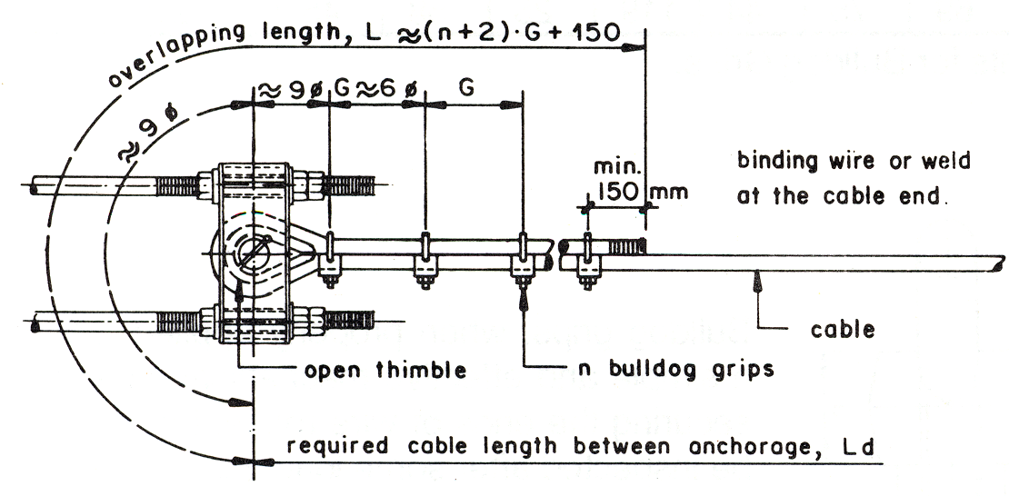
4.2.3 Cable Connections
Cable connections may be required because of a change in design or during erection of the bridge. If possible, the connection should be made with the same cable diameter or with the cable diameter that is next in sequence.

A) Cables of Different Diameters
Cable connections of different diameters (or equal) must be made with the correct cable terminals (refer to 4.2.2 C) and a double pin intersection.

B) Cables of Equal Diameter
Nominal Diameter of Rope (mm) | Required Number, n, of Bulldog Grips | Gap "G (mm) | Overlapping Length "L" (mm)
13 | 6 | 80 | 700
26 | 10 | 155 | 1700
32 | 12 | 190 | 2400
36 | 14 | 215 | 3100
40 | 16 | 240 | 3900
Table 4.2.6: Cable Connections: Number of Bulldog Grips, Gap, Overlapping Length
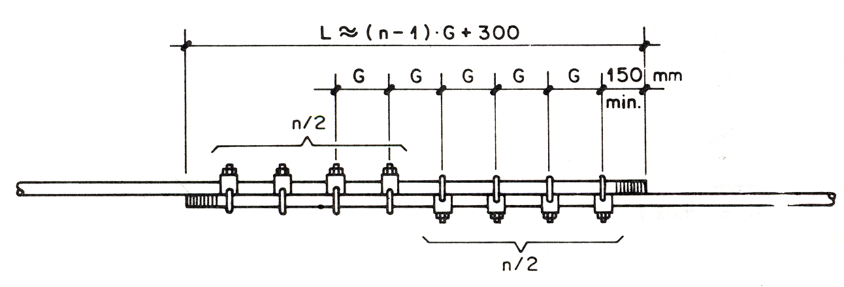
Connections of cables equal in diameter can be made (refer to 4.2.2 C) without thimbles but with twice the number of bulldog grips.

4.3 Steel Structures
4.3.1 Structural Steel

A) Specifications
Structural steel should comply with all the requirements for:

IS 226 -1975 Structural Steel
IS 800 -1984 General Construction in Steel

The tower design is based on the Swiss Standard SIA 161 (1979) for Steel Structures.

B ) Steel Grade
Standard quality FE 410

C) Compiled Data

Stress Case | Plate thickness (mm) | t ≤ 20 | 20 < t0 ≤ 40 | t > 40
Stress Case | Bars (mm) | ø ≤ 20 | ø > 20
Permissible Tensile Stress: σ_{at} = 0.6 f_{y} (N/mm²) |  | 150 | 144 | 138
Permissible Compressive Stress:  σ_{ac} in (N/mm²) for slenderness λ = 0  50  100  150  200  250 |  | 150  132  80  45  28  18 | 144  127  79  45  28  18 | 138  123  78  45  27  18
Permissible Bending Stress in Tension:  σ_{bt} = 0.66 f_{y} (N/mm²) |  | 165 | 158 | 152
Permissible Bending Stress in Compression:  σ_{bc} in (N/mm²) (σ_{bc} ≤ 0.66 fy);  Elastic Critical Stress in Bending: F_{cb} = ∞  1000 N/mm²  500  300  200  100  20 |  | 165  150  131  110  89  55  13 | 158  145  127  107  88  55  13 | 152  139  123  104  86  54  13
Permissible Average Shear Stress:  τ_{av.} = 0.4 f_{y} (N/mm²) |  | 100 | 96 | 92
Maximum Permissible Equivalent Stress:  σ_{P} = 0.75 f_{y} (N/mm²) |  | 188 | 180 | 173
Maximum Permissible Equivalent Stress:  σ_{e} = 0.9 f_{y} (N/mm²) |  | 225 | 216 | 207
Modulus of Elasticity: E = 200'000 N/mm²
Unit Weight: γ = 7850 kg/m³
Table 4.3. 1: Permissible Stress in Structural Steel

D) Cold-formed Steel

Cold-formed steel should comply with all the requirements for:

IS | 811 -1987 | Cold-formed Light Gauge Structural Steel Sections
IS | 808 -1989 | Dimensions for Hot-rolled Steel Beams, Columns, Channels, and Angle Sections

4.3.2 Fasteners

A) Specifications

Bolts, nuts, and washers should comply with all the requirements for:

IS | 1363 - 1984 (Part 1) | Hexagonal Head Bolts and Nuts
IS | 1367 - 1983 | Threaded Fasteners

B) Grade

Grade C, property Class 4.6

C) Compiled Data
Stress Case | Permissible Stress (N/mm²)
Stress in Axial Tension on Net Area σ_{tf} | 80
Stress in Shear on Gross Area: τ_{vf} | 80
Stress in Bearing on Gross Area: σ_{pf} | 250
Combined Tensile and Shear Stress | $\left(\frac{τ\text{Vf cal}}{τ\text{vt}}+\frac{σ\text{tf cal}}{σ\text{tf}}\right)$≤ 1.4
Table 4.3.2: Maximum Permissible Stress in Bolts for Class 4.6

4.3.3 Reinforcement Steel

A) Specifications
Reinforcement steel should comply with all the requirements for:

IS | 1786 - 1986 | High Strength Deformed Steel Bars for Concrete Reinforcement
IS | 456 -1978 | Plain and Reinforced Concrete

B) Steel Grade
Fe 415, High Yield Strength Deformed Bars

C) Compiled Data

Stress Case | Permissible Stress for Fe 415 (N/mm²)
Tension Stress in Steel: σ_{st} | 230
Compression Stress in Steel σ_{sc} | 190
Permissible Bond Stress for Anchorage in  Cement Mortar I : 1 and  concrete > 1: 2 : 4 σ_{sB} | 0.6
Modulus of Elasticity: E = 210'000 (N/mm²)
Unit Weight: γ = 7850 (kg/m³)
Table 4.3.3: Permissible Stress in Steel Reinforcement

4.3.4 Increase of Permissible Stresses
For occasional loadings combined with dead, live, and wind loads, the permissible stresses can be increased as follows:

Load | Material | Increase of Stress
Dead load, live load,  wind load and temperature,  or  wind load and seismic load | Structural Steel  Bolts and Tension Rods  Reinforcement Steel | 33%  25%  33%
Erection  (Secondary Effects) | Structural Steel  Bolts and Tension Rods | 25%  25%
Table 4.3.4: Increase of Permissible Stress

4.3.5 Rust Prevention
To prevent rusting in steel structures they should be hot-dip galvanized or painted (painting is optional only but not recommended), and should comply with all the requirements for:

IS | 8629 - 1977 | Protection of Iron and Steel Structures from Atmospheric Corrosion
IS | 2629 - 1966 | Recommended Practice for Hot-Dip Galvanizing of Iron and Steel
IS | 4759 - 1984 | Specifications for Hot-Dip Zinc Coatings on Structural Steel

4.4 Civil Structures

4.4.1 Concrete

A) Specifications

Concrete should comply with all the requirements for:

IS 456 - 1978 Plain and Reinforced Concrete
IS 269 -1989 Ordinary Portland Cement
IS 383 -1970 Coarse and Fine Aggregates

B) Concrete Grades

(Mixed by volume units; cement: sand: aggregates)
– Lean concrete 1: 4: 8 used as sub-concrete
– Concrete 1: 3: 6 (M10)
– Concrete 1: 3: 6 mixed with 40% boulders
– Concrete 1: 3: 6 mixed with 60% boulders, used as fill concrete
– Concrete 1: 2: 4 (M15)
– Concrete 1: 1½ :3 (M20)

Reinforced concrete should always be vibrated.

C) Compiled Data

Grade of Concrete |  | Permissible Stress (N/mm²)
 |  | 1: 3: 6  (M 10) | 1: 3: 6 + 40%  boulders | 1: 2:4  (M 15) | 1: 1½ :3 (M 20)
Stress in Compression | bending σ_{c} (extreme fiber) | 3.0 | 2.0 | 5.0 | 7.0
Stress in Compression | direct σ_{a} | 2.5 | 1.5 | 4.0 | 5.0
Shear stress, measured as inclined tension τ_{c} |  | 0.3 | 0.2 | 0.5 | 0.7
Stress in bearing |  | 2.0 | 1.0 | 3.0 | 4.0
Tension stress in bending  (plain concrete) |  | 0.3 | 0.2 | 0.5 | 0.7
Table 4.4.1: Permissible Stresses for Concrete

For occasional loading (wind, erection) combined with dead and live loads, the permissible stresses can be increased by 33%.

Modulus of Elasticity for Concrete 1: 2: 4 (M 15) and 1: 1½ :3 (M 20): E = 21000 N/mm²

In anchorage steel designs, the bond resistance of connection flats and rods and the bearing resistance of shuttering have generally been neglected.
4.4.2 Masonry

A) Specifications

The specifications and permissible stresses given below are based on:

IS 1597 – 1967 (Part 1) Code of Practice for Construction of Stone Masonry
SIA 178 – 1980 Swiss Standard for Stone Masonry
IS 2250 – 1981 Preparation and Use of Masonry Mortars

B) Types of Masonry

(mixed by volume units; cement: sand)
– Rubble masonry 1: 6
– Rubble masonry 1:4
– Block stone masonry 1:4

C) Compiled Data

Type of Masonry |  | Permissible Stress (N/mm²)
 |  | Rubble masonry  1:6 |  | Rubble masonry  1:4 |  | Block stone masonry 1:4
 |  |  |  |  |  | Stratified blocks |  | Non-stratified blocks
Slenderness Ratio h/d* |  | 0.5 | 2.0 | 0.5 | 2.0 | 0.5 | 2.0 | 0.5 | 2.0
Stress in Compression | bending  (extreme fiber) | 1.3 | 0.7 | 1.9 | 1.1 | 2.1 | 1.3 | 3.7 | 2.0
Stress in Compression | direct | 1.0 | 0.5 | 1.4 | 0.8 | 1.6 | 1.0 | 2.8 | 1.5
Tension stress in bending |  | 0.13 | 0.07 | 0.19 | 0.11 | 0.21 | 0.13 | 0.37 | 0.20
* h = height of wall, d = thickness of wall
Table 4.4.2: Permissible Stress for Masonry

If masonry walls are used in combination with concrete and the thickness of the concrete is greater than the thickness of the masonry, the permissible stresses for the appropriate concrete grade have to be applied.

4.4.3 Gabion

A) Specifications of Wire

Gabion wire should comply with all the requirements for:
IS 280 –1978 Mild Steel Wire for General Engineering Purposes
IS 4826 – 1979 Hot-dipped Galvanized Coatings on Round Steel Wire

B) Diameter of Wire
Mesh wire 10 SWG
Selvedge wire 7 SWG
Binding Wire 12 SWG
4.4.4 Timber

A) Specifications

Timber should comply with all the requirements for:
IS 883 -1970 Design for Structural Timber
IS 1141 - 1973 Seasoning of Timber
IS 401 -1967 Preservation of Timber

B) Types of Timber

– For walkway deck:
Group B (Modulus of Elasticity above 9800 and up to 12600 N/mm²)

– For formwork:
Group C (Modulus of Elasticity above 5600 and up to 9800 N/mm²)

The wood for decking should be property seasoned and preserved either with coal tar creosote, with a mixture of coal tar and kerosene, or with a chemical-type preservative. If creosote or tar/kerosene are used for protection, a deep impregnation of the preservative must be obtained; surface application has little value.

C) Compiled Data

Stress Case | Permissible Stress and Modulus of Elasticity (N/mm²)
Stress Case | Group B | Group C
Stress in bending  tension along grain  (extreme fibre) f_{b} | 130 | 70
Shear stress  along grain | 1.3 | 1.0
Stress in compression  parallel to grain f_{cp}  perpendicular to grain f_{cn} | 9.0  3.5 | 5.0  1.5
Modulus of Elasticity E | 12700 | 9400
Unit Weight (kg/m³) | 900 | 600
Table 4.4.3: Average Permissible Stress, Modulus of Elasticity, and Unit Weight of Timber
4.5 Unit Weight of Construction Material

The unit weight (mass) of construction material used in standard bridge construction is given in the following table. (For the purpose of load calculation, the weight (mass) is converted into SI units with the approximate value of 1 kg =10 N = 0.01 kN.)

Material | Weight  (kg/m³) | Load  (kN/m³)
Concrete: | 2200 | 22.0
Masonry:
– dry rubble | 2000 | 20.0
– rubble | 2200 | 22.0
Steel | 7850 | 78.5
Gabion | 1600 | 16.00
Water | 1000 | 10.0
Soil (According to survey and geological report) | 1600 to 2200 | 16.0 to 22.0
Timber for walkway deck (sal wood) | 900 | 9.0
Table 4.4.4: Unit Weight of Construction Material

New IS 9282 - 2000 has reduced the breaking load. Nevertheless, for trail bridges, the IS 9282 – 1979 shall be effective.
Pre-stretching should be done by cyclic loading of the rope to 5% to 40% of the minimum breaking load in sequence of 5% to 10%, 5% to 20% and 5% to 40% loading till elongation stabilizes.

